Article 78:
How Contract Length Can Strengthen Customer Lock-In
In fundamental business analysis, customer retention is widely acknowledged as the primary engine of high margin corporate compounding. Acquiring a new corporate customer requires substantial upfront expenditures on marketing, sales commissions, technical onboarding, and implementation engineering. If that customer cancels their relationship after twelve months, the vendor often fails to recoup its customer acquisition costs, resulting in negative net unit economics.
To insulate cash flows and maximize lifetime customer value, elite enterprises utilize structural contract architecture to deepen competitive moats. Examining how contract length switching costs interact reveals how multi-year agreements transform transactional client relationships into airtight economic partnerships. When structured effectively, long term contracts do not merely lock in revenue; they compound switching costs over time, rendering vendor replacement commercially unthinkable.
This institutional guide deconstructs the microeconomics of commercial contract duration, explains how multi-year agreements solidify customer retention, and demonstrates how disciplined allocators identify businesses with unbreakable customer lock-in.
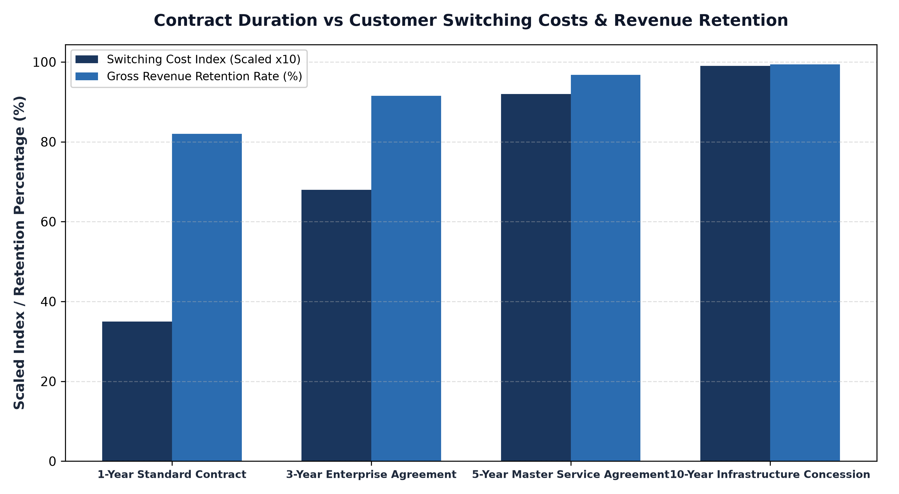
1. Beyond the Legal Document: The Compounding of Operational Integration
A common misconception among retail investors is assuming that a long term contract locks in a customer purely through legal threat. An investor assumes that a client remains loyal simply because breaking a five-year contract incurs punitive legal penalties. While contractual termination clauses provide baseline protection, the true economic lock-in is operational rather than legal.
When an enterprise signs a three, five, or seven year Master Service Agreement for mission critical software, logistics, or industrial gas supply, it initiates deep organizational integration. Over the multi-year contract term, the vendor's software APIs are integrated into hundreds of corporate databases, internal employee workflows are standardized around the vendor's user interface, and operational data accumulates within the vendor's platform. By year three, the client's entire business infrastructure is dependent on the vendor, making vendor replacement an operational nightmare.
2. Multi-Year Contracts and Inflation Escalators
Another crucial advantage of long duration contracts is the incorporation of formulaic pricing escalators. In transactional businesses, raising prices requires confronting the customer at every purchase, inviting negotiation and competitor bidding. In multi-year enterprise contracts, pricing increases are agreed upon upfront as binding contractual covenants.
Contracts routinely incorporate automated annual price escalations of four to seven percent, or index price adjustments directly to the Consumer Price Index (CPI) plus an agreed margin spread. This structure guarantees that the vendor's revenues and gross margins expand automatically year after year without triggering customer sales friction. Cash flow predictability surges, allowing management to plan capital expenditures and share repurchases with mathematical confidence.
3. Eliminating the Competitor Sales Window
In short duration, one-year contract models, competitors have an annual opportunity to pitch corporate clients. Every twelve months, the procurement department evaluates competing proposals, subjecting the incumbent to pricing pressure and margin erosion. Short contracts force the incumbent to spend heavily on defensive customer success teams just to protect existing revenue.
Long duration contracts completely shut down competitor sales windows for years at a time. When a corporate client signs a five-year commitment, competing sales representatives are locked out of the account for half a decade. Over that extended period, competitor sales teams reallocate their resources elsewhere, competitor product compatibility with the client's systems decays, and the incumbent's competitive moat widens undisturbed.
4. The MPLY Standard: Dominant Franchises with Contractual Moats
Long term equity compounding thrives when portfolios are constructed around companies that enjoy long duration contractual lock-in with premier corporate clients.
Investors seeking high conviction access to market leaders protected by unbreakable contractual moats can explore the Strategy Shares Monopoly ETF (MPLY) at https://strategysharesetfs.com/mply/. MPLY is an actively managed ETF that purposefully concentrates capital into 25 to 35 enduring corporate monopolies. By holding dominant platforms with multi-year enterprise contracts, high switching costs, and automated price escalators, MPLY ensures that underlying holdings compound shareholder wealth through predictable, high margin recurring cash flows.
From an enterprise procurement perspective, multi-year master service agreements establish significant bureaucratic inertia that reinforces customer lock-in. Once a corporate legal and procurement department completes the exhaustive compliance, security, and vendor risk assessments required to execute a multi-year contract, corporate executives are highly reluctant to reopen vendor reviews.
Furthermore, enterprise contracts frequently feature automatic renewal covenants unless written cancellation notice is provided six to twelve months in advance. This operational friction ensures that incumbent vendors enjoy near-automatic contract renewals, allowing customer lifetime value to compound predictably over multi-decade corporate relationships.
5. Frequently Asked Questions
Q1: Can long term contracts backfire if input inflation exceeds the contractual escalator?
In capital intensive industries, poorly structured fixed-price contracts can compress margins. However, elite monopolies utilize floating inflation-indexed escalators and fuel surcharges, ensuring that profit margins remain fully insulated from cost spikes.
Q2: How does Remaining Performance Obligation (RPO) reflect contract length on financial statements?
RPO measures total contracted revenue that has not yet been recognized, including deferred revenue and multi-year backlog. A surging RPO balance confirms that contract lengths and multi-year customer commitments are expanding.
6. Sources
Morningstar, Customer Switching Costs, Contract Duration, and Economic Moat Analysis: https://www.morningstar.com/articles/moat-research
Harvard Business Review, The Economics of Customer Lock-In and Contractual Switching Costs: https://hbr.org/1979/03/how-competitive-forces-shape-strategy
#EconomicMoat #CompetitiveAdvantage #Investing #Stocks #MPLY

