Article 79:
What Is a Cost Advantage Moat?
In the competitive warfare of global commerce, companies deploy diverse strategies to defend their market share. Some enterprises cultivate elite luxury brands that command emotional pricing premiums. Others engineer proprietary software codebases that impose insurmountable customer switching costs. Yet, in dozens of foundational global industries, from freight transportation to commodity processing, customer purchasing decisions are dictated strictly by price.
In price sensitive markets, an enterprise cannot survive by charging a premium. The only structural mechanism capable of generating durable excess profits in these industries is an unassailable cost advantage moat. When a company can produce, transport, or deliver a product or service at a fundamentally lower unit cost than any competitor, it establishes an economic fortress that turns competitor desperation into permanent shareholder wealth.
This institutional guide deconstructs the primary drivers of cost advantage moats, explains why scale economies create self reinforcing barriers to entry, and demonstrates how disciplined allocators identify low cost monopolies.
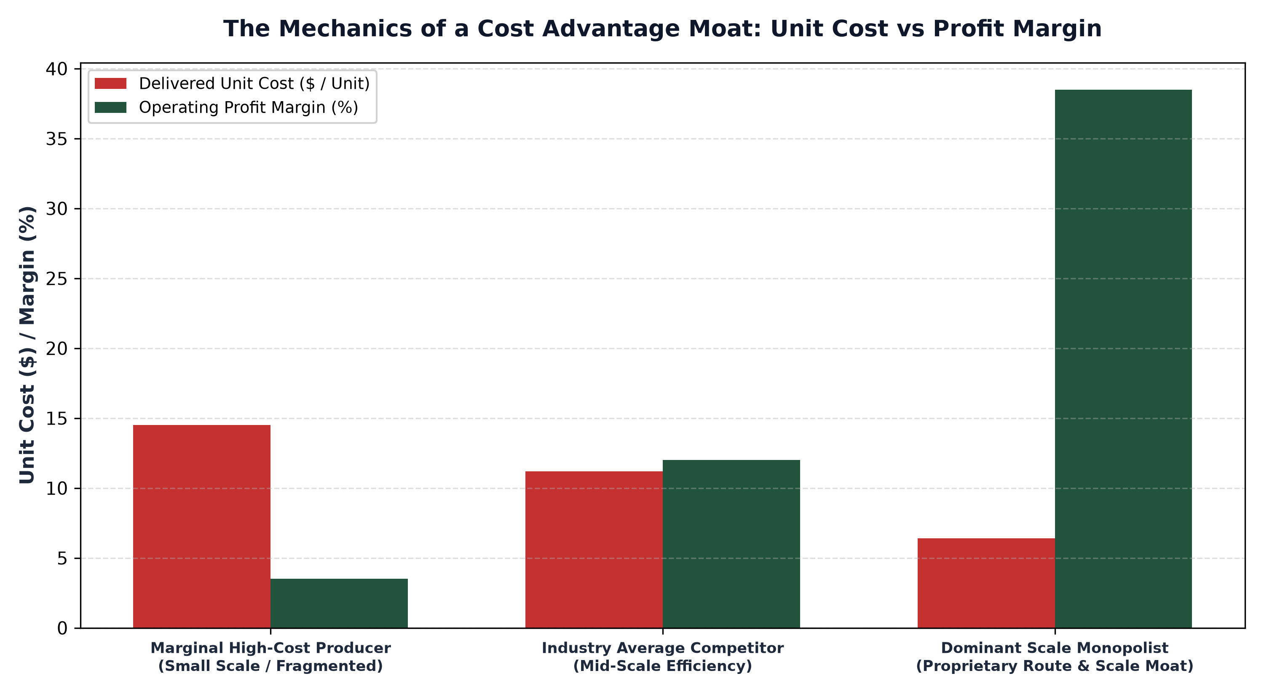
1. The Economics of Scale: Spreading Fixed Capital Costs
The most common and durable driver of a cost advantage moat is economies of scale. In heavy infrastructure, semiconductor fabrication, and transcontinental logistics, establishing operations requires billions of dollars in upfront fixed capital expenditures. Once these massive physical assets are constructed, the marginal cost of processing incremental volume is negligible.
The company that commands the largest market share processes vastly more unit volume over that fixed asset base, driving average unit costs down to levels that smaller competitors cannot match. Consider transcontinental freight railways. A dominant railway operating thousands of miles of track spreads its track maintenance, signal technology, and locomotive dispatching overhead across millions of carloads, operating at an operating ratio in the low sixty percent range. A smaller competitor processing half the volume faces structural cost disadvantages that guarantee inferior profitability.
2. Proprietary Processes and Unique Geographic Assets
Beyond raw scale, cost advantage moats can be established through proprietary manufacturing processes or irreplaceable geographic rights of way. An enterprise that invents a patented chemical synthesis process requiring 40% less energy and fewer raw materials possesses an insurmountable unit cost edge over legacy competitors for the duration of the patent life.
Similarly, geographic location can create permanent cost moats. An aggregate quarry located ten miles outside a booming metropolitan area enjoys massive transportation cost advantages over quarries located one hundred miles away. Because transporting heavy stone by truck is expensive, the near-city quarry can match competitor delivery prices while earning massive thirty percent operating profit margins, protected permanently by physical geography.
3. The Weapon of Low-Cost Pricing Power
The true power of a cost advantage moat is strategic pricing flexibility. A low cost monopolist does not need to undercut competitors continuously; it can price its offerings just below the marginal cost of the second most efficient producer. In this equilibrium, the low cost leader earns robust twenty to thirty percent returns on capital while competitors barely break even.
If an aggressive competitor attempts to contest market share by starting a price war, the low cost leader simply lowers prices further. While the low cost leader's profit margins compress slightly, the high cost competitor faces immediate operating losses and cash drain, quickly forcing them to abandon the price war or enter bankruptcy. The cost moat functions as an impenetrable economic shield.
4. The MPLY Framework: Prioritizing Structural Low-Cost Leaders
Long term equity compounding thrives when portfolios concentrate capital into enterprises that command permanent structural cost advantages within essential global industries.
Investors seeking high conviction access to dominant market leaders with unshakeable cost advantage moats can explore the Strategy Shares Monopoly ETF (MPLY) at https://strategysharesetfs.com/mply/. MPLY is an actively managed ETF concentrating capital in 25 to 35 enduring corporate monopolies. By holding businesses that dominate transcontinental transportation networks, specialized manufacturing bottlenecks, and proprietary financial market infrastructures, MPLY ensures that portfolio holdings maintain superior cost economics and durable compounding power.
In manufacturing and process engineering, cost advantage moats are governed by the classic Boston Consulting Group experience curve. Empirical industrial research demonstrates that each time cumulative production volume doubles, total unit manufacturing costs decline by a predictable percentage (typically twenty to thirty percent) due to worker specialization, process automation, and bulk raw material purchasing leverage.
The dominant scale leader that maintains the highest cumulative production volume permanently operates at the lowest unit cost point on the global industry cost curve. Smaller competitors producing at sub-scale volumes face structural cost penalties that guarantee inferior operating margins, leaving the scale leader with an impenetrable economic barrier to entry.
5. Frequently Asked Questions
Q1: Can a cost advantage moat be replicated if competitors raise more capital?
In scale-based infrastructure and geographic monopolies, no. Duplicating transcontinental rail corridors or global payment clearing networks is economically irrational and legally prohibited by zoning and regulatory authorities.
Q2: How does a cost advantage moat protect against macroeconomic inflation?
Because a low cost leader operates with superior gross margins, inflationary cost increases represent a smaller percentage of its total revenue, allowing it to preserve positive operating cash flow while marginal competitors slip into losses.
6. Sources
Morningstar, The Economics of Cost Advantage Moats and Scale Efficiency: https://www.morningstar.com/articles/moat-research
Harvard Business Review, Competitive Strategy and the Sources of Sustainable Cost Advantage: https://hbr.org/1979/03/how-competitive-forces-shape-strategy
#EconomicMoat #CompetitiveAdvantage #Investing #Stocks #MPLY

