Article 80:
How Market Share Can Affect Competitive Economics
In the lexicon of corporate strategy, market share is often discussed as a vanity trophy. Management teams celebrate market leadership in annual shareholder letters, boasting of being number one or number two in their chosen category. Skeptical investors, meanwhile, frequently point out that market share alone does not guarantee profitability, citing numerous high volume commodity businesses that command massive market share while earning dismal returns on capital.
While it is true that hollow market share in undifferentiated sectors creates little value, in industries characterized by high fixed capital costs, intellectual property standards, or network effects, market share fundamentally alters the underlying laws of unit economics. Analyzing how market share competitive economics interact reveals the mathematical threshold where expanding market share transitions from modest scale efficiency into unshakeable monopolistic pricing power.
This institutional guide explores how market share dictates industrial profitability, explains the tipping point dynamic in network and infrastructure markets, and outlines how disciplined allocators identify dominant market compounders.
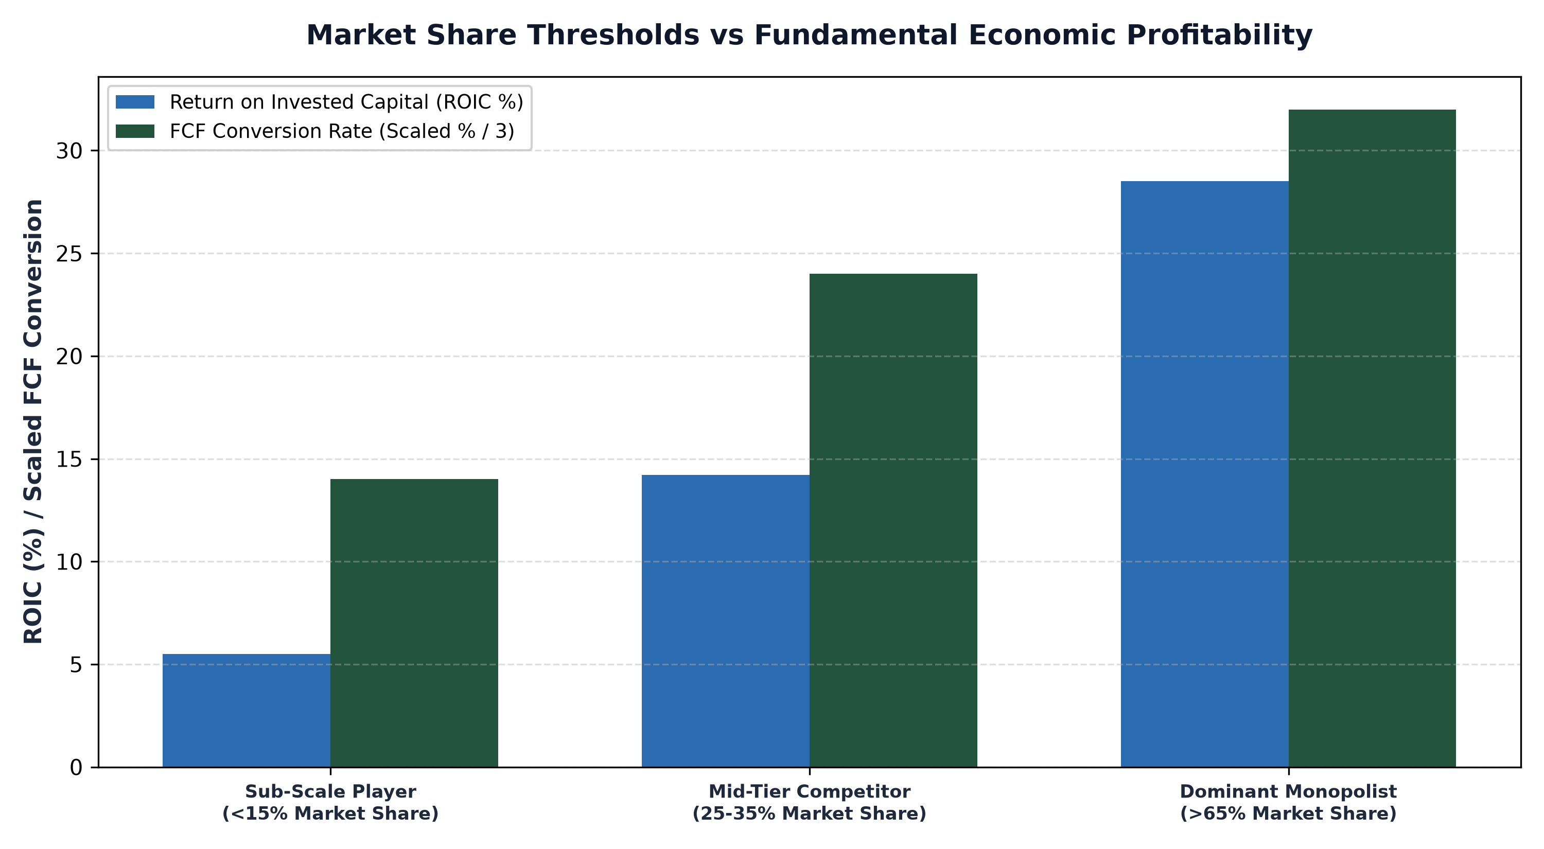
1. The Virtuous Cycle of Market Share and Reinvestment Velocity
In knowledge intensive and technology driven industries, market share is not merely a measure of historical sales; it is the engine of future research and development velocity. Consider enterprise software, specialized semiconductor design, or medical diagnostics. Developing the next generation platform requires hundreds of millions, or billions, of dollars in annual engineering R&D expenditures.
The company that controls 70% market share generates five times the cash flow of its nearest rival. Because it commands vast cash reserves, it can invest three times more in annual R&D while spending a significantly lower percentage of its total revenues on engineering overhead. This virtuous cycle ensures that the dominant player consistently launches superior product updates and deepens software integrations, steadily widening its technological advantage over sub-scale competitors.
2. Network Effects and the Winner-Take-All Tipping Point
In two-sided platform markets, such as digital payment clearing rails, securities exchanges, and digital marketplaces, market share dictates terminal economics through network effects. Metcalfe's Law states that the value of a telecommunications or digital network is proportional to the square of the number of connected users. Once a platform surpasses a critical market share threshold (typically 50% to 60%), the industry hits a decisive tipping point.
Buyers must participate on the platform because that is where all sellers congregate; sellers must list on the platform because that is where all buyers reside. At this stage, market share creates insurmountable switching costs. Competing platforms cannot attract liquidity even if they offer zero commission trading or subsidized merchant fees. The dominant platform captures monopoly pricing power, extracting basis point economic rents on global transaction volume with near zero variable cost.
3. Relative Market Share: The Rule of Three and Four
In corporate finance and competitive strategy, Boston Consulting Group's classic empirical research revealed the Rule of Three and Four: a stable industrial market will inevitably be dominated by three significant competitors, where the market leader commands roughly double the market share of the second player, and four times the market share of the third.
More importantly, profitability correlates directly with relative market share. The leader generates massive Return on Invested Capital and pristine free cash flow, the second player earns modest returns matching the cost of capital, and marginal sub-scale players face chronic capital impairment. Understanding this economic gradient allows allocators to avoid sub-scale value traps and concentrate capital strictly in dominant market leaders.
4. The MPLY Mandate: Pure Exposure to Dominant Market Leaders
High conviction active investing demands concentrating capital exclusively in enterprises that possess commanding relative market share within essential global industries.
Investors seeking an actively managed equity portfolio anchored in dominant corporate market leaders can explore the Strategy Shares Monopoly ETF (MPLY) at https://strategysharesetfs.com/mply/. MPLY is an actively managed ETF that purposefully concentrates capital into 25 to 35 enduring corporate monopolies. By screening for market leaders commanding overwhelming relative market share, high return on invested capital, and insurmountable network effects, MPLY ensures that portfolio holdings capture the immense economic benefits of structural industry dominance.
In capital-intensive infrastructure and technology platforms, market share determines whether an enterprise achieves Minimum Efficient Scale (MES). Minimum Efficient Scale represents the lowest point on the long-run average cost curve where a firm exhausts economies of scale and minimizes unit production costs.
Sub-scale competitors that fail to reach Minimum Efficient Scale suffer from chronically high unit costs and depressed Return on Invested Capital, rendering them vulnerable during cyclical downturns. Dominant monopolists operating well beyond Minimum Efficient Scale generate massive operating cash flows, allowing them to fund ongoing capital investments and shareholder distributions while sub-scale peers face capital exhaustion.
5. Frequently Asked Questions
Q1: Can high market share protect a company if a disruptive technological shift occurs?
High market share provides massive cash reserves that allow the dominant player to acquire emerging disruptors or fund aggressive internal R&D, but management must remain vigilant to avoid organizational complacency.
Q2: What is Relative Market Share (RMS)?
Relative Market Share is calculated by dividing a company's market share by the market share of its largest competitor. An RMS greater than 1.5 indicates decisive market leadership and superior unit cost economics.
6. Sources
Morningstar, Market Share Economics, Network Effects, and Sustainable Moats: https://www.morningstar.com/articles/moat-research
Harvard Business Review, The Logic of Market Leadership and the Economics of Scale: https://hbr.org/1979/03/how-competitive-forces-shape-strategy
#MonopolyBusinesses #MarketStructure #Investing #Stocks #MPLY

