Article 81:
What Is a Duopoly and How Does It Differ From a Monopoly?
When investors study industry concentration, economic moats, and business pricing power, they frequently encounter two structural terms: monopoly and duopoly. While both concepts describe markets characterized by severe barriers to entry and limited consumer choice, their operational dynamics and investment implications differ markedly. A pure monopoly consists of a single commercial provider controlling virtually an entire addressable market, whereas a duopoly features two dominant players controlling the overwhelming majority of market share.
For fundamental equity analysts, examining duopoly vs monopoly market structures is not merely an academic exercise in microeconomics. It represents a vital analytical framework for evaluating competitive durability, antitrust vulnerability, and long term cash flow reliability. While a pure monopoly commands absolute theoretical market control, it also attracts aggressive regulatory scrutiny, constant legislative oversight, and legal threats of structural breakup.
In contrast, a rational duopoly often delivers superior risk adjusted returns for equity investors, creating a competitive environment where two entrenched incumbents enjoy monopolistic economics while avoiding the severe regulatory crosshairs that target solitary market operators. This institutional analysis explores the economic mechanics governing duopolies and monopolies, detailing how price leadership functions and why concentrated markets generate superior returns on capital.
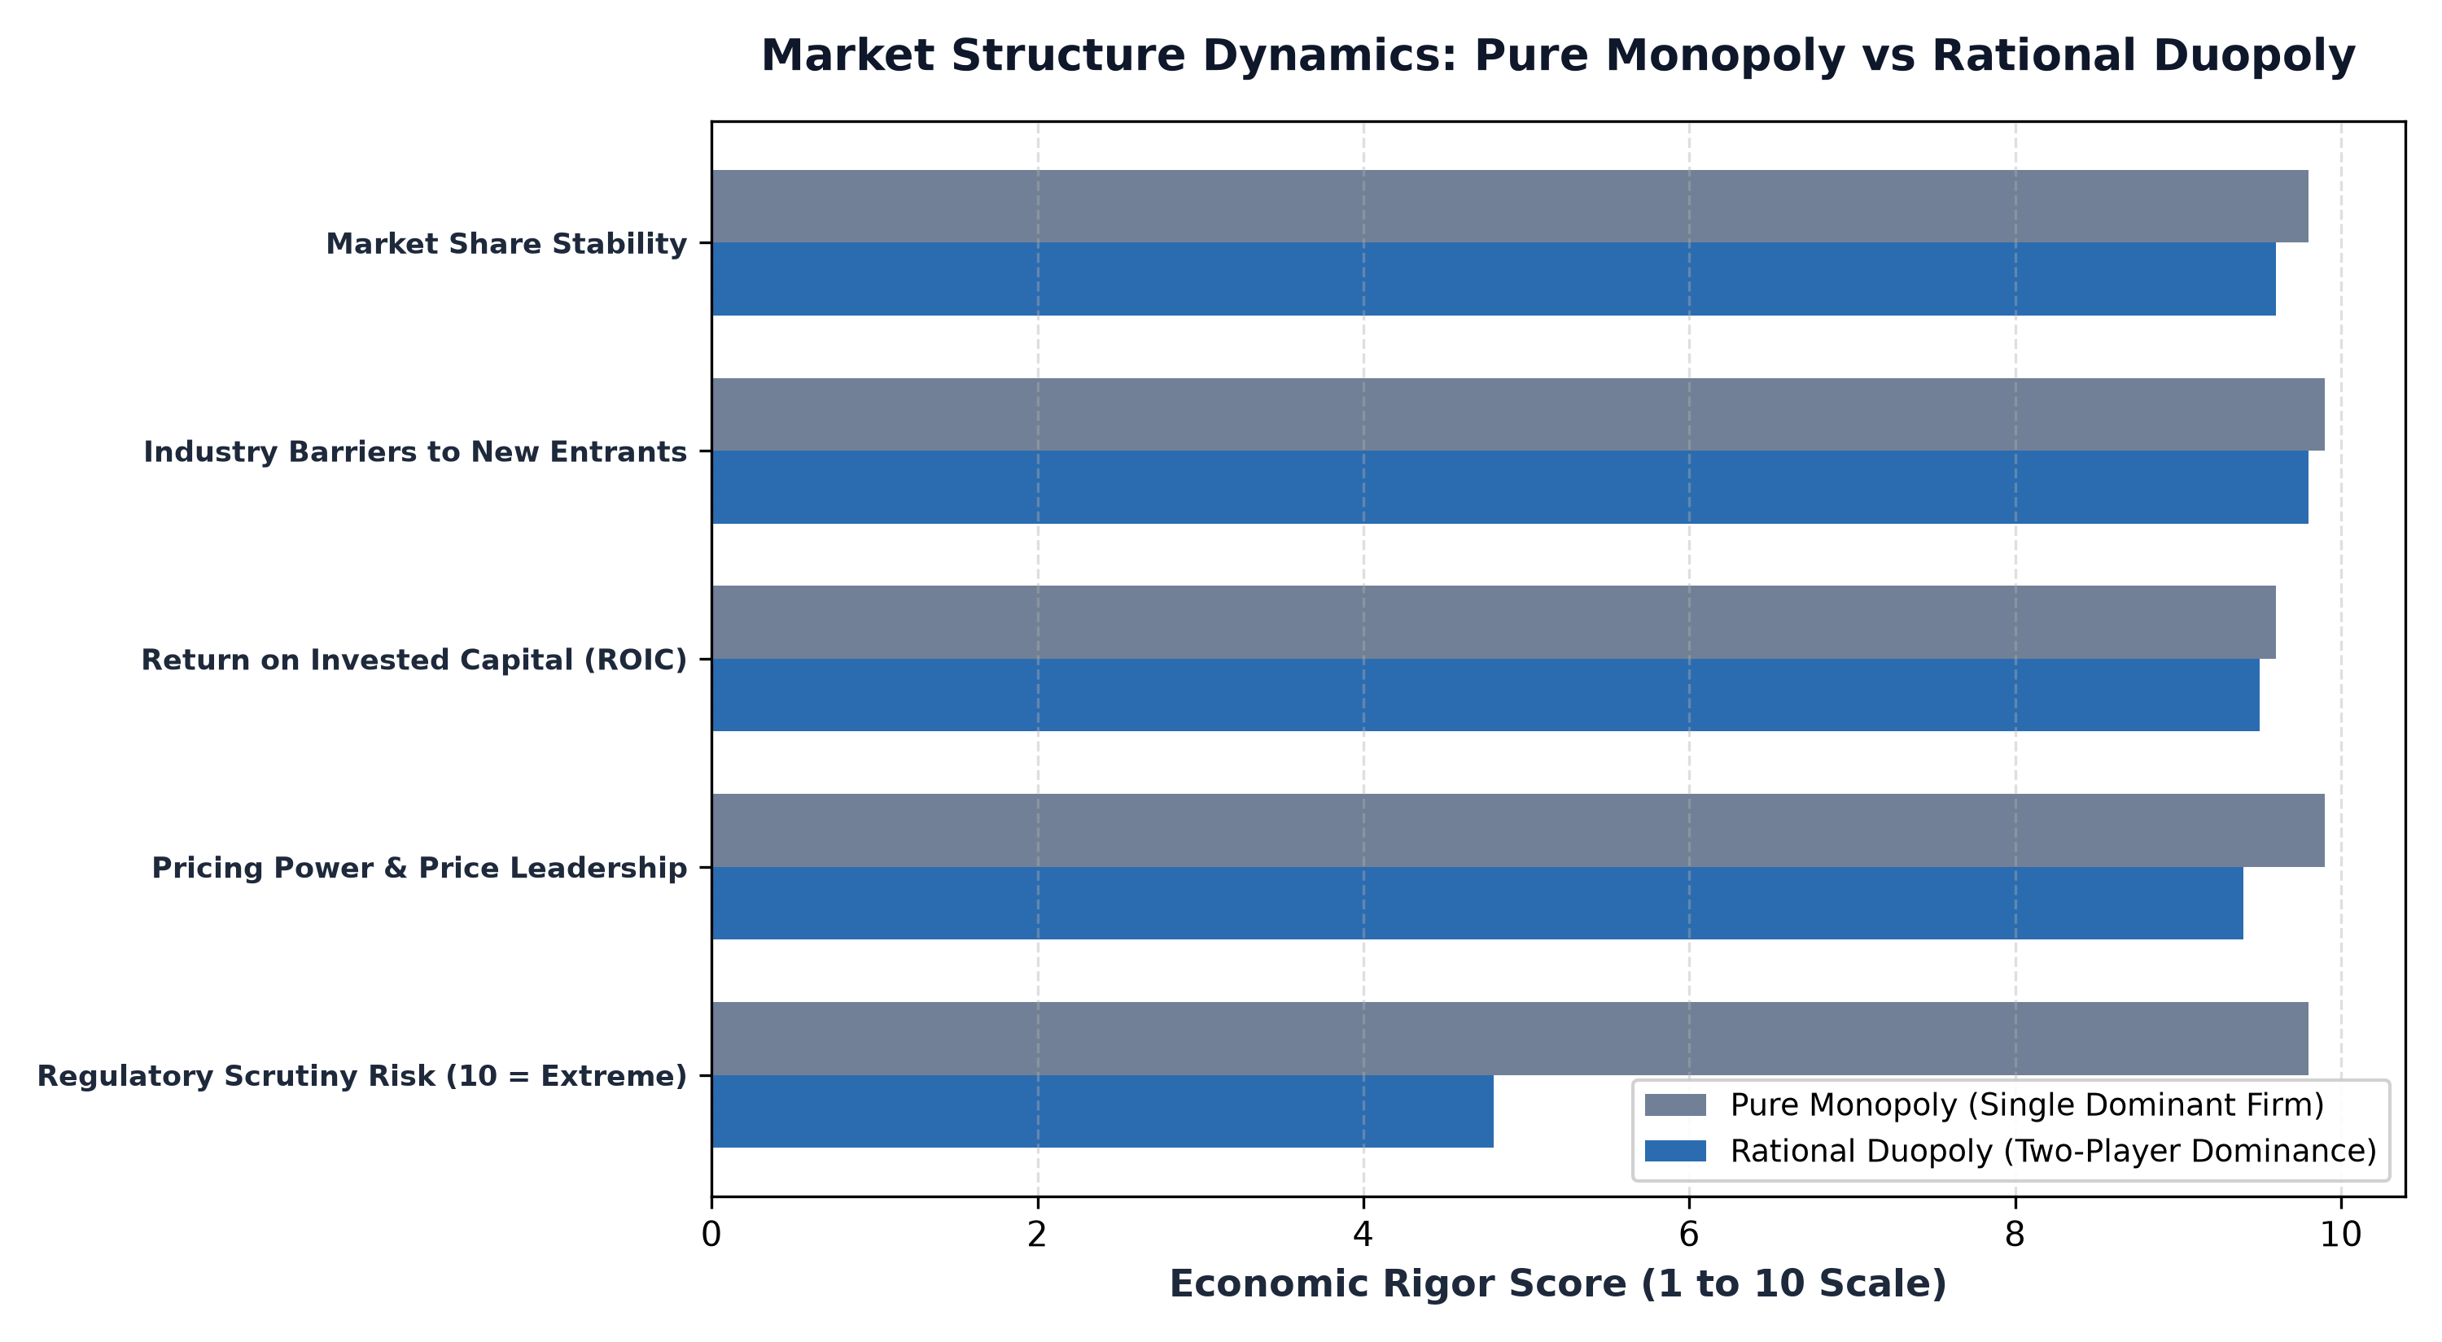
1. The Economics of Pure Monopoly vs Rational Duopoly
In neoclassical economic theory, a monopoly maximizes economic profits by setting price at the quantity where marginal revenue equals marginal cost, extracting consumer surplus without fear of competitive reprisal. True monopolies in the modern economy often arise from natural infrastructure barriers, exclusive government charters, or massive technological platform network effects that cannot be economically duplicated by rival capital.
A duopoly, however, operates under the game theoretic principles of Cournot and Bertrand competition. In a destructive duopoly where players compete strictly on price, profit margins collapse to marginal cost. However, in mature, institutional grade duopolies, players almost universally engage in tacit price leadership and capacity discipline. Instead of fighting ruinous price wars to gain a marginal point of market share, the two incumbents maintain price realization, match cost increases, and focus on customer retention, effectively dividing monopolistic economic profits between them.
2. Real-World Case Studies: Global Payment Rails and Aerospace
The clearest real-world manifestation of a rational duopoly in financial markets is the global payment processing network shared between Visa and Mastercard. Neither entity operates as a solitary monopoly, yet together they process the vast majority of non-cash global personal expenditures outside of closed domestic systems. Because both networks benefit from bilateral merchant-consumer network effects, new financial entrants cannot dislodge them, enabling both franchises to generate sustained Return on Invested Capital (ROIC) exceeding forty percent.
A similar physical dynamic exists in commercial aviation between Boeing and Airbus. The capital expenditure required to design, certify, and manufacture wide-body and narrow-body commercial airliners creates an insurmountable moat that precludes third-party entry. While execution missteps can cause temporary operational shifts between the two players, the underlying duopoly structure guarantees long-term commercial backlogs and secular pricing defense.
3. Regulatory Scrutiny: Why Investors Often Prefer Duopolies
From a regulatory perspective, operating as a solitary monopoly is inherently precarious. Antitrust regulators under the Federal Trade Commission and European Commission actively investigate single-firm market concentration, seeking remedies such as behavioral consent decrees, forced structural divestitures, or utility-style rate caps that compress corporate return on capital.
In contrast, a well-managed duopoly provides natural antitrust insulation. Because enterprise customers and consumers possess an alternative commercial counterparty, regulators find it considerably more difficult to establish illegal monopolization under Section 2 of the Sherman Act. The presence of two viable competitors legitimizes industry pricing, blunts public backlash, and protects shareholder equity from draconian legal dissolution, making duopolies exceptionally attractive to conservative compound allocators.
Furthermore, the stability of a rational duopoly depends heavily on symmetry in cost structures and access to proprietary distribution channels. When both participants share comparable scale efficiencies, neither party possesses an asymmetric cost advantage that would incentivize predatory pricing or margin sacrifice. This economic symmetry fosters a durable equilibrium where competitive tension is channeled into brand differentiation, product innovation, and customer retention, reinforcing the collective profitability of the entire industry structure.
4. Thematic Monopoly Analysis and MPLY's Investment Mandate
Understanding the microeconomic defense of concentrated market structures is essential when researching specialized equity portfolios focused on competitive advantages.
Investors examining funds focused on durable economic moats, pricing power, and monopolistic industry concentration can review the Strategy Shares Monopoly ETF (MPLY). Details regarding the fund's investment methodology and portfolio holdings are available at https://strategysharesetfs.com/mply/. MPLY actively seeks companies that operate within concentrated market structures, identifying businesses that possess insurmountable structural barriers, high returns on invested capital, and secular pricing power.
5. Frequently Asked Questions
Q1: Can a duopoly be legally prosecuted for price-fixing even without explicit collusion?
Under antitrust jurisprudence, conscious parallelism or matching competitor prices based on public market observation is legal. Regulators must prove explicit agreement, communication, or conspiratorial coordination between the two firms to establish illegal antitrust violation under Section 1 of the Sherman Act.
Q2: How does technological innovation threaten established duopolies?
Established duopolies are rarely disrupted by direct copycat entrants; rather, they are threatened by platform shifts that make their underlying product obsolete, such as decentralized protocols bypassing payment rails or alternative propulsion systems altering transit infrastructure.
6. Sources
Harvard Business Review, The Hidden Power of Duopolies and Market Concentration: https://hbr.org/2020/03/the-case-for-duopolies
Federal Trade Commission, Guide to Antitrust Laws: Monopolization and Market Power: https://www.ftc.gov/advice-guidance/competition-guidance/guide-antitrust-laws
Strategy Shares ETFs, MPLY Fund Philosophy, Strategy, and Holdings Overview: https://strategysharesetfs.com/mply/
#MonopolyBusinesses #MarketStructure #Investing #Stocks

