Article 82:
How to Analyze Revenue Quality in a Subscription Business
Over the past two decades, capital markets have placed an extraordinary valuation premium on recurring subscription business models. Investors prize subscription software, enterprise information services, and recurring industrial maintenance contracts because they eliminate the perpetual revenue reset that plagues transactional businesses. In a traditional transactional model, management teams must fight for customer acquisition anew each fiscal quarter, leaving cash flows exposed to macroeconomic volatility.
However, the simple presence of a recurring subscription billing model does not automatically guarantee financial excellence. In today's equity markets, countless companies market themselves as subscription compounders while suffering from high customer attrition, aggressive price discounting, and escalating customer acquisition costs. Conducting thorough due diligence on subscription revenue quality requires looking beneath reported top-line revenue growth to assess retention durability, contractual enforceability, and customer switching costs.
When properly evaluated, high-quality subscription revenue generates predictable, recurring free cash flow that expands organically with client growth. This institutional research guide outlines the forensic framework allocators must apply to evaluate subscription business models, distinguishing premier recurring franchises from vulnerable software commodities.
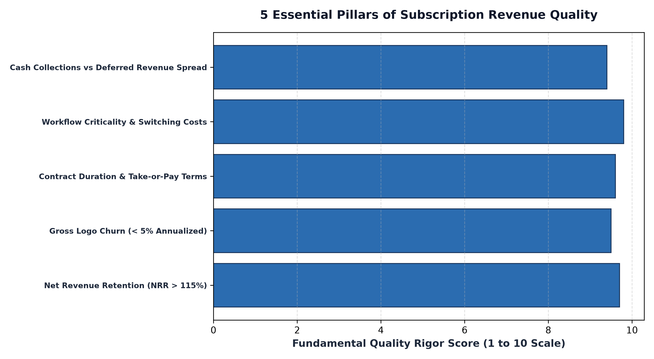
1. The Anchor Metric: Net Revenue Retention and Expansion
When analyzing subscription revenue quality, the single most critical quantitative metric is Net Revenue Retention (NRR), also known as Net Dollar Retention (NDR). NRR measures the percentage of recurring revenue retained from an existing customer cohort over a twelve-month period, incorporating price increases, cross-sells, upgrades, and subtracting cancellations and downgrades.
An elite enterprise subscription business maintains an NRR consistently above 115% to 125%. This level of retention confirms that even if the enterprise failed to sign a single new customer in a calendar year, its underlying organic business would still grow by fifteen to twenty-five percent purely through cohort expansion. Conversely, an NRR below 100% signals that customer churn and contraction are depleting the customer base, forcing the company into a treadmill of heavy sales and marketing expenditure just to maintain flat top-line performance.
2. Gross Churn vs Net Churn: Exposing Concealed Attrition
A frequent analytical error in subscription research is evaluating net retention without cross-referencing gross logo churn. Net retention can be artificially flattered by aggressive price hikes on a handful of large corporate accounts, masking the fact that dozens of smaller enterprise clients are abandoning the platform.
Forensic analysts inspect annual gross logo churn, which isolates the exact percentage of clients who cancel their contracts entirely. Elite subscription franchises, such as core enterprise resource planning systems and regulatory compliance databases, maintain annual gross churn below three to five percent. Low gross churn proves that the software or service is deeply integrated into client operations, creating prohibitive switching costs that prevent customers from migrating to rival platforms.
3. Deferred Revenue and Working Capital Float Mechanics
The balance sheet provides indispensable evidence of subscription revenue quality through the deferred revenue account. When an enterprise commands decisive market position, it possesses the negotiating leverage to demand annual or multi-year upfront payments from clients, rather than billing monthly in arrears.
These upfront cash collections appear on the balance sheet as deferred revenue liabilities while immediately inflating operating cash flow. This dynamic generates an operational float similar to that of an insurance company, allowing the business to fund research and capital investments using interest-free customer capital rather than relying on bank debt or dilutive equity offerings. Monitoring the spread between deferred revenue growth and recognized revenue growth reveals whether future pipeline demand is accelerating or contracting.
In addition to evaluating deferred revenue float, equity analysts must examine the composition of contracted backlog and Remaining Performance Obligations (RPO). RPO captures all future revenue that is legally contracted under executed client agreements but has not yet been recognized on the income statement. A growing RPO balance, particularly when weighted toward non-cancelable enterprise commitments exceeding twenty-four months, provides exceptional forward visibility into recurring cash flow generation, insulating the business from broader macroeconomic sales cycle lengthening.
4. Subscription Quality Frameworks and MPLY's Portfolio Strategy
Evaluating the microeconomic characteristics of recurring cash flows is central to institutional quality investing strategies.
Investors interested in how high-barrier, recurring revenue franchises fit into a disciplined equity strategy can examine the Strategy Shares Monopoly ETF (MPLY). Details regarding the fund's investment methodology and portfolio holdings are available at https://strategysharesetfs.com/mply/. MPLY actively seeks dominant companies with recurring revenue profiles, mission-critical workflow integration, and contractual pricing power that insulate cash flows from broader economic turbulence.
5. Frequently Asked Questions
Q1: Why is customer acquisition cost (CAC) payback period critical in subscription analysis?
The CAC payback period calculates the number of months required to recoup the sales and marketing dollars spent acquiring a customer. High-quality subscription businesses achieve payback in under twelve months, ensuring that customer lifetime value substantially exceeds acquisition costs.
Q2: How does inflation affect subscription businesses with multi-year fixed contracts?
If multi-year contracts lack contractual annual price escalators, inflation can erode operating margins. High-quality subscription franchises embed mandatory consumer price index adjustments or minimum annual escalators (typically 3% to 5%) in every multi-year agreement.
6. Sources
CFA Institute, Financial Statement Analysis: Revenue Recognition and Contract Quality: https://www.cfainstitute.org/en/membership/professional-development/refresher-readings/revenue-recognition
Morningstar, Evaluating SaaS and Subscription Business Moats: https://www.morningstar.com/articles/moat-research
Strategy Shares ETFs, MPLY Official Fund Portal and Investment Strategy: https://strategysharesetfs.com/mply/
#QualityInvesting #BusinessQuality #Investing #Stocks

