Article 83:
Gross Margin vs Operating Margin: What Investors Should Compare
On an income statement, profitability is reported across multiple sequential tiers, each measuring financial performance after deducting specific layers of expenditure. Among these metrics, gross margin and operating margin are the two most frequently scrutinized by fundamental equity investors. While casual market participants often treat margins interchangeably as generic markers of corporate profitability, they capture fundamentally different dimensions of business health.
Analyzing gross margin vs operating margin is a cornerstone of fundamental due diligence. Gross margin isolates the direct economic relationship between what a business charges for its offerings and what it costs to produce them, serving as the purest quantitative indicator of product pricing power. Operating margin, by contrast, factors in overhead expenses, selling costs, administrative salaries, and research investments, reflecting how effectively executive management converts gross profit into bottom line operating earnings.
Understanding the precise mechanics that separate these two margins empowers allocators to identify high quality businesses, detect emerging margin compression, and evaluate operational leverage. This institutional guide details the differences between gross and operating margins, explains how to interpret margin divergence, and illustrates why margin stability reflects durable competitive advantages.
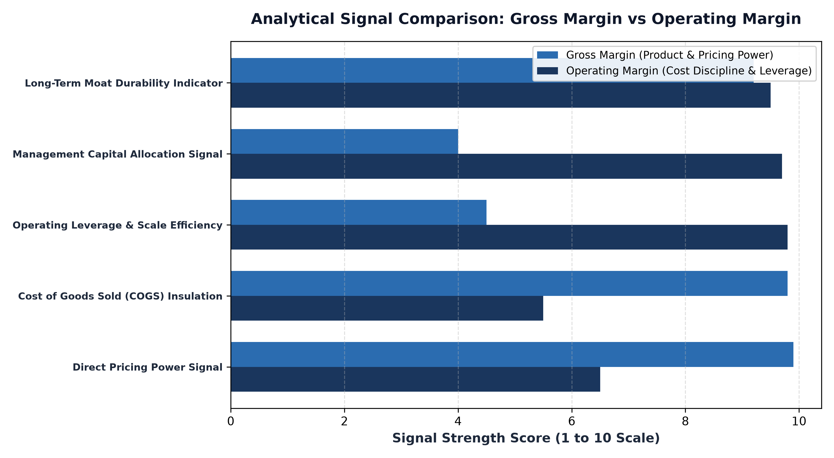
1. Gross Margin: The Definitive Barometer of Pricing Power
Gross margin is calculated by subtracting Cost of Goods Sold (COGS) from total revenue and dividing the result by revenue. COGS includes only the direct expenses directly tied to product creation or service delivery, such as raw materials, direct manufacturing labor, and data center hosting costs. Because general corporate overhead is excluded, gross margin evaluates the core unit economics of the enterprise.
A high, stable gross margin over multi-year economic cycles is the clearest financial signature of an economic moat. When raw material costs, freight rates, or component prices rise during inflationary shocks, a company with genuine monopoly power can raise prices without sacrificing unit volume, maintaining stable gross margins. Conversely, commodity producers and price takers are forced to absorb input cost spikes, resulting in immediate gross margin deterioration.
2. Operating Margin: Measuring Operating Leverage and Discipline
Operating margin, calculated by dividing operating income (EBIT) by revenue, accounts for all operational costs incurred to run the enterprise, including Selling, General, and Administrative (SG&A) expenses, corporate marketing campaigns, and Research and Development (R&D). Operating margin reveals how efficiently the business scales its fixed organizational overhead as revenue expands.
This dynamic is known as operating leverage. In businesses with high fixed costs and low variable costs, each incremental dollar of gross profit flows disproportionately down to operating income, driving rapid operating margin expansion. However, operating margin is also susceptible to executive mismanagement. A company can command an enviable eighty percent gross margin yet produce an anemic five percent operating margin if management squanders capital on bloated administrative bureaucracy or inefficient sales forces.
3. Interpreting Margin Divergence: Warning Signs and Catalysts
Sophisticated financial analysts pay particular attention when gross margin and operating margin diverge. Two primary divergence patterns yield vital qualitative insights into corporate trajectory:
Expanding Gross Margin with Contracting Operating Margin: This pattern often occurs in high-growth software and tech businesses that are aggressively reinvesting gross profits into future product roadmaps (R&D) or customer acquisition (SG&A). If the reinvestment is genuinely accretive, operating margins will eventually surge once growth matures. However, if the spending reflects defensive marketing against aggressive new entrants, it signals emerging franchise decay.
Stable Gross Margin with Expanding Operating Margin: This is the hallmark of mature corporate monopolies achieving powerful operational leverage. With core pricing power firmly intact, revenue growth outpaces modest corporate overhead growth, driving sustained expansion in operating earnings and free cash flow generation.
Additionally, allocators must evaluate how corporate management teams account for stock-based compensation within operating expenses. Many high-growth enterprises report non-GAAP operating margins that exclude equity compensation, creating a misleading impression of operational efficiency. A rigorous fundamental assessment evaluates GAAP operating margins, confirming that corporate earnings genuinely reflect the full economic cost of retaining top engineering and managerial talent without ongoing shareholder dilution.
4. Margin Resilience Within MPLY's Quality Architecture
Evaluating structural margin durability is an integral part of researching institutional quality equity strategies.
Investors interested in how pricing power, gross margin defense, and operating leverage inform high-conviction portfolio construction can review the Strategy Shares Monopoly ETF (MPLY). Details regarding the fund's investment methodology and portfolio holdings are available at https://strategysharesetfs.com/mply/. MPLY actively seeks dominant enterprises with structural gross margin advantages that enable them to compound shareholder capital through both inflationary environments and economic contractions.
5. Frequently Asked Questions
Q1: Is it possible for a company to have an exceptionally high gross margin but negative operating cash flow?
Yes. Early-stage biotechnology and cloud software companies frequently report gross margins above 75%, but because their R&D and customer acquisition expenditures exceed their gross profits, they operate with negative operating margins and negative cash flows.
Q2: Which margin metric is more reliable when comparing companies across different industries?
Neither should be compared across industries without context. Enterprise software companies naturally generate 70% to 80% gross margins, whereas freight railways and grocery chains operate with 20% to 30% gross margins. Margins must always be benchmarked against direct industry peers and historical multi-year trends.
6. Sources
CFA Institute, Financial Statement Analysis: Profitability Margin Ratios: https://www.cfainstitute.org/en/membership/professional-development/refresher-readings/profitability-analysis
Morningstar, Using Gross and Operating Margins to Identify Economic Moats: https://www.morningstar.com/articles/moat-research
Strategy Shares ETFs, MPLY Official Fund Portal and Quality Research Resources: https://strategysharesetfs.com/mply/
#QualityInvesting #BusinessQuality #Investing #Stocks

