Article 84:
Enterprise Value vs Market Capitalization: Why the Difference Matters
In financial media, stock market screeners, and general business news, a company's size is almost universally expressed through its market capitalization. Headlines routinely trumpet corporate milestones when a firm crosses a billion-dollar or trillion-dollar threshold, leading retail investors to assume that market capitalization represents the true total value of the enterprise. However, in professional investment banking, private equity, and fundamental equity research, relying solely on market cap creates a profound distortion.
Understanding enterprise value vs market capitalization is fundamental to proper business valuation. Market capitalization measures the aggregate market value of a company's outstanding equity shares alone. Enterprise value (EV), by contrast, represents the total theoretical takeover price of the entire operating business, accounting for both equity and net debt obligations. By incorporating debt, preferred stock, minority interests, and subtracting liquid cash, enterprise value reflects the full economic capital structure required to generate operational cash flows.
Failing to account for the difference between market cap and enterprise value can lead investors into dangerous valuation traps, causing heavily indebted companies to appear deceptively cheap while obscuring the true economic bargains offered by cash-rich franchise compounders. This institutional guide explores the mechanics of enterprise value, demonstrates how debt alters corporate valuation, and shows how allocators use EV to evaluate balance sheet safety.
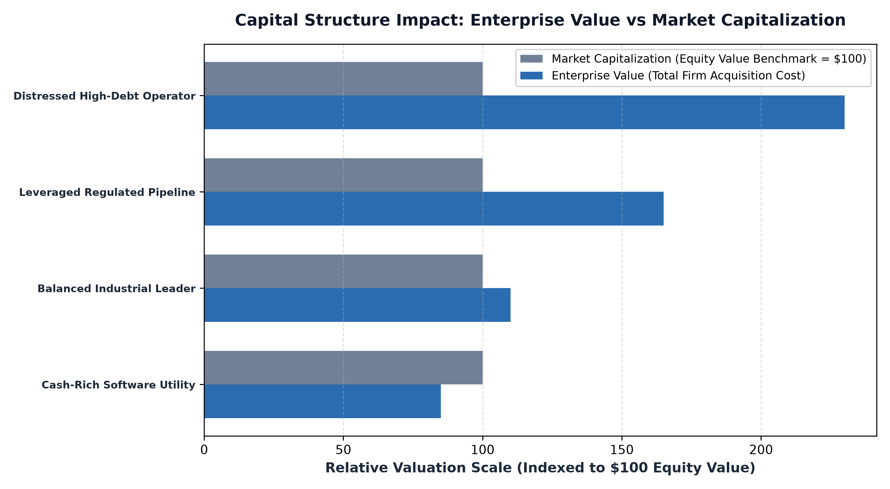
1. The Mathematical Architecture of Enterprise Value
The classic institutional formula for enterprise value is straightforward yet analytically profound: Enterprise Value equals Market Capitalization plus Total Debt plus Preferred Stock plus Minority Interests minus Cash and Cash Equivalents.
The logic underpinning this calculation is rooted in corporate acquisition mechanics. If a corporate acquirer were to purchase one hundred percent of a public company's common stock, paying its exact market capitalization, the acquirer would not simply walk away with unencumbered operational profits. The acquirer must immediately assume responsibility for all outstanding bank loans, corporate bonds, and preferred dividend obligations, which increases the real acquisition cost. However, the acquirer also inherits all cash sitting in the target company's bank accounts, which can be immediately swept to pay down acquired debt, reducing net expenditure.
2. Avoiding the Value Trap of Debt-Heavy Equity
The most perilous analytical mistake an equity allocator can make is screening for low price-to-earnings (P/E) ratios without evaluating enterprise leverage. Consider an industrial company with a five billion dollar market capitalization trading at an apparently cheap eight times earnings. If that same company carries fifteen billion dollars in net debt, its true enterprise value is twenty billion dollars.
In this scenario, equity holders own only twenty-five percent of the total capital structure, while bondholders hold a senior seventy-five percent claim on operating cash flows. In periods of rising interest rates or economic contractions, debt refinancing costs surge, consuming operating earnings and wiping out equity value entirely. By utilizing Enterprise Value to Operating Income (EV/EBIT) or Enterprise Value to Free Cash Flow (EV/FCF) instead of unadjusted P/E ratios, an investor evaluates the entire capital structure, immunizing the portfolio against leveraged balance sheet blowups.
3. Cash Fortresses: When Enterprise Value Is Less Than Market Cap
Conversely, premier corporate monopolies and high-margin software platforms often accumulate massive cash balances that exceed their total funded debt obligations. In these fortress balance sheet scenarios, net debt is negative, meaning that enterprise value is actually lower than market capitalization.
When an investor buys shares in a cash-rich compounder with a hundred billion dollar market cap and fifteen billion dollars in net cash, they are effectively purchasing the underlying operating franchise for only eighty-five billion dollars. The immense cash buffer provides downside defense, earns risk-free interest income during high rate cycles, and empowers management to opportunistically repurchase undervalued shares during market drawdowns.
Beyond evaluating funded debt and cash balances, a comprehensive enterprise value analysis requires inspecting off-balance-sheet commitments and capitalized operating leases. Under current accounting standards, long-term lease liabilities represent fixed financial obligations that function identically to funded debt. By capitalizing all structural lease commitments and unfunded pension liabilities into the enterprise value calculation, institutional analysts ensure that the total economic burden assumed by equity holders is completely accounted for prior to capital commitment.
4. Balance Sheet Quality in Active Mandates and MPLY
Rigorous scrutiny of enterprise value and capital structure is central to fundamental quality investing.
Investors seeking to understand how active management incorporates balance sheet due diligence and debt insulation can explore the Strategy Shares Monopoly ETF (MPLY). Information regarding the fund's holdings and active security selection is available at https://strategysharesetfs.com/mply/. MPLY actively seeks dominant franchise compounders that pair exceptional pricing power with conservative enterprise capital structures, ensuring that portfolio constituents possess the balance sheet resilience required to endure complete market cycles.
5. Frequently Asked Questions
Q1: Can enterprise value ever be negative?
Yes. In distressed micro-cap sectors or pre-revenue biotechnology firms where cash burn is high, a company's net cash balance can temporarily exceed its market capitalization, resulting in negative enterprise value. However, this usually reflects market expectations that cash will be rapidly incinerated by future operating losses.
Q2: Why do institutional acquirers use EV/EBITDA rather than Price/Earnings?
EV/EBITDA is capital structure neutral, allowing acquirers to compare operating efficiency across firms regardless of how much debt they use or differences in statutory corporate tax rates.
6. Sources
CFA Institute, Corporate Finance and Equity Valuation: Enterprise Value Multiples: https://www.cfainstitute.org/en/membership/professional-development/refresher-readings/equity-valuation-concepts
Morningstar, Enterprise Value vs Market Cap: Understanding Real Takeover Cost: https://www.morningstar.com/articles/moat-research
Strategy Shares ETFs, MPLY Fund Documentation and Security Selection Framework: https://strategysharesetfs.com/mply/
#StockValuation #Investing #FinancialAnalysis #Stocks

