Article 85:
How an Active ETF Can Differ From Its Benchmark
For decades, the exchange traded fund landscape was dominated almost exclusively by passive index tracking vehicles. These products were engineered with a singular objective: to replicate the exact returns of an underlying benchmark, such as the S&P 500 or Russell 2000, with minimal tracking error and negligible expense ratios. In this passive paradigm, tracking error is viewed as an operational flaw, and portfolio managers have zero discretionary authority over security selection or capital allocation.
However, the rapid ascent of actively managed exchange traded funds has fundamentally reshaped the allocator's toolkit. In an active fund, tracking error is not an operational failure; it is the intentional mathematical byproduct of seeking alpha. Analyzing active ETF benchmark differences requires understanding how active portfolio managers deviate from mechanical index rules, why concentration replaces dilution, and how discretionary oversight manages downside risk.
When allocators conduct due diligence on active ETFs, they must look past passive benchmark assumptions and evaluate the specific structural vectors through which active management delivers idiosyncratic value. This institutional guide details how active ETFs differentiate themselves from standard indices, outlines key portfolio metrics like Active Share, and demonstrates how active flexibility protects investor capital.
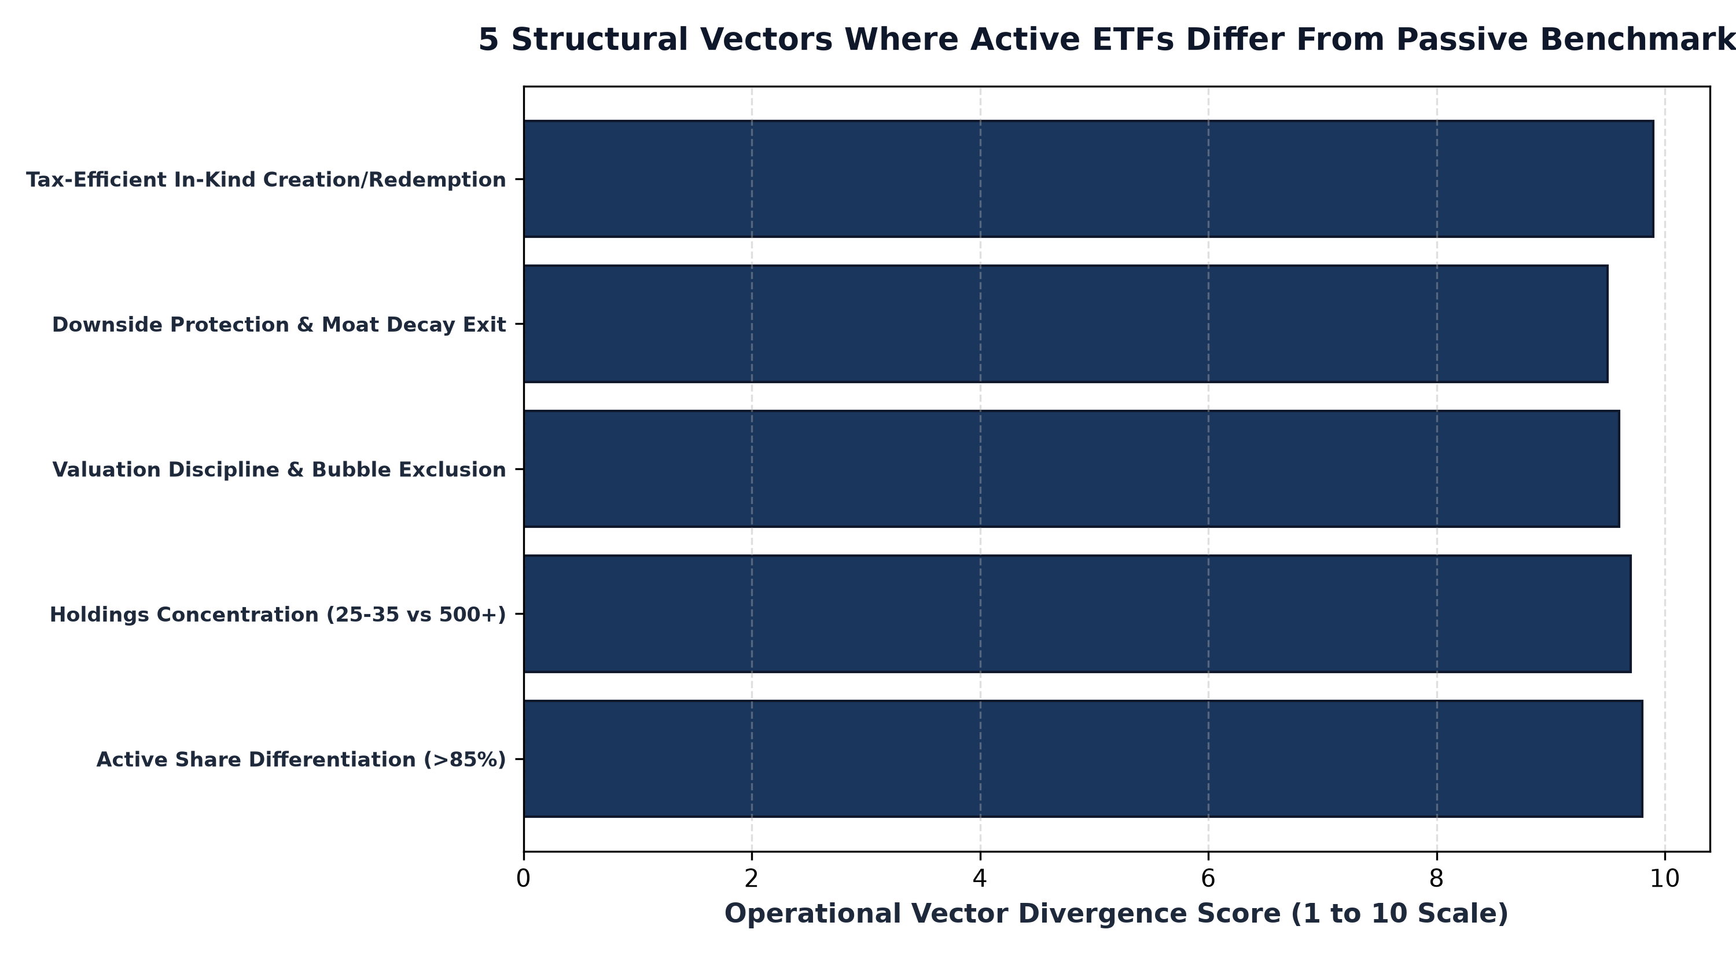
1. Active Share: The Metric of Genuine Independence
The primary quantitative tool for assessing how an active ETF differs from its benchmark is Active Share. Developed by academic researchers Martijn Cremers and Antti Petajisto, Active Share measures the percentage of a fund's portfolio holdings that differ from the benchmark index holdings. A fund with an Active Share of zero percent is a perfect index clone, while a fund with an Active Share of one hundred percent shares no common holdings or weights with the benchmark.
In the legacy mutual fund era, many active managers engaged in closet indexing, charging active management fees while maintaining an Active Share below sixty percent to protect their business from career risk. Modern institutional active ETFs reject this compromise. High-conviction active strategies routinely operate with Active Share exceeding eighty-five percent, concentrating capital into high-conviction holdings and providing allocators with genuine diversification rather than expensive beta replication.
2. Rejecting the Flaws of Market-Cap Capitalization Weighting
Standard equity benchmarks operate on market capitalization weighting formulas. While market-cap weighting provides automated liquidity, it suffers from a major structural flaw: momentum bias. In a passive index, as a stock becomes more overvalued and its valuation multiples expand, the index is mechanically forced to allocate a larger percentage of investor capital to that security, exacerbating bubble risk.
An active ETF breaks free from this mechanical constraint. Active managers maintain valuation discipline, trimming positions that become disconnected from fundamental intrinsic value and reallocating capital into undervalued, cash-generative franchises. Furthermore, when an index constituent experiences permanent competitive decay or accounting distress, passive funds must continue holding it until a scheduled committee rebalance, whereas active managers can liquidate deteriorating positions immediately.
3. Concentrated High-Conviction Portfolio Architecture
Another decisive area of differentiation is portfolio concentration. Broad market benchmarks typically hold five hundred to two thousand individual stocks. While this broad exposure eliminates single-stock default risk, it also creates severe performance dilution, ensuring that exceptional operational results from a company's top holdings are diluted by the long tail of mediocre, low-margin businesses.
Active equity ETFs frequently construct concentrated portfolios of twenty-five to forty high-conviction market leaders. By focusing capital exclusively on businesses that possess insurmountable economic moats, high returns on invested capital, and pricing power, active managers seek to construct a portfolio whose aggregate fundamental quality is vastly superior to the average constituent of a broad market index.
Furthermore, actively managed exchange traded funds offer superior adaptability during macroeconomic factor rotations. When monetary policy shifts, inflation accelerates, or credit spreads widen, mechanical benchmarks are incapable of adjusting their factor exposures. Active portfolio managers possess the discretion to dynamically tilt allocations toward balance sheet resilience, high cash return on invested capital, and secular monopoly pricing power, effectively shielding shareholder capital from thematic regime shifts that punish passive cap-weighted index holders.
4. Researching Active Strategies and MPLY's Independent Architecture
Understanding how an active ETF differentiates itself from broad indices is essential when conducting due diligence on specialized quality funds.
Investors researching how concentrated active management targets enduring economic moats can explore the Strategy Shares Monopoly ETF (MPLY). Details regarding the fund's investment mandate, Active Share, and portfolio holdings are available at https://strategysharesetfs.com/mply/. MPLY actively seeks companies that operate with monopolistic characteristics, maintaining high Active Share and rigorous fundamental discipline to deliver differentiated long-term capital compounding.
5. Frequently Asked Questions
Q1: Does an active ETF sacrifice the tax efficiency of a traditional passive ETF?
No. Active ETFs utilize the same in-kind creation and redemption mechanisms as passive ETFs, allowing portfolio managers to reallocate capital and exit positions without triggering taxable capital gains distributions for underlying shareholders.
Q2: How should an allocator evaluate tracking error in an active ETF?
In an active ETF, tracking error should not be evaluated as a negative tracking flaw, but rather in conjunction with the fund's information ratio and alpha generation to determine whether benchmark deviations are generating attractive risk adjusted excess returns.
6. Sources
CFA Institute, Active Management and Benchmark Differentiation: Evaluating Active Share: https://www.cfainstitute.org/en/membership/professional-development/refresher-readings/active-equity-investing
Morningstar, Understanding Active Share and Portfolio Concentration in ETFs: https://www.morningstar.com/articles/moat-research
Strategy Shares ETFs, MPLY Official Fund Portal and Active Strategy Overview: https://strategysharesetfs.com/mply/
#ActiveETFs #ETFInvesting #Investing #Portfolio

