Article 86:
How Portfolio Overlap Can Increase Hidden Concentration
Many wealth advisors and individual investors believe that holding a diversified collection of exchange traded funds guarantees genuine risk mitigation. An investor might allocate capital across a broad market S&P 500 fund, a large-cap growth ETF, a technology sector fund, and a quantitative quality momentum strategy. Looking at a brokerage statement showing multiple fund tickers, the investor feels confident that their wealth is prudently insulated against single-company failures and market shocks.
However, in contemporary financial markets, this assumption is often dangerously false. Looking beneath the surface of popular ETF combinations reveals severe portfolio overlap concentration, where identical mega-cap corporations dominate the underlying holdings of multiple distinct funds. Rather than achieving true asset diversification, the allocator has merely constructed an accidental, highly concentrated bet on a handful of market giants, while paying multiple layers of management fees.
Understanding how portfolio overlap functions, how to conduct an exposure audit, and how to distinguish accidental concentration from intentional active conviction is vital for modern wealth preservation. This institutional guide explores the mechanics of duplicate holdings, illustrates the systemic risks of correlated factor bets, and provides a framework for building authentically diversified equity allocations.
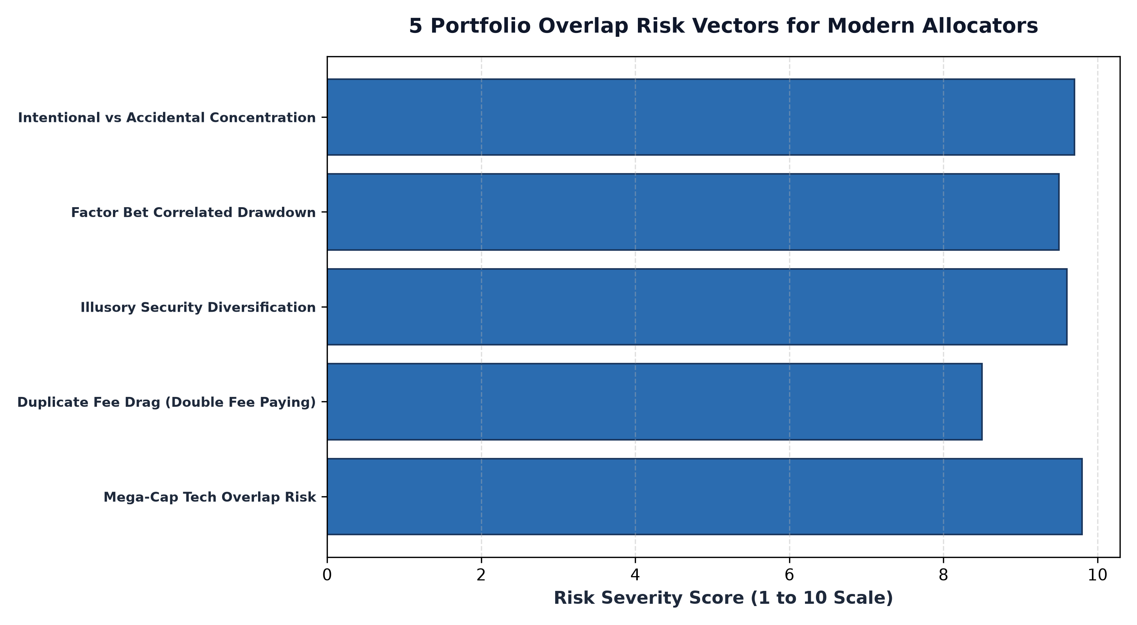
1. The Mechanics of Accidental Concentration
Accidental concentration occurs when market capitalization weighting schemes cause different investment mandates to converge on the exact same underlying corporate giants. Because the top seven to ten companies in the United States currently represent roughly thirty-five percent of the total market capitalization of the S&P 500, any index constructed on capitalization principles will inevitably tilt heavily toward these identical names.
When an investor pairs a core index fund with a large-cap growth fund and a thematic tech fund, the portfolio overlap frequently exceeds sixty to seventy percent. In practical terms, this means that more than two-thirds of the invested dollars are purchasing identical shares of the exact same five or six businesses. When a regulatory investigation, antitrust ruling, or tech valuation multiple contraction hits that group, the entire multi-fund portfolio suffers a simultaneous, correlated drawdown, completely puncturing the investor's illusion of safety.
2. Double Fee Drag and Redundant Management Costs
Beyond correlated drawdown vulnerability, high portfolio overlap creates severe fee inefficiency. An investor may pay an ultra-low expense ratio of three basis points on a core benchmark fund, but then pay thirty to sixty basis points on specialized thematic or growth ETFs that simply replicate sixty percent of that same core index.
By paying premium advisory or fund management fees to purchase stocks they already own in bulk, investors endure unnecessary fee drag without gaining incremental alpha. Professional allocators utilize portfolio look-through tools to calculate the true weighted exposure of each corporate holding across all accounts. If an overlap audit reveals redundant positions, the capital allocated to overlapping funds is essentially wasted beta replication that should be eliminated or redeployed into truly non-correlated strategies.
3. Accidental vs Intentional Concentration: The Allocator's Choice
It is crucial to emphasize that concentration itself is not inherently bad; accidental concentration is. Accidental concentration is born of ignorance, occurring when an investor buys multiple funds without realizing they contain duplicate holdings. In contrast, intentional concentration is a deliberate, highly disciplined investment strategy practiced by premier quality compounders.
In an intentional concentration framework, an allocator purposely targets twenty-five to thirty-five exceptional franchises with durable economic moats, pricing power, and fortress balance sheets. Because the portfolio manager consciously selects and monitors each holding, capital is allocated based on fundamental business quality rather than passive index weight. Intentional concentration provides authentic differentiation from broad market indices, giving the portfolio a distinct performance profile and genuine alpha potential.
Furthermore, intentional concentration eliminates the vast tail of unprofitable, capital-intensive businesses that dilute the returns of broad market benchmarks. By consciously pruning mediocrity and focusing capital exclusively on dominant commercial enterprises, an intentional manager transforms concentration from a hidden vulnerability into a powerful engine of long-term wealth compounding.
4. Intentional Concentration Strategies and MPLY's Mandate
Understanding how intentional concentration differs from passive benchmark overlap is essential when evaluating specialized active equity strategies.
Investors researching how high-conviction portfolios isolate durable corporate franchises without redundant index bloat can review the Strategy Shares Monopoly ETF (MPLY). Comprehensive fund details, holdings lists, and methodology information are available at https://strategysharesetfs.com/mply/. MPLY actively seeks companies that possess enduring competitive advantages and monopolistic pricing power, offering allocators a transparent, high-conviction vehicle engineered to serve as a distinct, differentiated satellite or core quality allocation.
5. Frequently Asked Questions
Q1: What percentage of portfolio overlap is considered excessive between two funds?
In professional asset management, an overlap exceeding forty percent between two funds designed to serve different mandates is generally considered inefficient, as it introduces substantial holding redundancy and double fee payment.
Q2: How can an investor identify hidden overlap across multiple brokerage accounts?
Investors can use dedicated portfolio look-through software or manually export holdings tables from ETF fact sheets, aggregating position weights in a master spreadsheet to calculate total effective exposure to each underlying company.
6. Sources
Morningstar, The Hidden Risks of ETF Portfolio Overlap and Redundant Holdings: https://www.morningstar.com/articles/moat-research
CFA Institute, Portfolio Management and Asset Allocation: Deconstructing Diversification: https://www.cfainstitute.org/en/membership/professional-development/refresher-readings/portfolio-management
Strategy Shares ETFs, MPLY Official Fund Portal and Portfolio Holdings: https://strategysharesetfs.com/mply/
#PortfolioConstruction #Diversification #Investing #Portfolio

