Article 87:
How Competitive Advantage Can Influence Reinvestment Decisions
In corporate finance and equity valuation, capital allocation is widely recognized as the single most consequential responsibility of executive leadership. Over a ten-year horizon, corporate executives typically deploy an amount of capital equal to or exceeding the entire initial market capitalization of their firm. How that capital is deployed, whether reinvested into organic capacity, funneled into acquisitions, returned through dividends, or used for share buybacks, determines whether shareholder value is multiplied or incinerated.
However, executive capital allocation decisions are not made in an abstract vacuum. They are profoundly governed and constrained by the presence or absence of an economic moat. Analyzing how competitive advantage reinvestment dynamics function reveals why businesses with durable competitive advantages compound capital at extraordinary rates, while commodity producers with weak moats destroy value whenever they attempt to grow.
When a company possesses a powerful competitive moat, every retained dollar of operating earnings can be reinvested at high rates of return, compounding intrinsic value exponentially. This institutional guide explores the microeconomic link between competitive advantage and corporate reinvestment, examines the mathematics of Return on Invested Capital (ROIC), and details how allocators evaluate reinvestment runways.
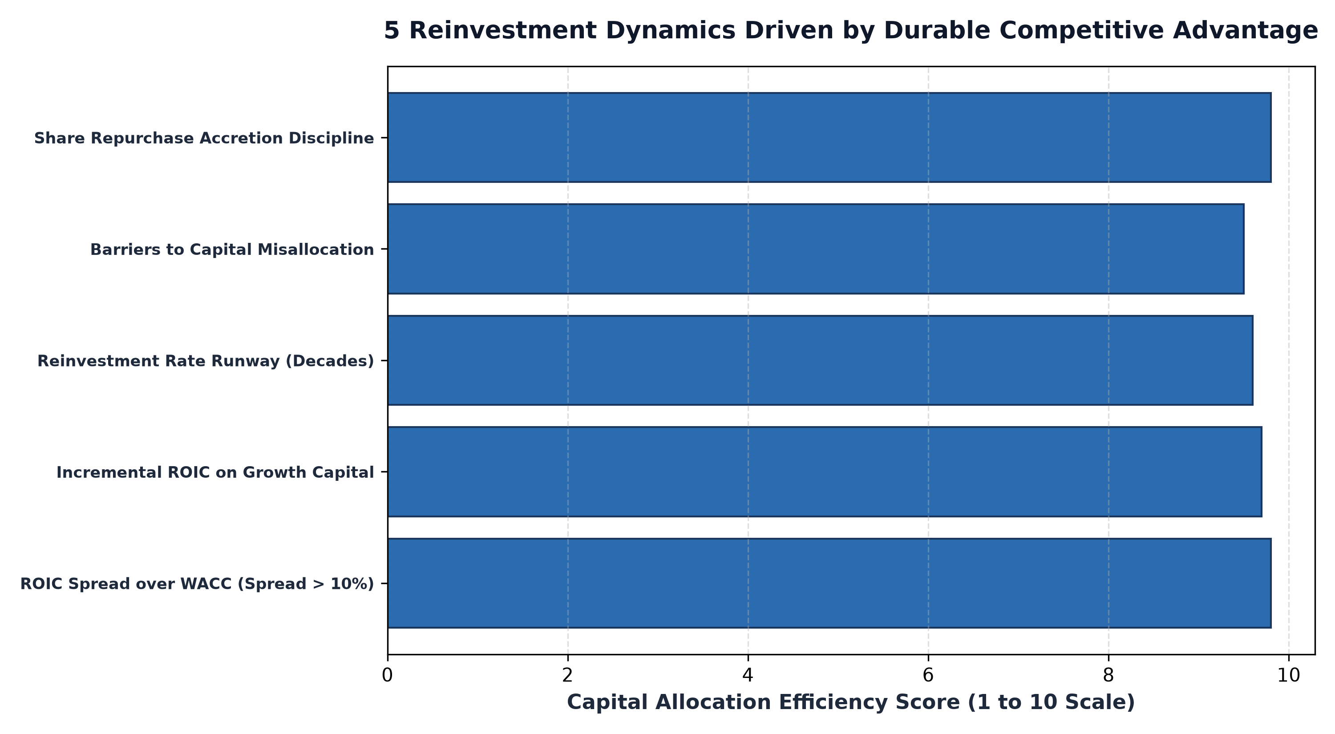
1. The ROIC Hurdle: Value Creation vs Value Destruction
To understand corporate reinvestment, an investor must master the relationship between Return on Invested Capital (ROIC) and the Weighted Average Cost of Capital (WACC). Economic value is created only when a company earns an ROIC that exceeds its cost of capital. The spread between ROIC and WACC represents economic profit.
In competitive industries lacking barriers to entry, ROIC gravitates toward WACC due to capital competition. In these low-moat environments, reinvesting capital into expansion is actually value-destructive. If a company earns a six percent ROIC while its cost of capital is eight percent, every dollar retained and plowed back into new factories or product lines destroys twenty cents of shareholder value. For these businesses, the only rational capital decision is to pay out all earnings as dividends, as reinvestment merely accelerates corporate decline.
2. High Moats and the Incremental Return on Invested Capital
Conversely, a company protected by insurmountable competitive advantages commands high pricing power and customer lock-in, enabling it to earn ROIC of twenty to thirty percent. For these elite franchises, the most critical metric is not merely historical ROIC, but Incremental Return on Invested Capital (iROIC).
Incremental ROIC measures the profit generated on each fresh dollar of capital deployed into the business. When an enterprise software utility, proprietary medical device manufacturer, or regulatory tollbooth possesses a wide reinvestment runway, it can deploy billions of dollars into high-return internal initiatives. Reinvesting eighty percent of earnings at a twenty-five percent iROIC generates a twenty percent annual compounding rate in intrinsic business value, creating an unstoppable compounding machine for patient shareholders.
3. Share Repurchases as Moat-Protected Capital Reinvestment
When a mature monopoly dominates its market so completely that further internal capacity expansion would trigger antitrust intervention, its competitive advantage dictates a different reinvestment pathway: disciplined share buybacks.
Because the underlying franchise produces massive, unencumbered free cash flow with minimal maintenance capital requirements, management can repurchase its own shares when trading at reasonable valuations. By retiring outstanding shares, executive leadership concentrates future cash flows into a shrinking share base, multiplying per-share earnings and intrinsic value without taking on risky diversification acquisitions. This capital discipline is the hallmark of mature corporate compounders.
Furthermore, wide-moat businesses avoid the destructive empire-building acquisitions that plague low-moat competitors. Confident in the durability of their core franchise, disciplined management teams reject overpriced corporate takeovers, focusing capital allocation strictly on expanding their technological lead, reinforcing distribution networks, and returning surplus cash to equity owners.
Furthermore, examining the spread between cash conversion rates and reported earnings reveals whether reinvested capital is generating tangible liquidity. Many capital-intensive businesses report accounting profits that are consumed entirely by maintenance capital expenditures, leaving zero discretionary cash for shareholders. In contrast, wide-moat compounders maintain high free cash flow conversion ratios, converting more than ninety percent of net income into liquid cash, which provides total strategic flexibility for value-accretive redeployment.
4. Reinvestment Discipline and MPLY's Quality Framework
Evaluating how competitive advantage guides capital allocation is fundamental to researching high-conviction quality strategies.
Investors examining funds focused on durable economic moats, superior ROIC, and disciplined capital allocation can review the Strategy Shares Monopoly ETF (MPLY). Details regarding the fund's investment methodology and portfolio holdings are available at https://strategysharesetfs.com/mply/. MPLY actively seeks dominant enterprises with proven competitive advantages that reinvest capital at high returns, creating durable intrinsic compounding across full economic cycles.
5. Frequently Asked Questions
Q1: What is the reinvestment rate and how is it calculated?
The reinvestment rate is calculated as net capital expenditures plus the change in non-cash working capital, divided by after-tax operating profit. It measures what percentage of earnings are plowed back into business growth.
Q2: Can a company have a high ROIC but poor long-term investment prospects?
Yes. A company can earn a fifty percent ROIC on its existing asset base, but if its addressable market is fully saturated and it lacks avenues to deploy new capital at similar rates, it cannot compound through reinvestment and must distribute cash to shareholders.
6. Sources
CFA Institute, Corporate Finance: Capital Allocation and Return on Invested Capital: https://www.cfainstitute.org/en/membership/professional-development/refresher-readings/capital-structure
Morningstar, The Power of the Reinvestment Moat: Evaluating ROIC and Capital Growth: https://www.morningstar.com/articles/moat-research
Strategy Shares ETFs, MPLY Official Fund Portal and Quality Research Resources: https://strategysharesetfs.com/mply/
#LongTermInvesting #Compounding #Investing #Stocks

