Article 88:
How Renewal Rates Can Signal Customer Stickiness
When equity analysts evaluate corporate durability, they frequently seek qualitative evidence of customer loyalty. Management presentations routinely highlight customer satisfaction surveys, brand affinity scores, and industry awards as proof of a dedicated client base. However, in fundamental investment research, subjective customer satisfaction metrics often prove unreliable. A customer may express positive brand sentiment in a consumer survey, yet switch instantly to a competitor the moment a discounted price promotion is offered.
For rigorous allocators, the definitive quantitative test of true customer stickiness resides in contract renewal rates. Analyzing renewal rates customer stickiness provides verifiable, balance-sheet-backed evidence of switching costs, mission criticality, and pricing power. When enterprise customers consistently re-sign multi-year commercial agreements at escalating price points, they demonstrate that the vendor's product or service has become an irreplaceable utility embedded within their operational infrastructure.
High contract renewal rates transform corporate revenue from volatile transaction flow into highly predictable annuity cash streams, insulating the firm from macroeconomic downturns. This institutional guide details how to analyze customer renewal metrics, explains the microeconomic drivers of switching costs, and illustrates why renewal durability reflects an enduring economic moat.
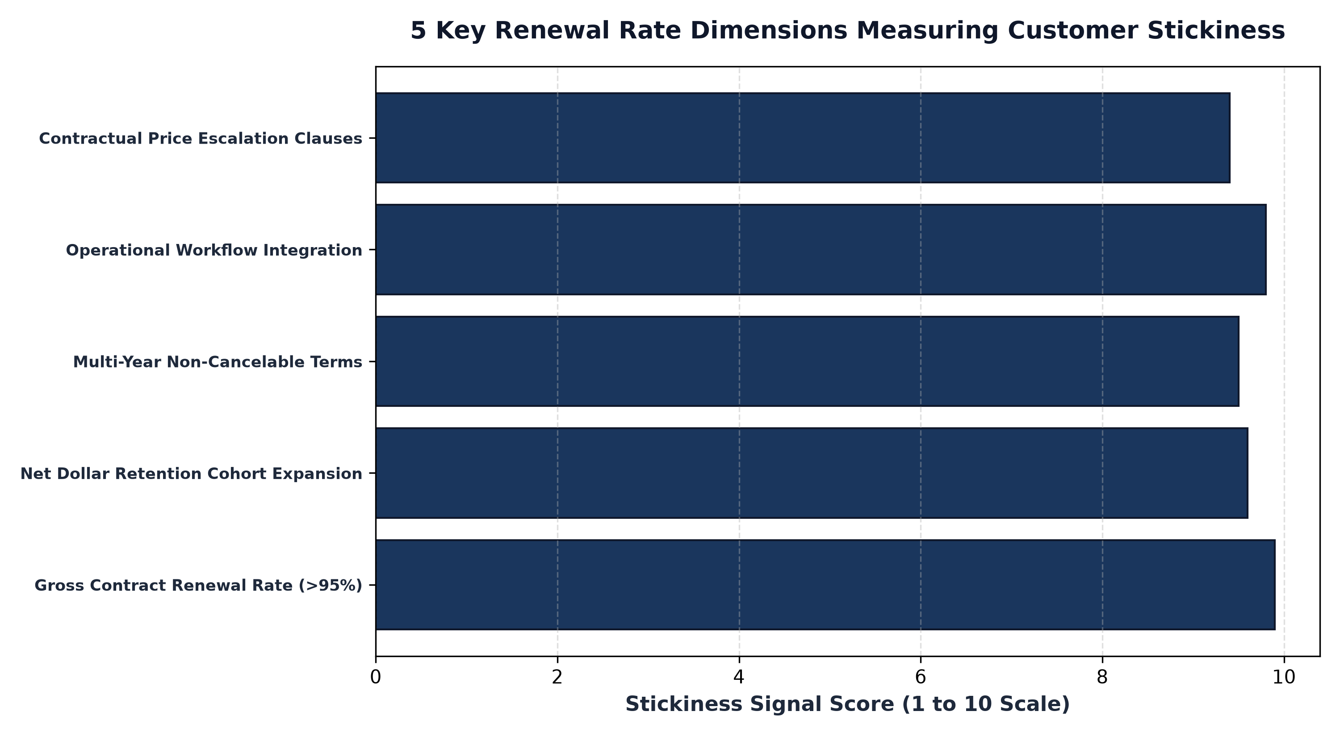
1. Gross Renewal Rate: The Purity of Customer Retention
To accurately evaluate customer stickiness, an analyst must examine the Gross Renewal Rate (GRR). GRR measures the percentage of existing contract value that successfully renews at the end of a contract term, capping retention at one hundred percent and excluding upsells or cross-sells.
An elite institutional enterprise maintains a GRR consistently above ninety-five to ninety-eight percent. This metric demonstrates that customer defections are virtually nonexistent, limited only to clients experiencing corporate bankruptcy or merger dissolution. A high GRR confirms that the business is not running on a leaky treadmill where sales teams must sign dozens of new clients simply to offset customer departures. With the revenue base firmly locked in, all new customer acquisition flows directly into top-line expansion and free cash flow generation.
2. Anatomy of Switching Costs: Why Customers Re-Sign
Why do enterprise clients renew contracts year after year, even in the face of steady annual price increases? The answer lies in insurmountable switching costs. High switching costs arise when the financial, operational, and organizational disruption of replacing a vendor vastly exceeds any potential price savings offered by a competing product.
Consider an enterprise enterprise resource planning (ERP) system, core banking ledger, or electronic health records database. Migrating from an established system requires hundreds of millions of dollars in consulting fees, eighteen months of employee retraining, and the existential risk of corporate data corruption or regulatory fines during cutover. Faced with these operational risks, corporate executives will willingly accept five to eight percent annual price increases rather than jeopardize business continuity. The renewal rate is not merely a reflection of satisfaction; it is a mathematical reflection of operational dependence.
3. Multi-Year Contracts and Contractual Price Escalators
Beyond measuring historical renewal percentages, sophisticated analysts inspect contract terms and structure. Premier franchise compounders do not operate on month-to-month service agreements; they secure three-year, five-year, or ten-year non-cancelable commercial contracts.
Crucially, these multi-year agreements embed contractual annual price escalators linked to inflation benchmarks or fixed annual percentage increases. This contractual structure provides two powerful investment benefits: absolute revenue predictability for multi-year cash flow forecasting, and automatic inflation pass-through that protects operating margins from labor and input cost surges. Contractual renewal strength acts as an impenetrable shield around corporate cash flows.
Furthermore, high renewal rates dramatically reduce customer acquisition costs over the long term. Because the company does not need to re-market to existing clients, sales and marketing expenditures can remain lean and highly targeted, driving superior operating margins and exceptional Return on Invested Capital.
Additionally, high contract renewal rates insulate corporate top lines from pricing pressure during deflationary or recessionary economic contractions. When corporate procurement officers mandate broad spending freezes, mission-critical utilities and essential enterprise software platforms are exempted from budget cuts due to the severe operational disruption that cancellation would cause. This non-discretionary status allows sticky franchises to preserve cash flow stability while transactional discretionary vendors suffer catastrophic revenue collapses.
4. Customer Stickiness and MPLY's Investment Mandate
Understanding the microeconomic defense provided by customer stickiness and renewal durability is central to researching specialized quality equity strategies.
Investors interested in how high switching costs, recurring contracts, and durable enterprise stickiness fit into a concentrated quality strategy can review the Strategy Shares Monopoly ETF (MPLY). Details regarding the fund's investment methodology and portfolio holdings are available at https://strategysharesetfs.com/mply/. MPLY actively seeks dominant franchise compounders that command mission-critical workflow integration, near-perfect renewal rates, and durable pricing power.
5. Frequently Asked Questions
Q1: How do gross renewal rates differ from net retention rates?
Gross renewal rate measures the retention of existing contract value capped at 100%, isolating customer churn. Net retention rate incorporates expansions, upsells, and price increases, and can exceed 100% (often reaching 115% to 125% in top-tier firms).
Q2: Can consumer businesses exhibit high switching costs comparable to enterprise software?
Yes. Consumer ecosystems with strong hardware-software lock-in, proprietary digital content libraries, or integrated smart-home networks create substantial switching friction that results in exceptionally high consumer renewal rates.
6. Sources
Harvard Business Review, The Real Economics of Customer Retention and Switching Costs: https://hbr.org/2014/10/the-value-of-keeping-the-right-customers
Morningstar, Switching Costs as a Source of Economic Moat Durability: https://www.morningstar.com/articles/moat-research
Strategy Shares ETFs, MPLY Official Fund Portal and Quality Research Center: https://strategysharesetfs.com/mply/
#EconomicMoat #CompetitiveAdvantage #Investing #Stocks

