Article 90:
What Is a Network Density Advantage?
In strategic management literature, network effects are widely celebrated as one of the most powerful forms of competitive advantage. Broad national or global networks, such as telecommunications grids, payment processing rails, and social media platforms, create immense value because each incremental user enhances the utility of the entire ecosystem for all participants. However, in physical logistics, transport infrastructure, waste management, and industrial distribution, a broad geographic footprint alone does not guarantee superior profitability.
In these physical distribution industries, the decisive economic moat is not merely network reach, but network density. Analyzing what is a network density advantage reveals how concentrating operations within specific geographic clusters or along targeted routes generates structural unit cost advantages that dispersed competitors cannot match. A company that dominates a local network cluster can serve customers at a fraction of the cost per stop, driving industry-leading operating margins.
Understanding how route density and local asset concentration build defensible competitive moats allows equity allocators to identify high-quality industrial compounders that function as local monopolies. This institutional guide explores the mechanics of network density advantages, explains the unit economics of clustered logistics, and details how density translates into durable pricing power.
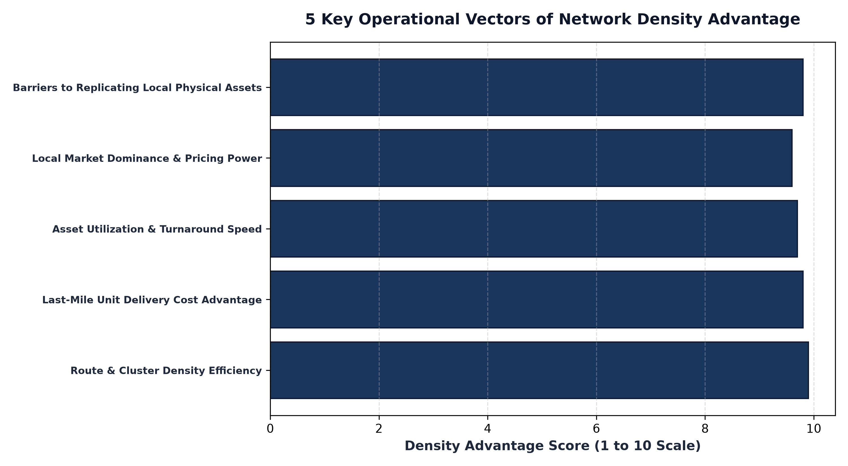
1. The Unit Economics of Route Density: The Cost per Stop
To comprehend the power of network density, one must analyze the microeconomics of the last-mile delivery stop. In physical distribution businesses, such as parcel delivery, uniform linen rental, beverage distribution, and commercial waste collection, the majority of operating expenses are fixed per vehicle route: driver wages, vehicle depreciation, fuel consumption, and vehicle insurance.
A carrier with high network density might serve thirty commercial stops along a single ten-mile street, stopping every three hundred yards. In contrast, a dispersed competitor with low density might travel fifty miles to serve those same thirty stops across an entire metropolitan area. The dense operator achieves dramatically lower transit time between stops, burning far less fuel and amortizing driver labor over more delivery transactions. This route density advantage produces a structurally superior cost per stop that competitors cannot bridge without winning massive local market share.
2. Local Monopolies: Density as a Geographic Tollbooth
Network density creates what industrial economists define as localized natural monopolies. While a company may not command eighty percent national market share, it may control eighty percent of the commercial delivery volume within twenty specific metropolitan MSAs.
In those concentrated markets, the dense operator functions as an economic tollbooth. Because no rival can achieve comparable unit delivery costs, any attempt by a competitor to enter the local market via price discounting results in severe losses for the challenger while the incumbent comfortably absorbs the competition. Furthermore, the incumbent commands decisive local pricing power, allowing it to raise service fees steadily without losing enterprise clients, who recognize that alternative vendors cannot match the frequency or reliability of the dense operator's route schedules.
3. Physical Asset Concentration and High Capital Utilization
Beyond route delivery, network density optimizes capital asset utilization across sorting facilities, rail freight terminals, and fulfillment warehouses. A company with high regional network density can operate sorting hubs at near one hundred percent capacity around the clock, driving fixed asset turnover and generating superior Return on Invested Capital (ROIC).
Freight railways and regional intermodal networks exemplify this dynamic. A railway that owns the dense mainline trackage connecting major industrial manufacturing corridors to deepwater ports commands irreplaceable physical route density. Replicating the physical right-of-way, trackage, and switching yards is economically and legally impossible, granting the incumbent an eternal physical density moat that compounds shareholder wealth over generations.
Furthermore, as network density expands within an existing geographic footprint, the incremental profit margins on new client additions are exceptionally high. Because the vehicle or train is already traversing the corridor, onboarding an adjacent corporate customer adds near-zero incremental transit cost, causing incremental revenue to drop directly down to operating cash flow.
4. Network Density and MPLY's Monopoly Framework
Evaluating how physical network density and localized natural monopolies generate defensible cash flows is central to fundamental quality investing.
Investors seeking to understand how durable economic moats, route density advantages, and infrastructure monopolies inform high-conviction portfolio construction can examine the Strategy Shares Monopoly ETF (MPLY). Details regarding the fund's investment methodology and portfolio holdings are available at https://strategysharesetfs.com/mply/. MPLY actively seeks dominant enterprises that control irreplaceable physical networks, localized infrastructure assets, and route density advantages that generate sustained pricing power and high returns on capital.
5. Frequently Asked Questions
Q1: How does a network density advantage differ from a standard network effect?
A standard network effect means each new user increases the platform's value for other users (e.g., social media or payment rails). A network density advantage is a supply-side cost advantage where geographic clustering lowers unit delivery and operating costs.
Q2: Can a new technology disrupt physical network density moats?
While automated routing software can optimize existing routes, physical density moats are deeply protected by physical real estate, municipal permits, and customer contracts, making them exceptionally resilient against pure digital disruption.
6. Sources
Harvard Business Review, Network Effects and Density: The Logistics of Competitive Advantage: https://hbr.org/2019/01/the-real-mechanics-of-network-effects
Morningstar, Analyzing Route Density and Infrastructure Moats in Transport: https://www.morningstar.com/articles/moat-research
Strategy Shares ETFs, MPLY Official Fund Portal and Quality Research Resources: https://strategysharesetfs.com/mply/
#EconomicMoat #CompetitiveAdvantage #Investing #Stocks

