What Is a Cost Advantage Moat
A cost advantage moat exists when a company can produce or deliver a product for meaningfully less than its competitors, and use that gap either to undercut rivals on price or to earn a fatter margin at the same price. It is one of the more common types of competitive advantage, and one of the easier ones for an investor to test, because unlike brand strength or switching costs, it shows up directly in unit economics rather than requiring a judgment call.

What to Look For
Three structural signals tend to separate a real cost advantage from a company that simply runs efficient operations this quarter. The first is scale: a retailer with thousands of stores can negotiate supplier terms a regional chain cannot match, and a chipmaker running factories at higher utilization spreads fixed costs over more units. The second is proprietary process, a company that has spent years refining a manufacturing method may produce more efficiently than a competitor trying to catch up from scratch. The third is locked-in access to cheaper inputs: a long-term contract on raw materials, or a logistics network built years ago at a cost a new entrant could not replicate today.
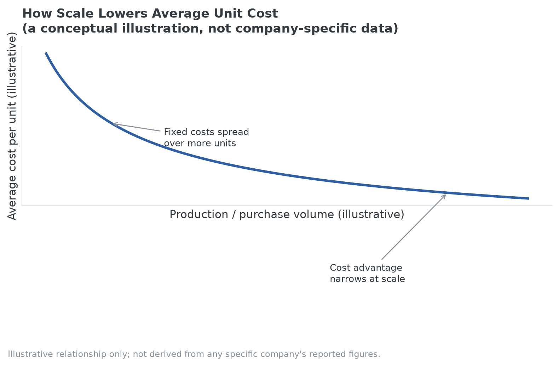
The first signal in practice: a conceptual illustration of how fixed costs spread over more units as volume grows. Not derived from any specific company's figures.

Where These Signals Show Up
Walmart is the standard reference case for the scale signal: its size lets it negotiate supplier terms that a regional chain cannot match, and that gap shows up directly in everyday shelf prices. Costco illustrates a related but distinct version, using a membership-fee model to run merchandise at thin, sometimes near-breakeven margins while the fee itself carries the profit, which lets it undercut competitors that need to price for margin on every item sold.
Southwest Airlines is the clearer example of the proprietary-process signal. Since its founding, it has flown a single aircraft family, the Boeing 737, rather than a mixed fleet. That choice simplifies pilot and mechanic training, lets crews and aircraft be swapped between routes without aircraft-specific requalification, and speeds up how quickly a plane can be turned around at the gate. The airline has said the practice saves hundreds of millions of dollars a year compared with operating a mixed fleet, the kind of structural cost gap that is hard for a competitor to close without rebuilding its own fleet strategy from scratch.

The Question That Actually Tests Durability
The common mistake is stopping at confirming a cost advantage exists and treating that as the same thing as confirming a moat. Cost advantages can erode faster than advantages built on brand or switching costs: a competitor that scales up eventually captures similar purchasing power, and a new manufacturing technology can wipe out years of process refinement overnight. A pure cost advantage, without something else layered on top of it such as a distribution network or brand recognition, also invites a price war that compresses margins for everyone in the industry, including the low-cost leader.
The evaluation question that actually separates a durable advantage from a temporary one is whether a well-capitalized competitor could replicate it within a few years. Cost efficiency by itself is common; cost efficiency that is genuinely hard to copy is rarer.
That durability question is also where cost advantage connects to how the Strategy Shares Monopoly ETF (MPLY) screens for potential holdings. Low cost is not itself one of the fund's named criteria, but industry concentration and control of the supply chain are, and a cost advantage is one of the more common mechanisms that produces both: a company that locks in the cheapest inputs, the most efficient process, or the tightest logistics network can use that edge to outlast smaller competitors, which over time concentrates an industry around a handful of survivors. That is the kind of position MPLY's screen is built to identify. But the fund's process asks the same durability question raised above, a cost edge a well-capitalized rival could close within a few years does not indicate the lasting concentration the fund is looking for, even if it produces a real advantage today. Readers interested in how MPLY weighs that distinction can review MPLY's investment approach on the fund's official page.

Sources
- Simple Flying, "Why One Of The World's Biggest Airlines Bet Its Future On A Single Aircraft Family" (Southwest Airlines single-fleet strategy and reported cost savings)
- Strategy Shares Monopoly ETF official fund page (screening criteria)
#CostAdvantageMoat #EconomicMoat #CompetitiveAdvantage #MPLY #Investing #ValueInvesting #Fundamentals

