What Is a Second Mover Advantage
A second mover advantage is the edge a company gains by entering a market after a pioneer has already tested it, rather than being first. It runs against the common assumption that being first is always best. In practice, the first company into a market often absorbs the cost of educating customers, working out product flaws, and building infrastructure that a later entrant can simply copy, improve, or avoid rebuilding from scratch.

What Second Movers Get for Free
A pioneer's mistakes are often the most valuable thing a second mover inherits. The first company has already found out which features customers ignore, which pricing model fails, and which technical approach does not scale. A second entrant can skip that trial-and-error phase entirely and launch with a more refined product on the first attempt.
Market education is another cost the pioneer usually pays alone. Convincing customers that a new category of product is worth buying at all takes marketing spend and time. Once that education has happened, later entrants can compete on quality and execution rather than spending resources explaining why the category matters in the first place.

Real Examples of Second Movers Winning
Search engines are the clearest case. AltaVista launched in December 1995 and became one of the dominant search tools of the mid-1990s, alongside Yahoo, Excite, and Lycos. Google did not launch until 1998, three years later, but its PageRank algorithm ranked pages by link popularity rather than raw keyword matching, and it did not suffer from the spam-cluttered results that increasingly plagued AltaVista as webmasters learned to game keyword-based rankings. By 2001, Google had captured roughly 85% of search market share. AltaVista, the pioneer, was acquired by Yahoo in 2003 and shut down in 2013.
Social networks followed a similar, faster-moving pattern. Myspace, founded in 2003, was the dominant social network in the United States for several years. Facebook launched in 2004, a year later, and overtook Myspace in global unique visitors by April 2008 and in US users by May 2009. Facebook's advantage was largely about design and control: a simpler, more consistent profile format and a tighter approach to how content spread, at a point when Myspace's freeform customization had become cluttered and harder to navigate.
Smartphones show the longest runway between pioneer and winner. IBM's Simon Personal Communicator, released in 1994, is generally credited as the first touchscreen smartphone, and later devices like the Palm Treo, Nokia 7710, and BlackBerry line built on that category through the 2000s. Apple's iPhone did not arrive until June 2007, thirteen years after IBM Simon, but it combined a capacitive multi-touch screen, a full mobile web browser, and, a year later, an app store into one product. What made the iPhone the category-defining device was not the idea of a touchscreen phone, which had existed for over a decade, but execution: interface design, developer ecosystem, and integration that the earlier entrants had not put together.
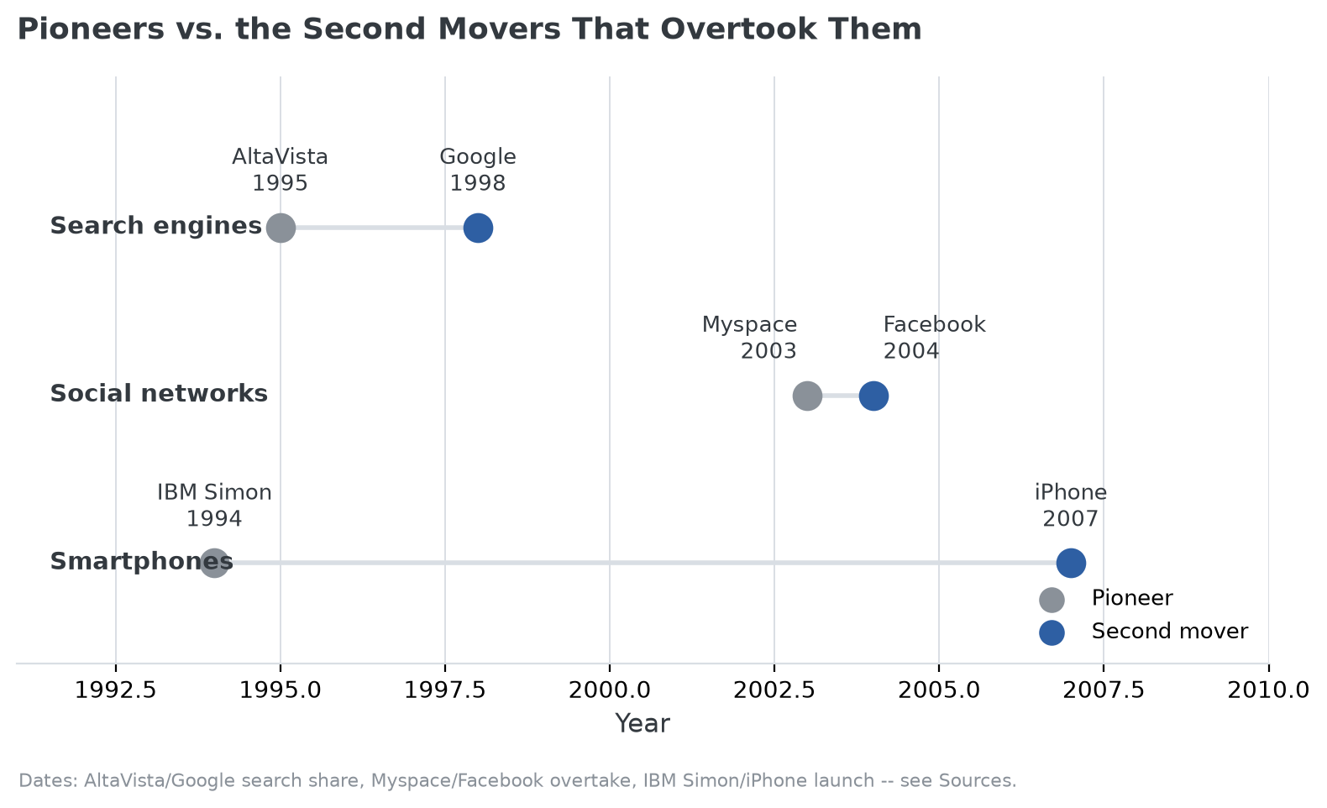
Launch or founding years for each pioneer and the second mover that overtook it. See Sources below.

When Being Second Does Not Work
The advantage is not automatic. If the pioneer builds strong network effects, meaning the product gets more valuable as more people use it, or locks customers in through high switching costs, a second mover can arrive with a technically superior product and still lose, because customers have little incentive to switch. Patents and regulatory approvals can also block a second mover from copying the parts of the pioneer's approach that mattered most.
That same list, network effects, switching costs, patents, regulatory approvals, is close to what the Strategy Shares Monopoly ETF (MPLY) screens for when it evaluates whether a company's market position is durable rather than temporary. The fund's process is not concerned with who entered a market first; it is concerned with whether a company's current position would actually survive a well-executed challenger, which is the same question this section is really asking about any pioneer facing a second mover. Readers interested in how a fund weighs that kind of durability can review MPLY's investment approach on the fund's official page.
The practical takeaway is that neither position, first or second, guarantees success. What tends to matter more is execution: whether a company can turn the lessons of an earlier entrant, or the ground that entrant already broke, into a genuinely better product, and whether the market's dynamics (network effects, switching costs, patents) leave room for a later arrival to catch up at all.

Sources
- Cybercultural, "Search Engines in 1998, Before Google Takes the Spotlight" (AltaVista launch, Google's rise)
- Wikipedia, "AltaVista" (founding date, 2001 search share, acquisition and shutdown)
- PCWorld, "Facebook Overtakes MySpace in U.S."
- AppleInsider, "The story of the original iPhone, that nobody thought was possible" (iPhone's June 2007 launch)
- SimpleTexting, "Smartphone history" (IBM Simon, 1994)
#SecondMoverAdvantage #BusinessStrategy #CompetitiveAdvantage #Innovation #MarketStrategy #Investing

