What Is MPLY ETF
The Strategy Shares Monopoly ETF, traded under the ticker MPLY, is an actively managed fund that looks for companies with what its issuer calls "Monopolistic Attributes." Rather than tracking a fixed index, the fund's managers select individual holdings based on a defined set of business characteristics associated with market dominance, then adjust the portfolio over time as that assessment changes.

What the Fund Screens For
MPLY's stated methodology looks for brand dominance, regulatory exclusivity, industry concentration, a history of antitrust scrutiny, monopolistic or oligopolistic economic rents, high barriers to market entry, pricing power, vertical integration and control of the supply chain, benefits from network effects, and protected intellectual property or patents. A company does not need every trait; the fund considers businesses that hold these characteristics individually, effectively a monopoly, or collectively with a small number of competitors, effectively an oligopoly.

Fund Basics
MPLY launched on May 15, 2025, giving it a track record of roughly a year as of late 2026. That is a meaningfully shorter operating history than most established equity ETFs, and it means the fund has not yet been tested through a full market cycle, including a sustained downturn.
The fund carries an expense ratio of 0.79%, both gross and net, and had roughly $18 million in assets under management as of late September 2026, according to the issuer's own site. That places it well below the size of most large, established sector or thematic ETFs, which can mean lower average daily trading volume and wider bid-ask spreads than an investor would see in a more heavily traded fund.
The portfolio held 100 positions as of the most recent public data, with its ten largest holdings, including Nvidia, Alphabet, Apple, Microsoft, and Amazon, making up roughly 64% of total assets. That level of concentration in mega-cap technology names means the fund's performance leans heavily on how a small group of dominant companies perform, more so than a broad-market index fund would.
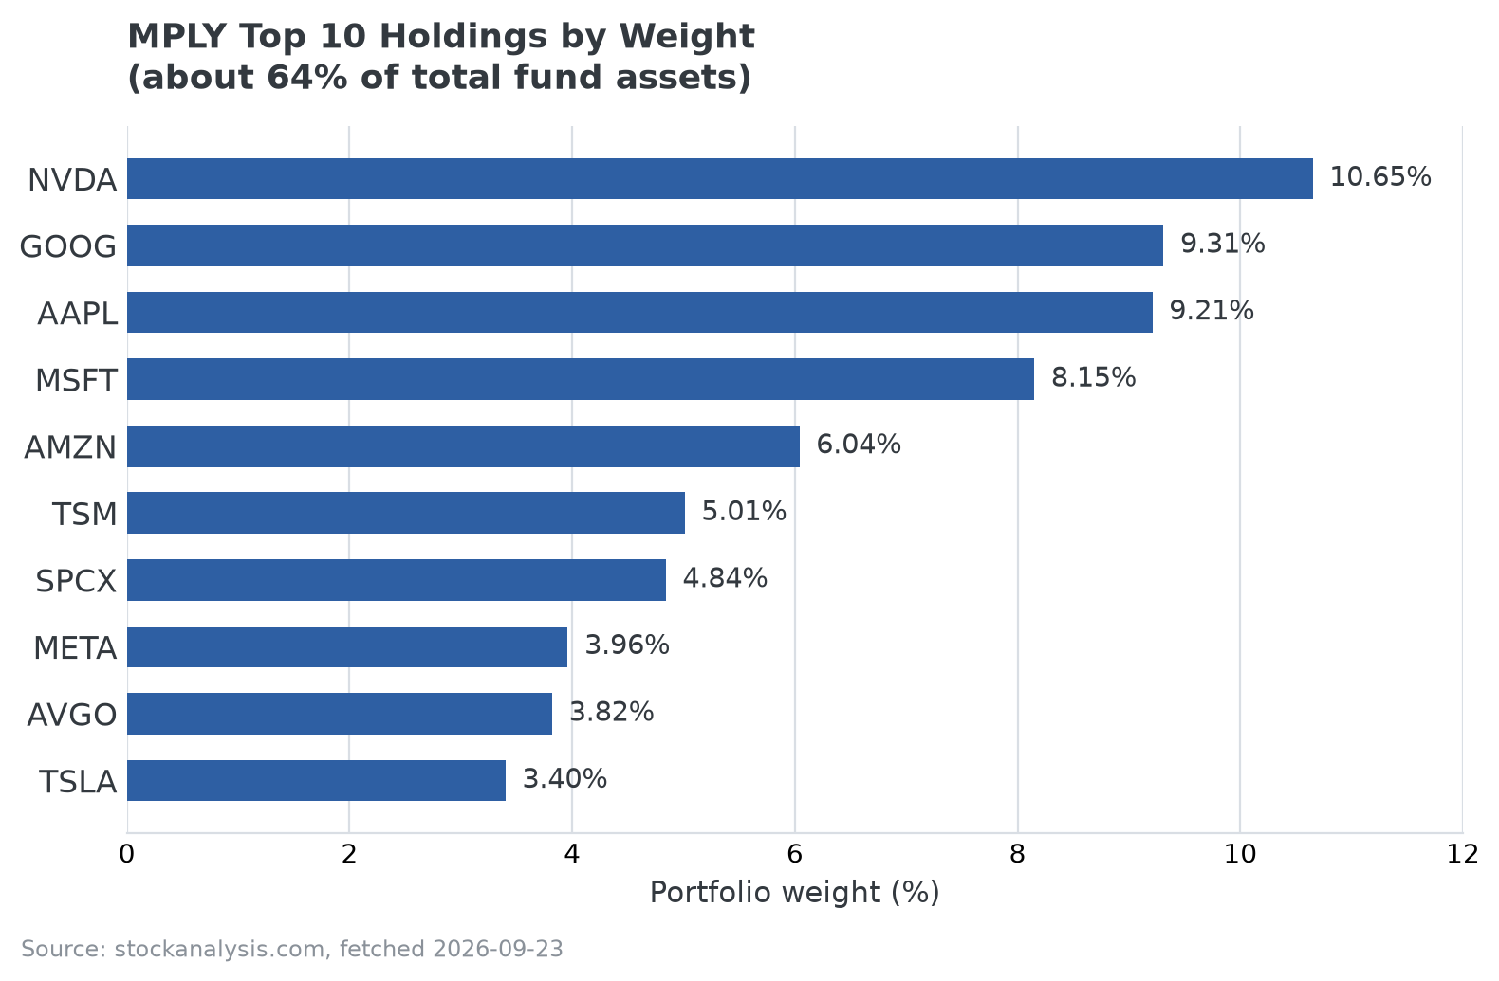
MPLY's ten largest holdings by portfolio weight. Source: stockanalysis.com, fetched 2026-09-23.

How It Has Performed So Far
As of August 31, 2026, the fund's trailing one-year return stood at 20.23% on a net asset value basis and 20.21% on market price, according to the issuer. Because the fund launched in May 2025, this figure reflects a single, specific market period rather than a return pattern proven across multiple years or market conditions. Investors researching the fund should treat any short-term performance figure as a snapshot rather than evidence of a repeatable strategy.

What to Weigh Before Researching Further
- Short operating history: inception in mid-2025 means no full market cycle has been observed yet.
- Concentration risk: roughly two-thirds of assets sit in ten holdings, most of them large technology companies.
- Smaller fund size: lower AUM than established ETFs can mean thinner trading liquidity.
- Active management: returns depend on the manager's ongoing judgment about which companies meet the monopoly/oligopoly screen, not a fixed, rules-based index.
MPLY is one option among several actively managed funds built around competitive-advantage or moat-style investing themes. Investors researching the space can review MPLY's investment approach directly through the issuer's site, which publishes current holdings, performance, and fund documents.

FAQ
What does the MPLY ticker stand for?
MPLY is the exchange ticker for the Strategy Shares Monopoly ETF, named for the fund's focus on companies with monopoly-like, or in some cases oligopoly-like, market positions rather than any reference to the board game.
Is MPLY a good investment?
That isn't a question this article can answer, and no article honestly can: it depends on an individual investor's goals, time horizon, and risk tolerance, and MPLY has a short public track record to evaluate against. What can be said is factual: the fund is actively managed, concentrated in its largest holdings, and carries a higher expense ratio and shorter history than many established ETFs, all of which are relevant to weigh, not reasons to buy or avoid it on their own.
How is MPLY different from a passive index ETF?
A passive index ETF tracks a fixed set of rules, typically weighting companies by market capitalization within a defined index. MPLY does not track a published index; its managers actively select and adjust holdings based on the fund's stated Monopolistic Attributes criteria, which means performance depends on the manager's ongoing judgment rather than a mechanical formula.
What are the main risks specific to MPLY?
Three stand out from currently available information: a short operating history with no full market cycle yet observed, concentration risk from roughly two-thirds of assets sitting in its ten largest holdings, and lower trading liquidity than an investor would find in a larger, more established ETF.

Sources
- Strategy Shares Monopoly ETF official fund page (inception date, expense ratio, AUM, trailing return, screening methodology)
- stockanalysis.com/etf/mply (holdings breakdown and secondary data verification)
#MPLY #MPLYETF #ETFResearch #MonopolyInvesting #CompetitiveAdvantage #ActiveManagement #Investing

