What Is Operating Leverage
Operating leverage describes how much a company's operating profit moves in response to a change in revenue, driven by the mix of fixed and variable costs in its cost structure. A business with high operating leverage sees profit swing further, in both directions, than its revenue does.

The Mechanism
A company with mostly fixed costs, rent, salaried staff, equipment depreciation, spends roughly the same amount whether revenue is up or down. Once revenue covers those fixed costs, each additional dollar of sales drops through to profit at a high rate, because there's little additional variable cost attached to it. A company with mostly variable costs, where expenses rise and fall closely with revenue, sees profit move roughly in line with revenue instead of amplifying it.

Why It Cuts Both Ways
High operating leverage is attractive on the way up: a software company with expensive fixed engineering costs but near-zero cost to serve an additional customer can see profit grow much faster than revenue as it scales. The same structure is painful on the way down: a revenue decline that would be a modest problem for a low-leverage business can turn into a much larger profit decline for a high-leverage one, since the fixed costs don't shrink just because revenue did.

How to Estimate It
A simple approximation is the percentage change in operating profit divided by the percentage change in revenue over the same period. A ratio meaningfully above 1 indicates high operating leverage, profit is amplifying revenue changes. A ratio close to 1 indicates operating profit is moving roughly in step with revenue, low leverage.

What Operating Leverage Doesn't Tell You
High operating leverage describes a cost structure's sensitivity, not whether the underlying business has any durable advantage protecting its revenue in the first place. A high-leverage business with unprotected revenue is simply a more volatile version of a vulnerable business, not a stronger one. The cost structure and the competitive position are separate questions.
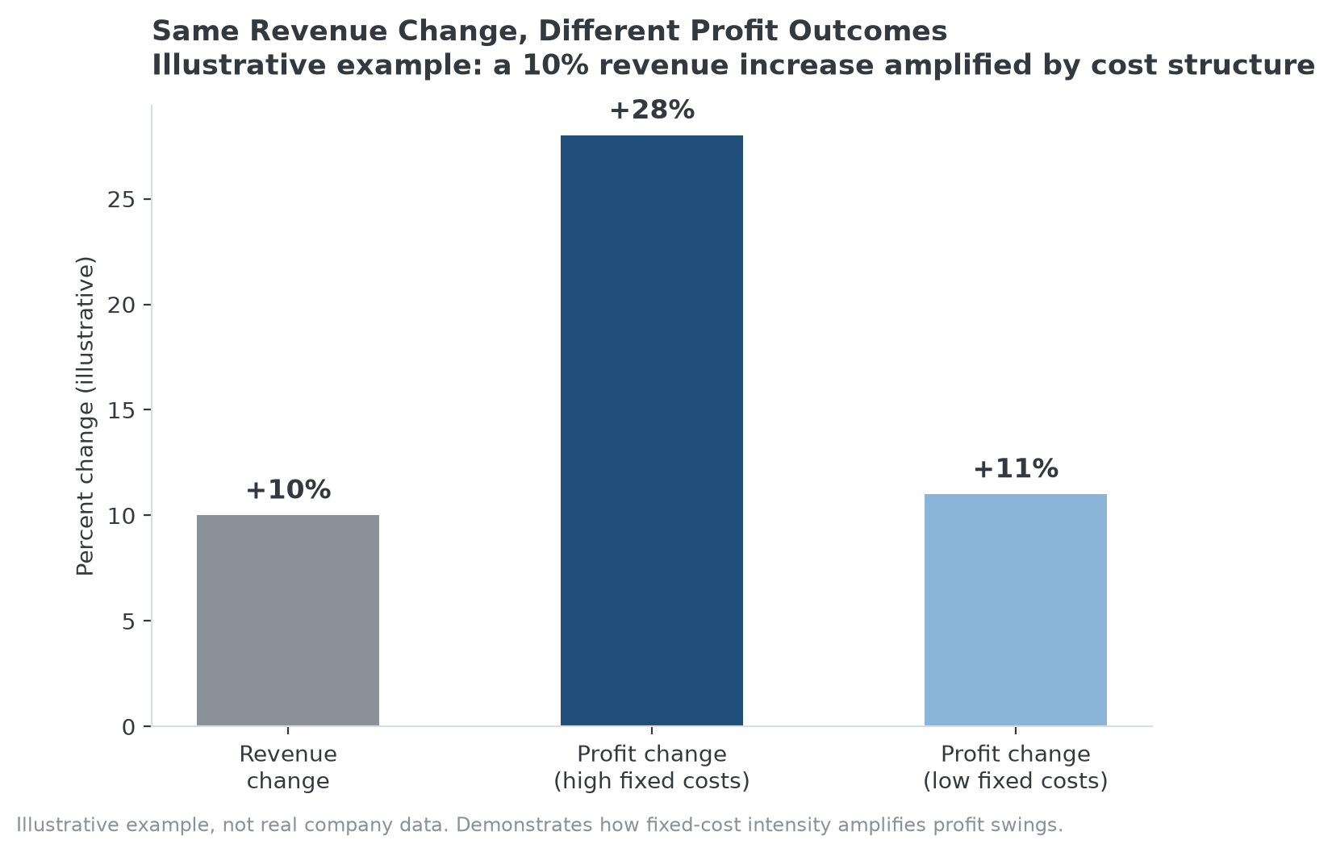
Illustrative example: identical 10% revenue growth produces very different profit outcomes depending on cost structure.

Why Dominant Businesses Often Carry High Operating Leverage
Operating leverage is a cost-structure characteristic, not itself one of the Strategy Shares Monopoly ETF's (MPLY) stated screening criteria, but the two are frequently found together in practice. A company with genuine industry concentration and high barriers to entry, the kind of position MPLY's process screens for, often also has low marginal cost to serve an additional customer once its dominant infrastructure, platform, or distribution network is built, which is exactly the fixed-cost-heavy profile that produces high operating leverage.
That combination cuts both ways for a reader evaluating a holding: the same leverage that amplifies profit growth when a dominant company is gaining share also amplifies the downside if its position weakens, which is why operating leverage is worth checking as a risk characteristic alongside MPLY's competitive-position criteria, not treated as confirmation of durability on its own. Readers can look at how this plays out across MPLY's current holdings directly.

Sources
- Strategy Shares Monopoly ETF official fund page
#OperatingLeverage #BusinessEconomics #Profitability #MPLY #Investing #Fundamentals

