What Is Operating Margin
Operating margin measures how much profit remains after covering both the direct cost of production and the operating expenses needed to run the business, marketing, administration, R&D, before interest and taxes. It's a fuller picture of business economics than gross margin, since it captures how efficiently the whole operation is run, not just the production side.

The Formula
Operating margin equals operating income divided by revenue, where operating income is gross profit minus operating expenses. A company with 40% gross margin but heavy marketing and administrative spending might end up with a 12% operating margin, the gap between the two numbers showing how much of the gross profit gets consumed running the rest of the business.

What the Gap Between Gross and Operating Margin Reveals
A wide gap between gross margin and operating margin usually means heavy spending on sales, marketing, or administration relative to revenue, sometimes justified by growth investment, sometimes a sign of an inefficient cost structure. A narrow gap means most of the gross profit is flowing through to operating profit, either because operating expenses are genuinely lean or because the company has scaled enough that fixed operating costs are spread over a larger revenue base.

Why Operating Margin Trends Matter
A single period's operating margin is a snapshot; the trend over several years, especially through a full economic cycle, is more informative. Operating margin expanding as a company scales suggests genuine operating leverage and improving efficiency. Operating margin compressing despite revenue growth can signal rising competitive pressure, deteriorating pricing power, or spending that's outpacing the returns it's generating.

The Limitation
Operating margin, like gross margin, varies structurally by industry, and a single strong reading doesn't establish durability on its own. A margin that's only ever been tested during favorable conditions is weaker evidence than one that has held up through a downturn or a period of real competitive pressure.
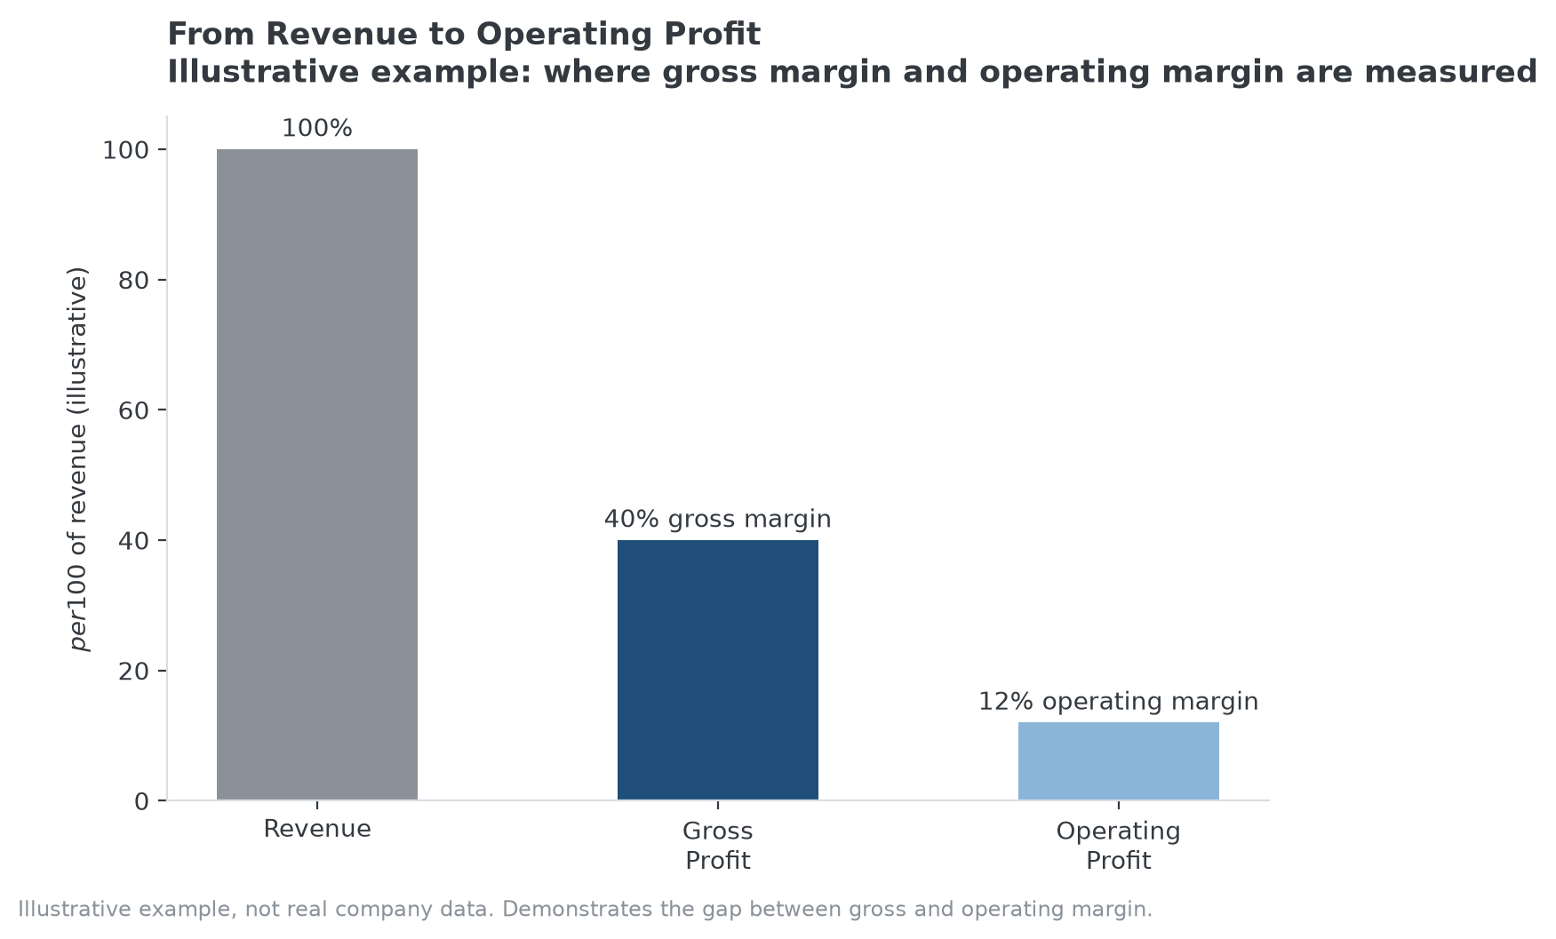
Illustrative example: operating margin is measured after operating expenses are subtracted from gross profit.

Where MPLY's Approach Connects
A durable, wide operating margin is generally a financial signature of the kind of position the Strategy Shares Monopoly ETF's (MPLY) stated criteria describe, industry concentration and pricing power specifically, though operating margin itself isn't a named criterion. A company's operating margin still depends heavily on management discipline over spending, so it's read as supporting evidence for a competitive-position thesis, not proof of one by itself.
MPLY's stated methodology and current holdings are where that thesis gets tested against real portfolio companies.

Sources
- Strategy Shares Monopoly ETF official fund page (screening criteria)
#OperatingMargin #QualityInvesting #Profitability #MPLY #Investing #Fundamentals

