What Is a Subscription Business Model
A subscription business model is a specific way of structuring a recurring revenue relationship: customers pay a fixed fee at regular intervals for continued access to a product or service, rather than paying once per unit of value received. It's one implementation of recurring revenue, distinguished by its specific operating mechanics: acquisition cost, churn, and lifetime value, more than by the industry it sits in.

The Core Economics
Subscription businesses are typically evaluated on a specific set of metrics that don't apply the same way to a one-off sales model: customer acquisition cost, the expense of winning a new subscriber; monthly or annual churn, the rate at which subscribers cancel; and customer lifetime value, the total revenue expected from a subscriber over their full relationship with the business. The relationship between these three, whether lifetime value comfortably exceeds acquisition cost, and how quickly that cost gets paid back, determines whether the model is actually profitable, independent of top-line subscriber growth.

Why Churn Is the Central Variable
A subscription model's entire economics hinge on how long the average customer stays. Even a modest reduction in monthly churn compounds significantly over a customer's full lifetime, since lower churn means each acquisition cost gets spread across more months of revenue. This is why subscription businesses tend to obsess over retention metrics in a way transaction-based businesses generally don't need to.

Where the Model's Durability Actually Comes From
The subscription structure itself doesn't create durability; it just concentrates the consequences of retention into a single, trackable number. A subscription business retains customers for the same underlying reasons any recurring-revenue business does, genuine switching costs, network effects, or habitual usage, not because subscription billing has some inherent protective power. Two subscription businesses with identical pricing can have very different long-term durability depending on which of those underlying forces is actually present.
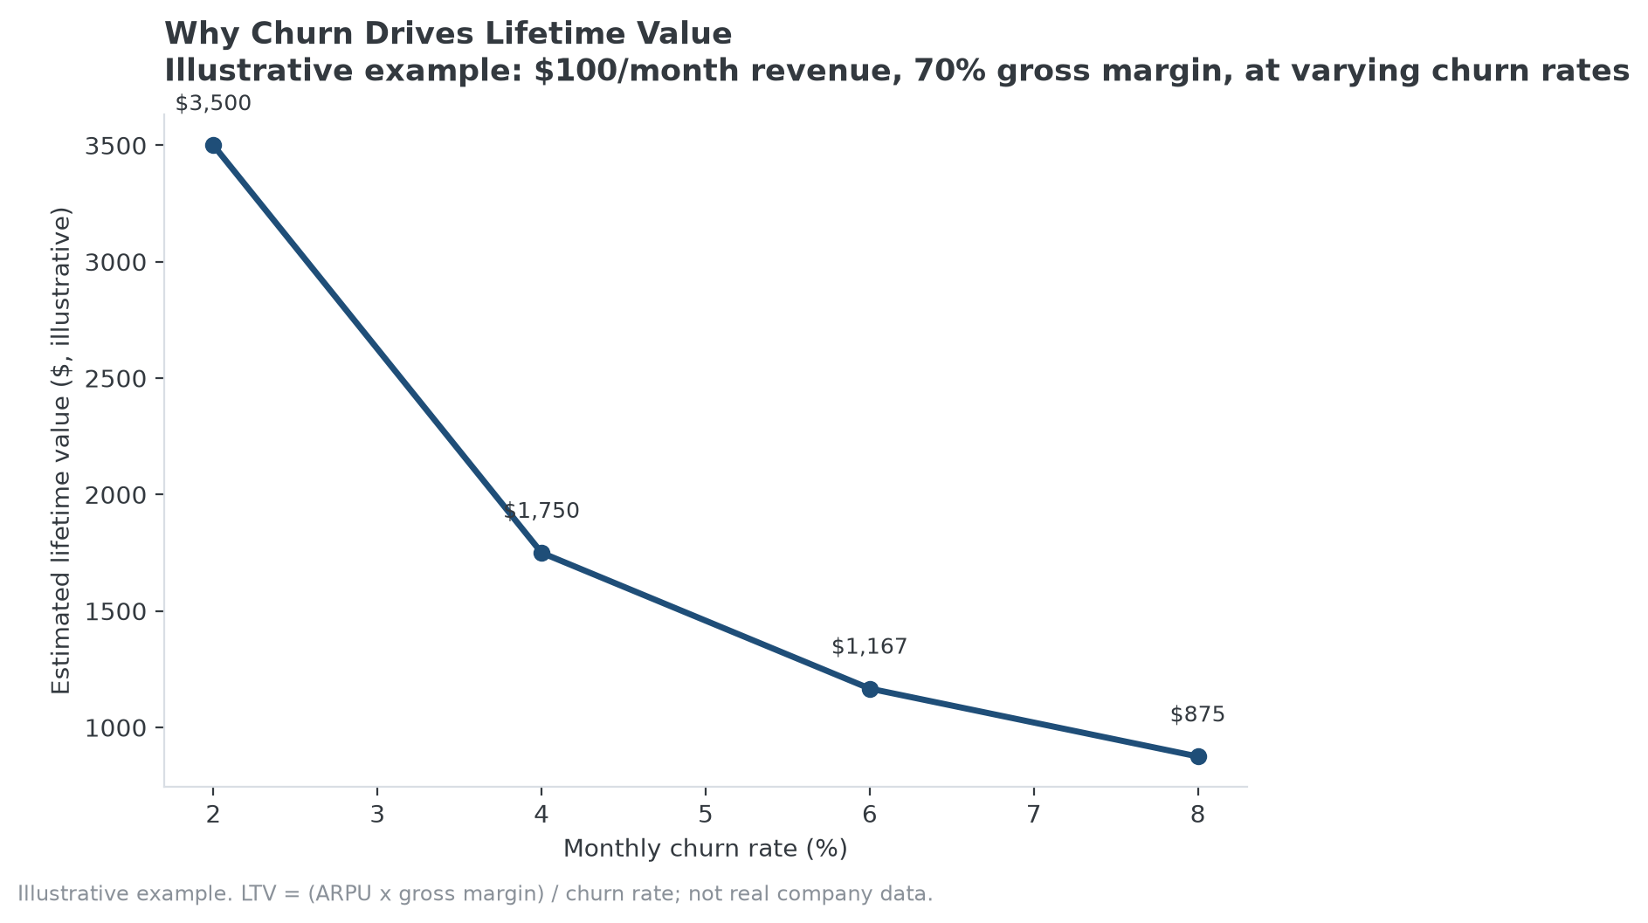
Illustrative example: how sensitive lifetime value is to a subscription business's churn rate.

How MPLY's Criteria Relate to the Subscription Model Specifically
The Strategy Shares Monopoly ETF's (MPLY) stated criteria don't address subscription billing as its own category, consistent with the distinction above: what matters to the fund's process is whether a subscription business's retention is backed by one of its named structural characteristics, brand dominance, network effects, switching costs rooted in barriers to entry, not the billing mechanism itself. A subscription company with low churn purely from customer inertia looks similar on a lifetime-value chart to one with low churn from a genuine moat, but only the second is the kind of position MPLY's screen is built to identify.
This distinction shows up directly in MPLY's current holdings, where subscription-model companies are represented specifically for the durable characteristics behind their retention, not for the billing structure itself.

Sources
- Strategy Shares Monopoly ETF official fund page
#SubscriptionBusiness #BusinessModels #RecurringRevenue #Churn #MPLY #Investing

