What Is Customer Lifetime Value
Customer lifetime value estimates the total revenue, or profit, a business expects to earn from a single customer over the full length of their relationship with the company. It reframes a single sale as part of a longer relationship, which changes how much a business can reasonably justify spending to acquire that customer in the first place.

A Common Formula
One widely used version: lifetime value equals average revenue per customer, multiplied by gross margin percentage, divided by the customer's churn rate. A customer generating $100 a month in revenue, at a 70% gross margin, with a 2% monthly churn rate, would have an estimated lifetime value of roughly $3,500. The formula's sensitivity to churn is the important part: even small changes in churn produce large changes in estimated lifetime value, since churn sits in the denominator.

Why It Changes How Acquisition Spending Gets Evaluated
Without a lifetime value estimate, a high customer acquisition cost can look unjustifiable when compared only to a single purchase. Once the full expected relationship is accounted for, the same acquisition cost can be easily justified, or still be too high, depending on how that cost compares to the full lifetime value rather than a single transaction.

The Estimation Risk
Lifetime value is a forward-looking estimate built on assumptions, average retention, stable margins, that may not hold, particularly for newer businesses without enough historical data to estimate churn reliably. A lifetime value figure built on a young, unproven customer cohort carries meaningfully more uncertainty than one built on years of actual retention data from a mature customer base.
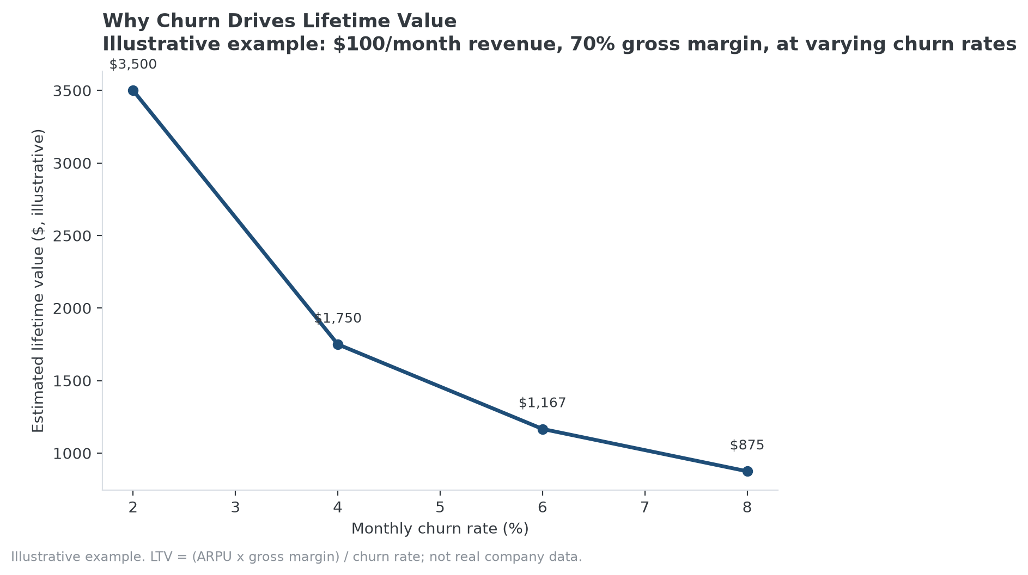
Illustrative example: the same lifetime value formula from above, plotted across a range of churn rates.

How This Connects to MPLY's Approach
High, durable customer lifetime value is generally a downstream signal of the same underlying characteristics the Strategy Shares Monopoly ETF's (MPLY) stated criteria describe, switching costs' structural drivers, brand strength, or network effects that support long, low-churn customer relationships, though lifetime value itself isn't one of the fund's named criteria. A company whose lifetime value holds up across a full economic cycle, not just during favorable conditions, is stronger evidence of the kind of durability the fund's screen is looking for than a lifetime value figure calculated from a few good quarters.
Readers can review MPLY's investment approach and current holdings on the fund's official page.

Sources
- Strategy Shares Monopoly ETF official fund page
#CustomerLifetimeValue #BusinessEconomics #Retention #MPLY #Investing #Fundamentals

