Customer Acquisition Cost vs Lifetime Value
Customer acquisition cost and customer lifetime value are usually discussed together because neither one means much in isolation. Acquisition cost tells you what a business spends to win a customer; lifetime value tells you what that customer is worth over time. The relationship between the two is what actually determines whether a growth strategy makes economic sense.

The Ratio That Matters
The lifetime-value-to-acquisition-cost ratio is the standard way of relating the two: a ratio of 3:1, lifetime value three times acquisition cost, is commonly treated as a reasonable minimum for a healthy business, though the right threshold varies by industry, margin structure, and how quickly the business needs to recover its cash. A ratio close to 1:1 suggests the business is barely breaking even on new customers before accounting for any other operating costs, regardless of how quickly it's growing.

Payback Period: The Timing Dimension the Ratio Misses
A healthy lifetime-value-to-acquisition-cost ratio can still hide a cash problem if the payback period, how long it takes to recover the acquisition cost from that customer's revenue, is too long relative to the business's available capital. A business with a strong 4:1 ratio but a three-year payback period needs meaningfully more capital to fund its growth than one with the same ratio and a six-month payback, even though the long-run economics look identical on paper.

Why Growth-Stage Companies Get This Wrong
A common mistake is projecting lifetime value from an early, unproven customer cohort while acquisition costs are already known and rising, an asymmetry that tends to make growth look more attractive than it actually is. Lifetime value assumptions deserve at least as much scrutiny as the acquisition cost figures they're being compared against, not less.
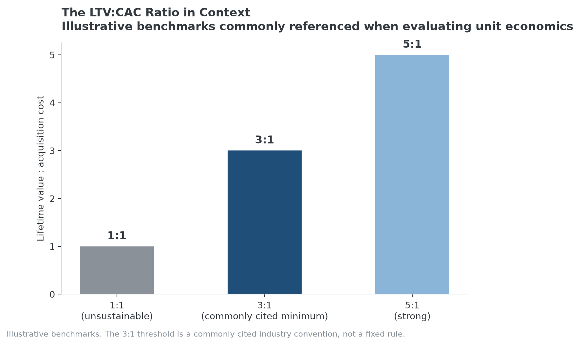
Illustrative benchmarks commonly referenced when evaluating LTV:CAC health.

Why Dominant Companies Often Show Stronger LTV:CAC Ratios
This relationship is a unit-economics tool for evaluating a specific growth strategy's efficiency, and it isn't itself one of the Strategy Shares Monopoly ETF's (MPLY) stated screening criteria. But the two are connected in practice: a company with genuine brand dominance, network effects, or high barriers to entry, the characteristics MPLY's process screens for, typically needs to spend less to acquire each new customer, since demand arrives through reputation, word of mouth, or a lack of viable alternatives rather than paid acquisition alone. That structural advantage tends to show up as a stronger LTV:CAC ratio and a shorter payback period than a comparable business without that position.
A weak or deteriorating LTV:CAC ratio at a company that otherwise screens well on MPLY's named criteria is worth investigating further, since it can be an early sign that a supposed competitive advantage is eroding faster than the qualitative screening criteria alone would reveal. Reviewing MPLY's current portfolio directly is the most reliable way to check how a specific holding stacks up.

Sources
- Strategy Shares Monopoly ETF official fund page
#CAC #CustomerLifetimeValue #UnitEconomics #BusinessEconomics #MPLY #Investing

