What Is a Monopoly Business
A monopoly business is one that faces no meaningful competition in its market, giving it the power to set prices and terms largely on its own rather than in response to rivals. True monopolies are rarer than the word's casual usage suggests, and studying how they actually form, and eventually erode, is more instructive than the dictionary definition alone.

De Beers: A Textbook Case
Cecil Rhodes began consolidating South Africa's competing diamond mines into De Beers Consolidated Mines in 1888, backed by Rothschild financing. Under Ernest Oppenheimer's leadership starting in 1926, De Beers built the Central Selling Organisation, a mechanism for controlling nearly the entire world's rough diamond supply through coordinated distribution and stockpiling, letting the company manage global diamond prices directly rather than compete for them. At its mid-20th-century peak, De Beers controlled roughly 80 to 90% of world rough diamond production and sales, about as close to a textbook monopoly as a modern industry has produced.
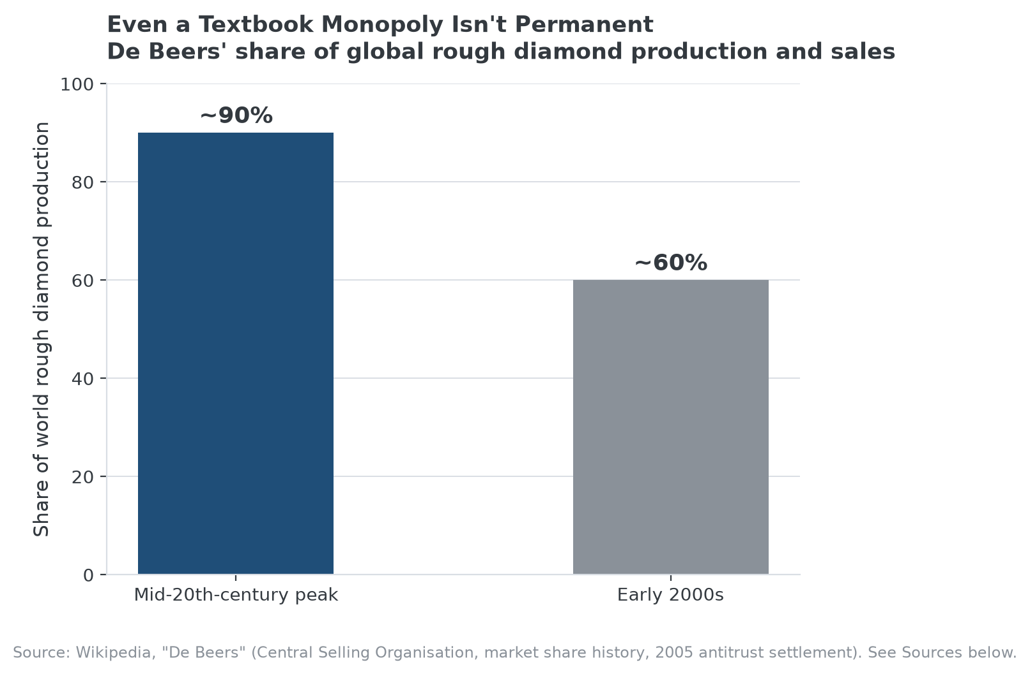
De Beers' dominance eroded gradually over decades, then ended formally after a 2005 US antitrust settlement.

How the Monopoly Actually Ended
De Beers' share fell from its peak to below 60% by the early 2000s as new diamond sources in Russia, Canada, and Australia developed outside its control, and the company eventually settled US antitrust litigation in 2005 for $295 million without admitting wrongdoing, alongside a separate agreement with European regulators. The erosion took decades, not years, but it happened even to one of history's most complete market-control structures once new supply sources and regulatory pressure both worked against it.

What Made It a Genuine Monopoly, Specifically
The combination that mattered was control of supply, most of the world's rough diamond production ran through De Beers' channels, paired with a coordinated distribution mechanism that let the company manage market prices directly rather than compete on them. Neither element alone would have produced the same durability: controlling supply without coordinated distribution still leaves room for price competition among controlled producers, and coordinated distribution without supply control leaves the door open to outside producers undercutting the arrangement.

Why Genuine Monopolies Are Rare and Usually Temporary
Sustained monopoly power generally requires either a resource genuinely difficult to replicate, De Beers' case, or a government-granted exclusivity, a regulated utility, for example. Even then, new supply sources, substitute products, technology shifts, or regulatory intervention tend to erode the position eventually, as De Beers' own multi-decade decline shows. A monopoly is a condition to keep testing, not a permanent state to assume.

How MPLY's Criteria Relate to Monopoly Economics
Monopoly economics are central to the Strategy Shares Monopoly ETF's (MPLY) name and stated approach, which explicitly screens for monopolistic or oligopolistic economic rents, industry concentration, and high barriers to market entry, the same characteristics De Beers' history illustrates in an unusually clean, historical form. The fund's process also has to weigh the same durability question De Beers' decline raises: a company's current dominance is a snapshot, and the fund's methodology treats it as something to keep testing rather than a permanent characteristic once identified.
MPLY's approach and current holdings are detailed on its official page.

FAQ
Are there true monopolies operating today?
Genuine, uncontested monopolies are rare in most industries; regulated utilities and certain government-licensed services are the clearest modern examples, since competition is legally restricted rather than simply difficult.
Is a monopoly always illegal?
No. Achieving a dominant position through superior products, business acumen, or historic accident isn't illegal in most jurisdictions. What's typically restricted is using that position through anticompetitive conduct to maintain or extend it unfairly.
Can a monopoly exist without government involvement?
Yes, as De Beers shows. Its dominance came from controlling a scarce natural resource and coordinating its distribution, not from a government grant, though it still eventually drew government antitrust scrutiny once its market power became a competition concern.

Sources
- Wikipedia, "De Beers" (Cecil Rhodes consolidation, Central Selling Organisation, market share history, 2005 antitrust settlement)
- Strategy Shares Monopoly ETF official fund page (screening criteria)
#Monopoly #MarketDominance #MPLY #EconomicMoat #CompetitiveAdvantage #Investing

