How to Identify a Durable Economic Moat
Identifying a moat isn't the same exercise as identifying a good company. A profitable, well-run business can still lack a durable advantage, and a company going through a rough patch can still have a real moat protecting its long-term economics. This is a practical checklist for separating the two, built around what to actually check, not just what to believe.

Start With the Financial Signature
- Gross margin trend over 5-10 years: stable or expanding margins through multiple cost cycles suggest pricing power; steadily compressing margins suggest the opposite.
- Return on invested capital versus cost of capital: a sustained, wide spread indicates real economic profit; a spread near zero suggests no durable advantage regardless of headline profitability.
- Market share trend over a full economic cycle, not just the past year or two: share that holds or grows through both expansions and downturns is a stronger signal than share that only grows in good times.

Then Check for a Specific, Nameable Source
A moat should be traceable to a specific mechanism, cost advantage, switching costs, network effects, brand, efficient scale, or a regulatory or IP barrier, not just asserted as "strong competitive position." If the answer to "why can't a well-funded competitor take this company's customers" is vague, the moat claim is probably vague too. Naming the actual mechanism also tells you what to monitor: a brand-based moat needs different tracking than a switching-cost-based one.

Stress-Test It Against a Real or Hypothetical Challenger
- Has a well-capitalized competitor actually tried to take share in this market, and what happened when they did?
- If no one has seriously tried, is that because the moat is strong, or because the market hasn't looked attractive enough yet to draw a serious challenger?
- What would a challenger with unlimited capital but no existing customer relationships need to do to compete meaningfully within three to five years?

Watch for Common False Positives
High current market share without evidence of why it's protected. A well-known brand without current evidence of pricing power. Consistent recent profitability that hasn't yet been tested by a downturn or a serious competitor. Each of these can look like a moat on a surface read of the numbers while actually reflecting a temporary or untested advantage rather than a durable one.
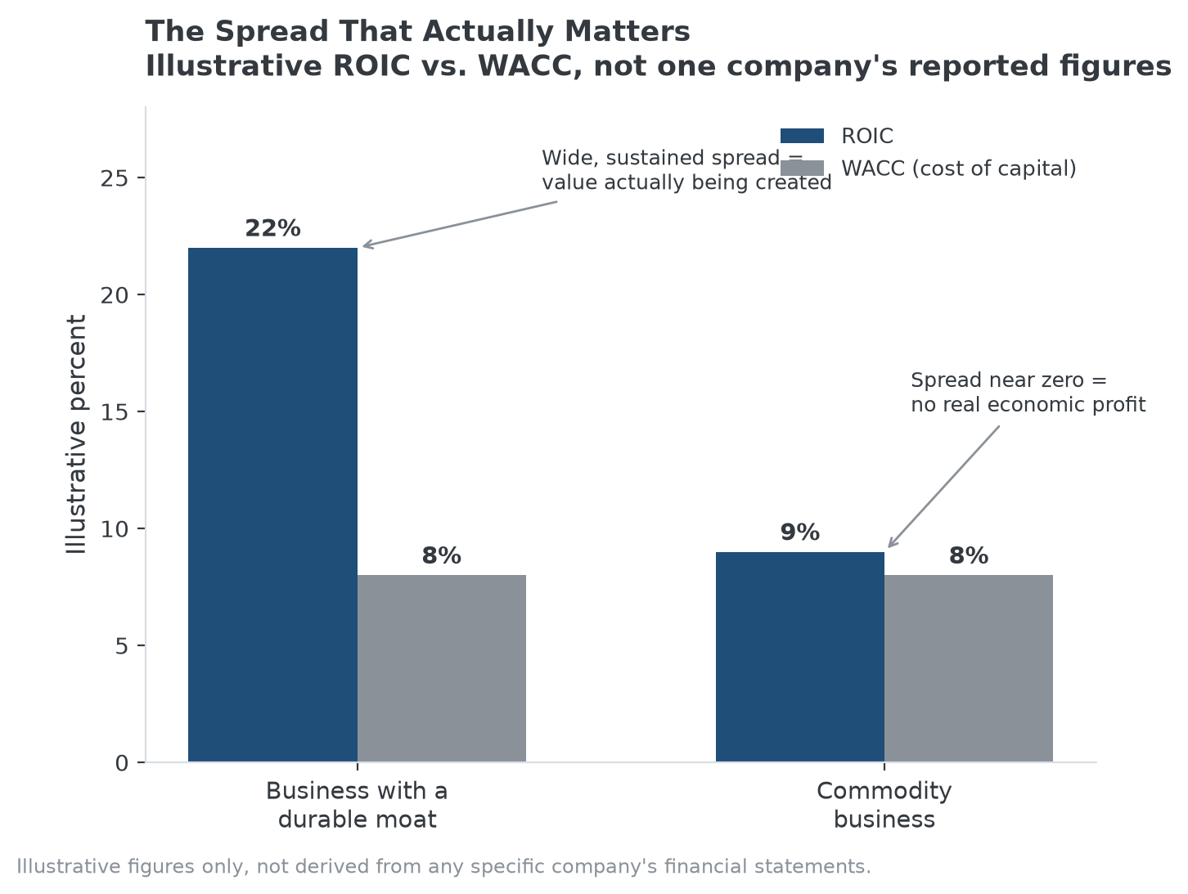
The ROIC-versus-WACC spread is one of the more concrete financial signals in this checklist. See No. 026 for the full quantitative framework.

How This Checklist Relates to MPLY's Screening Approach
This practical checklist overlaps closely with how the Strategy Shares Monopoly ETF (MPLY) describes its own process: evaluating brand dominance, regulatory exclusivity, industry concentration, barriers to entry, pricing power, supply-chain control, network effects, and protected IP as specific, nameable characteristics rather than a general impression of quality. The fund's approach is a version of the same discipline this checklist describes, verify the specific mechanism, don't take durability on faith.
Readers can review the fund's current holdings and full methodology on its official page.

FAQ
How many years of financial data should I look at before concluding a moat is durable?
There's no fixed number, but a full economic cycle, including at least one meaningful downturn, is a reasonable minimum. Two or three strong years alone can't distinguish a durable advantage from a temporary tailwind.
Can a company have more than one type of moat at once?
Yes, and it's common among the most durable businesses. A company might combine brand strength with switching costs, or network effects with regulatory barriers. Layered advantages are generally harder to displace than any single source alone.
Is a moat checklist a substitute for valuation?
No. Identifying a durable moat answers whether a business's economics are protected, not whether its stock is priced reasonably. A genuinely moated business can still be a poor investment at the wrong price.

Sources
- Strategy Shares Monopoly ETF official fund page (screening criteria)
#EconomicMoat #MoatAnalysis #CompetitiveAdvantage #StockResearch #MPLY #Investing

