How to Analyze Competitive Advantage in Stocks
Identifying that a company might have a competitive advantage is a qualitative exercise. Analyzing whether that advantage is actually showing up in the numbers, and how much it's worth, is a quantitative one. This is the financial-analysis framework: fewer checklist items than a qualitative moat review, but a more rigorous test of whether the advantage is real.

What to Look For: The Spread Between ROIC and WACC
Return on invested capital measures how much profit a company generates for every dollar of capital deployed in the business. Weighted average cost of capital measures what that capital actually costs the company to raise, from both debt and equity investors. The spread between the two, ROIC minus WACC, is a direct measure of economic profit: a company earning 22% on invested capital against an 8% cost of capital is creating real value every year it sustains that spread. A company earning 9% against the same 8% cost of capital is barely covering its cost of capital, regardless of how large or well-known it is.
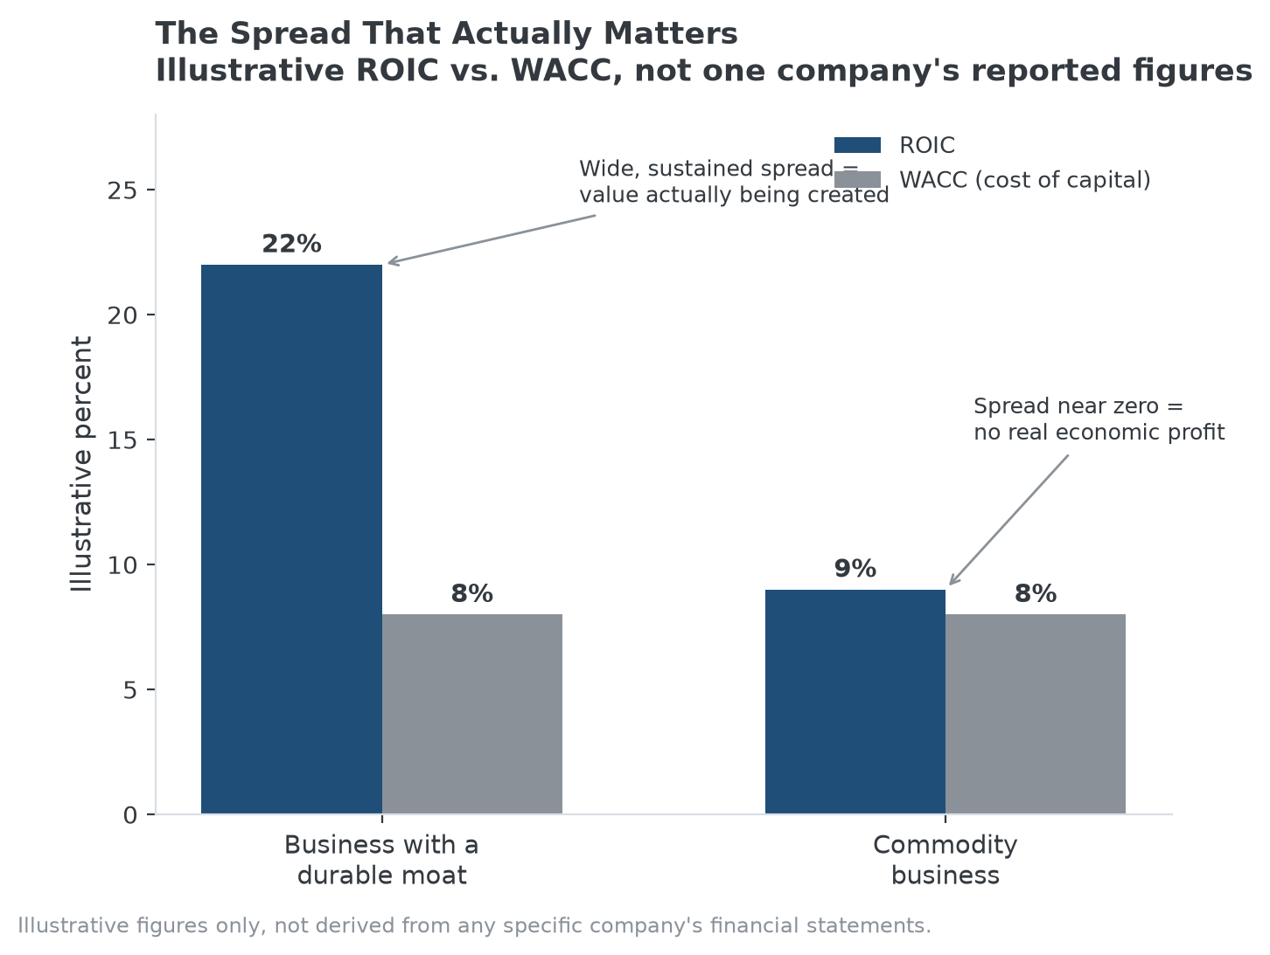
A wide, sustained ROIC-WACC spread is the clearest single quantitative signal of a durable advantage.

Key Metrics to Pull Together
- ROIC trend over at least one full economic cycle, not a single strong year.
- Gross and operating margin trend relative to direct competitors in the same industry, not just relative to the company's own history.
- Revenue growth composition: is it coming from higher volume, higher prices, or both, and how does that compare to unit cost growth over the same period?
- Free cash flow conversion: how much of reported earnings actually turns into cash the business can reinvest or return to shareholders?

How to Evaluate What the Numbers Are Telling You
A wide ROIC-WACC spread that has persisted for a decade across multiple economic cycles is meaningfully stronger evidence than the same spread measured over two unusually strong years. The question isn't just whether the spread exists today, it's whether it has survived a downturn, a strong competitor's entry, or an input-cost shock, since any of those events would have compressed a fragile advantage and left a durable one largely intact.

The Common Mistake
Treating high current profitability as proof of a durable advantage without checking whether it's actually a spread over the cost of capital, or without checking how long it's been sustained, is the most common analytical shortcut. A cyclical business can look highly profitable at the peak of its cycle and show a ROIC-WACC spread that evaporates or reverses at the trough, which is why the multi-year, multi-cycle view matters more than any single year's numbers.

Where MPLY's Approach Reflects This Same Analysis
The Strategy Shares Monopoly ETF's (MPLY) stated criteria, monopolistic or oligopolistic economic rents specifically, describe the same underlying concept this framework quantifies: sustained returns above what a normal competitive market would allow. A company whose ROIC-WACC spread is wide and durable across cycles is showing, in financial-statement form, the kind of position the fund's process is built to identify.
The fund's official page lists its current holdings for readers who want to check this analysis against actual companies.

Sources
- Strategy Shares Monopoly ETF official fund page (screening criteria)
#StockAnalysis #CompetitiveAdvantage #ROIC #EconomicMoat #MPLY #Investing

