Market Dominance vs Monopoly: What Is the Difference
"Dominant" and "monopoly" get used almost interchangeably in casual conversation, but they mean different things, and the difference matters both legally and analytically. Market dominance describes a company's competitive position, a matter of degree. Monopoly, in the legal sense used by antitrust regulators and courts, is a specific finding about market power and how it was obtained and used.
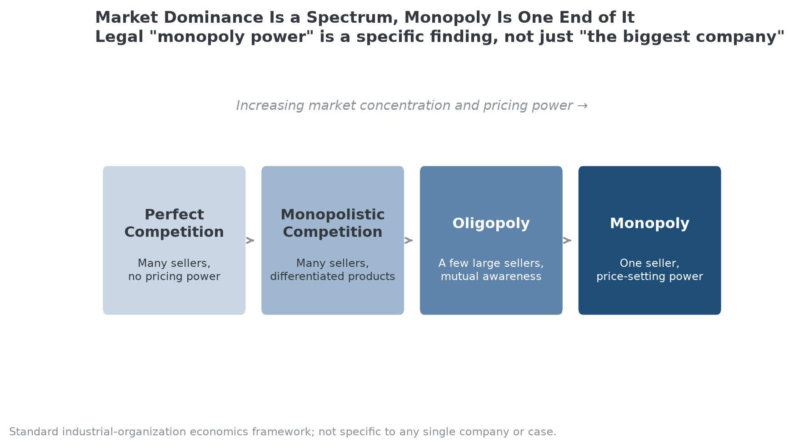
Monopoly is the far end of a spectrum of market structures, not a separate category applied casually to any large company.

The Legal Standard
The Sherman Antitrust Act, passed in 1890, prohibits monopolization under Section 2. The U.S. Supreme Court has defined monopoly power as "the power to control market prices or exclude competition," a two-part legal test that requires showing both that a company holds that power and that it was willfully acquired or maintained through anticompetitive conduct, not simply earned through superior products or business acumen. There's no single, fixed market-share percentage that automatically qualifies as a legal monopoly, though the landmark 1911 Standard Oil case treated the company's very high market share as central evidence of its monopoly power, and companies crossing roughly 50% share commonly draw increased regulatory and competitor attention even without a bright-line rule.

The Economic Spectrum
Economists describe market structure as a spectrum rather than a binary. Perfect competition sits at one end: many sellers, no individual pricing power. Monopolistic competition follows: many sellers, but with differentiated products that give each some limited pricing power. Oligopoly describes a market with a small number of large sellers who are aware of and react to each other's pricing decisions. Monopoly sits at the far end: a single seller with the power to set prices largely without competitive constraint. Most large, successful companies operate somewhere in the oligopoly range, not at the monopoly extreme, even when casual commentary calls them "a monopoly."

Why the Distinction Matters for Investors
A company with genuine market dominance, strong share, real pricing power, limited competitive pressure, can be an attractive business without meeting the legal bar for monopoly, and importantly, without carrying the same antitrust risk. Conflating the two can lead to two different mistakes: underestimating a genuinely dominant company's durability because it isn't a textbook monopoly, or overestimating a company's safety from regulatory action because its market position, while strong, has drawn genuine antitrust scrutiny.

How MPLY's Criteria Treat This Distinction
The Strategy Shares Monopoly ETF's (MPLY) own name invokes monopoly directly, but its stated criteria, monopolistic or oligopolistic economic rents, explicitly cover both ends of the dominance spectrum described above, not just literal monopolies. The fund's screening process also considers a company's history of antitrust reviews as one input, which is directly relevant to the legal distinction this article draws: a company can show strong market dominance while carrying meaningfully different regulatory risk depending on how that dominance was built and whether it has drawn formal antitrust scrutiny.
The fund's official page describes its full screening approach.

Sources
- Federal Trade Commission, "The Antitrust Laws" (Sherman Act overview)
- Wikipedia, "Sherman Antitrust Act"
- Strategy Shares Monopoly ETF official fund page (screening criteria)
#MarketDominance #Monopoly #Antitrust #CompetitiveAdvantage #MPLY #Investing

