What Is a Durable Competitive Advantage
"Durable competitive advantage" and "economic moat" describe the same underlying idea, a business characteristic that protects a company's profits from competition over a sustained period. They come from two different intellectual traditions that developed within a few years of each other in the 1980s, one from academic strategy research, the other from investing practice, and understanding both origins helps explain why the same concept gets described in slightly different language depending on who's using it.

The Academic Origin: Michael Porter
Harvard Business School professor Michael Porter published "Competitive Strategy: Techniques for Analyzing Industries and Competitors" in 1980, introducing what became known as Porter's Five Forces, a framework for analyzing the competitive intensity of an industry based on supplier power, buyer power, the threat of new entrants, the threat of substitutes, and rivalry among existing competitors. In 1985, Porter followed with "Competitive Advantage: Creating and Sustaining Superior Performance," which introduced value chain analysis and defined three generic strategies for achieving an advantage: cost leadership, differentiation, and focus.
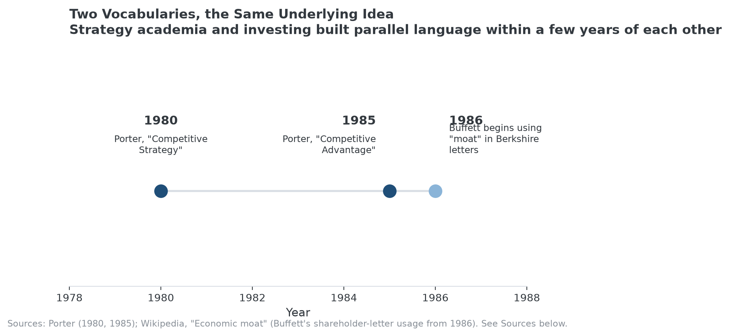
Two independent traditions arrived at the same underlying concept within six years of each other.

The Investing Origin: Warren Buffett
Around the same time, Warren Buffett began using "economic moat" in Berkshire Hathaway's shareholder letters, a metaphor borrowed from castle architecture rather than academic strategy literature. Buffett's version emphasized the same underlying idea, a durable barrier protecting profits, but was built for a practical investing audience rather than a business-school classroom, and it's the term now most associated with public-market equity analysis specifically.

What Changed and What Stayed the Same
Porter's framework is more structural and industry-level, analyzing why an entire industry is more or less attractive to compete in. Buffett's is more company-specific and outcome-focused, asking whether this particular business can keep earning above-average returns. Both frameworks converge on the same practical question: what stops a competitor, given enough time and capital, from competing away a company's profits? "Durable competitive advantage" tends to appear in more academic or formal business writing, closer to Porter's tradition; "economic moat" tends to appear in investing-specific commentary, closer to Buffett's.

Why the Vocabulary Distinction Rarely Matters in Practice
For research purposes, the two terms can be treated as functionally interchangeable, the underlying question, mechanism, and evaluation approach are the same regardless of which vocabulary a given source uses. What matters is applying the actual analysis, checking for a specific, nameable source of advantage and testing its durability, not which of the two traditions' terminology a particular analyst or article happens to prefer.

Where MPLY Fits Both Traditions
The Strategy Shares Monopoly ETF's (MPLY) stated screening criteria draw on the same underlying concept both traditions describe, without being tied to either vocabulary specifically. Its named characteristics, brand dominance, barriers to entry, network effects, pricing power, and the rest, map onto both Porter's generic strategies and Buffett's moat sources, which is consistent with the idea that this is one underlying concept described by two overlapping vocabularies, not two separate ideas.
MPLY's investment approach is published on its official page.

FAQ
Is "durable competitive advantage" the same as "economic moat"?
For practical research purposes, yes. Both describe a business characteristic that protects profits from competition over time. "Durable competitive advantage" traces more to academic strategy writing (Porter); "economic moat" traces more to investing commentary (Buffett), but the underlying analysis is the same.
Did Porter and Buffett work together or influence each other directly?
There's no documented direct collaboration between them on this concept. Porter's work came from academic strategy research; Buffett's came from investing practice. That they arrived at closely related ideas within a few years of each other, independently, is part of why the concept is worth treating as robust rather than a fad specific to one field.
Which term should I use when researching a stock?
Either works, since most financial databases, analyst reports, and books use them interchangeably. Search both terms when researching a company, since different sources default to different vocabulary.

Sources
- Wikipedia, "Competitive advantage" (Porter's 1980 and 1985 works, generic strategies)
- Wikipedia, "Economic moat" (Buffett's shareholder-letter usage from 1986)
- Strategy Shares Monopoly ETF official fund page (screening criteria)
#CompetitiveAdvantage #EconomicMoat #MichaelPorter #WarrenBuffett #MPLY #Investing

