What Is MPLY ETF
The Strategy Shares Monopoly ETF, traded under the ticker MPLY, is an actively managed fund that looks for companies with what its issuer calls "Monopolistic Attributes." Rather than tracking a fixed index, the fund's managers select individual holdings based on a defined set of business characteristics associated with market dominance, then adjust the portfolio over time as that assessment changes.

What the Fund Screens For
MPLY's stated methodology looks for brand dominance, regulatory exclusivity, industry concentration, a history of antitrust scrutiny, monopolistic or oligopolistic economic rents, high barriers to market entry, pricing power, vertical integration and control of the supply chain, benefits from network effects, and protected intellectual property or patents. A company does not need every trait; the fund considers businesses that hold these characteristics individually, effectively a monopoly, or collectively with a small number of competitors, effectively an oligopoly.

Fund Basics
MPLY launched on May 15, 2025, giving it a track record of roughly a year as of late 2026. That is a meaningfully shorter operating history than most established equity ETFs, and it means the fund has not yet been tested through a full market cycle, including a sustained downturn.
The fund carries an expense ratio of 0.79%, both gross and net, and had roughly $18 million in assets under management as of late September 2026, according to the issuer's own site. That places it well below the size of most large, established sector or thematic ETFs, which can mean lower average daily trading volume and wider bid-ask spreads than an investor would see in a more heavily traded fund.
The portfolio held 100 positions as of the most recent public data, with its ten largest holdings, including Nvidia, Alphabet, Apple, Microsoft, and Amazon, making up roughly 64% of total assets. That level of concentration in mega-cap technology names means the fund's performance leans heavily on how a small group of dominant companies perform, more so than a broad-market index fund would.
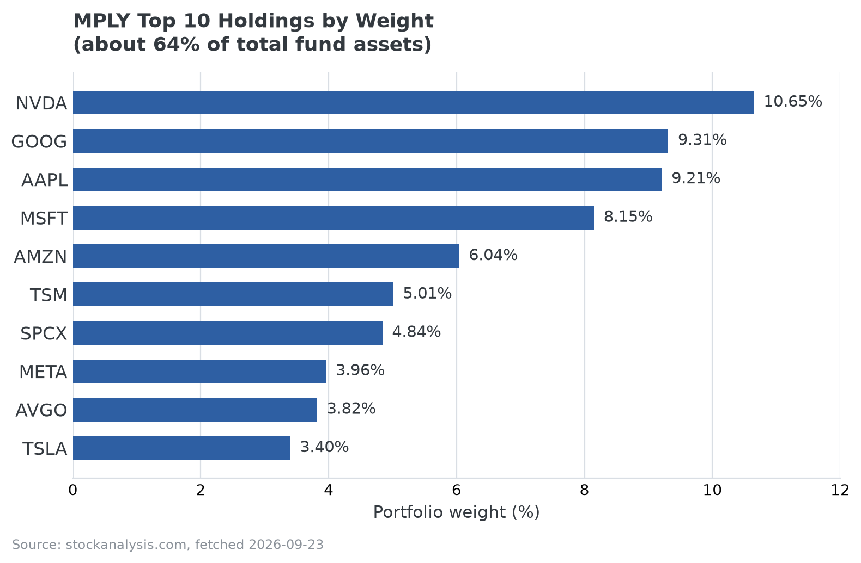
MPLY's ten largest holdings by portfolio weight. Source: stockanalysis.com, fetched 2026-09-23.

How It Has Performed So Far
As of August 31, 2026, the fund's trailing one-year return stood at 20.23% on a net asset value basis and 20.21% on market price, according to the issuer. Because the fund launched in May 2025, this figure reflects a single, specific market period rather than a return pattern proven across multiple years or market conditions. Investors researching the fund should treat any short-term performance figure as a snapshot rather than evidence of a repeatable strategy.

What to Weigh Before Researching Further
- Short operating history: inception in mid-2025 means no full market cycle has been observed yet.
- Concentration risk: roughly two-thirds of assets sit in ten holdings, most of them large technology companies.
- Smaller fund size: lower AUM than established ETFs can mean thinner trading liquidity.
- Active management: returns depend on the manager's ongoing judgment about which companies meet the monopoly/oligopoly screen, not a fixed, rules-based index.
MPLY is one option among several actively managed funds built around competitive-advantage or moat-style investing themes. Investors researching the space can review MPLY's investment approach directly through the issuer's site, which publishes current holdings, performance, and fund documents.

Sources
- Strategy Shares Monopoly ETF official fund page: strategysharesetfs.com/mply
- stockanalysis.com/etf/mply (holdings breakdown and secondary data verification)
#MPLY #ETFResearch #ActiveManagement

