How Customer Lock-In Creates a Moat
Customer lock-in is an umbrella term that covers several genuinely different mechanisms, and they don't all protect a business equally well. Sorting lock-in into its actual types is more useful than treating it as one undifferentiated concept, because the type determines both how durable the lock-in is and what would actually break it.

Contractual Lock-In
The most straightforward type: a customer is bound by a multi-year agreement, an early-termination fee, or a minimum-commitment contract. This is real, but it's also the weakest form of lock-in over the long run, because it has a fixed expiration date. Once the contract term ends, the customer's decision resets entirely to whatever the underlying product and price actually offer relative to alternatives.

Technical Lock-In
Covered in more depth elsewhere as switching costs, technical lock-in comes from integration depth: a customer's systems, workflows, or data are built around a specific product in ways that make migration genuinely costly and risky, independent of any contract. This type tends to be more durable than contractual lock-in because it doesn't expire on a schedule, it persists as long as the technical dependency does.

Data Lock-In
A customer who has accumulated years of historical data, records, files, project history, inside a specific product faces a distinct cost: not just relearning a new tool, but potentially losing or having to migrate that accumulated history. This is especially strong when the data format is proprietary or when exporting loses fidelity, structure, or metadata that doesn't transfer cleanly to a competitor's system.

Psychological and Habit Lock-In
The weakest and most easily broken type: a customer stays mainly out of familiarity or inertia, not because switching carries a real technical or financial cost. This is the same mechanism discussed in the recurring-revenue and retention context elsewhere, it can look identical to stronger lock-in on a retention chart while actually being far more fragile once a competitor makes switching easy or a customer has a specific reason to reassess.

Why Sorting Lock-In Into Types Matters
- Contractual lock-in tells you when the real test comes: at contract renewal, not before.
- Technical and data lock-in tell you the advantage is structural and won't simply expire, but also that it could weaken if industry standards make migration easier over time.
- Habit lock-in tells you the retention number is less trustworthy than it looks, and deserves more scrutiny, not less, than the other types.
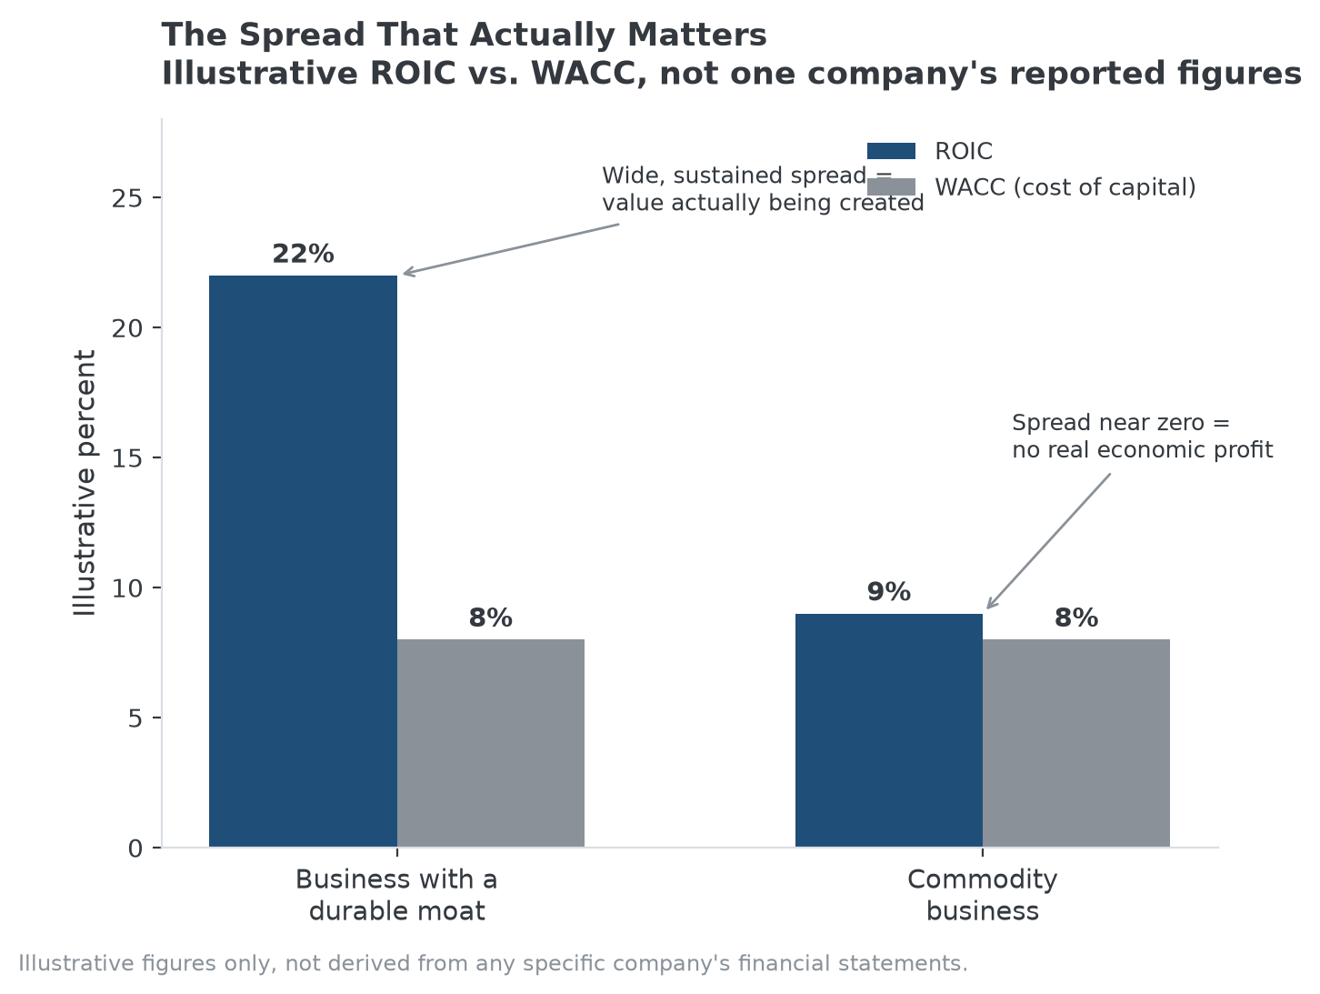
A business protected by structural lock-in should show this kind of sustained ROIC-WACC spread, not just low churn. See No. 026 for the full framework.

How MPLY's Screen Weighs Different Lock-In Types
Customer lock-in isn't named as a single category in the Strategy Shares Monopoly ETF's (MPLY) stated criteria, but it's a common mechanism behind pricing power and industry concentration, both of which are. The fund's process would reasonably weigh technical and data lock-in more heavily than contractual or habit-based lock-in, since the first two are structural and the second two are more easily reversed.
MPLY's official page lists its current holdings and investment approach.

Sources
- Strategy Shares Monopoly ETF official fund page (screening criteria)
#CustomerLockIn #SwitchingCosts #EconomicMoat #CompetitiveAdvantage #MPLY #Investing

