How Network Effects Create Market Dominance
Network effects don't just protect an existing position, in the right conditions, they can flip an entire market from one leader to another with surprising speed once a competing product crosses a critical threshold of adoption. The videotape format war between VHS and Betamax is one of the clearest, best-documented examples of that tipping dynamic in action.

The Setup: A Genuine Head Start
Sony launched Betamax in Japan in May 1975, roughly a year before JVC brought VHS to market in 1976 and 1977. Betamax also had real technical advantages in picture quality. On paper, the pioneer with the better product should have won.

The Mechanism That Flipped It
JVC licensed the VHS format openly to other manufacturers, while Sony required licensing fees and kept tighter control over Betamax production. That single decision mattered enormously once network effects entered the picture: more manufacturers building VHS players meant more players in stores, which meant more content available on VHS as the video rental industry took off, which made VHS more attractive to the next buyer, who then had access to a larger rental library, reinforcing the cycle further.
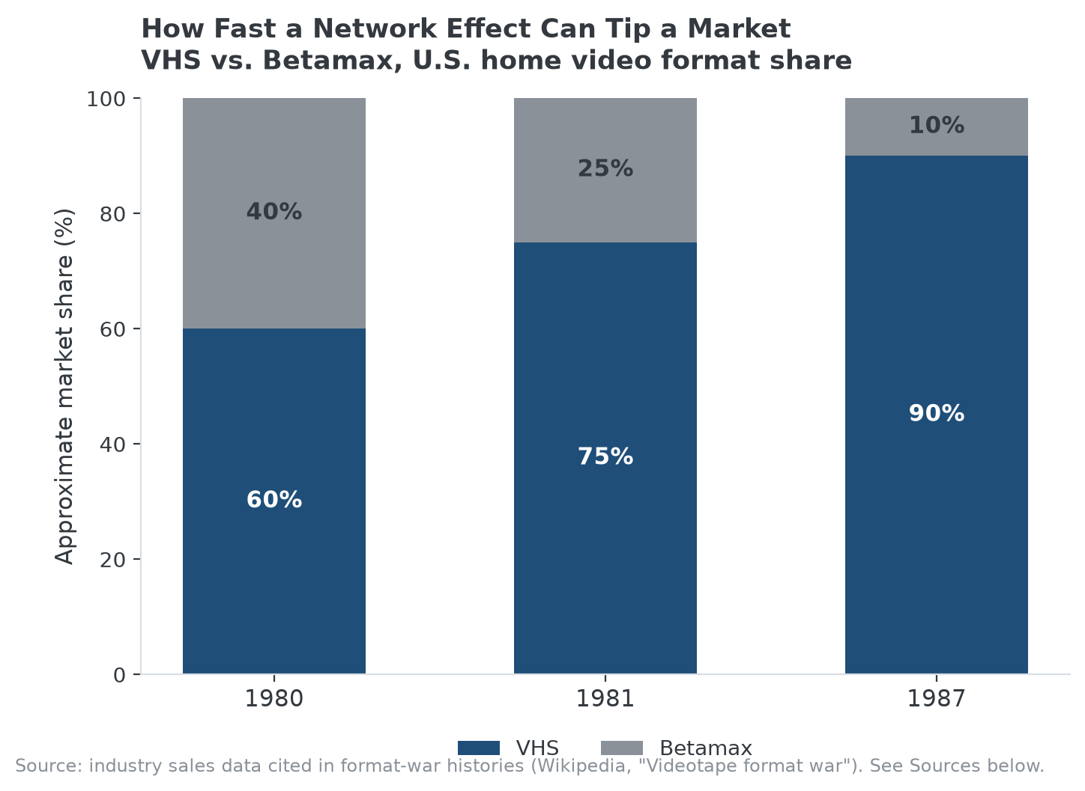
A one-year head start and better picture quality weren't enough once VHS's open licensing tipped the network effect.

How Fast the Tip Happened
By 1980, VHS already held roughly 60% of the North American market. By 1981, Betamax's share of US VCR sales had fallen to around 25%. By 1987, VHS commanded roughly 90% of the US market, and Betamax was effectively finished as a consumer format. The entire reversal, from Betamax's early lead to VHS's near-total dominance, played out over about a decade, most of the damage done within the first five years.

Why This Case Generalizes
The specific mechanism, open licensing driving hardware availability, which drove content availability, which drove consumer adoption, is a version of a pattern that recurs whenever a market has genuine network effects: the format, platform, or standard that reaches critical mass first in terms of ecosystem breadth, not necessarily product quality or launch date, tends to win the whole market rather than splitting it, because each additional adopter makes the leading option more attractive relative to the alternative, not just proportionally more popular.

How MPLY's Screen Applies This Lesson
Network effects and industry concentration are both named in the Strategy Shares Monopoly ETF's (MPLY) stated criteria, and the VHS-Betamax case is a useful historical illustration of how quickly those two characteristics can combine: a market that looks competitive can tip toward near-total concentration once a network effect passes its critical threshold, which is part of why the fund's process treats network effects as a potentially rapid path to durable market dominance, not just a slow-building advantage.
MPLY's current holdings and investment approach are on its official page.

Sources
- Wikipedia, "Videotape format war" (launch dates, licensing strategy, market share data)
- Strategy Shares Monopoly ETF official fund page (screening criteria)
#NetworkEffects #MarketDominance #EconomicMoat #CompetitiveAdvantage #MPLY #Investing

