How Barriers to Entry Protect Incumbent Companies
Barriers to entry are usually described as passive, structural features of a market: high capital requirements, regulation, scale. But incumbents don't just benefit from these barriers passively; in markets with genuinely scarce, physically limited resources, the incumbent's existing claim on that resource actively locks out new competition in a way that keeps reinforcing itself.

The Clearest Example: Airport Slots
Heathrow Airport, one of the world's busiest, operates at roughly 99% of its physical runway capacity. There's essentially no room left to add new flights without an airline giving up existing slots, the specific, scheduled landing and takeoff rights airlines need to operate there. British Airways alone holds roughly 51% of Heathrow's total slot capacity, a position built up over decades that a new airline cannot simply out-compete its way into, no matter how good its service or how low its fares, because the physical capacity to operate more flights at that airport doesn't exist to be won.
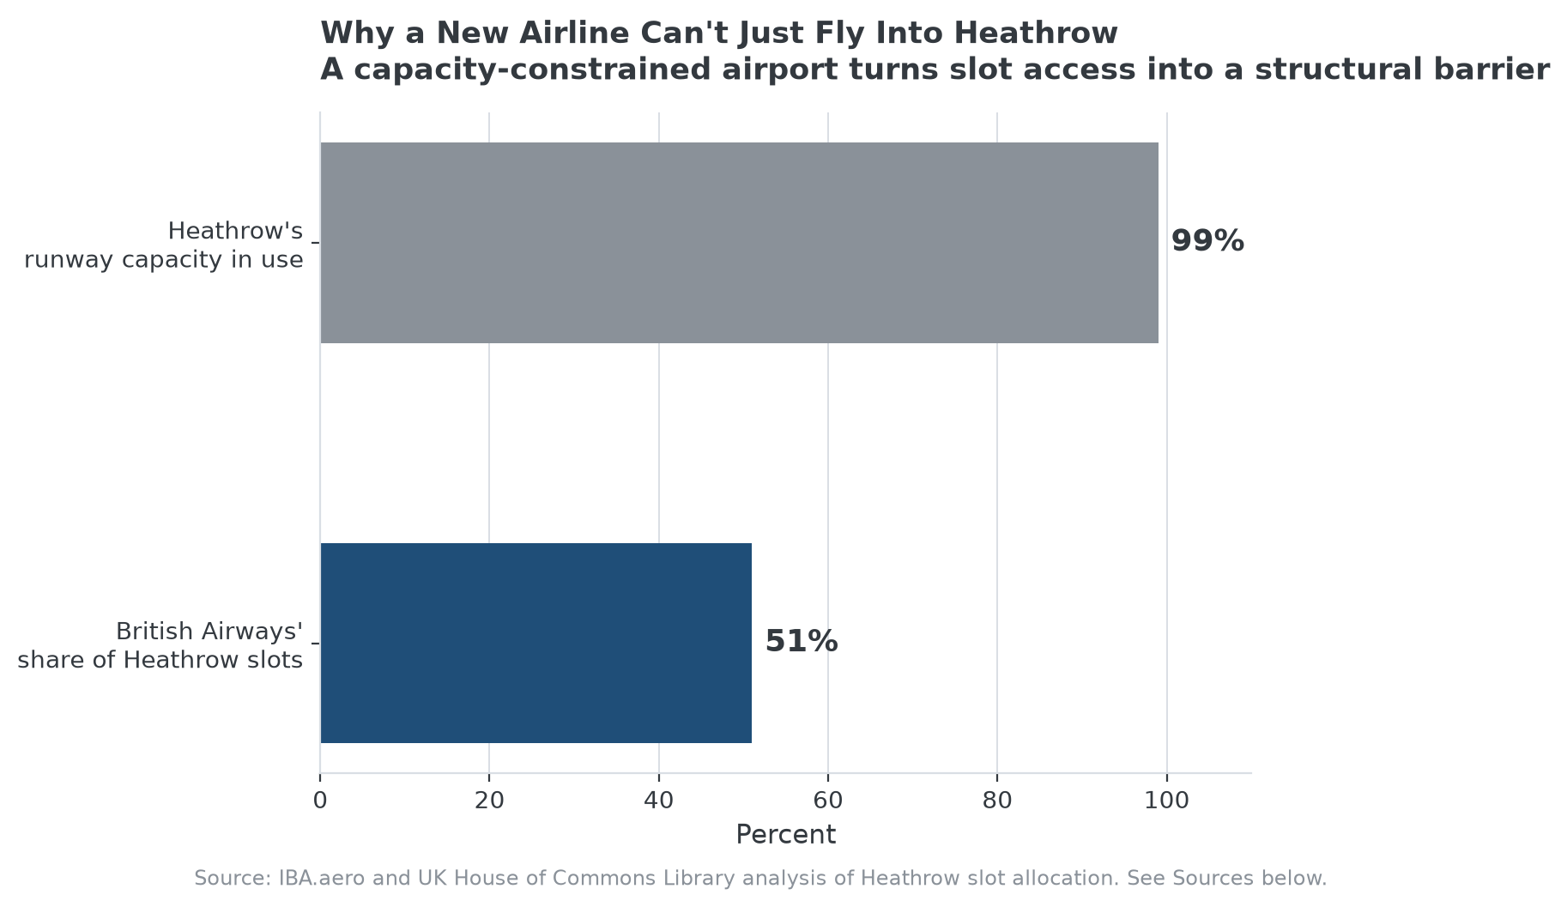
When the underlying resource is physically capped, incumbent share becomes a barrier in itself, not just a byproduct of one.

Why This Kind of Barrier Compounds
Regulatory reviews of the EU's slot allocation system found that under one percent of slots at major congested airports were being redistributed to new entrants each year, meaning the incumbent's position from a decade ago is still close to its position today. That's a meaningfully different, more durable kind of protection than a barrier built on temporary capital advantage: an incumbent doesn't need to keep outspending challengers to defend a scarce-resource position, it just needs to keep holding what it already has, since the resource itself isn't being created fast enough for a challenger to compete for a meaningful share of it.

Where This Type of Barrier Generalizes
The same logic applies wherever a business depends on a genuinely scarce, non-reproducible resource, broadcast spectrum, certain mineral rights, prime retail real estate in a supply-constrained city, or a limited number of gaming or banking licenses in a jurisdiction. In each case, the barrier isn't really about what it costs to compete, it's that there's a hard physical or regulatory ceiling on how much of the resource exists at all, and the incumbent already holds a share of a fixed pie a new entrant can only get by taking it directly from someone who already has it.

The Limit of This Protection
Scarce-resource barriers protect against direct competition within the same resource, but not against a shift that makes the resource itself less relevant. A dominant position in airport slots doesn't protect an airline if travel demand shifts to a different hub, or if a fundamentally different mode of transportation reduces the value of any given slot. The barrier is close to absolute within its category and largely irrelevant outside it.

How MPLY's Criteria Reflect This Kind of Barrier
High barriers to market entry are named directly in the Strategy Shares Monopoly ETF's (MPLY) stated criteria, and scarce, physically or legally capped resources represent one of the more durable versions of that characteristic the fund's process can identify, closer to an absolute protection than a barrier built purely on capital or execution advantage.
MPLY's official page describes its full investment approach.

Sources
- IBA.aero, "What is an airport slot, and how much are they worth?"
- UK House of Commons Library, "Airport slots: A short explainer"
- Strategy Shares Monopoly ETF official fund page (screening criteria)
#BarriersToEntry #EconomicMoat #CompetitiveAdvantage #MarketStructure #MPLY #Investing

