What Is Quality Investing
Quality investing is an approach built around buying strong, durable businesses rather than simply buying whatever is statistically cheapest. It sounds obvious in hindsight, but it represents a real shift from investing's earlier dominant philosophy, and understanding that shift, and the decades it took to become academically validated, explains why quality investing looks the way it does today.

The Starting Point: Deep Value
Benjamin Graham's 1949 book "The Intelligent Investor" established what became known as deep-value or "cigar-butt" investing: buying statistically cheap stocks, companies trading below the liquidation value of their assets, largely regardless of the underlying business's long-term quality. The metaphor was a discarded cigar butt with one puff left in it, worthless as a business, but still worth picking up for that last bit of value.
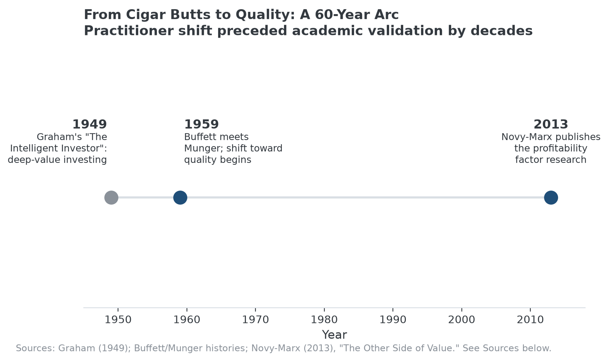
The practitioner shift toward quality preceded formal academic validation by more than fifty years.

The Shift: Buffett and Munger
Warren Buffett met Charlie Munger in 1959, and Munger's influence gradually pushed Buffett away from Graham's deep-value approach toward buying durable, well-run businesses even at less statistically extreme prices. Buffett later credited Munger directly with the shift, summarizing the resulting philosophy as preferring "a wonderful business at a fair price" over "a fair business at a wonderful price." That reframing, emphasizing the business's durability over the statistical cheapness of the stock, is the practical origin of what's now called quality investing.

The Academic Validation: Decades Later
It took until 2013 for the approach to receive rigorous academic validation. Robert Novy-Marx's research on the profitability factor showed that gross profitability, a measurable proxy for business quality, predicted stock returns with roughly the same power as the traditional value factor, and that highly profitable companies significantly outperformed unprofitable ones even after accounting for valuation. The academic finding arrived more than fifty years after Buffett and Munger's practitioner shift, a reminder that investing approaches can work in practice well before there's formal research explaining why.

What Quality Investing Looks For Today
In practice, quality investing screens for strong and stable profitability, high returns on invested capital, manageable debt, and often a durable competitive advantage that explains why those characteristics are likely to persist rather than mean-revert. It doesn't ignore price entirely, buying an excellent business at an absurd valuation is still a poor decision, but it treats business durability as the primary filter, with valuation as a secondary discipline layered on top.

Where MPLY Fits Within This Tradition
The Strategy Shares Monopoly ETF's (MPLY) stated approach sits within this same quality tradition, screening for durable competitive characteristics, brand dominance, barriers to entry, network effects, and the rest, rather than simply for statistical cheapness. Its focus on monopolistic and oligopolistic economic rents is a more specific version of the durable-profitability thesis both Munger's practitioner intuition and Novy-Marx's later research pointed toward.
The fund's current holdings and investment approach are on its official page.

Sources
- Acquirer's Multiple, "Value Investing Reimagined: How Buffett Moved Beyond Cigar Butt Stocks" (Munger's influence, 1959 meeting)
- Top1000Funds, "Quality factor explained by profitability: Robert Novy-Marx"
- Strategy Shares Monopoly ETF official fund page (screening criteria)
#QualityInvesting #WarrenBuffett #ValueInvesting #EconomicMoat #MPLY #Investing

