Free Cash Flow vs Net Income
Net income and free cash flow can tell noticeably different stories about the same company in the same period, and the gap between them is usually where the more useful information lives. Both are legitimate measures; they're just answering different questions.

What Net Income Measures
Net income follows accrual accounting: revenue is recognized when it's earned, not necessarily when cash is received, and expenses are matched to the period they relate to, not necessarily when cash is paid out. It includes non-cash charges like depreciation and amortization, and it can be shaped by accounting estimates and choices that are legitimate but don't always track cash movements directly.

What Free Cash Flow Measures
Free cash flow starts from actual cash generated by operations and subtracts the capital expenditures needed to sustain the business, arriving at a cash-based figure less exposed to accounting judgment. It answers a narrower, more concrete question: how much cash did this business actually generate and have available, after the reinvestment required just to keep running?
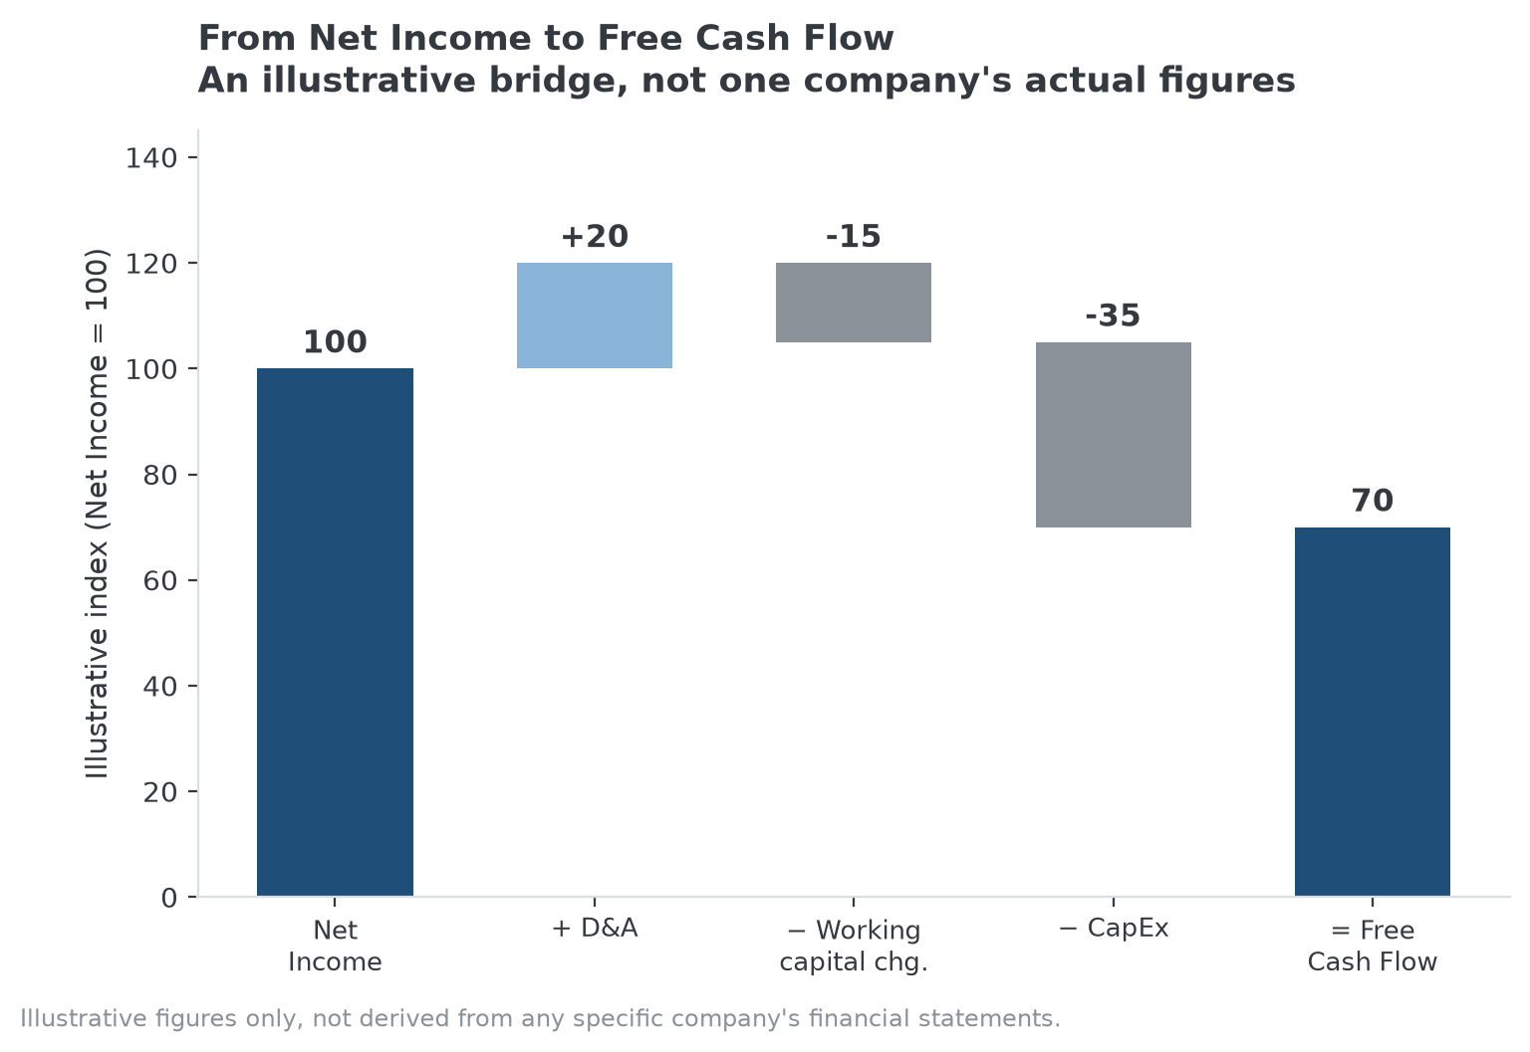
The bridge from net income to free cash flow, adding back non-cash charges and subtracting the capital actually reinvested.

Where the Two Diverge, and What It Signals
When free cash flow runs persistently below net income, it's often because capital expenditures or working capital needs are consuming more cash than the non-cash addbacks like depreciation provide, worth investigating rather than assuming it's simply a growth phase. When free cash flow runs persistently above net income, it often reflects a business with low capital intensity relative to its earnings, generating more actual cash than its accounting profit alone would suggest, generally viewed as a favorable characteristic.

Why Neither Number Alone Is Sufficient
Net income smooths out lumpy cash events through accrual accounting, which is useful for comparing profitability across periods, but it can mask real cash problems, or overstate them, in ways free cash flow reveals. Free cash flow is more resistant to accounting manipulation but can be genuinely volatile due to timing of capital projects or working capital swings that don't reflect the underlying business changing at all. Looking at both together, and understanding why they diverge in a specific period, gives a more complete picture than either number in isolation.

A Brief Note on Where This Connects to MPLY
This distinction is primarily an accounting and analysis question rather than a competitive-advantage one, and the Strategy Shares Monopoly ETF's stated screening criteria don't address it directly. To the extent it matters at all here, understanding the net income-to-cash-flow bridge is a useful general research skill for evaluating any company, including ones being assessed against MPLY's criteria, but it isn't itself one of the fund's named characteristics.

Sources
- Strategy Shares Monopoly ETF official fund page
#FreeCashFlow #NetIncome #Accounting #QualityInvesting #Investing

