Oracle On-Prem → Amazon RDS Oracle Migration Runbook (Detailed)

Purpose
Detailed procedure to migrate Oracle schemas and data from on‑premises Oracle to Amazon RDS for Oracle using Data Pump and S3 Integration.

Architecture Flow
On‑Prem Oracle → expdp → S3 → download_from_s3 → RDS DATA_PUMP_DIR → impdp → RDS

Prerequisites
• RDS Oracle with S3_INTEGRATION
• IAM role with S3 permissions
• Bastion host access
• Adequate RDS storage (≥ 1.5× dump size)

Step 1 — Export from On‑Prem
expdp system/password@ONPREM \
schemas=APP \
directory=DATA_PUMP_DIR \
dumpfile=app_%U.dmp \
logfile=app_export.log \
parallel=8 \
compression=all \
exclude=statistics

Step 2 — Upload to S3
aws s3 sync /dpump/ s3://<bucket>/oracle/prod-cutover/

Step 3 — Download into RDS
Run from SQL*Plus connected to RDS master user.
DECLARE
l_task_id VARCHAR2(100);
BEGIN
l_task_id := rdsadmin.rdsadmin_s3_tasks.download_from_s3(
p_bucket_name => '<bucket>',
p_s3_prefix => 'oracle/prod-cutover/',
p_directory_name => 'DATA_PUMP_DIR'
);
DBMS_OUTPUT.put_line('TASK_ID=' || l_task_id);
END;
/

Monitor Download Task
SELECT text
FROM TABLE(
rdsadmin.rds_file_util.read_text_file(
'BDUMP',
'dbtask-<TASK_ID>.log'
)
);

Verify Files
SELECT *
FROM TABLE(rdsadmin.rds_file_util.listdir('DATA_PUMP_DIR'));

Step 4 — Import into RDS
impdp master_user/password@//rds-endpoint:1521/ORCL \
directory=DATA_PUMP_DIR \
dumpfile=app_%U.dmp \
logfile=app_import.log \
parallel=8 \
schemas=APP \
transform=segment_attributes:n \
exclude=statistics

Validation — Invalid Objects
SELECT owner, object_type, COUNT(*)
FROM dba_objects
WHERE status='INVALID'
GROUP BY owner, object_type;

Recompile Objects
EXEC UTL_RECOMP.RECOMP_PARALLEL(4);

Gather Statistics
EXEC DBMS_STATS.GATHER_SCHEMA_STATS('APP');

Cutover Checklist
• Freeze writes
• Final export if needed
• Import delta
• Update connection strings
• Run smoke tests
• Monitor system

Security Best Practices
• Use Secrets Manager or CI variables for credentials
• Rotate master password after migration
• Restrict S3 bucket access
• Enable RDS audit logs

Outcome
Repeatable, auditable migration process with minimal operational risk.

Oracle On-Prem → Amazon RDS Oracle Migration
Detailed architecture diagram showing bastion host execution and GitLab CI/CD flow.

Architecture Diagram
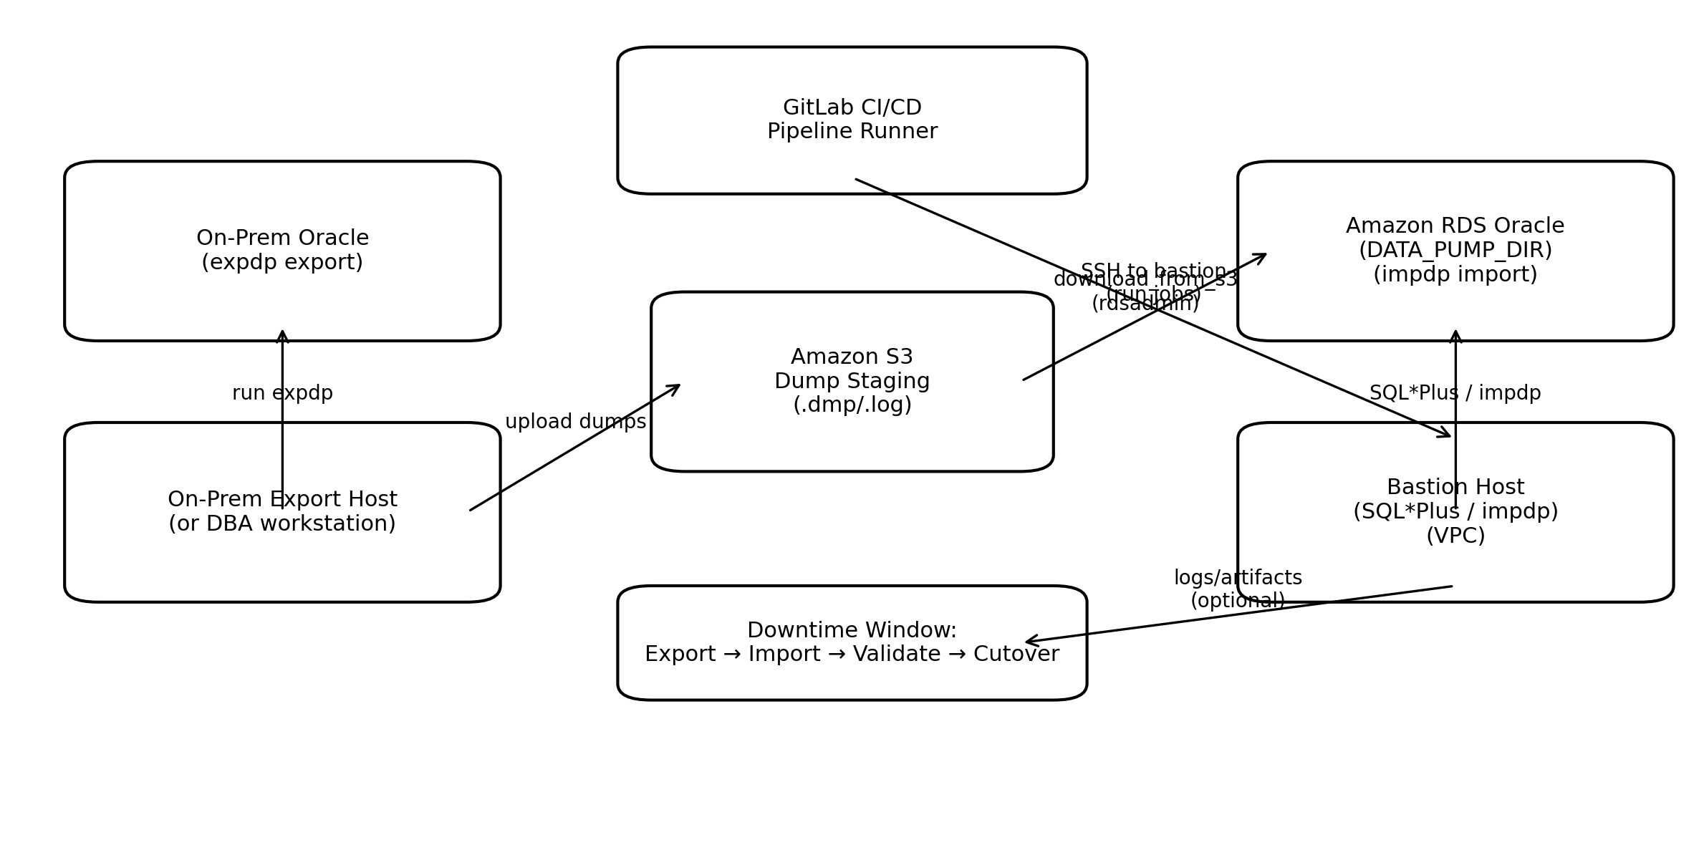

Legend
• expdp export is executed on-prem during downtime.
• Dump files are uploaded to Amazon S3 staging prefix.
• GitLab CI/CD connects to bastion host (SSH) to run SQL*Plus and impdp steps.
• RDS downloads dump files from S3 into DATA_PUMP_DIR using rdsadmin procedure.
• Bastion runs impdp to import dumps from DATA_PUMP_DIR into RDS.

