**Trainer Reference Manual:** Guide to Simplilearn Pedagogy, LMS Structure, and Training Delivery

Plan for Machine Learning

**Table of Contents**

1. **Objective**
2. **Description of the document**
3. **LMS components**
4. **Learning materials and hands-on activities**
5. **Guidelines for providing outcome-centric, high-engagement learning**
6. **Simplilearn’s pedagogy**
7. **Training delivery plan: Machine Learning Course**
8. **Curriculum**
9. **FAQs**

**Objective**

The trainer reference guide is a ready reckoner on Simplilearn standards and methods of course delivery, LMS structure, terminologies, and detailed information on course materials. The document provides the trainer with an overview of the learning path and curriculum of the machine learning course.

**Description**

This document provides a walkthrough of the LMS and highlights its components with a detailed description of the learning materials, including hands-on practices, projects, and assessments, and guidelines for ensuring engaging, outcome-centric learning.

At Simplilearn, we focus on high-engagement, outcome-centric learning. Our learning pedagogy aims to provide the most effective learning experience for the learners to enable course completion. The trainer plays a crucial role in achieving this goal. A set of guidelines are provided to the trainers to help them enable the learners to maximize their learning outcomes through the various resources provided by Simplilearn.

The trainer is provided with a detailed plan to deliver the content per the defined learning path and a comprehensive view of the curriculum to depict the skills and knowledge covered in each phase.

**LMS Components**

This section provides a walkthrough of the LMS structure, its components, and the terminology.

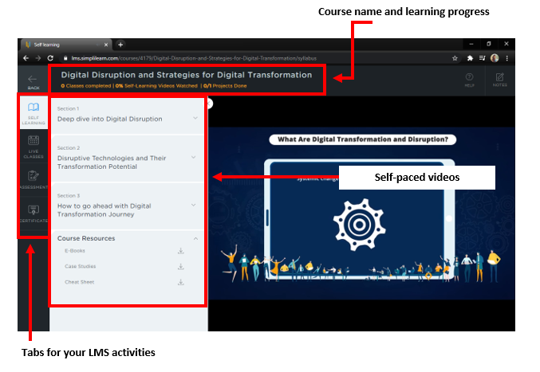

**Image 1**

1. The taskbar shows the name of the course and the learning progress.
2. The tabs provide information on:

* Table of Contents of the Online Self-learning (OSL) videos and Live Virtual Class (LVC)
* Schedule and details of the LVC
* Course completion criteria
* Course resources

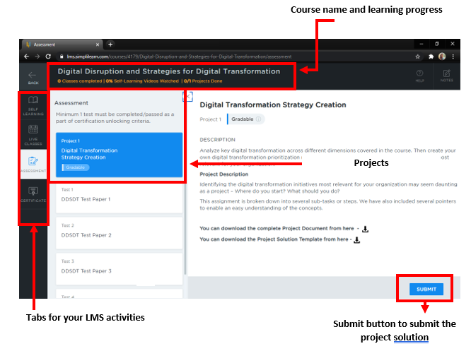

**Image 2**

1. Name of the course and learning progress
2. Project in the Assessment tab
3. Submit button for project solution

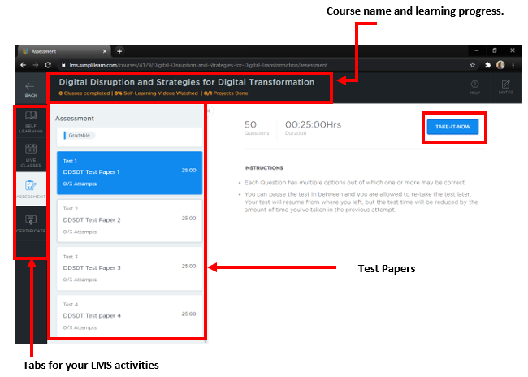

**Image 3**

1. Name of the course and learning progress
2. Test in the Assessment tab
3. Take-It-Now button for starting the Test

**Learning Materials and Hands-on Activities**

| Presentation or PPT or IPYNB | The course content is provided in PowerPoint presentations that are accessible only to the trainers. Every PPT slide includes **trainer notes** that provide cues on what needs to be covered in that slide. The presentation includes learning objectives for the course and each lesson, slides covering various topics, case studies, problem statements and guidelines on solving them, key takeaways from the lessons, MCQ-based knowledge checks, and lesson-end discussions. |
| --- | --- |
| Problem Scenarios | These are dedicated slides for the problem scenario presentation. These scenarios bring out the concepts covered so far by the trainer. |
| Lesson-End Project | This is a scenario-based project that the learners must complete under the trainers’ guidance. The difficulty level of these projects is higher than that of assisted or unassisted practices. Lesson-end projects are **NOT** gradable but must be submitted for evaluation and feedback from our **in-house experts or teaching assistants**.  **Note:  Lesson-End Projects are present at the end of the lessons. Lesson-End Projects are not considered for the** **Course Completion Criteria.** |
| Knowledge Checks | These are the multiple-choice questions (MCQs) available in the presentation to check the learners’ knowledge based on the concepts taught in that class. Knowledge checks are available in the **Table of Contents** as shown in **point 3.** |
| Course-end Project | This is a scenario-based project that the learners must complete under the trainers’ guidance. The difficulty level of this component is higher than the lesson-end projects. Course-end projects are gradable, and the completion of these projects is mandatory to proceed with the program. The details of course-end projects are available in the TOC. This component is available in the **Assessment Tab** as shown in **image 2**. |

**Guidelines for Providing Outcome-centric, High-Engagement Learning**

* While explaining a concept, the trainer is recommended to use slides to enhance the learning experience.
* Every slide in the presentation should be treated with importance and shouldn’t be skipped or overlooked.
* The flow of learning is designed after thorough research and must be strictly followed. Any feedback on the content or the flow of the lesson can be shared privately with the course’s learner success managers.
* Every class should begin with a recap of the concepts covered in the previous class(es), followed by the concepts that will be covered on that day, and then a Q&A at the end of the class. The trainer is encouraged to add value to a concept based on their experience and/or knowledge.
* There is also a HBR case study (problem statement) shared with learners as a prereader. The trainer must go through the problem statement and solution before conducting the case study session to have a complete understanding.
* The most suitable solution to the scenario described in the case is then discussed in the class. While explaining a concept, it is recommended that the trainer use slides to enhance the learning experience by discussing the possible solution to the problem statement and then discussing the approach taken by the organization.
* Promoting surveys during the session is as important as promoting them at the end of the lesson. Surveys help in analyzing the learners’ understanding, the trainer’s engagement with the learners, the delivery of content, and the assistance provided by the learner success managers during online and offline classes.
* Any escalation or learner misbehavior should be reported immediately to the learner success managers available.
* Simplilearn believes faculty are one of the most important pillars in course delivery. All the information needed to deliver the course is provided to the trainers. For any further details or assistance, contact the learner success managers for the course.
* The provided resources—mobile app, course components, community forum, and LMS access—enable hassle-free learning. Trainers should guide and encourage the learners to effectively use these resources to complete the course.
* The community forum on the LMS helps learners interact with one another and with trainers and learner success managers. At the end of every class, trainers can encourage learners to use our community forums.

**Simplilearn’s Pedagogy**

We have defined a pedagogy to deliver the best learning experience to our learners. The teaching methodology is tailored as per the requirements of the course. It is important that trainers familiarize themselves with this model to guide learners effectively.

**Training Delivery Plan for Machine Learning Course**

In this course, we teach how machine learning is applied in the real world using various case studies and the IPYNB notebook base approach.

The sequential flow and other information about the course are provided below:

* **Day-wise Agenda:** The day-wise agenda helps trainers and the learners know which topics or lessons will be conducted each day.
* **Course Materials:** The course materials are shared with the trainer and include:
  + Presentations or PPT module wise
  + Case Studies or Caselets
  + Projects

After detailing the course components and standards, let’s understand the flow of the program:

* The learning design of the day helps in understanding and planning the delivery of slides, practices, and Q&A. It also helps the trainer manage time for delivery.
* As soon as the session begins, the trainer must recap all the important concepts from the previous session before starting the presentation. If it is the beginning of the lesson, follow the sequence mentioned below:
  + **Learning Objectives:** This slide gives a gist of the concepts that will be covered in the day’s training.
  + The subsequent slides will have the trainer's notes to help the trainer explain the slide as instructed. As trainers prepare for class(es) in advance, these instructions are just an aid and need not be read out.
  + Towards the end of the presentation or lesson, after the remaining concepts are covered, trainers must ensure that **key takeaways** are met as expected, followed by **discussion.**
  + **Lesson-end project:** Since the learners are promised project-driven learning, the trainers are required to explain the **lesson-end project** slide in class.
  + Trainers must notify the learners that they will be assisted wherever required within the stipulated time. Link the problem statement with the project scenario.
* **Q&A** - Before concluding the session, conduct a quick **Q&A** to gather learners’ inputs on the trainer’s improvement areas. This will improve the effectiveness of the training. Request the learners to fill out a survey on the following parameters:
  + How the trainer conducted the session and their knowledge level
  + How the platform WebEx helped them during training
  + How the content is built and organized
  + How the presence of learner success managers made a difference
* The trainer will receive feedback and comments within 24 hours of the session.
* The trainer can continue following this approach throughout the training program if their NPS (Net Promoter Score) increases after the session.

**Curriculum**

**This section elucidates the sequential flow of lessons.**

















**Dos and Don’ts:**

* **Dos:**
  + Start every session on time and with a recap.
  + Encourage learners to ask more questions for a better understanding of concepts.
  + Share industry implementations of the concepts taught in every class.
  + Focus more on covering all the concepts and schedule a quick Q&A session at equal intervals.
  + Use the community forum to interact offline with the learners.
  + Encourage the use of Simplilearn’s content, platforms, and mobile applications.
  + Encourage learners to practice assignments and go through the OSL videos before attending the next sessions.
  + Encourage learners to participate in surveys.
  + Any session extension related information should be shared with LSM first before making an announcement in the session. Unless confirmed by Simplilearn, the trainers should not discuss with learners about session extension or cancellation.
  + Use "Epic Pen" for explaining concepts.
  + If any reference material needs to be shared, it must be vetted by the LSMs first and should be shared through a dedicated Simplilearn drive or dedicated community thread for that batch.
  + Encourage the learners to reach out to the Simplilearn support team for any additional support apart from the community threads.
  + The trainer must provide enough time for a dry run-in order to be well prepared to take the live class sessions.
* **Don’ts:**
  + Focusing more on answering the questions than covering the concepts
  + Overlooking slides or skipping hands-on
  + Deviating from the suggested flow and tailoring it to the needs
  + Pushing the concepts to be covered in the next sessions
  + Extending classes for more than 4 and a half hours
  + Promoting third-party vendors or the resources of external bodies
  + Sharing contact details with learners (Email ID or LinkedIn ID or Phone Number)
  + Using external content in Live Class sessions unless pre-approved by Simplilearn

**FAQs:**

**I have queries regarding the content. Whom should I contact?**

You can reach out to your learner success manager to share your feedback and views.

**Who is my learner success manager?**

Learner Success Managers are technical personnel who are the point of contact for all course-related issues and feedback. They actively take part in delivering the best experience to our learners by helping them and the trainers during the live virtual classes.

**How do I contact my learner success manager?**

Your Learner Success Manager (LSM) will contact you as soon as you are onboard. You can request the extensions or phone numbers and the official email address to interact with them.

**Will LSMs help me in the session?**

Yes, LSMs will help you with any customers, labs, and content-related issues. LSMs will be there to assist you online and offline as well.

**What is NPS? How does it affect me?**

NPS is a Net Promoter Score that is measured with a rating system.

NPS = (Promoters-Detractors)/Total Surveys * 100.

It affects you directly if fewer surveys are received or if the participants rate the session as passive or detractors.

**What do promoters, passives, and detractors refer to?**

Promoters are learners who rate the session a 9 or 10. This indicates that they are happy with the session conducted for the day.

Passives are learners who rate the session at 7 or 8. This indicates that they are unhappy with the session conducted today, but they could partially follow you.

Detractors are learners who rate from 0 to 6. This indicates that the session was not up to the mark and needs a lot of improvement.

**Should I follow the instructions?**

Yes, these recommendations have been tried and tested. It helped other trainers improve their NPS and we are sure that it will help you as well.

**Can I be creative?**

Yes, provided you are trying to explain the concepts with visual aids such as Epic pen, and UML diagrams.

**I would like to share some files with the learners. How do I do it?**

You can use our community forum for communicating and sharing study materials. Upload the files and then share the forum link in your classes.

**Can I share my contact details with the learners?**

No. We strictly avoid sharing trainer details with learners. Our community forum is recommended for communicating, where learners can message you and discuss offline.

**I need more resources. Whom should I contact?**

Please feel free to contact the Learner Success Managers (LSMs) for the course.

We wish you all the best for your upcoming training with us.

Please contact your learner success managers for further assistance and information.