PAY PORTAL

* **BASIC USE :-**

It is an application that can pay money from one user to another.

* **HOW IT WORK’S FOR THE USER :-**

At, the very initial stage it ask the user to choose between three interfaces which are PAYTM, BHIM, PHONEPE. Then it asks to make choice between two buttons which are Pay Now and Add Money. On making the choice it asks us to register by just giving few details such as Mobile Number, Card Number, Card Holder’s Name and the Card CVV. And as we click the ‘Save Card for Future Use’ button we are registered. We can also get registered at the time of adding money by just giving an extra detail that is amount to add along with all four details above.

As we are registered we can make as much transactions as we want at a time.

(Note : For sending money to other’s mobile number it is necessary that both the numbers should be Registered.)

It also has a Passbook Where we can check the Total Amount by giving our Mobile Number.

So we can make transactions with all the 3 Platforms by just Registering for one.

* **HOW IT WORK’S INTERNALLY** **:-**

The moment we are Registered it creates a Database Named ‘ MyDB ’. In this Database It creates a table named ‘paytm’ of 5 columns which are Mobile Number, Card Number, Card Holder’s Name and the Card CVV and Amount. It has Different buttons for Different Operations like the most important button is the ‘Save For Future Use ‘ as it the button which inserts the values in the tables. Then it has button for every other operation possible. Each Entry has its own Button. With the help of all these buttons and Operations it functions properly.

Pay Button – When we want to transfer or send money from one Mobile Number to another then we use this button. It adds the amount column of the Reciever’s Phone Number with the amount entered in the Entry of amount to be paid and subtracts the same amount from the sender’s Mobile Number.

Add Money Button – When we want to add money on a Mobile Number then we use this button. It adds the amount column of the User’s Phone Number with the amount entered in the Entry of amount to be added.

And Same is the Functioning in all the 3 platforms.

SPLASH SCREEN

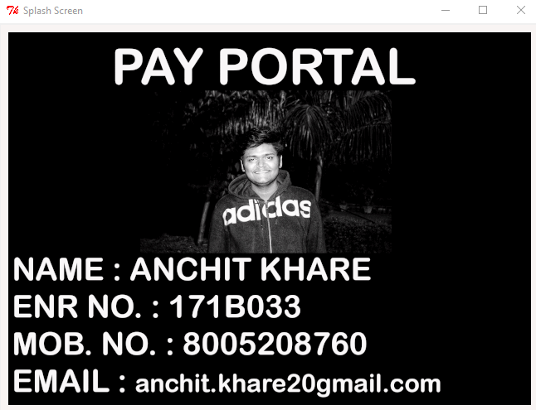

THIS THE SPLASH SCREEN OF THE PROJECT

FIRST SCREEN

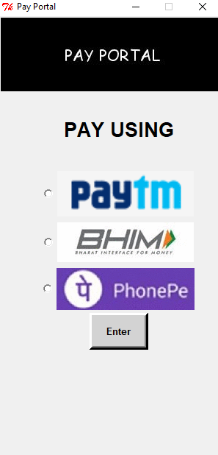

THIS IS THE FIRST SCREEN OF THE PROECT. YOU CAN SELECT THE PLATFORM FOR MAKING THE TRANSACTION.

SECOND SCREEN

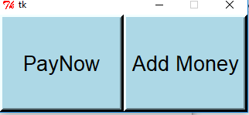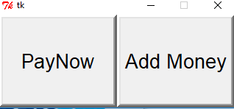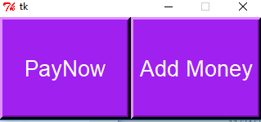

These are the Three different Screens for Three different platforms.

THIRD SCREEN

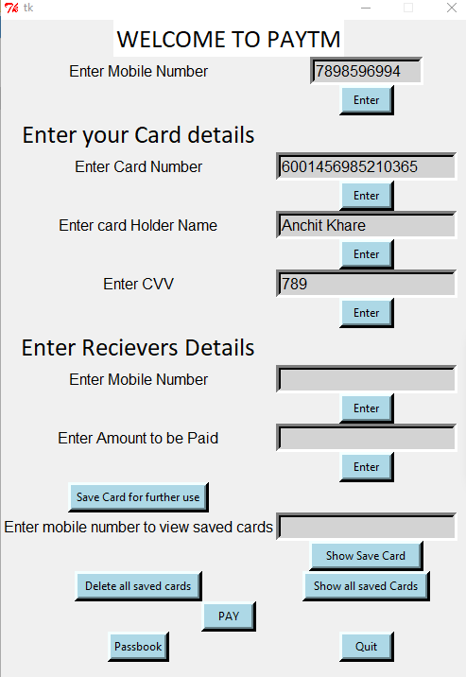

THIS SCREEN IS DISPLAYED ON PRESSING THE PAY NOW BUTTON.

FOURTH SCREEN

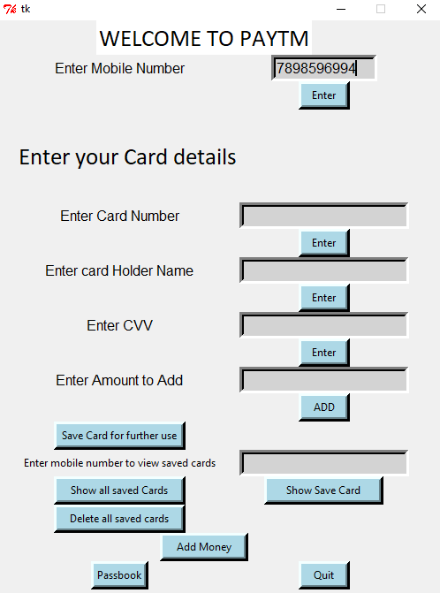

THIS SCREEN IS DISPLAYED ON PRESSING THE ADD MONEY BUTTON

FIFTH SCREEN

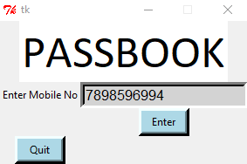

THIS SCREEN IS DISPLAYED ON PRESSING THE PASSBOOK BUTTON.

EACH OF THE PLATFORM HAS A DIFFERENT ROOT WINDOW.

ALL THE OTHER IMAGES ARE PRESENT IN THE FOLDER NAMED ‘PYTHON PROJECT’.