Learning-based sensor interpolation via kernel ridge regression

Bo-Ru Lai, You-Siang Chen, and Mingsian R. Bai

Department of Power Mechanical Engineering, National Tsing Hua University, No. 101, Section 2, Kuang-Fu Road, Hsinchu, Taiwan 30013.
Corresponding author: Mingsian R. Bai, Email: msbai@pme.nthu.edu.tw

Abstract

In this contribution, a deep neural network (DNN)-based sensor interpolation (SI) approach is formulated via kernel ridge regression. Previous research has shown that sound field can be interpolated by using kernel ridge regression, where the solution of the Helmholtz equation is employed as a reproducing kernel for field representation. Inspired by the kernel method, a network is implemented to learn the basis functions with reference to sensor locations and inverse kernel matrices. It follows that the latent variables of the lower-dimensional manifold of acoustic transfer functions (ATFs) can be obtained, based on sparse measurements. Simulations in a reverberant room are conducted to compare the proposed approach with two baseline interpolation methods. The results have demonstrated that the ATFs interpolated via the proposed network are in close agreement with the ground truth as well as the baselines.
Index Terms— DNN-based sensor interpolation, kernel ridge regression, plane-wave decomposition

- Introduction

In global sound field control and synthesis, a large amount of room impulse responses (RIRs) between the loudspeakers and the control points are required [1] [2] . In practice, however, it is too time-consuming to measure all RIRs and only a limited number of measurements are possible. Thus, sensor interpolation techniques have become highly desirable to be able to “interpolate” the RIRs based on the sparse Acoustic Transfer Function (ATF) measurements [3] [4] .
The sensor interpolation problem can be regarded as a manifold learning problem [6] [7] . Traditionally, basis function approaches were employed to learn the lower-dimensional manifold of ATF by representing the sound field as a series expansion of plane-wave components [8] [9] [10] [11] or equivalent simple sources [12] [13] [14] . A sparse representation adopted in Plane Wave Decomposition (PWD) is usually possible by using compressed sensing techniques [15] [16] . In addition, a sensor interpolation approach that captures the low-frequency dynamics of a room was suggested from the perspective of state-space acoustic modal analysis [17] .
Recently, a promising approach based on kernel ridge regression in machine learning was suggested for sound field interpolation [18] [19] . In light of the representer theorem [20] , the lower-dimensional manifold can be represented by finite terms of “reproducing kernels” in the Hilbert space. The manifold learning problem can thus be reformulated into a system of linear equations. Unlike the aforementioned basis function approach, the kernel approach is exact and without truncation. Another advantage of the kernel approach lies in its simplicity because the determination of the basis number is unnecessary. e.g., complicated two-staged procedure for trimming components and solving amplitudes in PWD.
The field interpolation problem can also be tackled by using Deep Neural Network (DNN) approaches. Ito et. al [21] suggested an encoder-decoder network for Head-Related-Transfer-Function (HRTF) interpolation. Inspired by kernel ridge regression, we propose in this paper a DNN for ATF interpolation based on sparse sensor measurements. The network aims to learn the basis functions from a limited number of measured ATFs. With the data-driven interpolation approach, tedious measurement process to acquire massive data with robots [22] is no longer necessary.
To demonstrate the efficacy of the proposed method, simulations were conducted for a uniform rectangular microphone array. Interpolation approaches using PWD [15] and kernel regression method [19] are adopted as the baselines.

- THE Sensor interpolatin problem

Figure 1 depicts the sensor interpolation problem, where one source and M microphones are considered. Let s(f) be the source signal at the frequency f. The sound pressure captured at the m^{th} microphone can be written as
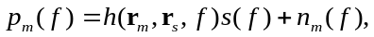 | (1)
where h(r_{m}, f) is the ATF between the source at r_{s} and the m^{th} microphone at location r_{m}, and n_{m}(f) denotes the associated sensor noise. The frequency variable f and source location r_{s} are omitted hereafter for brevity. The goal of sensor interpolation is to find a lower-dimensional manifold to represent the ATF, h(r), at an arbitrary microphone position r on the basis of the finite number of ATF measurements, h(r_{m}), m = 1, 2, …, M.
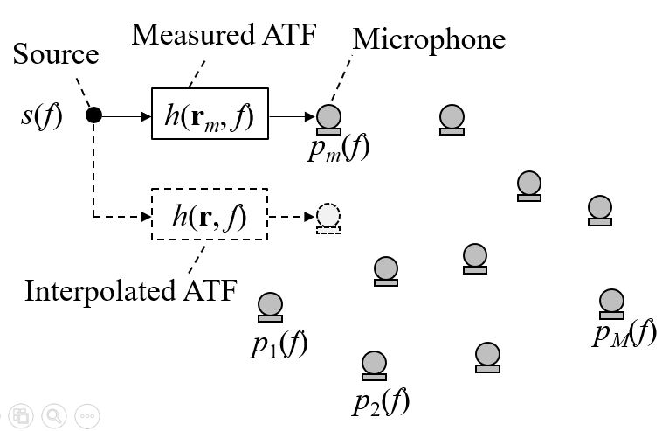
Fig. 1. Schematic diagram for defining the sensor interpolation problem.

- Related work

In this section, the sensor interpolation techniques based on PWD and kernel ridge regression are reviewed. These two approaches also serve as the baselines in the simulations.

  - Plane-wave decomposition

In PWD, the ATFs are represented in terms of plane-wave components with preselected wave number vectors, k_{n}, n = 1,2,…,N. Sampling the pressure field at M microphone positions leads to the following system of linear equations:
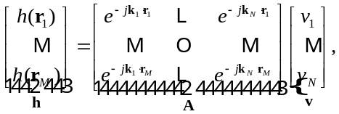 | (2)
where v_{n} for n = 1,2,…,N are the complex coefficients of the plane waves, r_{m}, m = 1, 2, …, M, denotes the position vector of the m^{th} microphone, and “·” denotes the inner product. Using the fact that M ≪ N in general, we apply the compressive sensing (CS) technique [23] to solve the least absolute shrinkage and selection operator (LASSO) [24] problem for the significant plane-wave components:
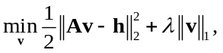 | (3)
where λ is the regularization parameter to promote the sparsity of v, and ||||₁ and ||||₂ denote the vector one-norm and two-norm, respectively. However, the CS procedure only helps trim down the plane-wave components to a tractable number N ’≪ N, but the coefficients obtained are often not sufficiently accurate. To remedy the problem, we apply Tikhonov regularization [25] to solve the linear system of the remaining plane-wave components for a more reliable coefficient vector, 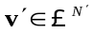
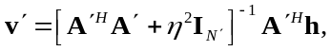 | (4)
where η is the regularization parameter, I_{N’} is the N’×N’ identity matrix, and A’ denotes the truncated propagation matrix with major plane-wave components retained. Therefore, the interpolated ATF can be easily reconstructed by replacing the location r with the interpolated point r’, as given by
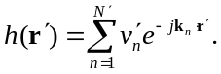 | (5)

3.2. Kernel ridge regression

Consider an ATF manifold h(r) as a function of position vector r in the Hilbert space The regression problem can be formulated as follows:
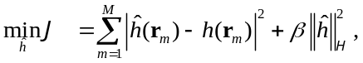 | (6)
where 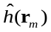 is the predicted ATF manifold at r_{m}, and 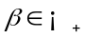 is the regularization parameter. Let κ be the reproducing kernel for the ATF manifold in the Hilbert space :
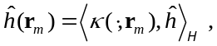 | (7)
where <, > denotes the inner product in the Hilbert space , the solution of the regression problem in (6) admits a representation of the form [20] :
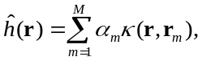 | (8)
where coefficients 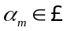 for m = 1, …, M. By substituting (7) and (8) into (6), a closed-form solution of the ATF manifold [26] can be derived [19] :
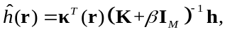 | (9)
where I_{M} denotes the M×M identity matrix, and
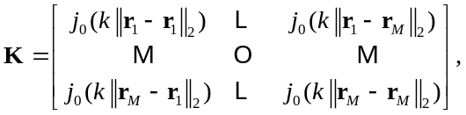 | (10)
 | (11)
in which k is the wave number, and j₀() = sin()/() denotes the zeroth-order spherical Bessel function that is also a solution of Helmholtz equation in spherical coordinates.

- proposed method

In this section, we present a deep sensor interpolation network as motivated by kernel ridge regression. As a data-driven approach, the network is intended to learn the kernel functions from sparse measured ATF data. These learnable kernel functions for all frequencies are trained in parallel, which allows the network to interpolate the ATF at one shot.

  - Kernel ridge regression-motivated DNN

The performance of the kernel method depends on the selection of the basis functions such as the radial basis function (RBF), plane-wave kernel, and reverberant field kernel [27] . In this study, we describe a DNN-based framework analogous to kernel ridge regression. Inspired by (9), the network seeks to learn the kernel function vector (KFV), κ, and the inverse kernel matrix (IKM), (K+βI_{M})⁻¹, from the measured ATF data. The overall system framework illustrated in Fig. 2(a) consists of two DNNs termed the KFV generator and the IKM generator. The input to the KFV generator is the Euclidean distance vector of the interpolated point and the microphone positions:
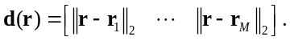 | (12)
The output of the KFV generator is the estimate of M-dimensional KFVs, 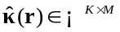, for K frequencies.
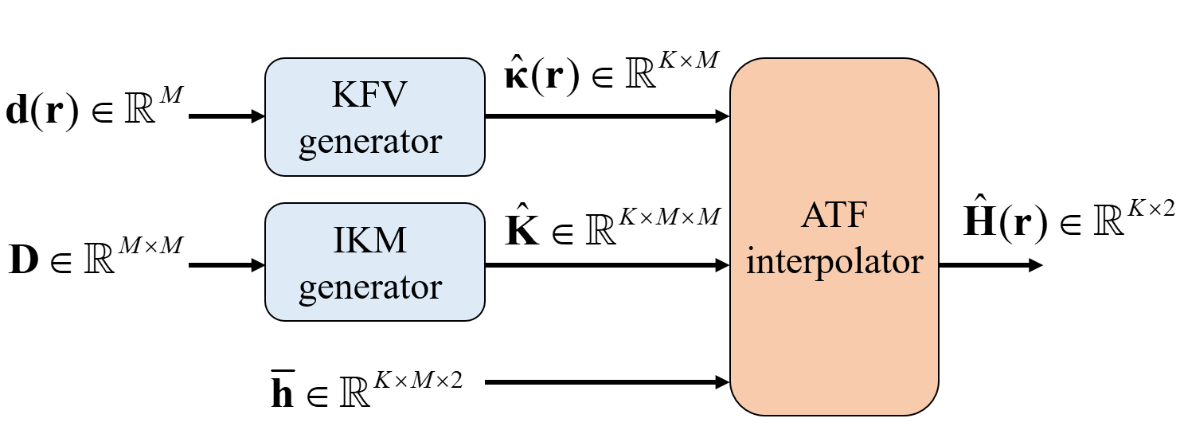
(a)
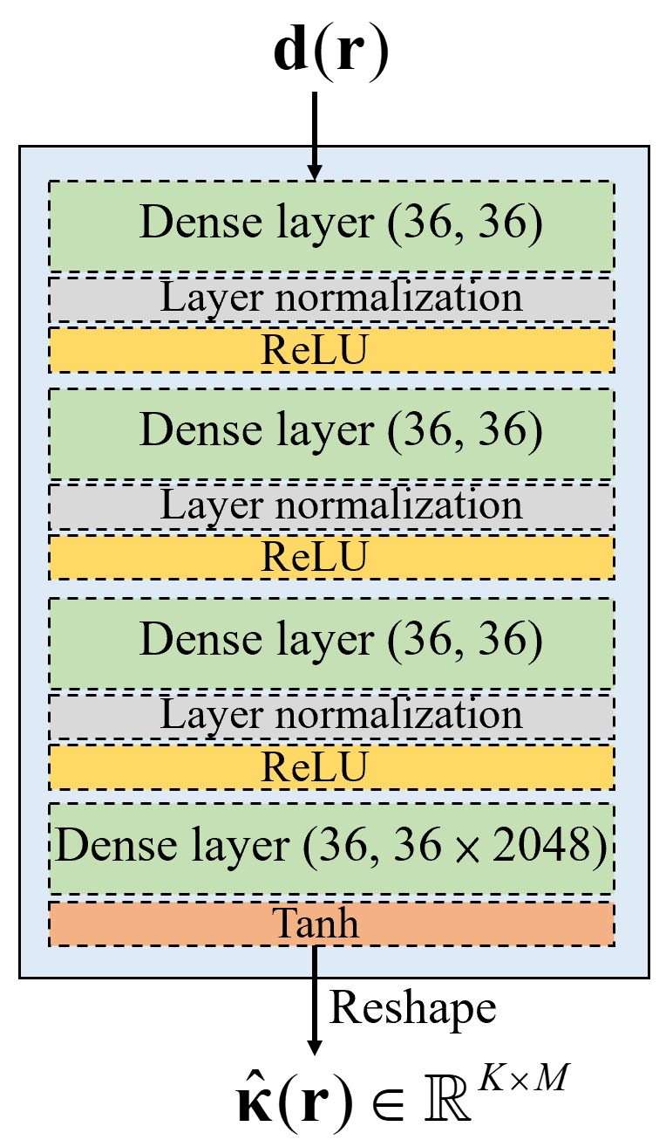 | 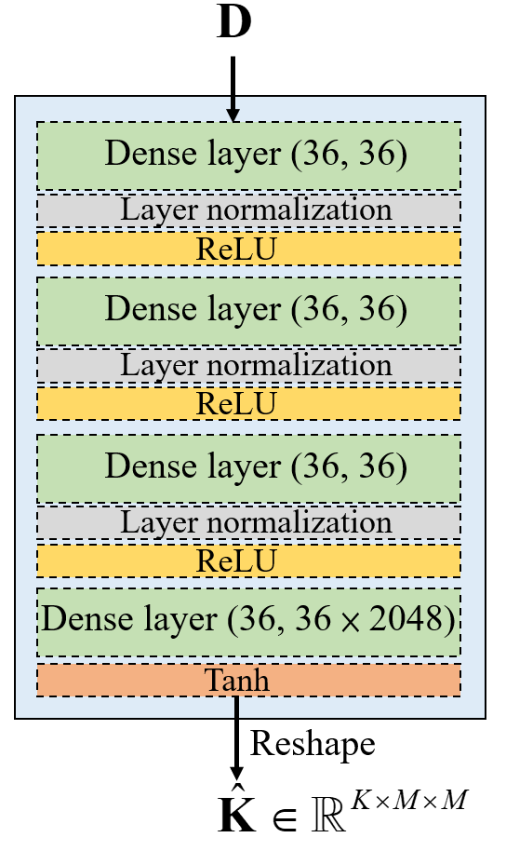
(b) | (c)
Fig. 2. Network structure of the proposed method, including (a) the overall framework, (b) the KFV generator, and (c) the IKM generator.

On the other hand, the input to the IKM generator consists of distances between microphones:
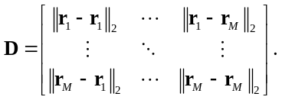 | (13)
The output of the IKM generator, 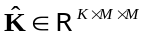, is the estimate of M ×M inverse matrices for K frequencies. Here, 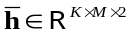 is constructed by stacking K real and imaginary parts of the measured ATFs. The matrix h̅_{k} is defined as
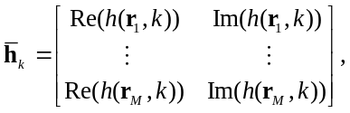 | (14)
where the subscripts k = 1, 2, …K denotes the k^{th} frequency index, while Re() and Im() denote the real and imaginary operator. Next, the k^{th} output estimates of the KFV,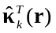, and IKM generators, K̂_{k}, and the measured ATFs h̅_{k} serve as the input to the “ATF interpolator.”
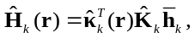 | (15)
where Ĥ_{k}(r) = [Re(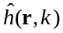) Im()] contains the real and imaginary parts of the k^{th} ATF estimate at the desired position r. The output at the right end of the ATF interpolator is the ATF Ĥ(r)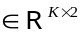 interpolated for all K frequencies.
Figures 2(b) and (c) detail the network of the KFV and IKM generators, respectively. The KFV generator is comprised of four dense layers. Layer normalization and Rectified Linear Unit (ReLU) activation are adopted for the layers. Hyperbolic tangent (Tanh) is used for the output activation. The output size depends on the number of measurements and the frequency bins, which is 36 and 2048 in our case. The IKM generator is constructed similarly.

  - Loss function

The loss function for the network training is based on the Frobenius distance between the measured and the predicted ATFs, where we rearrange the real and imaginary parts of the ATFs into a real-valued ground-truth ATF matrix H(r) and a real-valued interpolated ATF matrix Ĥ(r). The loss function can be written as
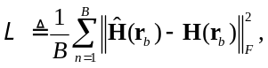 | (16)
where ||||_{F} is the Frobenius norm and B is the batch size for the mini-batch optimization.

- Simulations

  - Dataset generation and parameter settings

Figure 3 shows the simulation setup. All the ground-truth ATFs are generated by the image source method (ISM) [28] . A 4.6 m×5 m ×2.6 m rectangular room is assumed in the simulation.
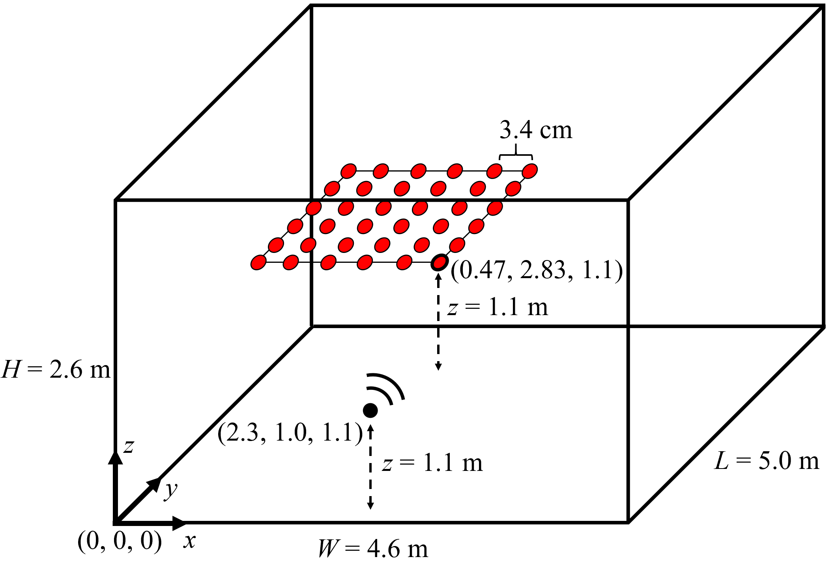
Fig. 3. Simulation setup.

The sound source is placed at (2.3, 1.0, 1.1) m and 36 measurement points with lattice spacing 3.4 cm are located at the corner where a microphone located at (0.47, 2.83, 1.1) m is designated as the origin. During training, only these 36 measurements serve as the training data, while other ATFs within the region of interpolation are treated as the testing data. The reverberation time T60 = 250 ms. The sampling rate is 16 kHz. Adam [29] is used as the optimizer with the learning rate 10⁻⁴.

  - Evaluation measures

To evaluate the interpolation approaches, we define two performance measures to quantify the interpolation errors. The magnitude matching error below is calculated as a function of frequency and location:
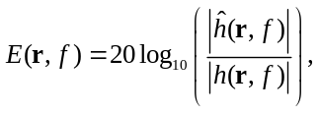 | (17)
where(r, f) and h(r, f) denote the interpolated and ground truth ATF, respectively. In addition, we define an overall performance measure in terms of the spatial root-mean-square (rms) matching error for the entire frequency range.
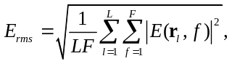 | (18)
where r_{l}, l = 1, 2, …, L, denote the position vectors of the evaluation points.

- Results and discussionS

The matching error at an interpolated point at (0.38, 2.91, 1.1) m is calculated for evaluation. The ATFs of the three approaches are compared in Fig. 4.
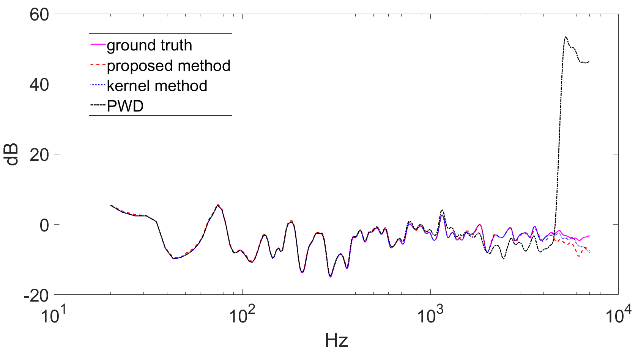
Fig. 4. Interpolated ATF magnitudes at (0.38, 2.91, 1.1)m

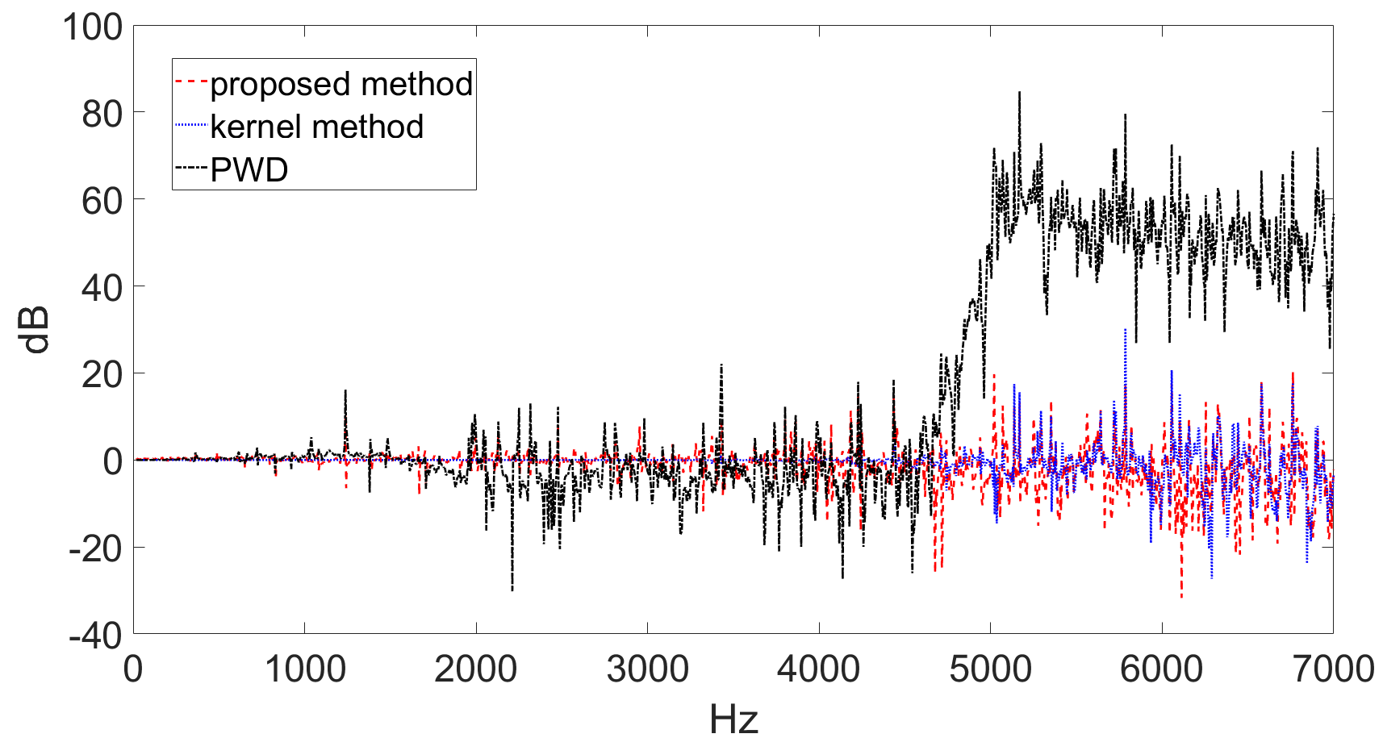
Fig. 5. Magnitude matching error plotted versus frequencies

As can be seen, all methods have comparable magnitude responses below 1 kHz. However, the response of PWD deviates drastically above 5 kHz. Figure 5 shows the matching error plotted versus frequencies. Overall, the matching error of PWD is the largest among all methods, particularly above the spatial aliasing frequency (5 kHz). The proposed method performed comparably with the kernel ridge regression for frequencies even above the spatial aliasing frequency.
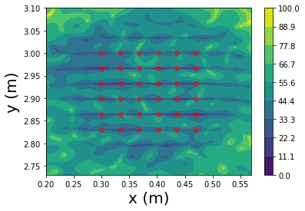
(a)
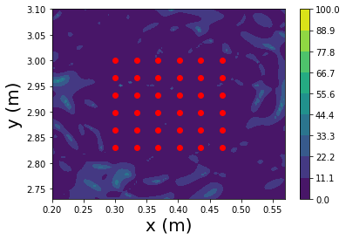 | 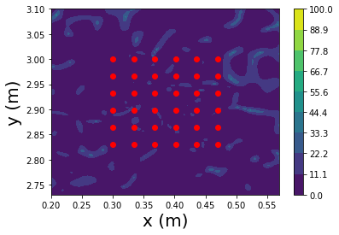
(b) | (c)

Fig. 6. Magnitude matching error at 5 kHz, including (a) PWD, (b) Kernel ridge regression, and (c) The proposed method. The red dots represent the measured points.

The spatial matching error, |E(r, f)| at 5 kHz, is shown in Fig. 6, where a 0.37 m×0.37 m planar region is considered. PWD performs the worst above the spatial aliasing frequency. Lastly, the spatial rms matching errors are summarized in Table I. Although the kernel method yields slightly better fit than the proposed approach inside the measurement region, the proposed approach performs better outside.

Table 1. Spatial rms matching errors inside and outside the measured regions. The best performance is boldfaced.
Method  Error | PWD | Kernel | Proposed
Inside measured region | 29.36 | 4.03 | 4.72
Outside measured region | 40.33 | 8.49 | 6.76

- ConclusionS

We proposed a DNN-based sensor interpolation technique, as inspired by kernel ridge regression. This method contains two sub-networks to learn the pseudo-kernel functions and the inverse kernel matrices. The proposed approach outperforms significantly PWD and performs comparably as kernel ridge regression. A loss function that accounts for the deviation from the Helmholtz equation is on the future research agenda.

8. References

- M. Miyoshi and Y. Kaneda, ‘‘Inverse filtering of room acoustics,’’ IEEE Transactions on acoustics, speech, and signal processing, vol. 36, no.2, pp. 145–152, 1988.
- M. R. Bai, Y. W. Chen, Y. C. Hsu, and T. Y. Wu, “Robust binaural rendering with the time-domain underdetermined multichannel inverse prefilters,” The Journal of the Acoustical Society of America, vol. 146, no. 2, pp. 1302-1313, 2019.
- H. Ito, S. Koyama, N. Ueno, and H. Saruwatari, “Feedforward spatial active noise control based on kernel interpolation of sound field,” in IEEE International Conference on Acoustics, Speech and Signal Processing (ICASSP). IEEE, 2019, pp. 511–515.
- D. Caviedes-Nozal, F. M. Heuchel, J. Brunskog, N. A. Riis, and E. Fernandez-Grande, “A Bayesian spherical harmonics source radiation model for sound field control,” The Journal of the Acoustical Society of America, vol. 146, no. 5, pp. 3425–3435, 2019.
- F. M. Heuchel, D. Caviedes-Nozal, J. Brunskog, F. T. Agerkvist, and E. Fernandez-Grande, “Large-scale outdoor sound field control,” The Journal of the Acoustical Society of America, vol. 148, no. 4, pp. 2392–2402, 2020.
- Laufer-Goldshtein, R. Talmon, and S. Gannot, A study on manifolds of acoustic responses, Springer, Cham, 2015.
- M. Hahamann, S. A. Verburg, and E. Fernandez-Grande, “Analysis of the sound field in a room using dictionary learning,” in International Congress on Acoustics. ICA, 2019, pp. 149-154.
- M. Nolan, M. Berzborn, and E. Fernandez-Grande, “Isotropy in decaying reverberant sound fields,” The Journal of the Acoustical Society of America, vol. 148, no. 2, pp. 1077-1088, 2020.
- M. Nolan, E. Fernandez-Grande, J. Brunskog, and C.-H. Jeong, “A wavenumber approach to quantifying the isotropy of the sound field in reverberant spaces,” The Journal of the Acoustical Society of America, vol. 143, no. 4, pp. 2514–2526, 2018.
- B. Rafaely, “Plane-wave decomposition of the sound field on a sphere by spherical convolution,” The Journal of the Acoustical Society of America, vol. 116, no. 4, pp. 2149-2157, 2004.
- M. Park and B. Rafaely, “Sound-field analysis by plane-wave decomposition using spherical microphone array,” The Journal of the Acoustical Society of America, vol. 118 no. 5, pp. 3094-3103, 2005.
- A. Sarkissian, “Method of superposition applied to patch near-field acoustic holography,” The Journal of the Acoustical Society of America, vol. 118, no. 2, pp. 671–678, 2005.
- T. Betlehem and T. D. Abhayapala, “Theory and design of sound field reproduction in reverberant rooms,” The Journal of the Acoustical Society of America, vol. 117, no. 4, pp. 2100–2111, 2005.
- C.-X. Bi, Y. Liu, L. Xu, and Y.-B. Zhang, “Sound field reconstruction using compressed modal equivalent point source method,” The Journal of the Acoustical Society of America, vol. 141, no. 1, pp. 73–79, 2017.
- S. A. Verburg and E. Fernandez-Grande, “Reconstruction of the sound field in a room using compressive sensing,” The Journal of the Acoustical Society of America, vol. 143, no. 6, pp. 3770–3779, 2018.
- R. Mignot, L. Daudet, and F. Ollivier, “Room reverberation reconstruction: Interpolation of the early part using compressed sensing,” IEEE Transactions on Audio, Speech, and Language Processing, vol. 21, no. 11, pp. 2301–2312, 2013.
- H. M. Jian, Y. S. Chen, and M. R. Bai, “Acoustic modal analysis of room responses from the perspective of state-space balanced realization with application to field interpolation,” The Journal of the Acoustical Society of America, vol. 152, no. 1, pp. 240-250, 2022.
- N. Ueno, S. Koyama, and H. Saruwatari, “Sound field recording using distributed microphones based on harmonic analysis of infinite order,” IEEE Signal Processing Letters, vol. 25, no. 1, pp. 135–139, 2018.
- N. Ueno, S. Koyama, and H. Saruwatari, “Kernel ridge regression with constraint of Helmholtz equation for sound field interpolation,” in International Workshop on Acoustic Signal Enhancement (IWAENC). IEEE, 2018, pp. 1-440.
- B. Schölkopf, R. Herbrich, and A. J. Smola, A generalized representer theorem, Springer, Berlin, 2001.
- Y. Ito, T. Nakamura, S. Koyama and H. Saruwatari, “Head-related transfer function interpolation from spatially sparse measurements using autoencoder with source position conditioning,” arXiv preprint arXiv:2207.10967, 2022.
- J. Le Roux, E. Vincent, J. R. Hershey, and D. P. W. Ellis, “MICbots: collecting large realistic datasets for speech and audio research using mobile robots,” in IEEE International Conference on Acoustics, Speech and Signal Processing (ICASSP). IEEE, 2015, pp. 5635–5639.
- G. F. Edelmann and C. F. Gaumond, “Beamforming using compressive sensing,” The Journal of the Acoustical Society of America, EL232–EL237, 2011.
- M. Elad, Sparse and Redundant Representations: From Theory to Applications in Signal and Image Processing, Springer, New York, 2010.
- M. Bertero, T. A. Poggio, and V. Torre, “Ill-posed problems in early vision,” Proceedings of the IEEE, vol. 76, no. 8, pp. 869-889, 1988.
- K. P. Murphy, Machine Learning: a Probabilistic Perspective, MIT Press, Cambridge, 2012.
- D. Caviedes-Nozal, N. A. Riis, F. M. Heuchel, J. Brunskog, P. Gerstoft, and E. Fernandez-Grande1, “Gaussian processes for sound field reconstruction, “The Journal of the Acoustical Society of America, vol. 149, no. 2, pp. 1107-1119, 2021.
- J. B. Allen and D. A. Berkley, “Image method for efficiently simulating small-room acoustics,” The Journal of the Acoustical Society of America, vol. 65, no. 4, pp. 943–950, 1979.
- D. P. Kingma and J. Ba, Adam, “A method for stochastic optimization,” arXiv preprint arXiv:1412.6980, 2014.

The work was supported by the Ministry of Science and Technology (MOST) in Taiwan, under the project number 110-2221-E-007-027-MY3.

