Report

on

TCS Stocks Market Analysis

**1. Objective:**

To analyse Tata Consultancy Services (TCS) stock data using SQL for data extraction and transformation, Excel for preliminary analysis and calculations, and Power BI for visualization and insights into trends, trading volumes, and price movements.

**2. Analysis Overview:**

**Key Metrics:**

* **Highest Price:** 3.32M
* **Lowest Price:** 3.25M
* **Opening Price:** 3.28M
* **Closing Price:** 3.28M

**Key Analysis Dimensions:**

1. **Yearly Analysis:** Opening, closing, highest, and lowest prices summarized by year.
2. **Quarterly and Monthly Trends:** Stock movements and volumes analysed seasonally.
3. **Day-Wise Insights:** Daily fluctuations and trade volumes examined.

3. **Insights and Findings Using Power BI and Excel**

1. **Yearly Trends:**
   * Yearly data highlights gradual price changes from opening to closing values.
   * Price fluctuations are consistent across years, reflecting market stability.
2. **Volume Analysis:**
   * **Yearly Volume Distribution:**
     + 2020: 26.22% (highest trading activity).
     + 2023: 2.06% (lowest activity).
   * **Quarterly Volumes:**
     + Q1 recorded the highest trading volumes (26.06%).
   * **Monthly Volumes:**
     + March had the highest activity at 11.43%, while September was one of the lowest.
3. **Price Analysis:**
   * The closing prices closely match opening prices across years, indicating minimal price swings over a single day.
   * Highest and lowest prices closely align yearly, reflecting tight price movement.
4. **Day-Wise Trends:**
   * Mondays and Tuesdays observed peak trading volumes.
   * Weekends (Saturday and Sunday) had the lowest trading activities.

The Power BI dashboard provides a detailed Market Analysis of TCS stocks, showcasing metrics like Opening, Closing, Highest, and Lowest prices. It includes Yearly, Monthly, and Day-wise trends through visuals for performance comparison. Dynamic filters enhance time-specific insights.

Power BI Dashboards Representation

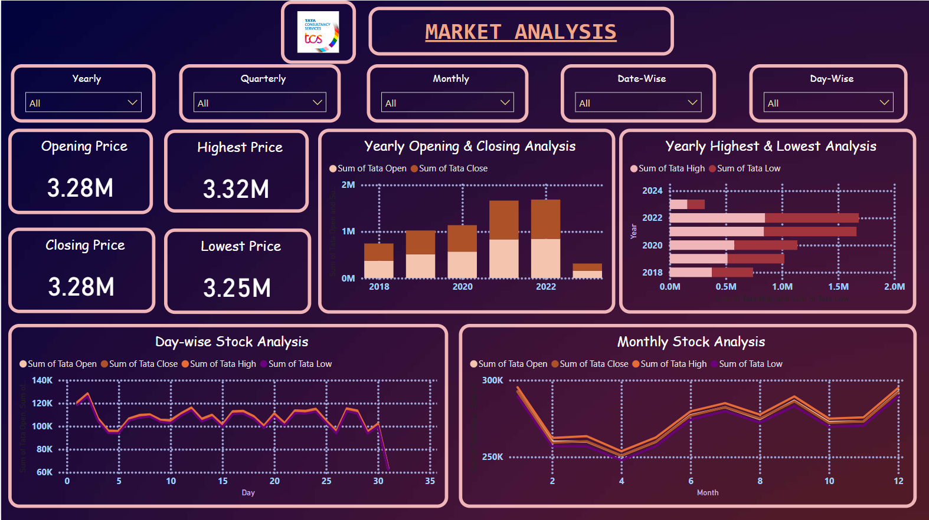

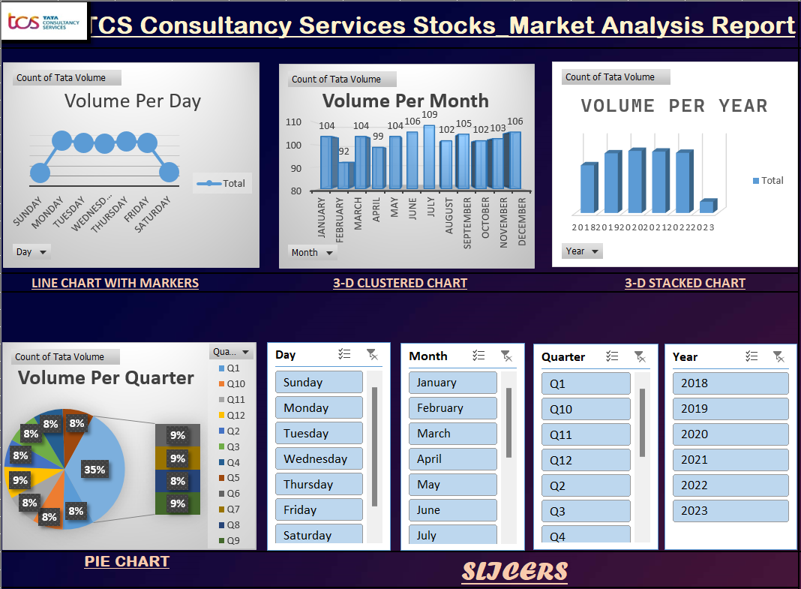

The Excel dashboard provides a comprehensive analysis of TCS stock trading volumes using visualizations like Line Charts, 3D Clustered and Stacked Charts, and Pie Charts. It highlights volume trends by Day, Month, Quarter, and Year, with interactive slicers for easy data filtering and detailed insights.

Excel Dashboards Representation

This Power BI dashboard provides an in-depth analysis of TCS stock performance, showcasing Quarterly and Yearly Stock trends through line graphs. It also includes detailed visualizations of trading volumes, segmented by Year, Quarter, Month, and Day, using donut charts to highlight proportional data distributions.

Power BI Dashboards Representation

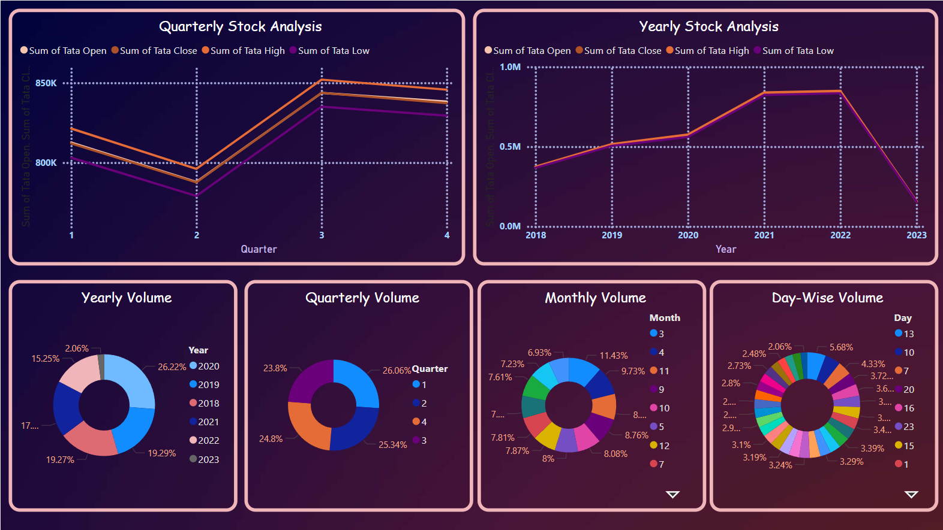

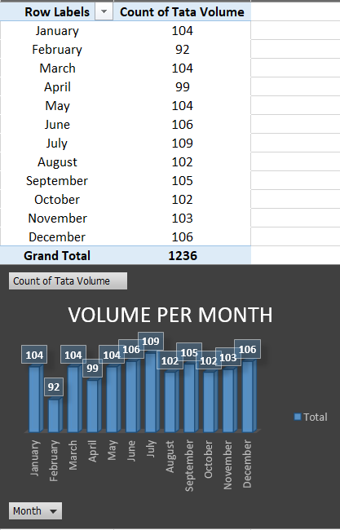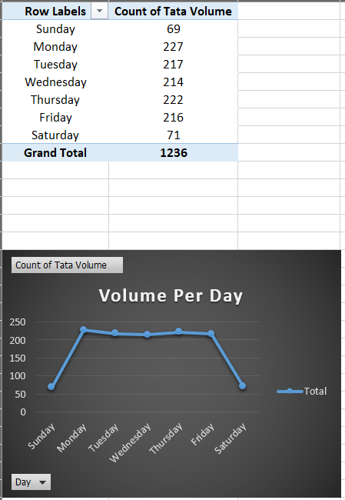

Excel Dashboards Representation

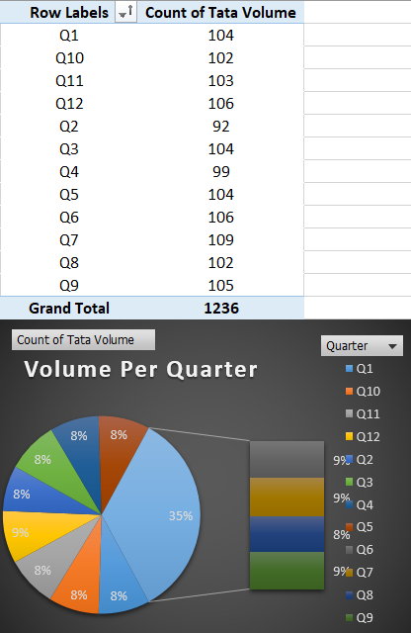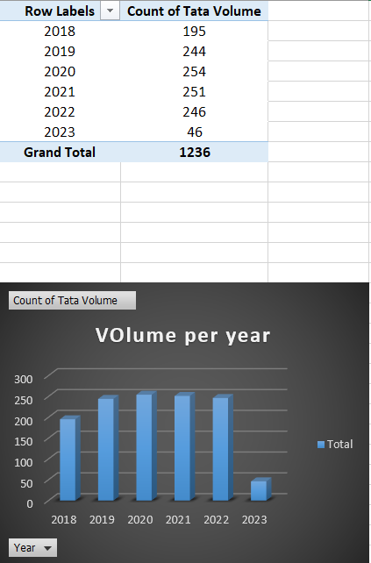

The Excel dashboard provides a comprehensive overview of the data distribution across various time dimensions, with visual and tabular representations. The report includes analyses of "Tata Volume" segmented by day of the week, month, year, and quarter. Here are the key highlights:

### **Volume Per Day**

The daily distribution shows the highest activity on Monday (227) and the lowest on Sunday (69). The trend indicates a decline during the weekend, suggesting a pattern of decreased engagement or operations.

### **Volume Per Month**

Monthly data displays relatively consistent volumes, with slight fluctuations. February exhibits the lowest volume (92), while June and December peak at 106. This suggests cyclical variations, possibly influenced by seasonal or operational factors.

### **Volume Per Year**

Yearly trends highlight growth from 2018 (195) to 2020 (254), followed by a slight decline in 2022 (246). The significant drop in 2023 (46) reflects incomplete data or a reduction in activities for the year.

### **Volume Per Quarter**

Quarterly data shows balanced contributions, with each quarter accounting for approximately 8% to 9% of the total. The pie chart emphasizes consistent distribution across quarters, with Q6 showing a slight peak (109).

This dashboard is effective for monitoring trends, identifying patterns, and aiding in strategic decision-making. It demonstrates a robust data visualization approach for better understanding performance and operations.

#### ****Queries Applied Using SQL:****

1. **Yearly Trends Query:**

* 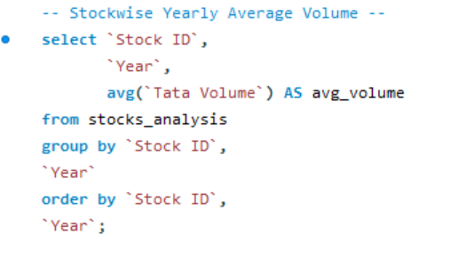Stock-wise Yearly Average Volume
* 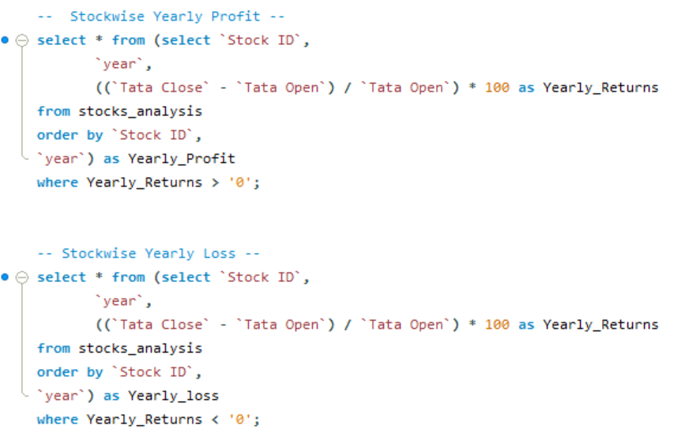Stock-wise Yearly Profit & Loss
* 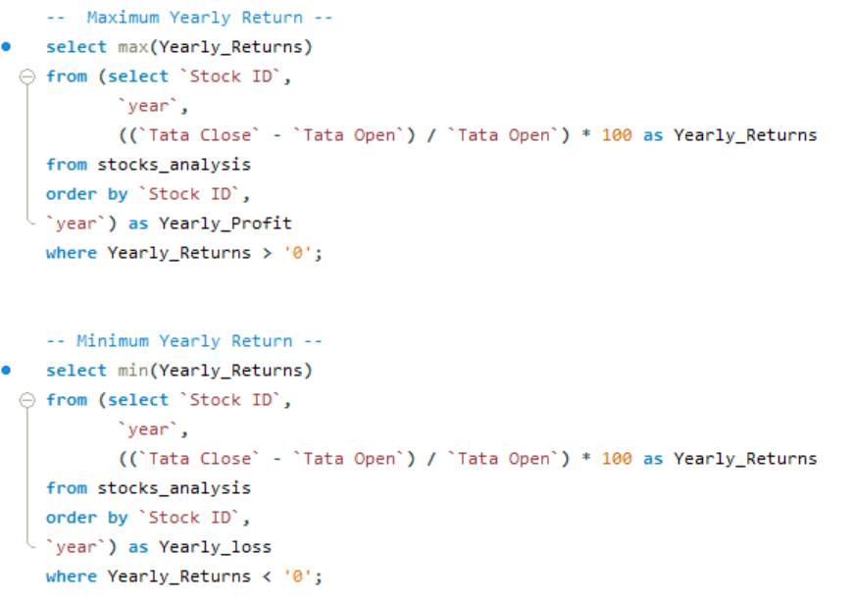Maximum & Minimum Yearly Return
* 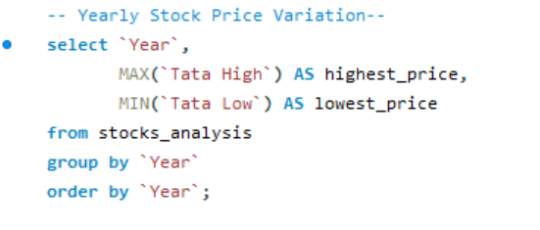Yearly Stock Price Variation

1. **Quarterly & Monthly Trends Query:**

* 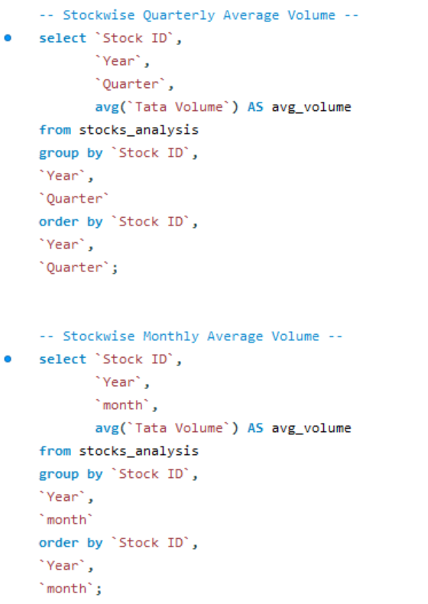Stock-wise Monthly & Quarterly Average Volume
* 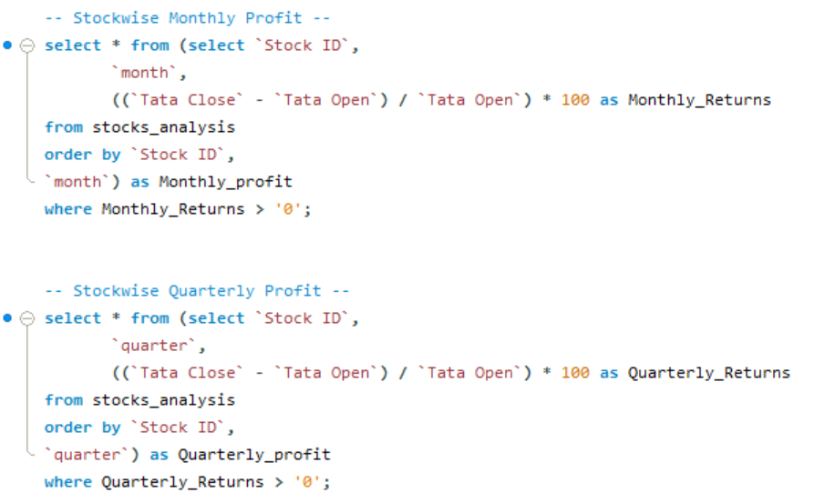Stock-wise Monthly & Quarterly Profit
* 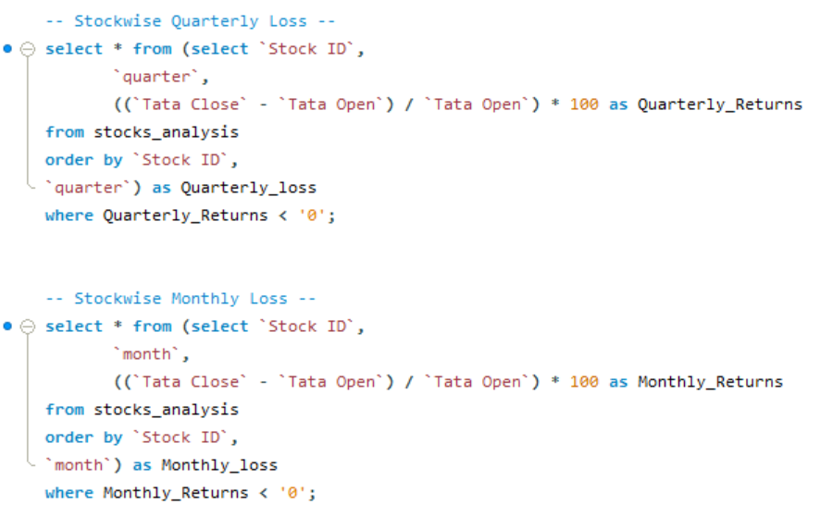Stock-wise Monthly & Quarterly Loss

* 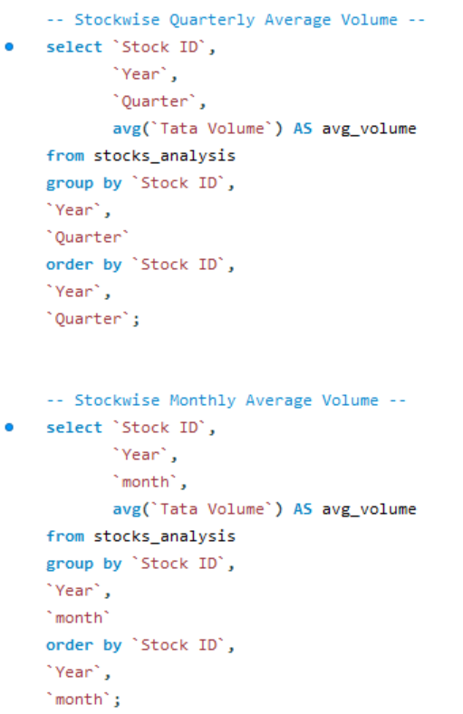Monthly & Quarterly Average Volume
* Monthly & Quarterly Stock Price Variation

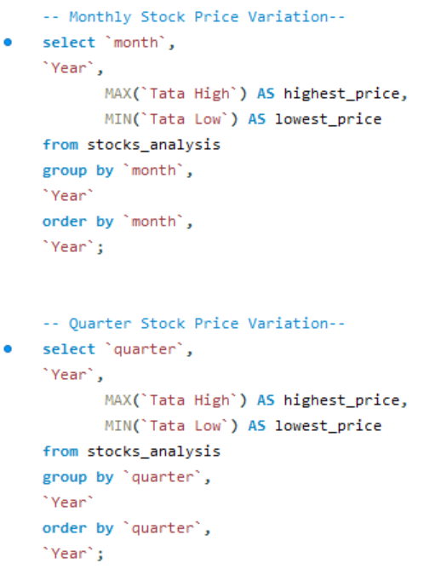

1. **Daily Trends Query:**

* 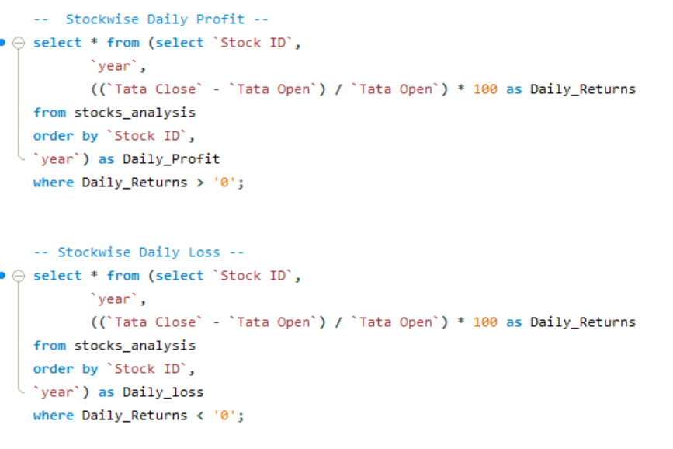Stock-wise Daily Profit & Loss
* 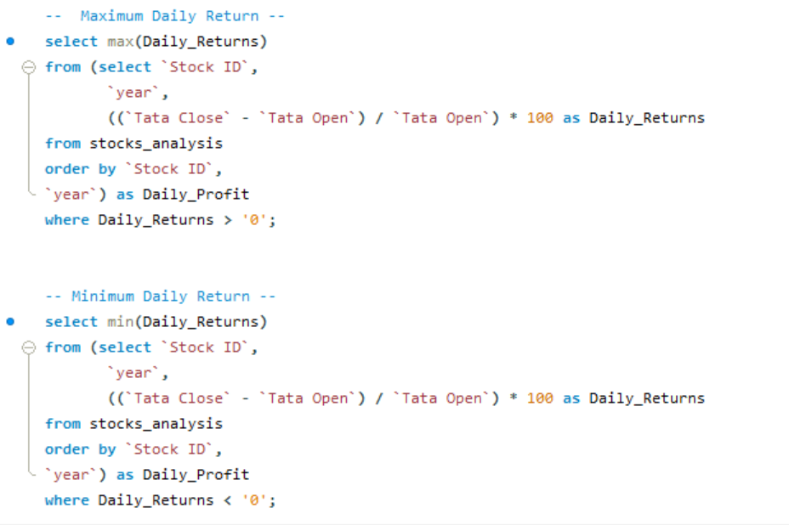Maximum & Minimum Daily Return