Movie Meta Data Dashboard — Power BI Project

Project Overview
This project presents an interactive Movie Meta Data built using Microsoft Excel and Power BI to analyze movie industry data. The dashboard provides insights into movie performance, financial metrics, genres, ratings, and trends over time.

Project Objective
The objective of this project is to analyze movie metadata and identify trends in revenue, profitability, ratings, and performance across movies, genres, languages, and years using Excel and Power BI.

Dataset Information
- Total Records: 5K Movies
- Key Columns:
  - Movie Title
  - Title Year
  - Genre
  - Director Name
  - Language
  - Budget
  - Gross Revenue
- IMDb Rating
- Duration
- Content Rating

It demonstrates strong skills in:
- Microsoft Excel – Data cleaning and preprocessing
- Power Query – Data transformation
- Power BI Desktop – DAX Calculations, Data modeling and visualization

Tools & Technologies Used
- Microsoft Power BI
- DAX (Data Analysis Expressions)
- Power Query (ETL)
- Excel / CSV dataset
- Dashboard Insights
Steps Performed
- Cleaned raw dataset in Excel (removed blanks, formatted columns).
- Imported cleaned dataset into Power BI.
- Created calculated column:
Profit Status (Hit / Flop)
Created measures:
- Total Movies
- Total Gross Revenue
- Average Budget
- Average IMDb Score
- Average Duration
Built interactive dashboard with slicers and KPI cards.

Financial Analysis
- Budget vs Gross comparison
- Profit trends
- Top highest-grossing movies

Category Analysis
- Movies by Genre
- Content Rating Distribution (PG, PG-13, R)
- Movies By Language

Trend Analysis
- Movies released by year
- Popularity trends over time

Geographic Analysis
- Country-wise movie production

Key KPIs
- Total Movies
- Average Budget
- Total Gross Revenue
- Average Ratings
- Average Duration

Business Value
- This dashboard helps stakeholders:
- Identify profitable movie categories
- Understand audience preferences
- Analyze industry trends
- Identify Movies Status
- Support data-driven decision making

Dashboard Preview

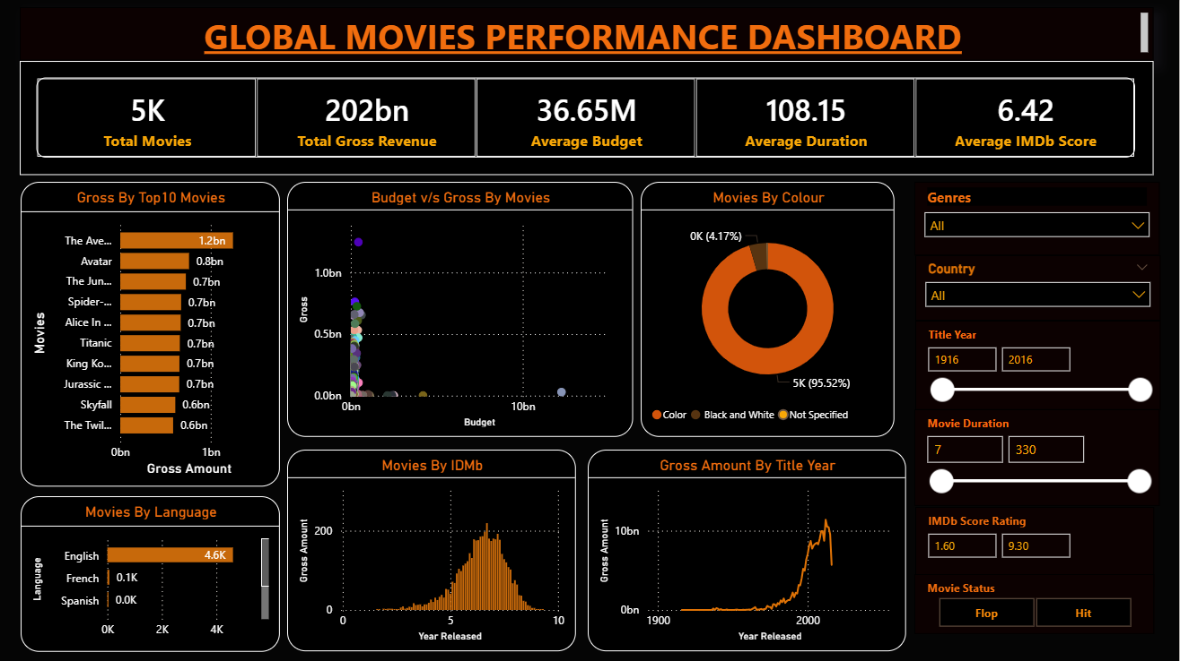

Skills Demonstrated
Technical Skills
- Data Cleaning & Preprocessing (Microsoft Excel)
- Data Transformation & Formatting
- Data Modeling in Power BI
- Creating Calculated Columns (Profit Status)
- Writing DAX Measures (Aggregations & KPIs)
- KPI Development
- Interactive Dashboard Design
- GitHub Project Documentation
Analytical Skills
- Profitability Analysis (Hit vs Flop Classification)
- Trend Analysis (Gross & Profit by Year)
- Budget vs Revenue Performance Analysis
- Genre & Language Distribution Analysis
- Business Insight Extraction
Visualization Skills
- KPI Cards
- Bar & Column Charts
- Line Charts
- Scatter Plot Analysis
- Pie Charts
- Slicer-Based Interactive Filtering

Author
ANCHU D
Data Analyst | Power BI | Python | SQL | Excel

