# Movies Database Uses

## User

1. Load all the users :
   1. Read operation
   2. No filter
   3. On home screen when user clicks on Login or switch button
2. Load specific user:
   1. Read operation
   2. Filter on UserId column
   3. When selecting a user, get the user information and set it in the web Session for future use

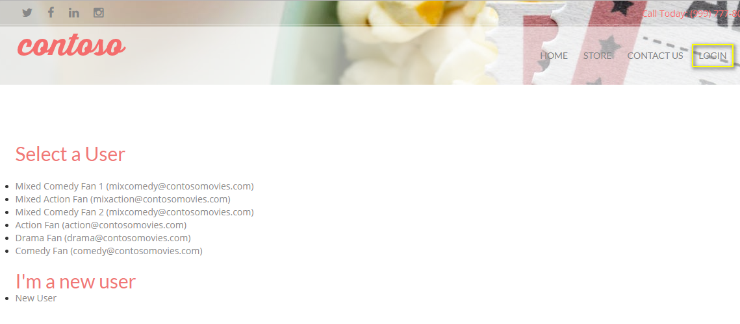

## Category

1. Load all the categories:
   1. Read operation
   2. No filter
   3. When a user clicks on store, then selects an item to see details

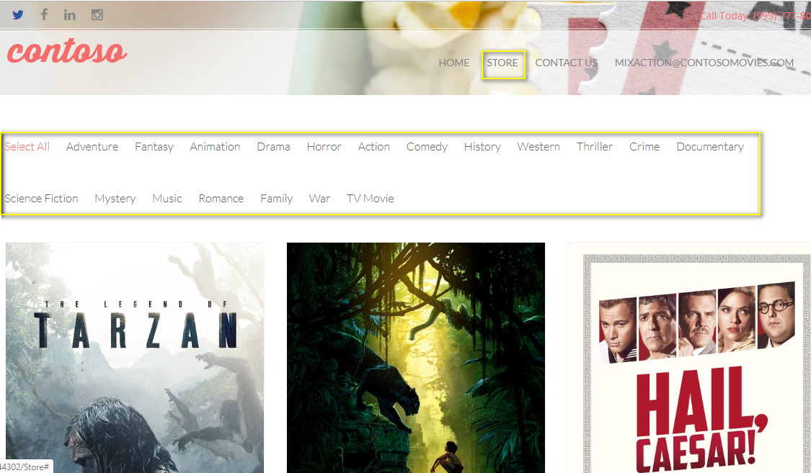

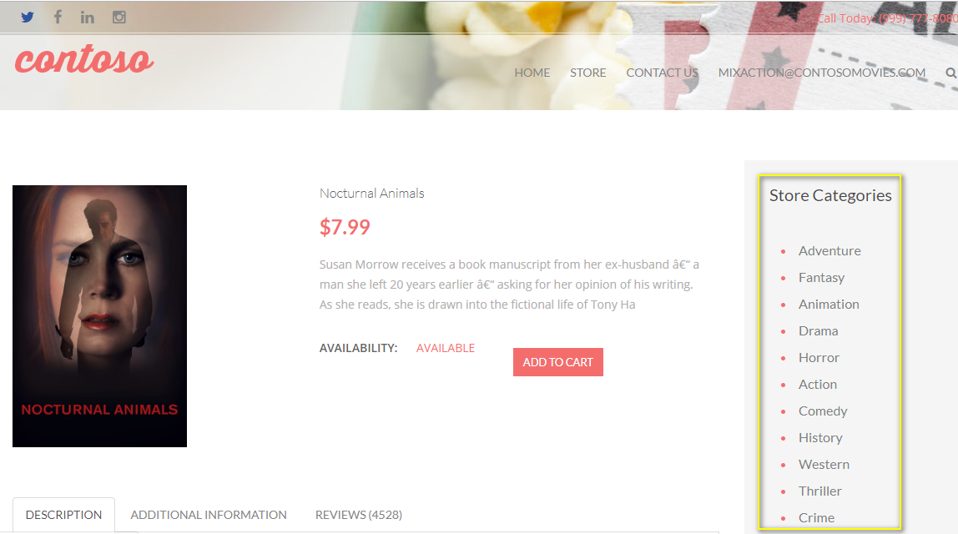

## Item

1. Load items by ImdbId:
   1. Read operation
   2. Filter on ImdbId column with distinct
   3. Showing items on home screen
2. Get item by id:
   1. Read operation
   2. Filter on ItemId column
   3. Show item details
3. Get items by category:
   1. Read operation
   2. Filter on CategoryId
   3. Showing items after selecting the category
4. Get random items:
   1. Read operation
   2. No filter
   3. Order by, skip and take
5. Related items:
   1. Read operation
   2. Filter on CategoryId and ItemId
   3. Take 10 items
   4. Show item details
6. New items:
   1. Read operation
   2. Filter on ItemId
   3. Take and suffle
   4. Show item details

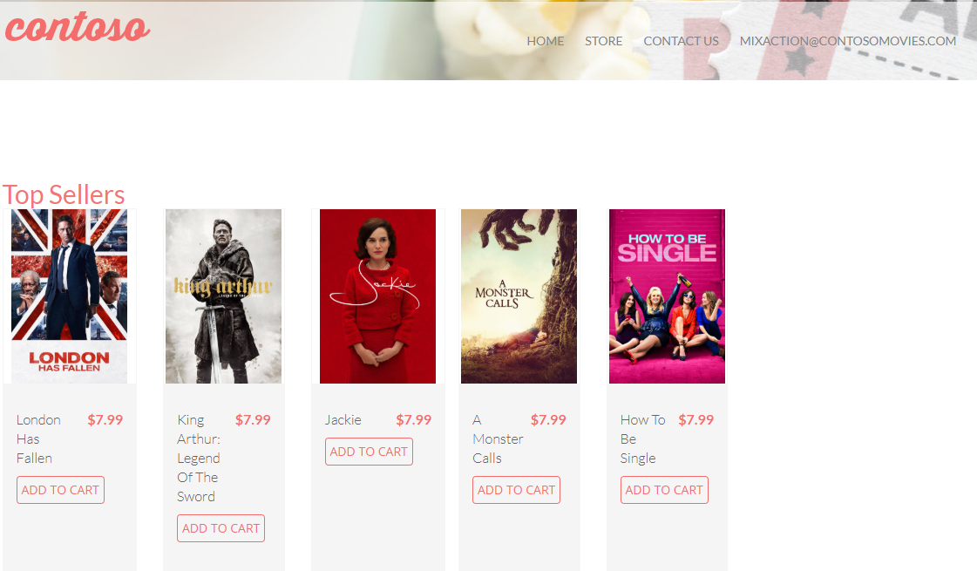

## Cart Item

1. Check cart item:
   1. Read operation
   2. Filter on CartItemId and ItemId
   3. When adding cart item
2. Get cart item:
   1. Read operation
   2. Filter on CartItemId
   3. Checking cart for deletion
3. Save cart item:
   1. Write operation
   2. Adding/updating cart
4. Delete cart item:
   1. Write operation
   2. Filter on CartItemId
   3. After completing order, clear the cart

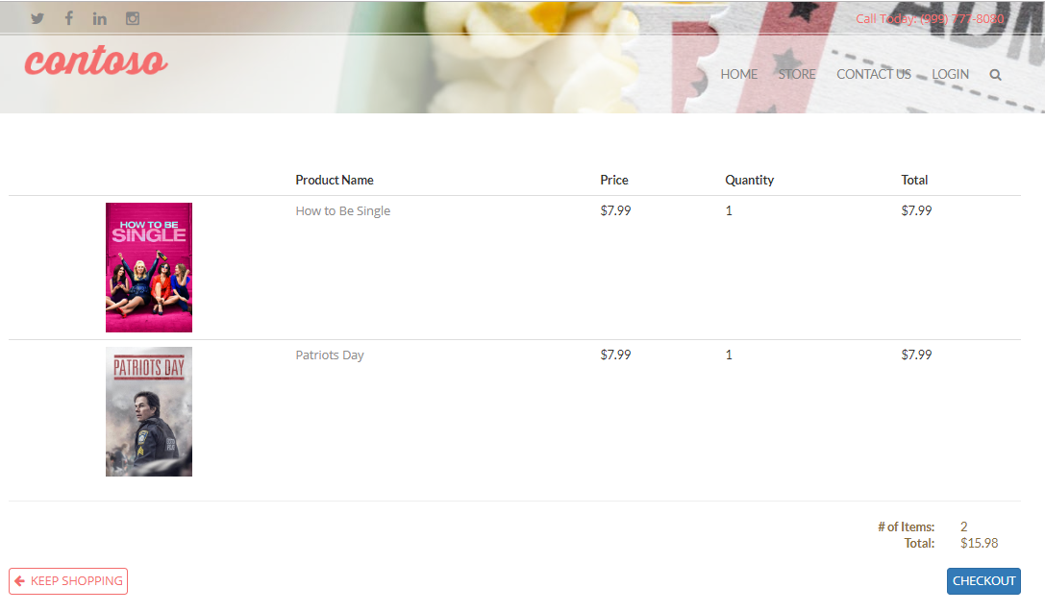

## Order & OrderDetails

1. Save order:
   1. Write operation
   2. Filter on OrderId for updating the order
   3. Save or update the order
   4. Clicking on Checkout button
2. Get order:
   1. Read operation
   2. Filter on OrderId
   3. Get order for updating the order status
3. Save order details:
   1. Write operation
   2. Saving order details for an order

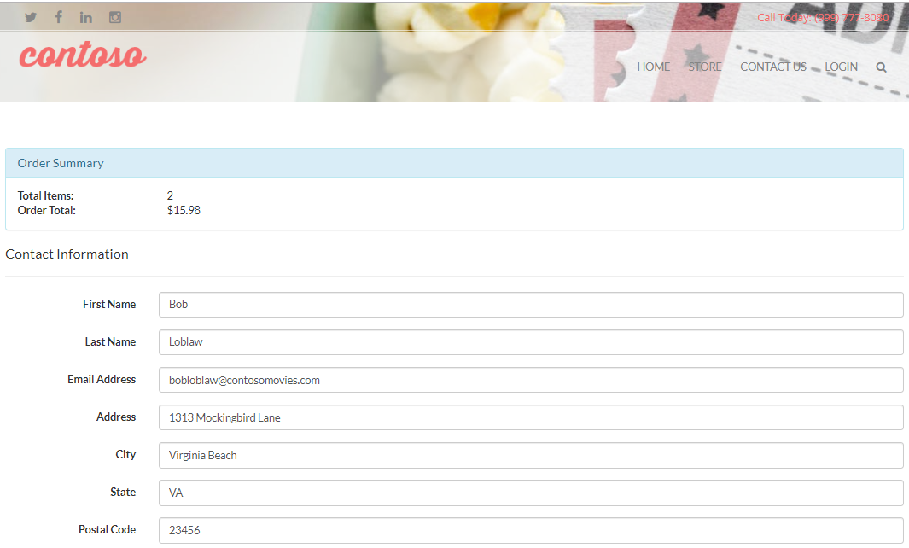

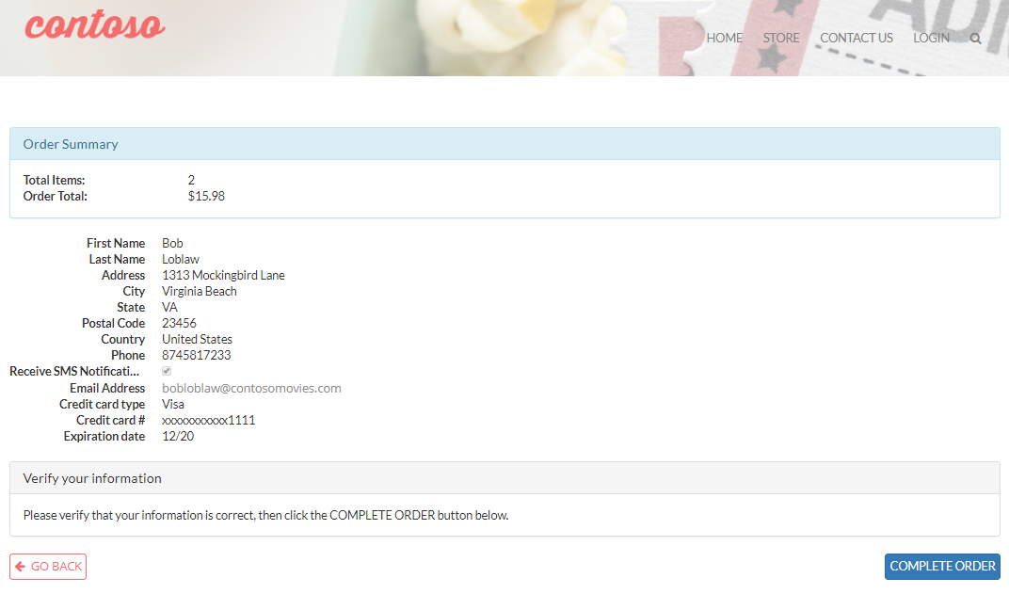

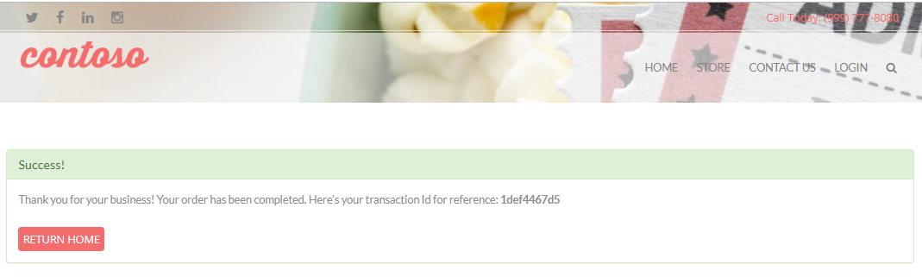

## Event

1. Create event:
   1. Write operation
   2. Save event
   3. When user selects an item
2. Get user events:
   1. Read operation
   2. Filter on UserId column
   3. Order by Created column and take
   4. Select user email
3. Get events by user:
   1. Read operation
   2. Filter on UserId
   3. Use information to retrieve association recommendation

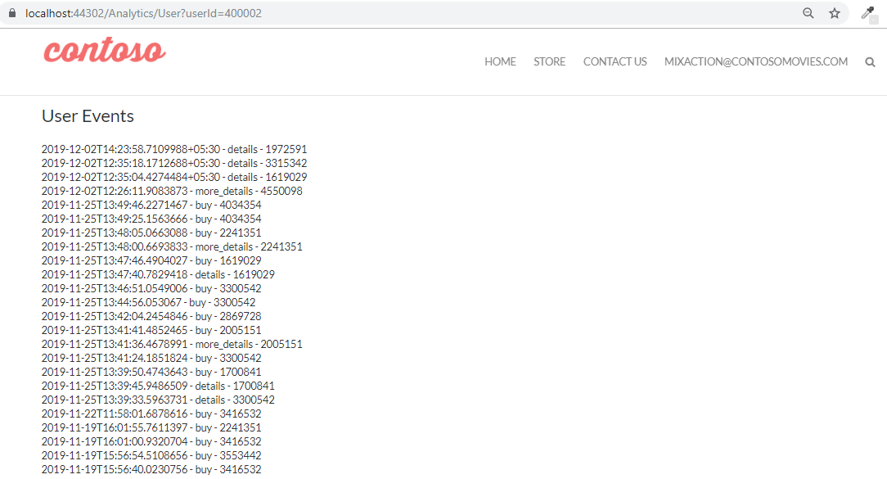

## Ratings

1. Get item rating:
   1. Read operation
   2. Filter on UserId
   3. Used to retrieve liked items from user
   4. Home screen shows the data

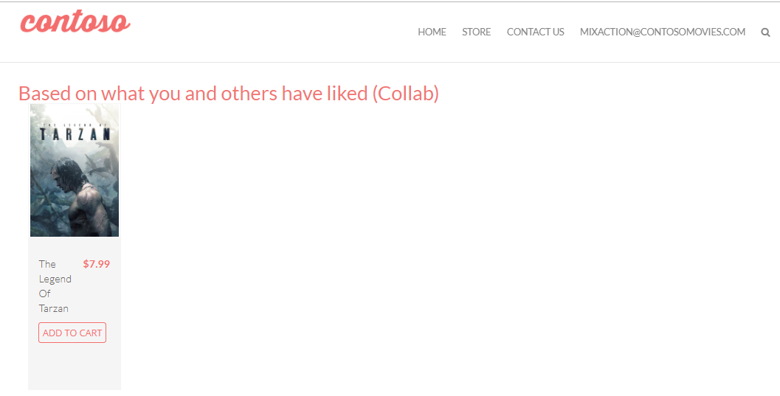

## ItemAggregate

1. Get item aggregates:
   1. Read operation
   2. No filter
   3. Order by BuyCount and take
   4. Used to identify top recommendation items

## Associations

1. Get associations:
   1. Read operation
   2. Filter on source and target column
   3. Order by descending confidence column
   4. Used to identify association recommendation

## Similarity

1. Get similar items:
   1. Read operation
   2. Filter on sourceitemid, targetitemid, and similarity
   3. Used to identify collaborative-based recommendation

## ItemCategory

Not used in web app