Title Page

Title of the Project:  
*DataSeek : One Stop Data Visualiser Tool*

Submitted by:  
Aman Singhal ( 2200971540016 )

Ankur Tyagi ( 2200971540021 )

Anshul Tiwari ( 2200971540028 )

Daksh Kaushik ( 2200971540047 )

Course/Program Name:  
Btech ( CS (DS) )

Instructor's Name:  
Mr. Adarsh Sahu

Date:  
27 Dec 2024

Institution Name:  
Galgotias College of Engineering and Technology

### 

### TABLE OF CONTENTS

1. Introduction ...........................................................................................3  
   1.1. Overview of Data Visualisation ...........................................3  
   1.2. Importance in Decision-Making ......................................4  
   1.3. Project Context: ………………………………………..............................4
2. Objectives ................................................................................................5
3. Scope ..........................................................................................................6
4. Methodology .........................................................................................7  
   4.1. Data Collection ............................................................................7  
   4.2. Data Processing .........................................................................8  
   4.3. Data Visualisation Design ...................................................9
5. Implementation ..................................................................................11  
   5.1. Setting Up the Environment ..............................................11  
   5.2. Code Snippets .............................................................................12  
   5.3. Integrating Visualisations ...................................................13
6. Features ...................................................................................................15  
   6.1. Interactivity ....................................................................................15  
   6.2. Error Handling ............................................................................16
7. Results and Discussion ..................................................................17
8. Conclusion .............................................................................................20
9. Future Work ..........................................................................................21
10. References .............................................................................................22
11. Appendices ...........................................................................................23

### INTRODUCTIONOverview

Data visualization is the art and science of transforming raw data into meaningful visual representations such as charts, graphs, and maps. It enables users to quickly understand trends, patterns, and relationships within data that might otherwise be hidden in rows and columns. By simplifying complex datasets, visualization supports better decision-making, communication, and insight generation.

In the modern era of big data, where vast amounts of information are generated daily, data visualization plays an increasingly vital role. It is widely used across industries like healthcare, finance, education, and business to make informed decisions based on data-driven insights. Tools like bar charts, line graphs, scatter plots, and heatmaps help stakeholders grasp the significance of data efficiently.

This project focuses on leveraging the power of visualization to assist users in analyzing large datasets. Using an interactive web-based interface built with Streamlit, it allows users to upload files or connect to databases. Once the data is loaded, users can explore it through customizable graphs and tables. Additionally, the project offers basic data manipulation features, making it a comprehensive solution for handling data.

By combining interactivity, simplicity, and versatility, this project aims to bridge the gap between data analysis and actionable insights. It empowers users to explore data intuitively and supports informed decision-making across various domains.

#### 

### Importance in Decision Making

Data visualization is an essential tool in decision-making, especially when dealing with large and complex datasets. In industries handling massive amounts of data, visualization provides a way to interpret raw information quickly, identify trends, and draw actionable insights. Without effective visualization, important details might remain buried, leading to missed opportunities or misinformed decisions.

This project directly addresses these challenges by offering a streamlined platform for both data visualization and manipulation. Using Streamlit as the interface, the tool enables users to connect with data sources such as CSV files, Excel sheets, or SQL databases. Once connected, users can create customizable visualizations like bar charts, scatter plots, line charts and histograms. These visualizations make it easier to spot anomalies, monitor performance metrics, and communicate insights effectively.

An additional strength of this project lies in its data manipulation capabilities. Decision-making often requires tailored views of data. With this tool, users can filter datasets dynamically, ensuring the data is in the right form for analysis. This flexibility enhances the decision-making process by allowing users to focus on specific areas of interest and explore various scenarios interactively.

For example, a business manager can upload sales data, visualize quarterly trends, and instantly filter underperforming regions for a deeper dive. Similarly, analysts in other fields can explore large datasets without writing code, making data exploration intuitive and efficient.

By linking visualization with manipulation, this project empowers users to make informed, real-time decisions based on clean and meaningful data.

### Project Context

In a world increasingly driven by data, the ability to analyze, visualize, and manipulate large datasets has become critical across industries. However, many existing tools for data visualization and manipulation require advanced technical skills, limiting their accessibility to a broader audience. This project bridges the gap by providing a user-friendly platform for seamless data exploration and visualization, catering to the diverse needs of data analysts, researchers, and decision-makers.

The tool leverages Streamlit, a lightweight and intuitive web application framework, to create a predefined interface for users. Upon accessing the platform, users can upload datasets in various formats, including CSV and Excel, or connect to SQL databases with provided credentials. This flexibility ensures compatibility with a wide range of data sources commonly encountered in big data environments.

What sets this project apart is its dual focus on data visualization and manipulation. Users can generate a variety of graphs, such as bar charts, line graphs, and scatter plots, to uncover trends and patterns in their data. Simultaneously, they can perform real-time data editing, including filtering rows, modifying columns, and refining specific entries. These features make the tool especially valuable in dynamic decision-making scenarios where data needs to be analyzed and adjusted simultaneously.

By combining interactivity, flexibility, and ease of use, this project aligns with the growing demand for accessible big data tools. It enables users to derive meaningful insights from complex datasets without requiring advanced technical expertise, making data-driven decisions more efficient and effective.

OBJECTIVES

Main Goals of the Project

#### The primary goal of this project is to develop a versatile and user-friendly platform that bridges the gap between data analysis, visualisation, and manipulation. Designed to cater to users across industries, the tool emphasizes accessibility, interactivity, and efficiency in handling large datasets.

#### Simplified Data Integration The tool aims to accommodate multiple data formats, allowing users to upload CSV files (200MB), Excel sheets (200MB), or establish connections to SQL databases. This flexibility ensures compatibility with a wide range of data sources encountered in real-world scenarios, especially those involving big data.

#### Interactive Data Visualisation The project focuses on enabling users to create dynamic, interactive graphs and charts tailored to their analytical needs. Whether it’s identifying trends through line graphs, highlighting outliers using scatter plots, or comparing metrics with bar charts, the tool ensures that data insights are visually accessible.

#### Real-Time Data Manipulation A significant goal is to integrate robust data manipulation features, filter specific entries, and reshape data sets directly. This ensures that users can refine their data without requiring external tools or advanced coding skills.

#### Accessible Web-Based Interface Leveraging Streamlit, the project seeks to create an intuitive, web-based interface that is simple to use for individuals with varying technical expertise.

#### Empowering Decision-Making Ultimately, the project aims to empower users to make informed, data-driven decisions by providing them with the tools to explore, visualize, and manipulate data seamlessly.

### Scope

The scope of this project encompasses the design and implementation of a user-friendly platform for data visualization and manipulation. It is tailored to meet the needs of individuals working with large datasets, offering tools to explore, analyze, and modify data in real time.

* Data Integration:  
  The platform supports a wide range of data formats, including CSV files, Excel sheets, and SQL databases. Users can upload local files or connect to databases using credentials, making it suitable for diverse industries like business analytics, research, and education.
* Visualization Capabilities:  
  The project focuses on enabling users to create interactive visualizations, such as bar graphs, line charts, scatter plots, and histograms. These visualizations are customizable, allowing users to adjust parameters like axis labels and data ranges to suit specific analytical needs.
* Data Manipulation Features:  
  The tool includes robust features for transforming data. Users can adjust rows, update columns, and modify individual entries directly within the platform. This flexibility ensures that datasets can be prepared and analyzed without requiring external preprocessing tools.
* Web-Based Accessibility:  
  Leveraging Streamlit, the platform provides a simple and interactive web interface. It is designed for users with varying levels of technical expertise, ensuring accessibility for both novice and experienced data analysts.
* Real-Time Performance:  
  The platform is optimized for handling large datasets efficiently, offering real-time feedback on visualizations and data edits. This ensures a seamless user experience, even with complex datasets.

### Limitations

While the project offers a versatile data visualization and manipulation tool, there are certain limitations. One key limitation is file size constraints. The tool may struggle to handle extremely large datasets upto 200mb, especially when dealing with complex CSV or Excel files, leading to performance slowdowns or potential crashes. Another limitation is database compatibility; although the tool supports SQL server connections, it may not integrate seamlessly with all database configurations or more complex database types. Furthermore, the interactivity features are tailored for moderate data sizes, and for very large datasets, real-time updates or dynamic visualizations could be slow or unavailable. Finally, the user interface is designed to be simple and intuitive but may lack advanced features or customizability seen in professional data visualization tools (Tableau and PowerBi), which might limit power users or users with highly specific needs.

### 

### Expected Outcomes

Despite these limitations, the project is expected to achieve several significant outcomes. The tool will provide efficient data exploration, allowing users to upload and visualize data quickly without needing advanced technical knowledge. By enabling users to manipulate the rows and columns and specific data, it will facilitate informed decision-making, especially for business or research-related tasks. Additionally, the interactive visualizations will help users identify trends and patterns in big data more effectively. Non-technical users will be empowered to perform complex data analysis tasks independently. Overall, our project aims to streamline the process of data analysis, making it more accessible and efficient, even for those with limited technical expertise.

METHODOLOGY

Data Collection

Data collection is a fundamental aspect of the project, as it forms the basis for all subsequent processing, visualization, and analysis. In this project, data collection refers to the process of gathering various types of data from multiple sources, which can then be processed and visualized through the Streamlit application. The project supports three primary data collection methods: CSV files, Excel files, and SQL databases. Each data source provides unique advantages, and the ability to handle all three ensures that the tool is flexible enough to accommodate a wide range of user needs.

#### **1. CSV Files**

CSV (Comma Separated Values) is one of the most commonly used formats for data storage and sharing. It is a simple, text-based format that stores data in rows, with each value separated by a comma. The tool allows users to upload CSV files directly to the interface. This method of data collection is beneficial because CSV files are widely compatible with many applications and programming languages, making them easy to integrate and manipulate.

Users can upload CSV files containing structured data, such as tabular datasets, financial data, survey results, or any other dataset that fits the tabular format. The simplicity of CSV files makes them ideal for this project as they are easy to parse and process. However, due to the plain text nature of CSV files, large datasets can lead to slower processing times, which may affect the tool’s performance with big data.

#### **2. Excel Files**

Excel files offer more advanced features than CSV files, such as support for multiple sheets, formulas, and rich formatting. The project allows users to upload Excel files (.xls or .xlsx formats), making it suitable for a wide range of data collection scenarios, especially those that involve more complex datasets or when data is presented in multiple sheets.

Excel files are commonly used in business environments for accounting, reporting, and statistical analysis. The project’s ability to handle Excel files enables users to work with a variety of data that may have multiple attributes, structured across different sheets, each representing different aspects of the data. Excel files are particularly advantageous because they allow users to store both raw data and calculated results within the same file, making them more flexible for detailed analysis.

However, Excel files can also present challenges, especially with large files. Unlike CSVs, Excel files are binary and require more resources to process, which can be a limitation if users try to upload very large files. Additionally, Excel files can have hidden sheets or macros that may complicate the data extraction process.

#### **3. SQL Databases**

For more dynamic and scalable data collection, the tool supports the integration of SQL databases. By connecting to an SQL server with appropriate credentials, users can pull data directly from a live database. This option is particularly valuable for users who need to work with real-time data or large datasets that would be inefficient to upload as static files.

SQL databases are commonly used in organizations to store transactional data, customer information, or other data that is updated regularly. The project supports a wide range of SQL databases, including MySQL, PostgreSQL, and Microsoft SQL Server. By connecting to these databases, the tool enables users to execute SQL queries to extract specific datasets, which are then visualized and manipulated within the application.

This method is advantageous because it provides access to large, constantly updated datasets without the need for repeated file uploads. However, the complexity of SQL databases also means that users need appropriate access credentials, and database connectivity can sometimes be impacted by network issues or permission restrictions. Additionally, the design of the SQL database itself can affect the ease of data extraction, as complex relationships between tables or the absence of indexes can slow down query execution.

Data Processing

Data processing in this project involves the steps necessary to clean, prepare, and transform the raw data from various sources (CSV, Excel, and SQL) into a format suitable for visualization and manipulation. This stage is crucial because it ensures that the data is accurate, consistent, and ready for analysis.

1. Data Cleaning: The first step in data processing is cleaning the raw data. This involves handling missing or incomplete data, correcting any inconsistencies, and ensuring that all values are formatted correctly. For instance, in CSV or Excel files, data might have missing values or incorrectly formatted dates. These issues are addressed by either filling in missing data using predefined rules or removing incomplete rows. SQL data might require similar cleaning if there are discrepancies in data entries or formatting inconsistencies across tables.
2. Data Transformation: After cleaning, the data is transformed into a suitable structure for analysis. This might involve converting data types (e.g., from string to date or numerical values), standardizing column names, and combining data from multiple sheets or tables. For SQL data, transformation can include running queries to aggregate or filter specific data, such as selecting records within a certain date range or summing financial figures.
3. Data Filtering: The project also involves filtering the data to ensure that only relevant information is visualized. For example, if a user is analyzing sales data, the tool might allow the filtering of records based on criteria such as region, time period, or product category. This helps focus the analysis on specific subsets of data that are of interest.

These data processing steps ensure that the data is clean, structured, and ready for meaningful visualization and manipulation within the Streamlit application.

Data Visualisation

In this project, data visualization is an essential aspect that allows users to interact with their datasets, making it easier to derive insights. The project uses Streamlit as the primary framework to provide a web-based interface for users to upload data and view visualizations. Once the data is uploaded, users can interact with a variety of charts and graphs generated using Plotly, which offers high-quality, interactive visualizations.

The visualizations in this project include bar charts, line graphs, scatter plots, pie charts, and histograms, each designed to handle different types of data and provide clear insights. For example, bar charts are ideal for comparing categorical data, while line graphs are used for tracking changes over time. Scatter plots help explore relationships between variables, and pie charts are used to show proportional data. Histograms are designed to analyze the distribution of data points across specific ranges.

Plotly is used for its interactive capabilities, allowing users to zoom, pan, and hover over data points to gain additional information. These interactive features enhance the user experience, enabling deeper data exploration without overwhelming the interface with excessive information.

Additionally, Boto3 is integrated into the project to allow seamless interaction with Amazon Web Services (AWS). This enables users to access large datasets stored on AWS S3, facilitating the loading of data directly from cloud storage into the application for visualization.

Additionally, in Boto3, the AWS SDK for Python, error handling is essential when working with AWS services. Two common exceptions are NoCredentialsError and PartialCredentialsError, which are related to the management of AWS credentials.

### 1. NoCredentialsError

The NoCredentialsError is raised when AWS credentials are missing or cannot be found. This typically occurs when attempting to interact with AWS services (e.g., S3, DynamoDB) without providing valid credentials through one of the following methods:

* Environment variables
* AWS configuration files (~/.aws/credentials)
* IAM roles (when running in an AWS environment like EC2 or Lambda)
* Manually setting credentials in the code

### 2. PartialCredentialsError

The PartialCredentialsError is raised when some of the required AWS credentials are provided, but the set is incomplete. For instance, the aws_access_key_id might be provided without the corresponding aws_secret_access_key, or one of the environment variables might be missing. This error ensures that an incomplete credentials set does not silently go unnoticed, which could lead to failed API calls.

Overall, the design prioritizes usability, providing users with an intuitive interface to visualize and manipulate large datasets interactively.

Tools and Techniques

The project leverages several powerful visualization tools and techniques to ensure that users can efficiently interact with and interpret large datasets. The primary tools used for creating these visualizations are Streamlit, Plotly, pyODBC, pandas and Boto3. These tools work together to deliver dynamic, interactive, and visually appealing charts.

#### 1. Streamlit:

Streamlit serves as the foundation of the application, providing an easy-to-use framework for building web-based data applications. Streamlit's simplicity allows users to upload their datasets and visualize them seamlessly in a web interface. The integration with Python libraries is smooth, which makes it an ideal choice for this project, as users can build interactive dashboards for data analysis without extensive front-end development.

Key features of Streamlit that support the visualizations include:

* Widgets: Streamlit allows the inclusion of interactive widgets, such as dropdowns, sliders, and buttons, to enable users to filter and adjust the displayed data dynamically.
* Real-time updates: As users interact with the interface, the visualizations update in real-time, reflecting changes made through filtering, date selection, or variable adjustments.

#### 2. Plotly:

Plotly is a library that specializes in creating interactive and highly customizable visualizations. It is used in this project to create graphs that users can engage with dynamically. Plotly's ability to generate detailed, responsive charts with minimal code makes it a perfect fit for big data applications.

Visualization types include:

* Bar Charts: For comparing categories and visualizing distributions.
* Line Graphs: Ideal for showing trends over time, such as sales or user activity.
* Scatter Plots: Used to illustrate relationships between two variables and detect correlations.
* Pie Charts: Perfect for showing proportions and percentage breakdowns of a whole.
* Histograms: To represent the frequency distribution of a continuous variable.

Plotly's interactive features, like zooming, panning, and tooltips that show detailed information when users hover over data points, enhance the user experience by allowing deeper exploration of the visualized data.

### pyODBC

pyODBC is a Python library that allows you to connect to databases using the Open Database Connectivity (ODBC) protocol, which is compatible with a wide variety of relational database management systems (RDBMS) such as SQL Server, MySQL, PostgreSQL, and more. It acts as a bridge between Python and databases, enabling seamless execution of SQL queries and retrieval of data directly within Python applications.

Key features of pyODBC that support the database connection and data retrieval include: Connection pooling, Cross-database compatibility, SQL Query Execution, Fetching results

### 

### pandas

pandas is a powerful Python library designed for data manipulation and analysis. It provides data structures like DataFrame and Series that are highly efficient for handling and analyzing large datasets. pandas simplifies tasks such as cleaning, filtering, merging, and aggregating data, making it an ideal choice for data analysis and manipulation.

Key features of pandas that enhance data handling include: DataFrame, Data Import and Export, Data Cleaning, Grouping and Aggregation

#### 3. Boto3:

Boto3 is the AWS SDK for Python, enabling the project to interact with Amazon Web Services (AWS), particularly S3for cloud storage. With Boto3, the tool can access large datasets stored on AWS, allowing users to import data directly from the cloud. This integration is vital for dealing with big data, as it removes the limitations imposed by file size when uploading from local sources.

Key features of Boto3 that support visualizations include:

* Cloud Data Access: Users can pull data from AWS S3 storage and use it within the project for real-time visualization, eliminating the need for manual file uploads.
* Seamless Integration: Once data is pulled from AWS, it is processed and visualized using Plotly, making the cloud-to-dashboard process seamless for the user.

### Techniques for Visualization:

* Data Aggregation: Before visualizations are created, the data is aggregated using filters, grouping, and summarization techniques, ensuring that the visualizations represent meaningful insights.
* Interactivity: Techniques such as adding hover effects, tooltips, and real-time filtering ensure that users can explore their data interactively. For instance, users can apply filters to focus on specific time periods, categories, or ranges.

#### 

IMPLEMENTATION

Step-by-Step Breakdown

Streamlit

Streamlit was chosen as the main framework for building the web interface. It allowed for quick development of an interactive dashboard for visualizing data. The first step was setting up Streamlit using pip install streamlit. After that, I created the layout for uploading files (CSV, Excel, or SQL database). Streamlit's file uploader widget made it easy for users to upload datasets, while other widgets like dropdowns, sliders, and date pickers were implemented for filtering and interacting with data.  
  
import streamlit as st

uploaded_file = st.file_uploader("Choose a file")

Plotly

Plotly was used to create interactive visualizations. After uploading the data, I used Plotly Express for generating visualizations such as bar charts, line graphs, and scatter plots. Plotly's ability to provide dynamic charts was integrated by using the st.plotly_chart() function to display graphs directly on the Streamlit interface. This allowed users to hover, zoom, and interact with the data in real-time.

import plotly.express as px

fig = px.bar(data, x='Category', y='Value')

st.plotly_chart(fig)

Boto3

Boto3 was integrated to connect the application with AWS services, especially for retrieving datasets stored in Amazon S3. After configuring AWS credentials, I used Boto3’s S3 client to access and download data. This enabled cloud storage integration, allowing users to load large datasets directly from the cloud.

import boto3

s3 = boto3.client('s3')

s3.download_file('bucket_name', 'file_key', 'local_path')

pandas

pandas is a powerful library for data manipulation and analysis in Python. It provides data structures like DataFrames, which are highly efficient for handling and analyzing structured data. pandas can easily interact with pyODBC to load data from a database into a DataFrame, making it easier to manipulate and visualize the data.

import pandas as pd

pyODBC

pyODBC is a Python library that provides an interface to connect to databases using the Open Database Connectivity (ODBC) standard. It supports a wide range of relational databases, including Microsoft SQL Server, MySQL, PostgreSQL, and others. By using pyODBC, Python applications can execute SQL queries, fetch results, and interact with databases in a seamless manner.

To use pyODBC, you need to install the library and configure an ODBC connection.

import pyodbc

Code Snippet

The first step in the implementation was creating an interface where users could upload their data. Streamlit’s file uploader widget allows users to upload CSV or Excel files. Once the file is uploaded, it is read into a pandas DataFrame, which makes it easier to manipulate and visualize.

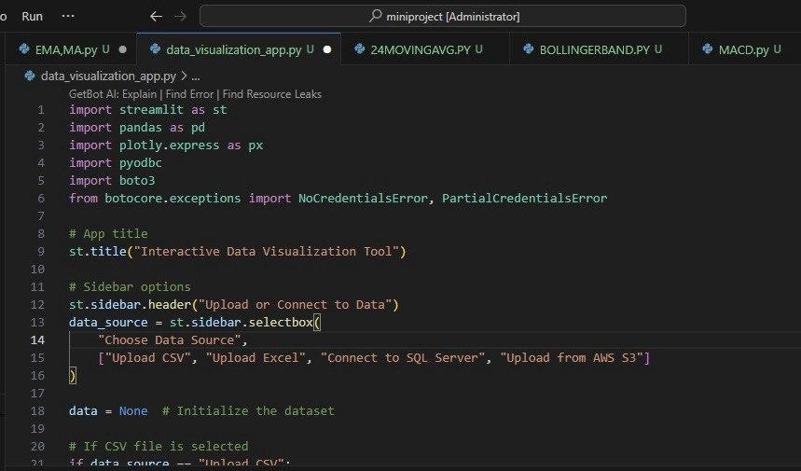

Integrating Visualisations

After the data is uploaded, visualizations are created using Plotly, which is integrated into the Streamlit interface using

st.plotly_chart()

This integration enables the display of interactive charts, where users can hover over data points, zoom in, and filter data dynamically.

The integration when run successfully gives out the output in the form of a network URL.

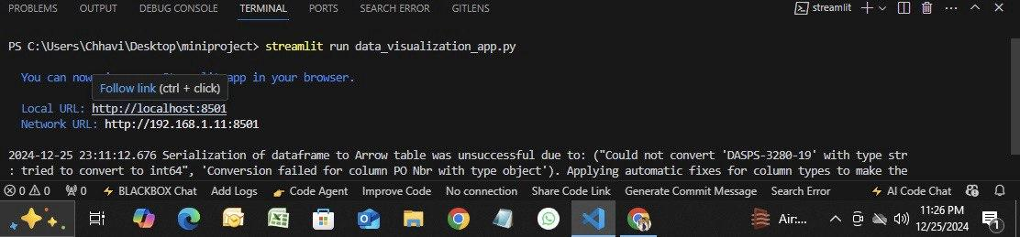

Now, let’s have a look at how each technology works in order to achieve this project as a whole. To understand the flow of this project, let’s have a look at the architectural diagram of the project.

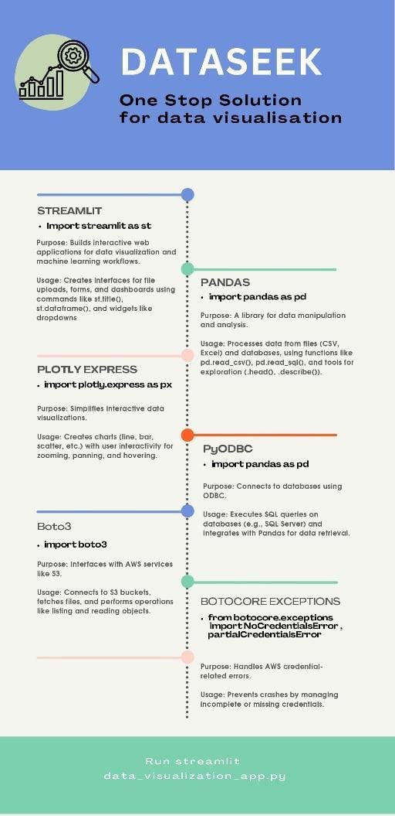

Framework and Technology

* Programming Languages: The tool will primarily be developed using Streamlit for client-side interactions, with Python as the backend language for data processing and server-side logic.
* Web Frameworks:
  + For the frontend, Streamlit Library will be utilized to create a responsive user interface, allowing for dynamic updates of the visualizations.
* Data Visualization Libraries:
  + BOTO3 will be used for custom data visualizations, offering flexibility and the ability to create intricate graphics.
  + Plotly.express may be integrated for simpler charting needs, benefiting from its ease of use and quick implementation.
* Database Management: Depending on user requirements, a combination of SQL (e.g., PostgreSQL) and NoSQL (e.g., MongoDB) databases will be employed to manage and store user-uploaded datasets.

Development Process

* Agile Methodology: The implementation will adopt an Agile approach, allowing for iterative development cycles (sprints). Each sprint will focus on specific functionalities, enabling continuous feedback and adjustments.
* Version Control: All development will be conducted using Git for version control, facilitating collaboration and ensuring that all changes are tracked and managed effectively.
* Coding Standards: Establishment of coding guidelines will ensure that development is consistent and maintainable. This will include documentation of code and adherence to best practices.

Data Integration

* Data Upload Functionality: Users will have the capability to upload various file formats (CSV, Excel and MYSQL) directly through the interface. Backend components will parse the files upon upload and transform the data into a usable format.
* Real-Time Data Processing: The system will enable real-time processing of data changes and updates to visualizations, utilizing BOTO3 for live data streaming where applicable.
* Error Handling: Robust error handling will be integrated into the data processing pipeline to manage file upload issues, data parsing errors, and visualization rendering problems, ensuring a smooth user experience.

User testing and Framework

* Beta Testing: Before a full release, a beta version of the tool will be made available to a select group of users. Their feedback will be crucial for identifying usability issues and areas for improvement.
* Continuous Integration/Continuous Deployment (CI/CD): Implementing CI/CD practices will enable rapid deployment of fixes and enhancements based on user feedback.
* User Training and Documentation: Comprehensive user documentation will be provided, including tutorials and walkthroughs on how to use the tool effectively. Additional webinars or workshops may be organized to facilitate user adoption.

### 

### FEATURES

The interactive data visualization tool is designed to provide a range of features that enhance user experience and analysis capabilities. Below are the primary features of the tool:

User-Friendly Interface

* Intuitive Dashboard: The tool includes a clean and organized dashboard that allows users to navigate through functionalities easily.

Data Upload and Management

* Multiple File Formats Supported: The tool supports a variety of data formats for upload, including CSV, Excel (XLSX), and direct database connections (e.g., SQL databases).
* Data Cleaning and Preprocessing: Integrated data cleaning tools will allow users to remove duplicates, handle missing values, and apply basic transformations before visualization.

#### 

#### 

#### 

Interactive Data Visualisation

* Customizable Charts and Graphs: Users can create various types of visualizations, including bar charts, line graphs, Histogram, scatter plots, and more, with customizable options for labels (X and Y axis).
* Real-Time Data Interaction: Users can interact with their visualizations in real time, allowing them to zoom, filter, and select data points dynamically.

Advanced Analytical Features

* Multi-Dimensional Analysis: The tool enables users to perform multi-dimensional analyses by allowing comparisons across multiple parameters simultaneously.

Export and Sharing Options

* Downloadable Visualizations: Users can export visualizations as image files (PNG, JPG) or PDF documents for easy sharing and presentation.
* Collaboration Features: Users can share datasets or visualizations within the platform, enabling collaborative analysis and decision-making.

User Documentation and Support

* Comprehensive User Guide: A detailed user manual, including tutorials and use cases, will be accessible within the tool to help users navigate its features.
* Support Forum: A community forum will be established where users can discuss issues, share tips, and provide feedback.

Security and Privacy

* Data Security Measures: User data will be securely stored and encrypted, adhering to best practices in data privacy.
* User Authentication: A secure user authentication process will ensure that only authorized users have access to specific datasets or visualizations.

### RESULTS & DISCUSSION

This section presents the expected results from the implementation of the interactive data visualization tool, followed by a discussion that explores the implications of these results for users and stakeholders.

Expected Results

* User Engagement: The tool is anticipated to significantly increase user engagement by providing an intuitive and interactive platform for data exploration and visualization. User feedback will likely indicate that the customizable visualizations streamline their analysis process.
* Improved Data Understanding: Users should demonstrate a marked improvement in their ability to analyze and interpret complex datasets. Through interactive visualizations, users can uncover patterns and insights that may have been obscured in traditional data formats.
* Increased Collaboration: The collaboration features are expected to enhance teamwork and knowledge sharing among users. Feedback from beta testing will help assess how effectively users can share visualizations and datasets.
* Efficiency in Data Processing: The integration of data cleaning and preprocessing tools is expected to reduce the time users spend preparing data for analysis. Preliminary observations may indicate an increase in the speed at which users go from data upload to visualization.
* Enhanced Accessibility: The support for multiple data formats, along with comprehensive user documentation and tutorials, is likely to make the tool accessible to a broader audience, including non-technical users.

Discussion

* Impact on Data-Driven Decision Making: The successful implementation of the tool should empower users to make more informed, data-driven decisions. As users become proficient with the tool, we expect to see a shift in organizational culture towards more analytical approaches to problem-solving.
* Challenges and Limitations: While the tool is designed to provide a user-friendly experience, initial user testing may reveal challenges, such as difficulties in navigating certain features or understanding complex visualizations. Continuous user feedback will be essential to address these issues promptly.
* Future Enhancements: Based on user feedback gathered during beta testing, we anticipate rolling out enhancements to address any usability challenges. Potential future features may include machine learning integrations for predictive analytics or additional visualization types based on user demand.
* Adoption and Learning Curve: While the tool aims to be intuitive, there may still be a learning curve, especially for users unfamiliar with data visualization principles. Ongoing support and resources will be crucial to facilitate user adoption and continuous learning.
* Ethical Considerations: Handling user data comes with ethical responsibilities. Ensuring that data privacy and security measures are integral to the tool’s design will be necessary to gain user trust and foster a culture of data integrity.

### CONCLUSION

In conclusion, the development of the interactive data visualization tool represents a significant advancement in the way users can engage with and analyze data. By integrating user-friendly features, advanced analytical capabilities, and collaborative functionalities, the tool aims to empower users at various skill levels to explore complex datasets effectively and derive actionable insights.

Summary

1. Enhanced User Experience: The tool’s intuitive interface, simplify data uploading and visualization, allowing users to focus on analysis rather than technical barriers.
2. Real-Time Interaction: Interactive visualizations enable users to engage dynamically with their data, facilitating a deeper understanding of trends and patterns that may otherwise be overlooked.
3. Accessibility and Support: The tool's support for multiple data formats and a comprehensive user guide make it accessible to a broader audience, ensuring that even non-technical users can benefit from data visualization.
4. Continuous Improvement: Ongoing user feedback will be critical for iterating on the tool’s features, ensuring it meets evolving user needs while maintaining high standards of data security and ethics.

Implications For The Future

The potential impacts of this tool extend beyond individual users to organizations as a whole. By promoting a culture of data-driven decision-making, businesses and teams can leverage insights derived from robust analyses to inform strategies and optimize operations. The accessibility of this tool should encourage a wider adoption of data literacy across various sectors, thus bridging the gap between technical and non-technical stakeholders.

As we look to the future, continuous enhancements and updates based on user feedback will drive the evolution of the tool, ensuring it remains aligned with technological advancements and user needs. Ultimately, we believe this interactive data visualization tool will significantly contribute to the analytics landscape, enabling users to unlock the full potential of their data.

We would use the data to predict the outcome of the company, to foster an environment where teams can work together more effectively, ensuring far better productivity and analysis.

In the future, color coding can be added to the project to enhance data visualization and improve user experience. By using different colors for categories or values in charts and tables, users can quickly identify patterns, trends, or anomalies in the data. This can be achieved using Plotly's built-in color scales or by integrating custom color schemes to represent specific data attributes more effectively.

In the future, duplicate data removal can be implemented directly in the SQL server by using SQL queries ensuring that only unique records are stored. This will improve data consistency and reduce redundancy, leading to more efficient database management and accurate analysis.