TinyML Smart Plug for Complementary Protection Against Progressive Fire-Inducing Electrical Faults in Residential Circuits

by

Alex A. Alferez
Jett M. Lumabi
Francis M. Peña

A Thesis Report Submitted in Partial Fulfilment
of the Requirements for the Degree of
Bachelor of Science in Electronics Engineering

Ateneo de Naga University
April 2026

APPROVAL FORM

This is to certify that we have supervised the preparation and read the senior project paper entitled TinyML Smart Plug for Complementary Protection Against Progressive Fire-Inducing Electrical Faults in Residential Circuits and that the said paper has been submitted for final examination by the Oral Examination Committee.

_________________________
Referendo D. Soriano, Ph. D.
Academic Advisor

As members of the Oral Examination Committee, we certify that we have examined this paper and hereby recommend that it be accepted as fulfillment of the senior's project requirement for the Degree Bachelor of Science in Electronics Engineering.

__________________________  Engr. Anacleto S. Casimiro  Panel Member 1 | __________________________ Joel R. Noche, Ph. D.  Panel Member 2

__________________________
Engr. Jean Paul I. Paje
Panel Member 3

This senior project paper is hereby approved and accepted by the College of Science and Engineering as a fulfillment of the senior's project requirement for the Degree Bachelor of Science in Electronics Engineering.

__________________________  Celeste M. Ojeda, Ph. D.  Department Chair | __________________________  Referendo D. Soriano, Ph. D.  Dean

ABSTRACT
This study developed a TinyML Smart Plug as complementary socket-level protection for progressive fire-inducing electrical faults in 230V residential circuits. The prototype addressed sustained overload, degraded socket-contact heating, and load-limited series arc faults, which may remain hazardous before conventional breaker operation. It integrated voltage, current, and temperature sensing with an ESP32-S3 controller, relay-based load isolation, local audio-visual alerts, Firebase logging, and a Progressive Web App for monitoring and basic relay control. Local firmware handled calibration, thermal estimation, threshold protection, load-context classification, and Random Forest series-arc inference; the cloud interface supported visualization, logging, labeling, and operator interaction. Evaluation included sensor calibration and revalidation, controlled overload tests, socket-heating characterization and protection tests, induced series-arc data collection, waveform-feature extraction, manual labeling, and embedded model deployment. Revalidation produced mean absolute errors of 3.910V, 0.178A, and 1.02°C for the voltage, current, and temperature channels, respectively. The highest-stress overload case reached 17.30A mean current and 19.73A peak current before relay disconnection after 61.382s. Heating tests showed faster temperature rise in the degraded socket than in the normal socket under comparable loading. For trial-level series arc detection, the embedded model and firmware persistence logic achieved 97.50% accuracy, 98.97% precision, 96.00% recall, and 97.46% F1-score across tested loads. The results support controlled laboratory feasibility for calibrated sensing, deterministic threshold protection, and on-device TinyML inference in a smart plug that complements, but does not replace, mandatory residential electrical protection.
Keywords: TinyML, Smart Plug, Series Arc Fault Detection, Socket Heating, Overload Protection

ACKNOWLEDGEMENT
The successful completion of this research endeavor owes its existence to the invaluable assistance and unwavering support of these people, without whom the project would not have been possible. We wish to express our deepest gratitude to the following:
Dr. Referendo Soriano, PECE, our research adviser, for devoting his time, sharing his wealth of expertise, and providing unwavering support during this research journey. His advice has been invaluable in influencing the course of our project.
Engr. Anacleto Casimiro, Dr. Joel Noche, and Engr. Jean Paul Paje, our panel members, who have demonstrated their expertise and professionalism in providing insightful suggestions and comments, who undoubtedly elevated the quality of this project.
Engr. Kris Lloyd Villamonte, Sir Jojo, Sir Bob, and other electricians and staff that helped us during our testing period and kept us safe from harm, even taking some of the electrical scares themselves.
Our Friends, whose unwavering support and companionship helped us navigate the challenges and triumphs of this entire research, we express our heartfelt appreciation.
Our Parents and Family, we owe an immeasurable debt of gratitude. Their love and support during the hardest times sustained us throughout the arduous process of developing this project.
To Almighty God, finally, as we acknowledge His divine providence, from whom we drew the strength and inspiration to persevere in our research efforts. It is through His grace that we found the resilience and determination to see this project through to its completion.

TABLE OF CONTENTS

APPROVAL FORM | ii
ABSTRACT | iii
ACKNOWLEDGEMENT | iv
1 INTRODUCTION | 17
1.1 Background of the Study . . . . . . . . . . . . . . . . . . . . . . . . . . . | 17
1.2 Statement of the Problem . . . . . . . . . . . . . . . . . . . . . . . . . . . | 19
1.3 Significance of the Study . . . . . . . . . . . . . . . . . . . . . . . . . . . | 20
1.3.1 Residential Households . . . . . . . . . . . . . . . . . . . . . . . . | 20
1.3.2 Local Government Units . . . . . . . . . . . . . . . . . . . . . . . | 21
1.3.3 Electrical Practitioners and Safety Inspectors . . . . . . . . . . . . | 21
1.3.4 Engineering and Academic Community . . . . . . . . . . . . . . . | 22
1.3.5 Policymakers and Standards Stakeholders . . . . . . . . . . . . . . | 22
1.4 Objectives . . . . . . . . . . . . . . . . . . . . . . . . . . . . . . . . . . . | 22
1.5 Scope and Delimitations . . . . . . . . . . . . . . . . . . . . . . . . . . . | 23
1.5.1 Scope of the Study . . . . . . . . . . . . . . . . . . . . . . . . . . | 24
1.5.2 Methodological Limitations . . . . . . . . . . . . . . . . . . . . . | 25
1.5.3 Technical Limitations . . . . . . . . . . . . . . . . . . . . . . . . . | 25
1.5.4 Practical Limitations . . . . . . . . . . . . . . . . . . . . . . . . . | 26
2 REVIEW OF RELATED LITERATURE | 28
2.1 Theoretical Background . . . . . . . . . . . . . . . . . . . . . . . . . . . . | 28
2.1.1 Residential Fire-Risk and Protection Gap . . . . . . . . . . . . . . | 28
2.1.2 Electrical Fault Mechanisms . . . . . . . . . . . . . . . . . . . . . | 29
2.1.3 Conventional Protective Devices and Their Limits . . . . . . . . . | 31
2.1.4 Thermal Behavior of Poor Contacts and Degraded Sockets . . . . . | 31
2.1.5 External Temperature Measurement and Hotspot Underestimation . | 32

v
    - Waveform Disturbance and Conduction Intermittence 33
    - Non-Intrusive Load Monitoring and Load Families 34
  - Related Studies 36
    - Non-Intrusive Load Monitoring and Load-Family Identification Studies 36
    - TinyML Feasibility on Resource-Constrained Microcontrollers 37
    - Arc-Fault Detection Studies and the Relevance of Multi-Domain Features 38
      - Waveform Disturbance 39
      - Conduction Intermittence 40
    - Studies on Overload Monitoring and Threshold-Based Protection . 41
    - Receptacle Heating Studies and Early Socket-Temperature Trip 42
    - TinyML Training 43
    - Testing and Validation 44
  - Synthesis 46
- METHODOLOGY 48
  - System Model 48
    - Conceptual Framework 48
    - System Architecture 50
  - Program and Firmware Flow 51
    - Initialization and Sampling 51
    - Protection-State Evaluation 53
    - Timing Constants 53
    - Data Logging and PWA Communication 55
      - Telemetry Fields 57
  - Physical Setup and Hardware Implementation 57
    - Sensing Subsystems and Hardware Blocks 57
    - Full Schematic Discussion 58
    - Signal Conditioning and Enclosure Implementation 62
  - TinyML Development and Deployment Workflow 66
    - Context Model 69
    - Arc Model 70
    - Feature Selection for the Deployed Arc Model 71
    - Training Split and Model Evaluation 71
  - Sensor Calibration and Computations 72
    - Voltage Calibration 72
    - Current Calibration 73
    - Device Temperature Measurement Calibration 76
  - Socket-Heating Temperature Models 77
    - Expected Normal Temperature Model 77
    - Estimated Socket Temperature Model 79
    - Least-Squares Gain and Regression Derivation 80
    - Firmware Implementation of Constants 81
  - Waveform Feature Computation and Selection 81
    - Feature-Set Contract Between Firmware, Trainer, and PWA 82
    - Collected Candidate Features 84
      - Current-Magnitude and Baseline Features 84
      - Conduction-Gap and Pulse Features 85
      - Spectral and Residual Features 86
      - Waveform Shape and Harmonic Features 87
    - Selected Features Used by the Deployed Arc Model 88
    - Features Shown in the PWA 89
  - Fault Detection and Protection Logic 89
    - Voltage Supervision 89
    - Overload Protection 90
    - Socket-Heating Protection 91
    - Series Arc-Fault Protection 91
    - Protection Priority and Latching 92
  - Test and Evaluation Procedures 93
    - Sensor-Validation Metrics 93
    - Overload Test Procedure 94
    - Socket-Heating Test Procedure 95
    - Series Arc-Fault Test Procedure 96
    - Classification Metrics 98
- RESULTS AND DISCUSSION 100
  - Sensor Validation 100
    - Voltage Sensor Validation 100
    - Current Sensor Validation 101
    - Device Temperature Measurement Validation 101
  - Overload Protection 102
  - Socket-Heating Characterization 103
  - Socket-Heating Protection Validation 108
  - Series Arc-Fault Detection 112
  - Arc-Fault Dataset Summary 113
  - TinyML Model Performance 114
  - Model Limitations 118
  - Overall Prototype Feasibility 119
- CONCLUSION AND RECOMMENDATION 120
  - Conclusions 120
  - Recommendations 121
REFERENCES 123
- Sensor Calibration 131
APPENDICES 131
- Board Layout 133
- Socket Heating Characterization 135
  - Water Heater 135
  - Water Heater + 1 Halogen Lamp 138
  - Water Heater + 2 Halogen Lamps 142
  - Water Heater + 3 Halogen Lamps 145
  - Water Heater + 4 Halogen Lamps 147
- Socket Heating Testing 150
  - Water Heater 150
  - Water Heater + 1 Halogen Lamp 153
  - Water Heater + 2 Halogen Lamps 157
  - Water Heater + 3 Halogen Lamps 160
  - Water Heater + 4 Halogen Lamps 161
- Arc Fault Testing 164
  - Water Heater 164
  - Halogen Lamp 165
  - Electric Kettle 165
  - 40W Electric Fan 166
  - Handheld Vacuum 167
  - Vacuum Cleaner (Electrolux) 168
  - Angle Grinder 169
  - Bench Cutter 170
  - Impact Drill 170
  - Heat Gun 171
- Arc Fault Data Collection Logs 173
  - Dataset Preparation Summary 173
  - TinyML Training Report and Export Summary 174
  - Embedded Model Export Summary 176

G Letters and Proposals |  | 178
G.1 Assistance Letter Request for the PPA | . . . . . . . . . . . . . . . . . . . . | 178
G.2 Safety Guideline Proposal to the PPA | . . . . . . . . . . . . . . . . . . . . | 179
H Gantt Chart |  | 184
I Cost Breakdown |  | 185

LIST OF TABLES
  - Summary of electrical faults 35
  - Feature families relevant in the study 45
  - Main firmware variables used by the prototype 50
  - Selected firmware timing and sampling constants 54
  - Selected telemetry fields shown in the PWA 57
  - Major hardware elements of the prototype 66
  - Deployed Random Forest arc-model settings 70
  - Socket-heating constants verified from firmware 80
  - Collected waveform features and deployed model feature selection 83
  - Voltage-protection thresholds verified from firmware 90
  - Principal protection thresholds verified from firmware 92
  - Validation results for the voltage sensor 100
  - Validation results for the current sensor 101
  - Validation results for the device temperature measurement thermistor channel102
  - Overload evaluation results 103
  - Summary of socket-heating characterization data 107
  - Socket-heating protection validation results 112
  - Trial-level confusion matrices for series arc-fault testing 113
  - Trial-level arc-fault performance metrics 114
  - Per-load trial-level performance metrics 116
  - Voltage Sensor Calibration Data 131
  - Current Sensor Calibration Data 132
  - Reference Temperature and Thermistor Resistance Calibration Data 132
  - Characterization Data of Water Heater Load in Normal Socket 135
  - Characterization Data of Water Heater Load in Corroded Socket 137
xi

  - Characterization Data of Water Heater + 1 Halogen Load in Normal Socket 138
  - Characterization Data of Water Heater + 1 Halogen Load in Corroded Socket140
  - Characterization Data of Water Heater + 2 Halogen Load in Normal Socket 142
  - Characterization Data of Water Heater +2 Halogen Load in Corroded Socket 144
  - Characterization Data of Water Heater + 3 Halogen Load in Normal Socket 145
  - Characterization Data of Water Heater +3 Halogen Load in Corroded Socket 147
  - Characterization Data of Water Heater + 4 Halogen Load in Normal Socket 148
  - Characterization Data of Water Heater +4 Halogen Load in Corroded Socket 149

  - Socket Heating Testing Data of Water Heater in Normal Socket 150
  - Socket Heating Testing Data of Water Heater in Corroded Socket 152
  - Socket Heating Testing Data of Water Heater + 1 Halogen Lamp in Normal Socket 154
  - Socket Heating Testing Data of Water Heater + 1 Halogen Lamp in Cor-
roded Socket 155
  - Socket Heating Testing Data of Water Heater + 2 Halogen Lamp in Normal Socket 157
  - Socket Heating Testing Data of Water Heater + 2 Halogen Lamp in Cor-
roded Socket 159
  - Socket Heating Testing Data of Water Heater + 3 Halogen Lamp in Normal Socket 160
  - Socket Heating Testing Data of Water Heater + 3 Halogen Lamp in Cor-
roded Socket 161
  - Socket Heating Testing Data of Water Heater + 4 Halogen Lamp in Normal Socket 162
  - Socket Heating Testing Data of Water Heater + 4 Halogen Lamp in Cor-
roded Socket 163

  - Arc Fault Evaluation of Water Heater Test Result 164
  - Arc Fault Evaluation of Water Heater Test Confusion Matrix 164

  - Arc Fault Evaluation of Water Heater Test Performance Matrix 165
  - Arc Fault Evaluation of Halogen Lamp Test Result 165
  - Arc Fault Evaluation of Halogen Lamp Test Confusion Matrix 165
  - Arc Fault Evaluation of Halogen Lamp Test Performance Matrix 165
  - Arc Fault Evaluation of Electric Kettle Test Result 166
  - Arc Fault Evaluation of Electric Kettle Test Confusion Matrix 166
  - Arc Fault Evaluation of Electric Kettle Test Performance Matrix 166
  - Arc Fault Evaluation of 40W Electric Fan Test Result 166
  - Arc Fault Evaluation of 40W Electric Fan Test Confusion Matrix 167
  - Arc Fault Evaluation of 40W Electric Fan Test Performance Matrix 167
  - Arc Fault Evaluation of Handheld Vacuum Test Result 167
  - Arc Fault Evaluation of Handheld Vacuum Test Confusion Matrix 168
  - Arc Fault Evaluation of Handheld Vacuum Test Performance Matrix 168
  - Arc Fault Evaluation of Vacuum Cleaner (Electrolux) Test Result 168
  - Arc Fault Evaluation of Vacuum Cleaner (Electrolux) Test Confusion Matrix 168
  - Arc Fault Evaluation of Vacuum Cleaner (Electrolux) Test Performance Ma-
trix 169
  - Arc Fault Evaluation of Angle Grinder Test Result 169
  - Arc Fault Evaluation of Angle Grinder Test Confusion Matrix 169
  - Arc Fault Evaluation of Angle Grinder Test Performance Matrix 170
  - Arc Fault Evaluation of Bench Cutter Test Result 170
  - Arc Fault Evaluation of Bench Cutter Test Confusion Matrix 170
  - Arc Fault Evaluation of Bench Cutter Test Performance Matrix 170
  - Arc Fault Evaluation of Impact Drill Test Result 171
  - Arc Fault Evaluation of Impact Drill Test Confusion Matrix 171
  - Arc Fault Evaluation of Impact Drill Test Performance Matrix 171
  - Arc Fault Evaluation of Heat Gun Test Result 171
  - Arc Fault Evaluation of Heat Gun Test Confusion Matrix 172
  - Arc Fault Evaluation of Heat Gun Test Performance Matrix 172

  - Arc-fault dataset preparation summary 173
  - Prepared data division and label counts 174
  - Selected Random Forest training settings 174
  - Held-out frame-level Random Forest test metrics 175
  - Held-out event-level Random Forest test metrics 175
  - Embedded Random Forest arc-model input order 176
  - Hazard identification and mitigation strategy 181
  - Proposed schedule of activities requiring PPA assistance 182
  - Proposed daily testing hours 182
  - Prototype hardware cost breakdown 185

LIST OF FIGURES

  - Conceptual framework of the TinyML Smart Plug. 49
  - System architecture of the TinyML Smart Plug. 51
  - Program flowchart of the TinyML Smart Plug firmware. 52
  - PWA block diagram and Firebase data path. 55
  - Actual PWA live dashboard. 56
  - Actual PWA history-log view 56
  - Block diagram of the prototype hardware. 58
  - Full schematic of the TinyML Smart Plug prototype. 59
  - Second-order multiple-feedback low-pass anti-aliasing circuit. 62
  - Bode response of the anti-aliasing filter 62
  - Three-dimensional model of the prototype without the case. 64
  - Actual prototype assembly without the case. 64
  - Three-dimensional model of the prototype with the case. 65
  - Actual prototype with the case installed. 65
  - Data logging, labeling, and TinyML deployment workflow 67
  - TinyML processing sequence from feature logging to embedded inference. 67
  - Arc labeling using logged waveform data. 68
  - Local Python TinyML trainer 69
  - Data-collection setup for voltage calibration. 72
  - Cubic regression for voltage calibration. 73
  - Data-collection setup for current calibration. 74
  - Load setups used for current calibration. 74
  - Cubic regression for current calibration. 75
  - Data-collection setup for device temperature measurement calibration. 76
  - Testing setup block diagram for overload evaluation. 94
  - Actual test setup for overload evaluation. 94
  - Testing setup block diagram for socket-heating evaluation. 95
  - Corroded socket contacts used for degraded-contact testing. 95
  - Actual test setup for socket-heating evaluation. 96
  - Series arc-fault test platform. 97
  - Testing setup block diagram for series arc-fault evaluation. 97
  - Actual test setup for series arc-fault evaluation. 98
  - Water heater temperature trend during socket-heating characterization. 104
  - Water heater plus one halogen lamp temperature trend during characterization.104
  - Water heater plus two halogen lamps temperature trend during characteri- zation. 105
  - Water heater plus three halogen lamps temperature trend during characteri- zation. 106

xv

xvi
  - Water heater plus four halogen lamps temperature trend during characteri- zation.............................................................................................................106
  - Water heater temperature trend during socket-heating protection validation.................................................................................................................108
  - Water heater plus one halogen lamp trend during protection validation..........109
  - Water heater plus two halogen lamps trend during protection validation........109
  - Water heater plus three halogen lamps trend during protection validation......110
  - Water heater plus four halogen lamps trend during protection validation.......111
  - Trial-level performance metrics by recognized and unrecognized load setup.…………………………………………………………….115
  - Grouped trial outcomes for recognized and unrecognized load setups...........117
  - Normalized grouped trial outcomes by load family…………………………..117
  - PCB layout for the power-supply section............................................................133
  - PCB layout for the voltage-regulator section......................................................133
  - PCB layout for the battery and power-distribution section................................134
  - PCB layout for the processor section.....................................................................134
  - PCB layout for the signal conditioner and relay latch.........................................134
  - Gantt chart of project activities...............................................................................184

Chapter 1 INTRODUCTION

This chapter presents the foundation of the study by establishing the residential electrical-fire problem, the limitations of conventional protection in detecting progressive fault conditions, and the need for a complementary socket-level monitoring device. It also defines the problem addressed by the research, identifies the significance of the proposed system, states the objectives that guided the development and evaluation of the prototype, and clarifies the scope and limitations of the study.

1.1 Background of the Study
Electrical faults remained one of the leading causes of residential fires in the Philippines. Bureau of Fire Protection records showed that electrical faults accounted for 27.09% of reported fire incidents, while related literature also identified undetected electrical abnormalities, faulty outlets, overloaded circuits, degraded wiring, and faulty appliances as recurring causes of residential fire events [1]–[3]. These incidents did not only result in property loss, but also caused injuries, displacement, and long-term economic hardship for affected households.
Residential electrical service in the Philippines, particularly in provincial and urban domestic settings such as those commonly found in Naga City, generally consisted of a 230V, single-phase, two-wire, 60Hz supply [4]. Although this configuration could technically accommodate more advanced protective devices, the actual residential protection landscape still depended primarily on miniature circuit breakers (MCBs), with wider adoption of specialized protective devices such as AFCIs and GFCIs remaining limited by cost, availability, and lack of mandatory implementation in ordinary homes [5]. As a result, many households still relied on protection systems that were effective mainly against high overcurrent and short-circuit events, but not against slowly developing pre-fire electrical conditions.
This created a critical safety gap. Conventional MCBs were designed primarily to protect fixed building wiring from sustained overcurrent and short-circuit damage. They were not designed to warn occupants about gradual or localized electrical hazards before those hazards escalated into ignition. In particular, they did not directly detect progressive contact heating at a socket, persistent sub-trip overload behavior, or low-current series arc faults that occurred below the breaker’s immediate trip region. In poor or degraded electrical connections, a small region of elevated resistance could generate intense localized heating under otherwise ordinary current flow. This condition could persist long enough to char surrounding material, deform outlet components, and eventually cause fire even without a classical breaker trip [6], [7].
At the same time, recent developments in non-intrusive electrical monitoring, embedded machine learning, and low-cost microcontrollers made it possible to design a more accessible protective device. Non-intrusive sensing enabled waveform-based monitoring without modifying existing building wiring [8]. Machine learning methods, especially Random Forest-based classifiers, had already demonstrated strong performance in electrical-fault classification tasks [9]. TinyML deployment on microcontrollers further showed that real-time inference could be achieved within tight memory, latency, and power constraints [10]. These developments suggested that a practical, socket-level protective device for residential environments was already technically feasible.
This study therefore developed an ESP32-based protective smart plug that combined voltage, current, and thermal sensing with hybrid fault detection. The system was designed as a complementary protection layer for Philippine single-phase residential circuits. It focused on three progressive fire-inducing fault conditions: overload-related hazardous overcurrent behavior, series arc faults from unstable electrical conduction, and contact heating at the plug-socket interface. Rather than replacing mandatory protection, the device was intended to provide earlier warning, localized monitoring, and automatic disconnection when hazardous conditions were detected before they escalated into more serious fire events.

1.2 Statement of the Problem
The preceding discussion shows that residential electrical fire prevention does not only depend on clearing severe short circuits or major overloads. It also requires attention to progressive electrical hazards that may remain energized while still producing thermal or waveform abnormalities. This study was therefore concerned with the protection gap between normal household operation and the point at which conventional circuit protection is forced to operate.
Residential electrical fires remained a persistent public safety concern because the electrical protection normally present in ordinary homes was not sufficient to address all dangerous fault mechanisms. The Philippine residential setup commonly relied on MCBs as the primary mandatory protective device [4], [5]. While effective against major overload and short-circuit events, these devices did not provide early warning for progressive hazards and did not directly detect the low-current or localized fault mechanisms that often preceded electrical fires.
A particular problem involved fault conditions that developed below the level of obvious breaker action. A household branch circuit could remain energized while a socket or terminal connection slowly degraded, while intermittent series arcing occurred during unstable conduction, or while a connected load remained in a hazardous but not immediately breaker-tripping overcurrent state. In such cases, occupants could remain unaware of the developing danger until visible damage, smoke, or ignition had already begun. This protection gap became more serious in settings where advanced commercial arc-fault protection was uncommon and where households continued to rely on low-cost, conventional protective hardware alone.
Although advanced protective technologies already existed, their direct adoption in ordinary Philippine homes remained limited. AFCIs and related commercial systems could improve safety, but they were not yet common in many residential settings because of cost, product availability, installation practice, and regulatory limitations [5]. Existing research prototypes also often relied on intrusive instrumentation, laboratory-grade measurement equipment, or computation-heavy processing that was not suitable for low-cost embedded deployment. Moreover, arc-fault detection systems in both literature and practice still faced nuisance-alarm challenges when normal appliance behavior, switching events, or electrically noisy loads produced signatures similar to true faults.
This study therefore addressed the need for an affordable, socket-level, non-intrusive protective device that could operate alongside conventional circuit protection. Specifically, the device needed to detect and respond to three progressive fault classes relevant to residential fire safety: overload-related hazardous current behavior, induced series arc faults, and contact heating at the socket interface. The device also needed to operate on resource-constrained embedded hardware, provide local protection even without cloud access, and support logging and remote visibility when network connectivity was available.

1.3 Significance of the Study
This study is expected to provide substantial benefits to residential users, fire-safety stakeholders, engineering researchers, and policymakers by addressing a practical gap in household electrical protection. Since progressive electrical hazards may develop before conventional protective devices operate, the development of a socket-level smart plug offers a complementary approach for earlier detection, localized monitoring, and automatic response. The study also supports the principles of Sustainable Development Goal 11 by contributing to safer and more resilient communities through an accessible residential safety technology [11]. The key beneficiaries and their potential gains are outlined below.

1.3.1 Residential Households
Residential households are the primary beneficiaries of this study. The proposed smart plug provides an added layer of protection against electrical hazards that are not easily visible to ordinary occupants, such as sustained overload, socket-contact heating, and series arc faults. By monitoring voltage, current, and temperature at the outlet level, the device can alert users and disconnect the connected load when hazardous conditions are detected. This gives households earlier awareness of possible electrical danger before the condition develops into visible damage, smoke, or fire.
The study is especially relevant to ordinary residential users who rely mainly on conventional circuit breakers for electrical protection. While breakers remain necessary, they may not directly detect localized socket heating or low-current arc behavior. The prototype therefore demonstrates how a plug-through device can supplement existing household protection without requiring permanent rewiring of the home.

1.3.2 Local Government Units
Local government units, disaster risk reduction offices, and fire-safety stakeholders may benefit from the study because it presents a possible technology-based approach for improving household-level fire prevention. Since electrical faults remain a recurring cause of residential fire incidents, devices capable of detecting early electrical abnormalities can support broader fire-risk reduction efforts.
The study may also help fire-safety personnel and community safety programs explain the importance of monitoring progressive electrical hazards, not only severe short circuits. By showing that overload, contact heating, and series arc faults can be monitored at the socket level, the research provides a technical basis for promoting more proactive residential electrical-safety awareness.

1.3.3 Electrical Practitioners and Safety Inspectors
Electrical practitioners, technicians, and safety inspectors may benefit from the study because it highlights fault conditions that are not always addressed by ordinary visual inspection or conventional overcurrent protection. The prototype demonstrates how localized sensing can identify abnormal behavior at the plug-socket interface, where degraded contact, poor fit, corrosion, or thermal buildup may occur.
The study may also support future diagnostic practices by showing the value of combining current behavior, temperature behavior, and fault-event logging. Although the device is not a substitute for professional electrical inspection, it provides a possible tool for observing early warning patterns that may guide maintenance, troubleshooting, or further assessment of residential electrical installations.

1.3.4 Engineering and Academic Community
The engineering and academic community may benefit from the study through its documented integration of embedded sensing, TinyML inference, threshold-based protection, relay actuation, and cloud-assisted monitoring in a single residential prototype. The study provides a development workflow that includes sensor calibration, waveform-feature extraction, series arc data collection, model training, embedded deployment, and controlled fault evaluation.
This contribution is relevant to future research in embedded electrical safety, smart protection devices, TinyML, non-intrusive monitoring, and Internet-of-Things-based residential systems. It may also serve as a reference for researchers who aim to improve arc-fault classification, socket-heating estimation, overload response, or real-time protection on resource-constrained microcontrollers.

1.3.5 Policymakers and Standards Stakeholders
Policymakers, standards stakeholders, and residential-safety advocates may benefit from the study because it demonstrates the feasibility of treating intelligent fault detection as a complement to existing electrical protection. The prototype does not replace code-mandated devices such as circuit breakers, but it shows how additional outlet-level protection may help address hazards that are difficult to detect using conventional protection alone.
The findings may contribute to future discussions on affordable residential safety devices, smart-home electrical protection, and the gradual modernization of household fire-prevention strategies. By presenting a locally developed prototype for Philippine residential conditions, the study may help inform future research, policy planning, or pilot implementation of complementary electrical-safety technologies.

1.4 Objectives
This study aimed to develop an intelligent ESP32-S3-based protective smart plug that provides complementary, socket-level protection for Philippine single-phase residential circuits by detecting progressive fire-inducing electrical faults through hybrid on-device sensing, analysis, and fault response.
Specifically, the study aimed to:
- Design and develop an ESP32-S3-based smart plug prototype integrating voltage, current, and temperature sensing, embedded processing, relay-based load disconnection, and local audio-visual fault indication for residential single-phase applications;
- Calibrate and validate the voltage, current, and temperature sensing subsystems against appropriate reference instruments to establish measurement accuracy suitable for threshold-based protection and machine learning-based analysis;
- Implement a hybrid fault-detection system that uses on-device TinyML classification for series arc-fault detection and deterministic threshold-based logic for overload and socket-heating protection;
- Develop a complementary protection, alert, and monitoring mechanism that operates alongside existing safety devices through local audio-visual alerts, relay disconnection, fault-event logging, and a Firebase-integrated Progressive Web App for real-time visualization and basic remote-control functions; and
- Evaluate the developed system under controlled laboratory conditions involving overload, induced series arc fault, and socket/contact-heating scenarios in terms of detection behavior, system response, measurement reliability, and operational feasibility.

1.5 Scope and Delimitations
The scope and delimitations define the boundary within which the prototype was designed, tested, and interpreted. Since the study involved electrical safety, embedded sensing, machine learning, and controlled fault simulation, the boundaries are separated into the actual coverage of the work and the methodological, technical, and practical limitations that affected the interpretation of the findings.

1.5.1 Scope of the Study
This study focused on the design, development, calibration, and controlled evaluation of an intelligent protective smart plug for Philippine residential electrical systems. The prototype was intended for 230V, single-phase, two-wire, 60Hz circuits typical of ordinary household branch connections. It was developed as a plug-through, socket-level device that could be inserted into an existing outlet without requiring permanent modification of the building wiring.
The study covered the complete prototype process, including hardware integration, firmware development, signal acquisition, sensor calibration, feature extraction, TinyML model deployment, threshold-based protection logic, relay actuation, local notification, cloud logging, and remote data visualization. The final system architecture used a ZMPT101B-based voltage sensor, an ACS37035 current sensor digitized through an MCP3204 external SAR ADC, and a TTC05103JSY 10k$Ω$ thermistor for temperature measurements. Current analysis was executed on the ESP32-S3 Xiao using embedded sampling, windowed feature computation, and on-device inference for real-time protection decisions.
The developed prototype monitored three primary fault conditions relevant to residential fire risk: overload current behavior, induced series arc faults, and contact heating at the plug-socket interface. Within this scope, the device was implemented as a complementary safety function rather than a replacement for breaker protection. Overload protection used current-based warning and trip logic, socket-heating protection used estimated socket-temperature behavior and a conservative 40°C control threshold, and series arc-fault detection used on-device Random Forest inference based on extracted current features and lab-generated labeled data.
The study evaluated the prototype under controlled laboratory scenarios involving resistive overload simulation, controlled series arc generation, and simulated contact heating using a degraded socket sample. The emphasis of the evaluation was on technical feasibility, detection behavior, protection response, measurement reliability, and prototype operability in a socket-level residential use case. It did not seek to replace utility protection, distribution-panel protection, or full-house fault-monitoring systems.

1.5.2 Methodological Limitations
The study was conducted under controlled laboratory conditions rather than in occupied residential homes. Although this was necessary for safety, repeatability, and controlled comparison, laboratory conditions did not fully reproduce the variability of actual household environments. Factors such as wiring age, long-term humidity exposure, appliance diversity, plug fit, environmental contamination, user behavior, and branch-circuit variability in actual homes were not comprehensively represented. The findings therefore demonstrated controlled technical feasibility rather than complete real-house field performance.
The series arc-fault dataset used for training, validation, and detection was based on controlled fault inducement rather than naturally occurring household arc events. The arc generator used a repeatable electrode separation and recontact mechanism to create series arcs under known conditions, and the collected labels were derived from induced test events. This approach was appropriate for safe data collection and reproducibility, but naturally occurring residential arc faults may exhibit wider variability in duration, intermittence, load interaction, and noise than the controlled setup reproduced. Consequently, model generalization to all real-world arc behaviors remained limited.
The training and validation scope was also limited by the load families included in the experiments. The device was tested using selected load categories that were safe and practical for induced-fault experimentation. It did not comprehensively include all possible household load types, such as sensitive SMPS loads, phase-angle-controlled loads, or mixed electronic loads, because some of these devices could be damaged during induced fault testing. The resulting model performance should therefore be interpreted within the conditions and load classes represented in the collected dataset.

1.5.3 Technical Limitations
The contact-heating function was constrained by the non-intrusive thermal architecture of the prototype. The thermistor channel did not directly measure the true internal contact-spot temperature inside the socket interface. Instead, it measured a delayed external thermal response that the firmware interpreted as an estimated socket-temperature proxy. For that reason, the implemented 40°C threshold should be understood as a conservative, device-specific control threshold for an indirect external sensor that could under-read the true hidden hotspot. This limitation was influenced by thermistor placement, thermal lag, enclosure conduction, and the presence of cooling hardware inside the prototype.
The prototype also remained susceptible to nuisance detections under certain operating conditions. As with AFCI research and other arc-detection systems, normal events such as switching transitions, relay actuation, brushed-motor behavior, intermittent appliance conduction, or electrically noisy loads could generate arc-like signatures. Although the firmware and model pipeline were designed to reduce false positives, nuisance alarms and classification ambiguity remained possible, particularly for unseen load types or fault-adjacent events not fully represented in the training data.
The device provided only local, socket-level sensing. It monitored the branch segment and connected load at the outlet where it was installed; it was not designed to provide whole-house monitoring, multi-branch coordination, or exact upstream fault localization. It therefore could not be treated as a substitute for panel-level protective infrastructure, wiring inspection, or full-building electrical diagnostics. In addition, very low-power loads were outside the reliable operating range of the arc-detection pipeline because low current levels may reduce signal-to-noise ratio and weaken waveform-feature reliability.
Remote visualization, cloud logging, and web-based control also depended on Wi-Fi and internet availability. Core protection functions were implemented locally on the device, but convenience features such as Firebase logging, Progressive Web App visualization, and remote monitoring were not fully available when network connectivity was unstable or unavailable.

1.5.4 Practical Limitations
The prototype was constrained by practical hardware and packaging limitations. Because it used a relay, heatsink, fan, sensing modules, and protective enclosure, the device was larger and heavier than an ordinary household plug accessory and was not yet optimized for consumer-ready ergonomics. The available GPIO, memory, enclosure space, and power arrangement also limited future expansion of hardware features.
The study was also limited to prototype performance and technical feasibility. It did not comprehensively address long-term field aging, certification, mass-manufacturing readiness, regulatory approval, market adoption, user acceptance, maintenance practice, or full economic comparison with commercial AFCI/GFCI solutions. Latched fault handling also required user awareness and intervention for confirmation, reset, or continued operation after certain protective events.
For these reasons, the prototype was not presented as a complete solution to residential electrical fire prevention. It was instead framed as a complementary protective layer that could operate alongside existing technologies and provide earlier local awareness of progressive fire-inducing electrical faults under the tested conditions.

Chapter 2

REVIEW OF RELATED LITERATURE

This chapter reviews the literature that supports the development of the proposed TinyML Smart Plug as a socket-level protection device for progressive electrical-fire precursors. Rather than treating electrical faults as a single undifferentiated class of events, the review is organized around the specific hazards that motivated the prototype: overload-related thermal stress, localized contact heating at the plug-socket interface, series arc faults, and abnormal supply conditions that may intensify equipment stress or affect protection behavior. It also reviews related literature on non-intrusive load monitoring, TinyML deployment on microcontrollers, current-signal feature extraction, embedded fault detection, and validation practices for protection-oriented devices. The chapter is divided into three major parts: theoretical background, related studies, and synthesis.

2.1 Theoretical Background
This section presents the theoretical concepts needed to understand the fault conditions addressed by the study. It begins with the residential electrical-fire problem and then narrows the discussion to electrical fault mechanisms, conventional protective devices, contact heating, external temperature measurement, waveform disturbance, conduction intermittence, and load-family behavior. These concepts establish why the proposed system was designed as a complementary socket-level protection device rather than as a replacement for existing circuit protection.

2.1.1 Residential Fire-Risk and Protection Gap
Electrical faults remain a persistent residential safety problem because not all hazardous conditions develop as instant catastrophic failures. In the Philippines, [1] identified electrical issues as the leading cause of recorded fire incidents, emphasizing that domestic electrical safety remains a practical and not merely theoretical concern. This is reinforced by NFPA fire statistics showing that electrical failure or malfunction continues to account for a substantial share of home structure fires, injuries, and losses [2].
The core implication for this study is that many dangerous electrical events evolve gradually. Some are cleared quickly by conventional protection, but others develop in a sub-breaker regime in which heat, contact degradation, and intermittent conduction are already becoming hazardous while the branch circuit still appears electrically acceptable. This gap between ordinary operation and fully developed failure is the operating space addressed by the proposed smart plug.
Since residential fire risk can arise from different electrical mechanisms, the next section distinguishes among the fault classes that may occur in household circuits and clarifies which of these are most relevant to the proposed device.

2.1.2 Electrical Fault Mechanisms
Overload is a sustained current demand above the intended operating capacity of a conductor, outlet, or protection device. It is fundamentally a thermal process because Joule heating rises with current and time. Conventional low-voltage breakers are intentionally inverse-time devices: lower overcurrents are tolerated longer, while larger overcurrents trip more quickly [12]. This design is necessary to avoid nuisance trips, but it also means that a localized plug, relay, receptacle, or appliance cord can remain under significant thermal stress before upstream protection is forced to operate. For common PVC-insulated low-voltage cables, the 70°C conductor temperature remains a meaningful thermal reference, and repeated thermal stress accelerates insulation aging and deterioration [13], [14].
Short circuits and ground faults are more abrupt fault classes. A short circuit produces a low-impedance path and very high current, while a ground fault diverts current through an unintended path to earth or grounded metal. For personnel protection, the danger of ground-fault current is severe because fibrillation can occur at relatively low current levels, especially when body resistance is reduced by moisture [15]. In practice, these fault classes are already well served by breakers and residual-current or ground-fault protective devices, so they are reviewed here mainly to clarify why they were not the primary target of the present smart plug.
Arc faults occupy a more difficult middle ground. A parallel arc can resemble a short circuit and may trip conventional overcurrent protection, but a series arc is limited by the load current and may therefore remain below the normal breaker trip region. AFCI literature consistently identifies this as the main reason arc-fault protection was developed: the waveform can be thermally dangerous without becoming a classical overcurrent event [16]. For a smart plug intended to protect the immediate load connection, this distinction is crucial because many plug-side and cord-side failures are series-arc-like before they ever become hard faults.
High-resistance connection faults are especially relevant to this study because they explain why socket-level temperature monitoring is needed. A loose, corroded, worn, oxidized, or mechanically weakened contact increases local resistance, so the same operating current generates disproportionate local heating according to P=I²R. Classic NIST work on glowing electrical connections and later studies on high-resistance mechanisms show that such faults can persist for long periods, ignite nearby polymers, and remain effectively invisible to ordinary breakers or GFCIs because the total current may stay within an otherwise normal appliance range [17], [18].
Overvoltage and undervoltage are not the main fire mechanisms targeted by the research prototype, yet they remain important because they influence equipment stress and protection logic. Transient overvoltages can damage connected electronics, which is why surge protective devices are used to limit overvoltage at the load side [19], [20]. Sustained undervoltage can also be harmful because some loads, especially motors, may overheat or operate inefficiently under depressed supply conditions. In the context of this study, voltage supervision therefore serves two purposes: direct protection against abnormal supply conditions and better interpretation of current-based fault signatures.
After identifying the major electrical fault mechanisms, it is necessary to examine how existing protective devices respond to these conditions. This establishes why some faults are already adequately handled by conventional protection, while others require complementary monitoring.

2.1.3 Conventional Protective Devices and Their Limits
Conventional protection is effective because it is selective, but that same selectivity creates blind spots. Miniature circuit breakers primarily protect branch wiring against overload and short circuit. Their thermal-magnetic behavior, including fast tripping at high multiples of rated current and delayed tripping at lower overcurrent levels, is intentionally coordinated around conductor protection rather than local receptacle or plug-blade temperature [3], [21], [22].
Ground-fault circuit interrupters compare outgoing and returning current and trip on small imbalances, typically around the milliampere range associated with leakage or shock hazards [23]. AFCIs were introduced to detect wiring arcs that overcurrent protection can miss, especially series arcs in branch circuits [16]. Surge protective devices, meanwhile, are intended to clamp transient overvoltages and prevent damage to downstream equipment [19], [20].
Taken together, these devices provide important layers of protection, but none directly measure the thermal condition of the plug-socket interface. They are therefore not designed to identify a local hotspot created by poor contact pressure, oxidation, or partial separation while the total current remains modest. This is the central theoretical justification for the proposed prototype: not replacement protection, but complementary protection at the socket level, where early-stage heating and unstable conduction can begin.
Because conventional protection does not directly observe the plug-socket interface, the next section focuses on the thermal behavior of poor contacts and degraded sockets, which form one of the main fault targets of the study.

2.1.4 Thermal Behavior of Poor Contacts and Degraded Sockets
The literature on glowing contacts, poor plug-receptacle interfaces, and overheated outlets converges on a single physical principle: electrical-fire precursors are often thermally local before becoming electrically global. The Development and Analysis of Electrical Receptacle Fires, authored by [24], documented that loose terminal conditions resulted in substantial overheating, visible damage, and failure in receptacle systems. Later fire studies showed that glowing connections can persist, consume surrounding non-metal parts, and ignite plastics even though conventional protection may not operate [7], [17].
The importance of a socket-level monitor is therefore not merely that it measures temperature, but that it measures temperature near the region where hidden degradation manifests first. The thermal process may be modeled as a first-order system in which the local node temperature rises progressively toward a steady-state value set by injected Joule heating, thermal resistance to ambient, and thermal capacitance. In this view, dangerous faults do not need to create instant flame to be serious; they only need enough sustained local power to initiate oxidation, polymer softening, charring, and further growth of contact resistance.
Standards and fire studies also show that external body temperature is not equivalent to true contact temperature. IEC 60884-1 classifies household plugs and socket-outlets for ordinary ambient temperatures not normally exceeding 40°C and uses temperature-rise criteria at internal conductive points rather than prescribing one universal external body limit [25]. IEC 60227 similarly preserves 70°C as a meaningful conductor-temperature reference for common PVC-insulated cable families, since this region is associated with insulation stress and visible wire degradation [14]. UL 498 also provides temperature-rise limits for attachment plugs and receptacles under test conditions [26]. When these standards are interpreted together with thermal lag and hidden contact-spot behavior, an early external intervention threshold becomes more defensible for a non-intrusive prototype.

2.1.5 External Temperature Measurement and Hotspot Underestimation
For embedded socket monitoring, the NTC thermistor is useful because it is low-cost, sensitive in the temperature range of interest, easy to interface with, and suitable for continuous protection duty [27], [28]. However, the same literature also warns that NTC measurements must be interpreted with care. [27] defines thermal time constant as the time required for the sensor to traverse 63.2% of a sudden temperature change, while [28] notes that the thermistor is useful for over-temperature protection but does not directly measure the hottest internal point of the system. [29] further explains that poor sensor placement increases lag because the controller only reacts to the temperature it “sees” through the measurement point.
This matters directly for receptacle monitoring because the hottest point is usually inside the contact interface, and not at the external surface touched by the thermistor. [30] argued that surface temperature is a poor severity indicator when overheated contact spots are thermally separated from external surfaces. The study by [31] on indirect thermography indicates that the internal temperature of electromechanical relay contacts can significantly exceed the package temperature. In other words, an external sensor reading near 40°C can correspond to a hidden contact zone already much hotter than the measured point.
For that reason, the 40°C threshold used in this study is best interpreted as a conservative early intervention threshold for a non-intrusive, thermally lagged sensor used to estimate a hidden hotspot. It sits below the internal temperature region associated with clearly abnormal accessible heating and well below severe material-stress levels, while remaining sufficiently above normal ambient temperatures. This provides a safety margin for sensor lag, thermal gradients, and placement uncertainty.
With the thermal aspects of the fault problem established, we now turn our attention to series arc faults. Unlike contact heating, which is mainly thermal and localized, series arcs need to be detected based on their waveform behavior, as they can occur at current levels that are limited by the load.

2.1.6 Waveform Disturbance and Conduction Intermittence
Arc fault detection is possible only because arcing modifies the current waveform in ways that healthy operation does not. The literature repeatedly describes arc currents as random, discontinuous, pulse-rich, and rich in abnormal harmonic or high-frequency energy, but it also warns that the exact appearance depends strongly on the connected load [32]–[34]. This has two important implications for the study.
First, it justifies a waveform-disturbance family of features. These include descriptors related to harmonic distortion, spectral change, residual impulsiveness, and band-energy redistribution. In the literature, THD, high-frequency noise, residual or singular components, and spectral fluctuation are regularly used because arcs inject non-stationary energy that does not behave like ordinary steady-state appliance current [34]–[39].
Second, it justifies a conduction-intermittence family of features. Series arcs and unstable contacts often create partial conduction, zero-current gaps, restrikes, half-cycle asymmetry, and irregular zero-cross behavior. Accordingly, the literature emphasizes zero-current features, pulse counting, current-fluctuation descriptors, and zero-cross interval instability because they directly represent the intermittent-recontact nature of arcing and poor electrical connection [34], [36], [37].
Viewed together, waveform disturbance and conduction intermittence form a multi-domain profile of an arc fault. However, these indicators cannot be interpreted in isolation because many normal household loads are also electrically nonlinear. The next section therefore discusses the importance of non-intrusive load monitoring and load-family context in reducing false detections.

2.1.7 Non-Intrusive Load Monitoring and Load Families
A further theoretical issue is that many healthy appliances are already nonlinear. Motors produce inrush and commutation effects; rectifier and SMPS loads draw peaky current; and phase-angle-controlled loads intentionally chop the waveform. NILM research demonstrates that these differences are not just nuisance artifacts but informative load signatures that can be extracted from current and voltage waveforms for appliance identification and load disaggregation [8], [40]–[42].
This is precisely why load family matters in fault detection. A waveform that looks abnormal for a resistive heater may be normal for a universal motor or rectifier load. Consequently, the detector must distinguish fault-induced non-stationarity from load-intrinsic nonlinearity. Context-aware inference, whether framed as NILM, load-family recognition, or appliance-family conditioning, is therefore not optional but a false-positive control strategy.
TinyML makes this context-aware approach feasible on embedded hardware. Reviews of machine learning for microcontroller-class hardware and TensorFlow Lite Micro show that lightweight models can run within tight power, memory, and latency budgets when the feature space and runtime are carefully designed [32], [43]. This makes a hybrid embedded architecture realistic: deterministic thresholds for hard safety limits, with lightweight inference for ambiguous waveform cases such as load-dependent series arcs.
To summarize the theoretical boundary of the study, Table 2.1 compares the main electrical fault classes reviewed in this section. The table identifies the primary hazard associated with each fault, whether conventional protection generally handles it, and how each fault class relates to the proposed smart plug.
Table 2.1. Summary of electrical faults
Fault class | Primary hazard | Conventional protection | Relevance
Overload | Thermal stress, insulation degradation, fire risk | Partial | Central target because branch breakers protect wiring, not necessarily the plug-socket interface.
Short circuit | Immediate high-current damage and fire | Yes | Reviewed for scope delimitation; not the main target of the smart plug.
Ground fault | Shock and leakage hazard | Yes | Reviewed to distinguish personnel-protection devices from the proposed socket-level fire-prevention focus.
Series arc fault | Ignition-capable arcing below ordinary breaker trip levels | Not always | Central target because its current is load-limited and often waveform-dependent.
High-resistance connection | Localized contact heating, glowing, melting, ignition | No | Central target because the contact can overheat without causing a classical overcurrent event.
Overvoltage | Equipment damage and stress | Partial | Included as voltage supervision for supply-state interpretation.
Undervoltage | Equipment stress, motor overheating, unreliable operation | Partial | Included as a supporting measurement-quality and supply-state condition.

Table 2.1 shows that the proposed smart plug is not intended to replace breakers, GFCIs, AFCIs, or surge protective devices. Instead, it is positioned as a complementary protection layer for progressive fire-inducing faults that may remain dangerous before conventional protection is forced to operate. Standard circuit breakers are already effective at mitigating immediate, high-current events; therefore, this research excludes short circuits and high-current parallel arc faults as primary targets. The scope instead concentrates on more insidious fault conditions such as overload behavior that creates slow cumulative heat damage, series arc faults that operate below ordinary breaker thresholds, and contact heating caused by degraded plug-socket interfaces.
It also clarifies why the study uses the term contact heating rather than treating high-resistance connection as the final hazard itself. A high-resistance connection is the electrical condition, but the fire-relevant consequence is localized heating. Contact heating is therefore defined in this study as the hazardous thermal state that occurs when a poor or loose localized connection at the plug-socket interface generates intense heat from ordinary operating current. This is the specific thermal pathway the prototype aims to detect because it can develop without immediate conventional protection response.

2.2 Related Studies
With the theoretical basis of residential faults and the limitations of standard protective devices established, this section evaluates existing research to determine the most appropriate technical direction for the study. The review begins with non-intrusive load monitoring because load context affects how waveform disturbances should be interpreted. It then moves to TinyML feasibility, arc-fault detection features, threshold-based overload protection, receptacle heating studies, TinyML training strategy, and validation practices.

2.2.1 Non-Intrusive Load Monitoring and Load-Family Identification Studies
Recent non-intrusive load monitoring studies support the idea that useful appliance information can be extracted from centralized electrical measurements without installing dedicated sensors on every device. [8] shows that NILM can be used not only for energy disaggregation but also for automation-oriented services in residential buildings, while the PLAID dataset in [40] demonstrates that plug-load identification from sampled voltage and current waveforms is feasible across many household appliances and operating instances. Together, these studies justify the use of one electrical measurement stream for both protection and context recognition [8], [40].
Feature-based NILM studies are especially relevant because they show that load identification does not always require large end-to-end deep-learning models. [41] uses steady-state current waveform features in a rule-based framework, while [42] demonstrates that percentage THD can serve as a meaningful descriptor of load patterns in smart-home environments. These findings support classifying appliances into load families, such as resistive, inductive, rectifier/SMPS, phase-angle-controlled, and brush-motor loads, before interpreting abnormal waveform behavior [41], [42].
The importance of load-family recognition in this study is therefore protective, not merely descriptive. Healthy household loads can naturally produce commutation spikes, conduction gaps, or harmonic distortion that may resemble fault behavior if they are evaluated without context. The NILM literature supports the claim that family recognition provides a necessary interpretive layer before a protection-oriented detector decides whether a waveform disturbance is intrinsic to the load or evidence of a developing electrical fault [8], [40]–[42].
Since load-family recognition requires embedded interpretation of waveform features, the next section examines whether machine-learning inference can realistically be performed on a microcontroller-class smart plug.

2.2.2 TinyML Feasibility on Resource-Constrained Microcontrollers
The feasibility of running machine-learning models on microcontroller-class hardware is well established in the TinyML literature. The review in [32] explains that successful deployment depends on a hardware-aware workflow in which data preparation, feature design, model selection, and resource limits are considered together rather than separately. This is directly relevant to the study, since the proposed smart plug must perform sensing, signal processing, inference, actuation, and communication inside a constrained embedded system [32].
This feasibility is reinforced by [43], which presents TensorFlow Lite Micro as an inference framework designed for systems with severe memory and runtime constraints, and by [10], which shows that TinyML-style anomaly detection can be built around low-cost runtime operations when the processing pipeline is designed carefully. These studies support a compact, feature-based embedded pipeline over a large end-to-end model that would be harder to justify on a small microcontroller [10], [43].
The practical implication is that the strongest embedded design is not necessarily the most complex one, but the one that preserves physical interpretability and remains deployable under real runtime limits. This supports the study’s hybrid philosophy: deterministic threshold logic for conditions with clear physical limits, and lightweight inference for ambiguous waveform cases in which feature interaction and load context materially improve detection quality [10], [32], [43].
Having established that TinyML deployment is feasible, the review now focuses on the most difficult fault class for the proposed system: series arc detection. Unlike overload and socket heating, arc faults often require multi-feature interpretation because their current magnitude alone may not be sufficient.

2.2.3 Arc-Fault Detection Studies and the Relevance of Multi-Domain Features
Recent arc-fault literature consistently shows that low-voltage series arcs are difficult to detect because they are load-dependent, stochastic, and often masked by healthy nonlinear appliances. The review in [33] identifies recurring challenges in AI-based arc-fault detection, including limited data, false alarms, missed detections, and poor generalization across loads. This is important to the study because it shows that arc detection should be framed as a constrained, multi-feature classification problem rather than as a single-threshold decision on one waveform quantity [33].
Feature-oriented studies point in the same direction. [34] combines current-fluctuation features with zero-current features to capture the concealed and random character of series arcs. [35] examines THD as a discriminant for series-arc behavior in single-phase networks, while [36] combines high-frequency noise sensing with zero-crossing period analysis in a multi-load setting. More recent works such as [37], [38], and [39] also rely on multi-feature fusion, even though their final models differ. The common message across these studies is that useful arc evidence comes from combining complementary indicators of distortion, randomness, interruption, and context rather than from relying on current magnitude alone [34]–[39].
Another consistent lesson from this literature is that useful arc information is not confined to a single frequency band or a single analysis domain. Some studies exploit high-frequency content, some rely on zero-current or cycle-randomness descriptors, and others combine several feature families before classification. For the study, this supports organizing the current-signal review into two coherent groups: waveform disturbance and conduction intermittence. These groups are not independent mechanisms, but complementary views of the same arc process [34]–[39], [49].

2.2.3.1 Waveform Disturbance
Waveform-disturbance features describe how arcing injects broadband distortion, cycle asymmetry, and unstable spectral content into the current waveform. A useful starting point is the family of frequency-band energy features. [49] performs FFT-based integration of current content above 100Hz and shows that arc states increase integrated spectral content, while [50] uses time-frequency decomposition and sub-band energy to characterize serial arc behavior. These studies support the logic of the midband residual ratio, which isolates spectral energy in a selected midband after suppressing the dominant fundamental structure, then normalizes that energy against a baseline current reference so that the resulting ratio is more comparable across loads [49], [50].
A second waveform-disturbance descriptor is spectral change over time. [49] treats cycle-to-cycle difference and current-cycle similarity as ways to capture arc randomness, while [51] includes spectral flux in a broader waveform-monitoring feature space. For the study, spectral flux is therefore best understood as a frame-to-frame measure of spectral instability rather than as a direct measure of arc magnitude. This makes it useful for identifying the non-stationary spectral injections associated with unstable conduction [49], [51].
Waveform disturbance also includes half-cycle shape distortion. [49] explicitly notes that, under arc conditions, the current can exhibit missing waveforms, positive-negative irregularity, and semi-axis asymmetry. That observation supports the use of half-cycle asymmetry in the study, where the positive and negative portions of the waveform are compared as a compact way to quantify unequal conduction between half cycles [49].
For harmonic distortion, the literature supports a contextual rather than absolute interpretation. [35] investigated THD for series-arc detection, while [42] shows that THD is also informative for distinguishing healthy load patterns, and [52] explicitly uses THD together with the amplitudes of the third and fifth harmonics, RMS, RMS change rate, and pulse-derived features. This means THD should not be treated as a standalone proof of arcing; instead, it is better used as one disturbance feature inside a broader decision process that already accounts for the natural nonlinearity of certain appliance families [35], [42], [52].
Finally, high-frequency energy elevation is one of the most common spectral signatures of series arcing. [53] designed a band-pass filter specifically to isolate arc-related content and then developed an algorithm using arc-signal energy and pulse counts, while [36] also relies on high-frequency noise as part of its detection logic. These studies support the study’s use of a high-frequency energy-change feature that tracks whether the upper-band energy share increases relative to a baseline or broader band, thereby capturing the broadband elevation that often accompanies arcing [36], [53].
Waveform-disturbance features are useful because they capture the spectral and harmonic effects of arcing. However, arcing is also a conduction problem: the current may extinguish, restrike, and become discontinuous.

2.2.3.2 Conduction Intermittence
Conduction-intermittence features describe how series arcs repeatedly extinguish and restrike, producing irregular current continuity even when the overall load current remains modest. [34] is the clearest support for this line of reasoning because it explicitly computes a zero-current time-proportional coefficient and combines it with a current-fluctuation measure. That makes [34] the proper anchor for the study’s low-current runtime and low-current ratio features: both are intended to quantify how much of the observation window is spent in weak or interrupted conduction [34].
The same physical logic supports zero-dwell behavior around the zero-current region. In a healthy waveform, the near-zero portion of the cycle is relatively regular, whereas in an arc state, extinction and restrike can increase or destabilize the time spent near zero current. [36] relies directly on zero-crossing period analysis, and [34] likewise centers its method on zero-current behavior.
Changes in RMS from one analysis interval to the next also belong to the conduction-intermittence family when they are interpreted as evidence of unstable conduction rather than simple load switching. [52] explicitly includes RMS and the change rate of RMS between adjacent cycles in its lightweight arc-fault method. This provides direct support for the study’s use of an absolute delta-of-RMS feature to capture cycle-to-cycle instability that is too persistent and irregular to be explained by healthy steady-state conduction [52].
[54] introduces a moving Z-score method calculated from dual FFT bands. Building on this concept, the current study employs an absolute z-deviation from a rolling RMS baseline, adapting the normalization principle outlined in [54]. This feature generates a load-relative deviation score that helps maintain meaningful thresholds across appliances with significantly different baseline currents [54].
The arc-fault literature supports feature-based classification because series arcs are ambiguous and load-dependent. In contrast, overload is more directly tied to current magnitude and heating duration.

2.2.4 Studies on Overload Monitoring and Threshold-Based Protection
Threshold-based domestic protection remains relevant because overload is a physical stress problem before it is a machine-learning problem. [44] presents a smart overload trip system that measures current and disconnects supply when the current exceeds a preset value, while [45] presents an ESP32-based smart multiplug with current and temperature monitoring, remote control, and protective thresholding. These studies support the study’s use of direct and interpretable current-limit logic for overload protection [44], [45].
Their importance to the study is architectural. They show that the smart-plug form factor can already accommodate sensing, communication, and protective switching. The present study therefore extends an already credible embedded architecture, but directs it toward a broader protection role by combining threshold protection with context-aware fault interpretation rather than stopping at current monitoring alone [44], [45].
Since overload protection addresses current-related thermal stress, the next related fault concern is localized socket heating. Unlike overload, contact heating may occur even when total load current remains within a range that does not immediately force upstream breaker operation.

2.2.5 Receptacle Heating Studies and Early Socket-Temperature Trip
The most important heating studies for this project are the ones showing that poor contact is a local and progressive fire mechanism. [24] demonstrated that loose terminal conditions can produce severe overheating and receptacle damage across many test configurations. [17] showed that receptacles and attachment plugs subjected to glowing conditions could suffer severe material damage, while the current path itself could continue functioning. These findings strongly support the idea that a connection can remain electrically functional even when thermally dangerous.
[46] simulated poor electric contact between plug and receptacle and showed that contact pressure strongly influences temperature rise and fire risk. [47] experimentally studied the ignition process caused by poor electrical contact and described a staged mechanism progressing from resistive heating and pyrolysis to arc-accelerated ignition. [7] also investigated glowing contact in electrical fires and highlighted that glowing phenomena may persist for hours while transferring hazardous heat to surrounding materials. Taken together, these studies show that socket heating is not a secondary symptom but a primary ignition pathway.
The temperature-threshold question is best interpreted through studies of hidden versus measured temperature. [30] argued that there can be a large difference between overheated contact-spot temperature and external surface temperature. [31] again demonstrated that external package temperature can under-read internal contact temperature. This is the strongest scientific support for an early trip threshold such as 40°C at an external thermistor sensor. The argument is not that all outlets melt at 40°C, but that a 40°C external reading can already correspond to a hidden contact region operating far above that value. Considering the literature on standards, degradation, thermal lag, and indirect sensing, along with the limitations of the NTC sensor, the 40°C threshold is treated in this study as a conservative estimated tripping temperature.
The related studies on overload and socket heating justify deterministic threshold protection, while the arc-fault studies justify feature-based inference. The next section connects these two approaches by discussing how TinyML training should be structured for embedded fault detection.

2.2.6 TinyML Training
The reviewed literature also supports the overall training strategy used by the study. First, feature nomination should begin from fault physics rather than from blind feature accumulation. NILM and arc studies consistently favor features that describe harmonic content, waveform stability, conduction gaps, restrikes, and cross-cycle irregularity because these are closer to the physical differences between healthy nonlinear loads and unstable electrical faults [34]–[37], [41], [42]. This supports the study’s decision to treat waveform disturbance and conduction intermittence as two coherent feature families.
Second, the training data should represent the operating regimes the detector will actually see. That means not only arc windows, but also normal steady-state windows, turn-on transients, and load-family diversity. The literature on load dependence and false positives makes this especially important: a detector trained only on clean resistive examples will not generalize well to motors, rectifiers, or phase-angle loads [8], [33], [40]. Thus, the training pipeline used in the project, which captures start, steady, and arc segments, follows a structure already justified by the literature.
Third, model selection in TinyML is not solely about raw test accuracy. The reviews by [32] and [43] both imply that model choice must account for runtime footprint, deterministic behavior, and deployment simplicity. For this reason, a practical workflow is to screen plausible feature subsets using a relatively fast ensemble method, then finalize a compact classifier such as a Random Forest or other lightweight model for deployment. This kind of staged search is consistent with the broader TinyML literature because it balances exploratory breadth with embedded realism.
Finally, the load-family context should be trained separately or jointly in a way that informs the final arc decision. The literature strongly suggests that context should influence thresholds, persistence rules, or posterior interpretation rather than being treated as an isolated auxiliary label [8], [33], [41]. In practical terms, this means a smart plug should recognize whether it is observing a resistive heater, a motor, a rectifier, or a phase-angle-controlled load before deciding how aggressively to interpret impulsive waveform disturbances.
After establishing how the model should be trained, the next concern is how the system should be validated. Because the proposed device addresses different fault classes, the validation procedure must also be divided according to the physical behavior of each fault.

2.2.7 Testing and Validation
The validation literature supports using controlled, repeatable fault-induction methods rather than waiting for naturally occurring household faults. [48] constructs a dedicated AC arc-fault platform with a fixed electrode, a moving electrode driven by a stepper motor, and multiple household loads, which is the kind of repeatable setup needed for arc-data collection and algorithm evaluation. This supports the use of controlled arc-generation procedures in the study [48].
Validation should also extend beyond one appliance type. The load-diversity argument in NILM and arc-fault work implies that good performance on one heater or one motor is insufficient. A protection-oriented smart plug should therefore be validated across several load families, nuisance events, and non-fault transients so that its specificity is tested alongside its sensitivity [33], [40], [41], [48].
For overload and contact-heating validation, the literature supports a layered approach. Threshold-based smart-plug studies validate whether trip logic responds consistently when safety limits are exceeded, while poor-contact studies justify separate thermal validation for localized heating risk. The resulting implication for the study is that overload, arc detection, and contact heating should not be merged into one generic accuracy test; they require distinct procedures, reference measurements, and nuisance checks [44]–[48].
Table 2.2 summarizes how the reviewed literature maps to the feature and decision families used in the study. It groups the quantities into waveform disturbance, conduction intermittence, and deterministic stress variables to clarify why the prototype combines feature-based TinyML inference with threshold-based protection logic.
Table 2.2. Feature families relevant in the study
Feature family | Representative quantities | Literature connection
Waveform disturbance | Midband residual ratio; mid/high-frequency spectral flux; half-cycle asymmetry; current THD; high-frequency energy delta | Arc studies report random harmonic and high-frequency disturbance, while NILM studies show that healthy loads also have family-specific spectral signatures [34]–[39], [41], [42], [49]–[53].
Conduction intermittence | Low-current run time; low-current ratio; zero-dwell ratio; absolute RMS-current delta; baseline z-deviation | These quantities represent restrikes, current interruption, partial conduction, and unstable near-zero conduction timing, which are physically consistent with series arcs and weak-contact behavior [34], [36], [37], [52], [54].
Deterministic stress variables | RMS current; estimated socket temperature; voltage sag or abnormal supply condition | These variables encode thermal or electrical stress and remain essential even when machine learning is added. They improve interpretability and provide hard safety overrides for overload and heating events [3], [27]–[29], [44], [45].

Table 2.2 shows that the proposed feature set is not arbitrary. The waveform-disturbance features represent spectral and harmonic effects of arcing, while the conduction-intermittence features represent the extinguish-and-restrike behavior of unstable current flow. The deterministic stress variables remain necessary because some faults, particularly overload and socket heating, are better handled through direct physical thresholds than through classification alone. This table therefore supports the hybrid architecture of the study: machine learning is used where waveform interpretation is ambiguous, while deterministic logic is retained where physical safety limits are clear.

2.3 Synthesis
The reviewed literature supports the proposed smart plug most strongly when the device is framed as a complementary socket-level protection layer. Existing smart-plug and overload-monitoring studies already show that compact embedded devices can measure current and temperature, communicate with users, and actuate protective switching [44], [45]. At the same time, poor-contact fire studies show that the plug-receptacle interface is itself a meaningful origin of heating and ignition risk [46], [47]. Taken together, these findings justify a protection device that monitors hazards locally at the socket rather than relying only on upstream protection behavior [44]–[47].
The literature also shows that overload, contact heating, and series arcing are related but not equivalent fault classes. Overload is fundamentally a current-stress problem and is therefore well-suited to deterministic threshold logic. Contact heating is a localized thermal problem caused by degraded or poor electrical contact and therefore requires direct local temperature supervision. Series arcing, by contrast, is load-dependent and stochastic; it often appears as a mixture of spectral disturbance, zero-current behavior, and cycle irregularity rather than as a dramatic increase in current magnitude. This is why the most defensible design is a hybrid one: hard thresholds for direct electrical or thermal stress, and feature-based inference for ambiguous waveform cases [34]–[39], [44]–[47].
A second synthesis point concerns context. NILM and load-identification studies establish that healthy appliances have distinct waveform signatures, while arc-fault studies show that many healthy nonlinear behaviors can resemble fault signatures if load context is ignored. Therefore, load-family recognition is not merely an added analytics feature; it is part of the protection logic itself because it helps separate load-intrinsic nonlinearity from fault-induced non-stationarity [8], [33]–[42].
A third synthesis point concerns implementation feasibility. The TinyML literature shows that on-device inference is realistic on microcontroller-class hardware when the pipeline is built around compact features, controlled memory use, and deployment-aware model selection. That makes the proposed architecture technically plausible: a smart plug can combine deterministic rules with a lightweight model, provided the feature computation, inference path, and safety logic are kept small, interpretable, and robust [10], [32], [43].
The gap addressed by the study is therefore clear. Prior work has separately shown the feasibility of smart-plug monitoring, the need for local supervision of poor-contact heating, the value of load-aware waveform interpretation, and the practicality of TinyML on constrained hardware. What remains comparatively underdeveloped is a single embedded device that unifies these ideas into one protection-oriented platform. The proposed TinyML Smart Plug addresses that gap by combining socket-level thermal supervision, threshold-based overload protection, load-family recognition, and multi-feature series-arc interpretation in one embedded system [8], [10], [32]–[47].

Chapter 3 METHODOLOGY

This chapter describes the design, implementation, computation, training, deployment, and evaluation procedures used for the TinyML Smart Plug. The methodology begins with the system model and firmware flow, then proceeds to the physical prototype, progressive web application (PWA), TinyML workflow, sensor calibration, waveform-feature computation, protection logic, and test procedures. This order follows the flow of the prototype itself: the hardware measures voltage, current, and temperature; the firmware converts these measurements into calibrated electrical and thermal variables; the TinyML pipeline classifies load context and series-arc behavior; and the protection manager decides whether to warn, log, or disconnect the load.

3.1 System Model
This section defines the prototype as a research system before the firmware, hardware, and test procedures are discussed in detail. It connects the measured inputs, embedded computations, cloud interface, and protection outputs so that the later methodology can be traced back to the same system boundaries.

3.1.1 Conceptual Framework
The prototype was modeled as an input–process–output system. Its inputs were the mains-voltage sensor, current sensor, thermistor, and wireless connection; its processing stage was the ESP32-S3 firmware with calibration, thermal estimation, waveform-feature extraction, TinyML inference, relay control, and cloud logging; and its outputs were warnings, PWA monitoring, stored event records, and relay disconnection when a protection condition was latched.
Figure 3.1 summarizes this research model.
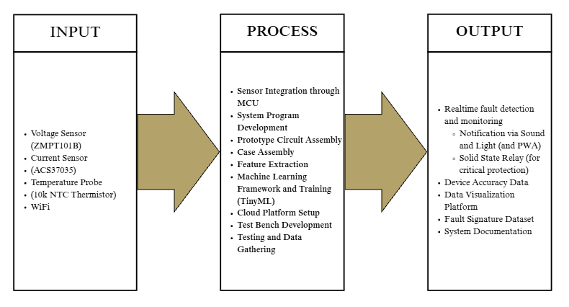
Figure 3.1. Conceptual framework of the TinyML Smart Plug.

Figure 3.1 presents the conceptual framework of the TinyML Smart Plug using an input-process-output structure. The input stage consists of the sensing and communication components used by the prototype, including the voltage sensor, current sensor, temperature probe, and Wi-Fi module. These inputs allow the system to acquire electrical and thermal conditions from the socket and load during operation. In the process stage, the acquired signals are integrated into the system program, converted into protection variables and waveform features, and used for machine-learning-based fault evaluation. This stage also includes prototype assembly, case assembly, cloud platform setup, firmware and model training, and testing and data gathering, which together support the development and validation of the smart plug. The output stage represents the expected functions and deliverables of the system, including real-time fault detection and monitoring, sound and light notification, relay-based circuit isolation, device accuracy data, data visualization, platform development, fault-signature dataset generation, and system documentation. The framework shows that the prototype was designed not only as a monitoring device, but as a complementary protection system capable of sensing abnormal socket conditions, processing them locally, notifying the user, logging relevant data, and opening the relay when a confirmed critical fault is detected.
The design variables used by the system are summarized in Table 3.1. The table separates direct measurements from computed variables so that later equations can be traced to the firmware implementation.
Table 3.1. Main firmware variables used by the prototype
Variable group | Source | Application
RMS voltage | ZMPT101B channel and voltage calibration | Voltage monitoring, mains-present logic, undervoltage and overvoltage protection
RMS current | ACS37035 channel, MCP3204 ADC, anti-aliasing filter, and current calibration | Load monitoring, overload protection, thermal load term, and arc-feature extraction
Device temperature measurement | 10k$Ω$ thermistor and divider computation | Baseline thermal measurement for socket-temperature estimation
Waveform features | Current samples processed by the arc-detection module | Context classification and Random Forest arc inference
Protection state | Protection manager and relay driver | Warning, latching, relay disconnection, and event logging
Table 3.1 shows that current is used by several subsystems: it supports ordinary overload detection, thermal compensation, and the TinyML feature vector. Therefore, the current channel was treated as a shared measurement path whose calibration and sampling behavior must remain consistent across protection functions.

3.1.2 System Architecture
The same behavior can be described as a layered embedded system. The sensing layer captures voltage, current, and socket temperature; the firmware layer computes calibrated variables and protection states; the TinyML layer provides context-aware series-arc inference; and the PWA layer displays live and historical data using Firebase services [55], [56].
Figure 3.2 presents the system architecture used to connect these layers.
Figure 3.2. System architecture of the TinyML Smart Plug.

Figure 3.2 places the ESP32-S3 at the center of the design. The microcontroller receives conditioned analog signals, runs the protection and TinyML routines locally, drives the relay and indicators, and uploads selected telemetry. Firebase and the PWA also carry basic remote control fields, such as fault clearing and relay-control commands, but these commands do not replace the local protection logic. Keeping the protection decision on the microcontroller prevents the relay action from depending on internet availability, while the cloud and PWA remain useful for visualization, logging, labeling, review, and operator interaction.

3.2 Program and Firmware Flow
This section introduces the firmware flow that connects the measured hardware signals to the protection and reporting behavior. The discussion follows the same order used by the embedded program: initialization, repeated sampling and feature computation, state evaluation, relay actuation, and cloud/PWA updates.

3.2.1 Initialization and Sampling
The firmware follows a repeated acquisition, computation, inference, and protection cycle. On startup, the ESP32-S3 initializes the sensors, relay driver, OLED display, buzzer, Wi-Fi, Firebase interface, and local protection state. In the main loop, it samples the voltage, thermistor, and current waveform, applies calibration and filtering, computes thermal and waveform features, updates the context classifier, evaluates the arc classifier, and passes the resulting variables to the protection manager.
Figure 3.3 shows the operating sequence implemented by the firmware.
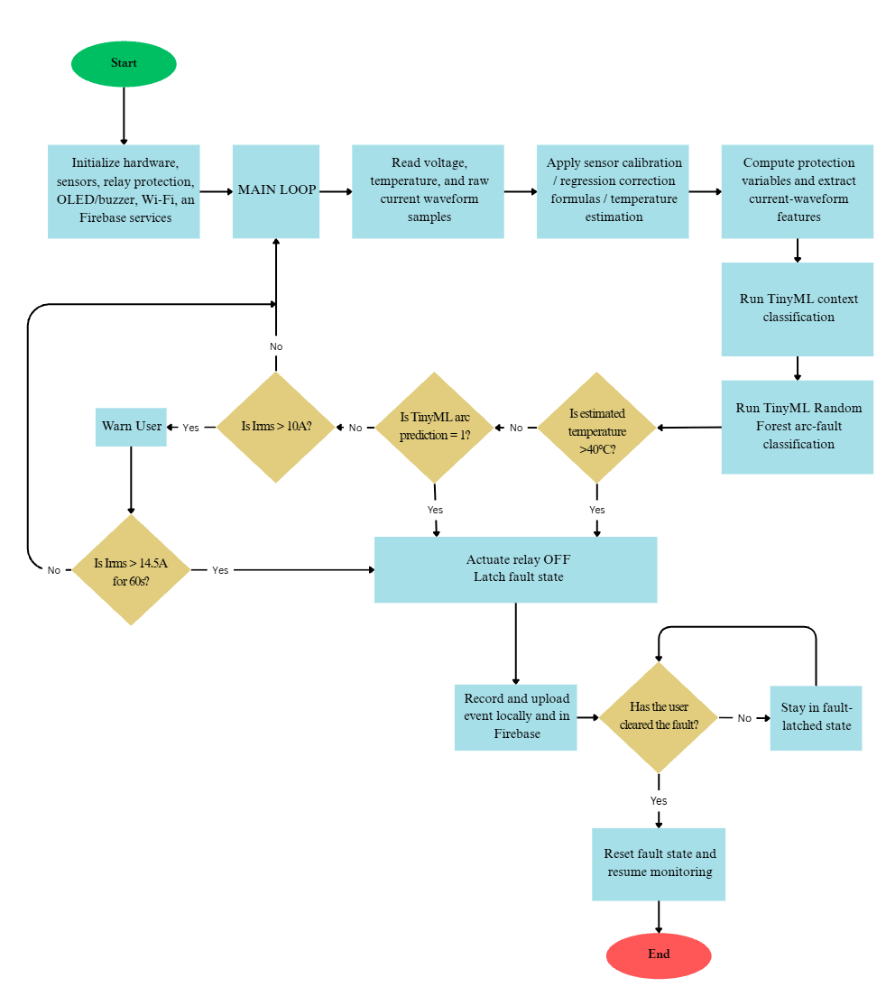
Figure 3.3. Program flowchart of the TinyML Smart Plug firmware.
The flowchart separates slow supervision from waveform-based inference. RMS voltage, RMS current, and thermistor temperature are updated for ordinary monitoring and deterministic protection. In parallel, the current waveform is sampled at the higher ADC rate, conditioned, framed, and converted into candidate waveform features. Usable feature frames update the load-context classifier first; the accepted load-family code and confidence are then appended to the arc-model input vector before Random Forest inference. The result is not used as a single-frame trip command. It is passed to the protection manager, where persistence counters, blanking intervals, and fault latches determine whether the relay should remain energized, warn the user, or disconnect the load. Another is that since the system targets fire-inducing faults, thermistor temperature is treated with the highest priority because it is the most direct indicator of socket heating. Arc-fault inference is evaluated next because waveform discontinuities and intermittent conduction can produce localized heating even before a sustained current burden is established. Overload protection is handled after these conditions because excessive current is treated as a time-dependent stress that requires persistence before relay action. Thus, the protection manager resolves the fault sequence by prioritizing temperature, then arc fault, and then overload.

3.2.2 Protection-State Evaluation
Figure 3.3 shows that a relay trip can be caused by a sustained overload, an estimated socket over-temperature, or an arc-fault classification. The overload path issues a warning above 10.0A, but relay disconnection is based on persistence above 14.5A. This persistence is implemented as a score that increases every 10s while the condition remains active and trips when the score reaches 6, equivalent to approximately 60s of sustained overload. This makes the overload behavior closer to inverse-time protection logic than to an instantaneous cutoff [22].
The socket-heating path compares the estimated socket temperature with thermal warning and trip thresholds. The voltage path provides abnormal-supply supervision and relay response where implemented, but it is not presented as a replacement for a surge protective device, AVR, GFCI, AFCI, branch-circuit breaker, or certified wiring protection. The firmware also latches fault states. After relay disconnection, the event is recorded locally and uploaded when the network is available. The plug remains in the fault state until the user clears the fault through the device or application workflow. This prevents a hazardous load from being automatically re-energized after a transient communication or reset event.

3.2.3 Timing Constants
The sampling, protection, and reporting constants used by the firmware are listed in Table 3.2. These values were taken from the firmware configuration file and the current-feature implementation, so they describe the deployed firmware behavior rather than nominal design wishes.
Table 3.2. Selected firmware timing and sampling constants
Constant | Value | Role
Target current sampling rate | 27,000Hz | Current waveform acquisition for feature extraction
Arc runtime frame length | 512 samples | FFT and time-domain feature window, approximately 18.96ms at the target sampling rate
Arc runtime hop length | 256 samples | Overlap between consecutive feature frames, approximately 9.48ms per hop
Feature emission cadence | Every 3 hops | Approximate 35.16Hz feature output rate for logging and inference
MCP3204 SPI clock | 1.2MHz | 12-bit current ADC transfer clock
Voltage sampling interval | 250$μ$s | Firmware voltage-window acquisition interval
Load-context acquisition window | 5s | Time allowed for stable load-family estimation before latching context
Overload warning threshold | 10.0A | Local warning level before sustained overload trip scoring
Sustained overload trip threshold | 14.5A | Current level used by the relay-trip persistence score
Sustained overload score timing | 6 steps at 10s | Approximately 60s of sustained overload before relay trip
Socket-temperature trip threshold | 40$​^{∘}C$ | Estimated socket-temperature threshold used by thermal protection
Arc persistence counter | +2, -6, trip at 8 | Leaky counter that requires repeated arc-positive frames before relay action
Arc hold interval | 800ms | Short hold after arc indication to stabilize the protection state
Cloud live update interval | 10s normal, 5s fault | Firebase/PWA telemetry cadence, slower than local protection evaluation

Table 3.2 explains why the current path is handled separately from slow telemetry. Arc-fault detection requires waveform frames with millisecond-scale timing, while Firebase updates and PWA displays operate at a slower human-monitoring cadence. Consequently, relay protection does not wait for Firebase or the PWA; the remote interface records, visualizes, and sends basic control fields, while the local firmware evaluates the safety states on the device.

3.2.4 Data Logging and PWA Communication
The monitoring system was implemented as a PWA connected to Firebase. The PWA was not placed in the protection path; the ESP32-S3 still made relay decisions locally. The PWA instead provided live measurements, protection status, event history, CSV download, labeling support, and review of waveform-derived features. This separation allowed the prototype to remain protective during network loss while still supporting data collection and analysis.
Figure 3.4 shows the PWA and Firebase data path.
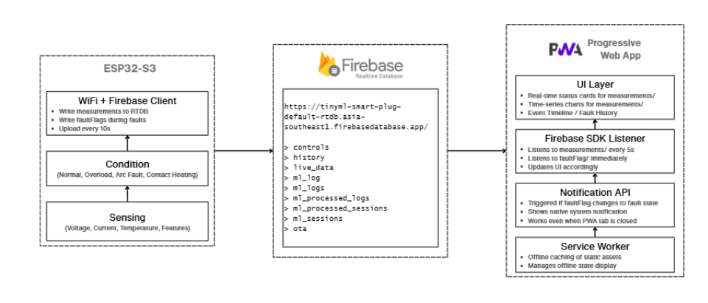
Figure 3.4. PWA block diagram and Firebase data path.

Figure 3.4 shows that the firmware publishes selected telemetry to Firebase, while the browser-based PWA subscribes to the same data for display and logging. The Firebase tree also includes control fields used for basic operator commands, such as clearing faults or relay control; however, the protection decisions and trip persistence remain local to the ESP32-S3. This arrangement matches the PWA role described in Firebase documentation: the web client improves access and installation behavior, but the embedded device remains responsible for field decisions [55], [56].
The live dashboard used during testing is shown in Figure 3.5.
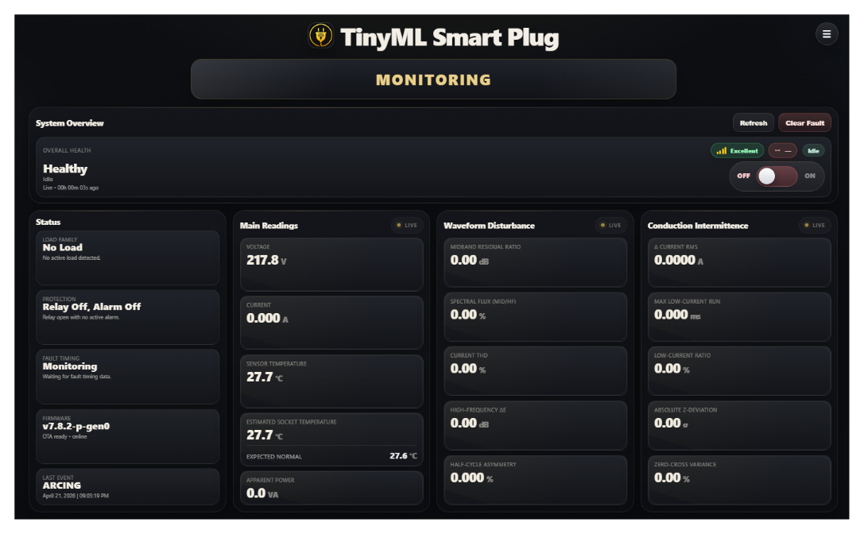
Figure 3.5. Actual PWA live dashboard.

Figure 3.5 displays the status and protection state, the main measurements, displays waveform-disturbance features, and displays conduction-intermittence features. The dashboard intentionally distinguishes the device temperature measurement from estimated socket temperature because the relay-facing thermal decision uses the compensated estimate, not the raw thermistor reading alone.
The event-history page is shown in Figure 3.6.
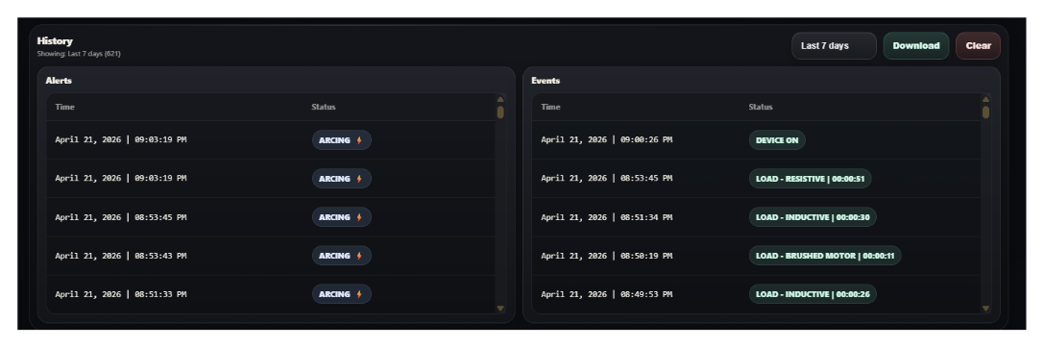
Figure 3.6. Actual PWA history-log view.
Figure 3.6 documents the alert and event list. The history function was useful for checking whether the firmware sequence matched the expected warning, persistence, and latching behavior during overload, heating, and arc-fault trials.

3.2.4.1 Telemetry Fields
The PWA displayed only a selected subset of firmware variables. The most important telemetry fields are listed in Table 3.3.
Table 3.3. Selected telemetry fields shown in the PWA
Field | Firmware source | Interpretation
Voltage and current | Calibrated sensor routines | Electrical state of the connected load
Device temperature measurement | Thermistor routine | External temperature at the sensor position
Estimated socket temperature | Thermal estimator | Protection-facing estimate of socket temperature
Arc probability and class | Random Forest inference | TinyML arc-fault decision support
Context family and confidence | Context prototype model | Load-family estimate used by arc-threshold selection
Relay and fault state | Protection manager | Whether the load is energized or latched off

Table 3.3 shows that the PWA was both an operator display and a research instrument. During data collection, these fields allowed the researchers to compare raw measurements, computed estimates, and protection outputs in the same session record.

3.3 Physical Setup and Hardware Implementation
The physical setup translates the system model into the actual prototype used for testing. This section introduces the hardware blocks, full schematic, signal-conditioning path, enclosure arrangement, and component roles before the calibration and protection computations are presented.

3.3.1 Sensing Subsystems and Hardware Blocks
The physical implementation combined a line-side plug, protected outlet, solid-state relay module, ESP32-S3 controller, voltage sensor, current sensor, NTC thermistor, anti-aliasing circuit, backup supply, OLED display, buzzer, and enclosure. The hardware was organized so that mains conductors, sensing circuits, low-voltage logic, and user-interface wiring could be traced separately during testing.
Figure 3.7 gives the hardware block-level view before the detailed schematic is introduced.
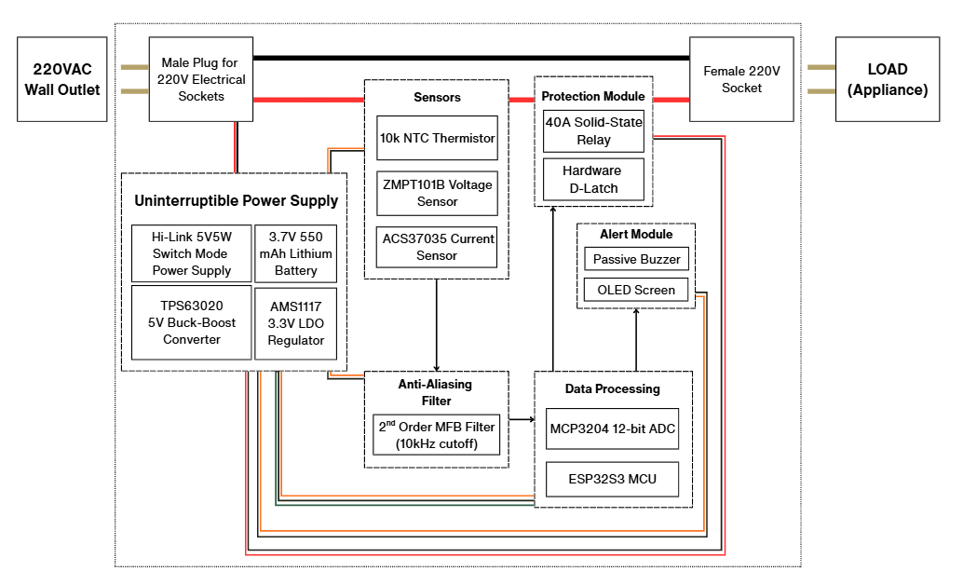
Figure 3.7. Block diagram of the prototype hardware.
Figure 3.7 shows the main hardware path of the prototype before the detailed schematic is introduced. The $220V_{AC}$ input enters through the male plug and is routed to the protected female socket through the 40A solid-state relay, which serves as the final protective actuator before the load. The voltage, current, and temperature sensors monitor the socket condition, while the anti-aliasing filter and MCP3204 SAR ADC prepare the current waveform for processing by the ESP32-S3. The isolated power supply provides the required 5V, 3.3V, and backup battery rails for the sensing, processing, relay, and alert modules. This arrangement allows the firmware and hardware latch to remove power from the protected outlet and activate the buzzer and OLED notification once a protection condition is confirmed.

3.3.2 Full Schematic Discussion
The full circuit schematic is shown in Figure 3.8.
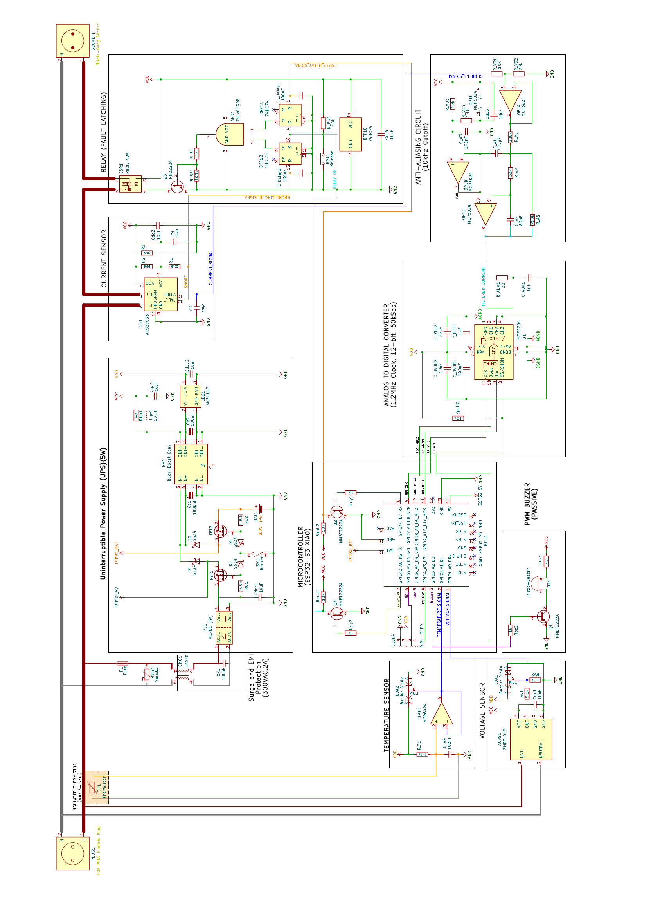
Figure 3.8. Full schematic of the TinyML Smart Plug prototype.

Figure 3.8 presents the complete hardware implementation of the TinyML smart plug prototype. The schematic is discussed according to the circuit flow: AC input protection, low-voltage power conversion, voltage, current, and temperature sensing, signal conditioning, analog-to-digital conversion, ESP32-S3 processing, relay fault latching, and user notification. Appendix B provides the detailed board-layout views, while this section explains how each block contributes to sensing, protection, and prototype operation.
The AC input enters through the line-side plug and is routed first to the input-protection stage. A fuse interrupts abnormal overcurrent conditions, while a varistor suppresses transient overvoltage events on the line. After this stage, the live and neutral conductors continue toward the relay-controlled outlet and the internal power-supply circuit. This places the first hardware protection layer before the load and before the low-voltage electronics.
The power-supply section converts the mains input into the regulated rails used by the controller and sensing circuits. These rails supply the ESP32-S3, ADC, operational amplifiers, sensors, OLED display, buzzer, and relay-control logic. Diode-isolated routing and local regulation help provide stable low-voltage power. The rocker-switch path also uses MOSFET switching to reduce the exposure of the regulated control rail to mechanical switch sparks, contact bounce, and switching transients during manual switching.
The voltage-sensing path uses the ZMPT101B voltage sensor to provide a scaled representation of the AC line. This signal is used by the firmware for RMS-voltage monitoring and mains-present detection. Through this path, the ESP32-S3 can determine whether the outlet is energized, whether the mains has vanished, and whether voltage has returned after an interruption, supporting relay-state handling, fault recovery, and data interpretation.
The current-sensing path uses the ACS37035 current sensor placed in series with the load. Its analog waveform is the main input for RMS-current computation, overload monitoring, waveform-feature extraction, and arc-related analysis. The same sensor also provides a hardware short-circuit output. In this prototype, that output was configured at $28.28A_{pk}$, equivalent to $20A_{RMS}$ for a sinusoidal waveform. This pin was included as a backup relay-trip layer independent of the firmware decision, although it was not formally tested during validation.
The measured current waveform is routed to the anti-aliasing and signal-conditioning stage before digitization. This stage limits unwanted high-frequency components and prepares the waveform level for the ADC input. The conditioned signals are digitized by the MCP3204 analog-to-digital converter and transferred to the ESP32-S3 through the SPI interface lines SDI-MOSI, SDO-MISO, SPI_CLK, and CS_ADC. This bridges the analog sensing circuits and the digital protection firmware.
The ESP32-S3 XIAO is the central processing section of the prototype. It receives digitized waveform data, evaluates voltage and current conditions, reads the temperature input, executes the local protection logic, controls the relay command, drives the OLED display, activates the buzzer, and handles wireless monitoring and logging. The thermistor is installed near the plug-side wire-contact region to observe localized socket heating. During installation, the sensing point was insulated with Kapton tape, coupled using thermal paste, secured with another Kapton layer, and covered with electrical tape to reduce ambient-air influence on the reading.
The relay circuit acts as the output actuator that connects or disconnects the protected socket from the input line. It is not driven directly as a simple ESP32-S3 output. Instead, the relay command passes through a hardware fault-latching circuit so that a detected fault remains stored after the relay opens. This is necessary because opening the relay can remove the measured fault from the sensor inputs. Without a latch, the device could repeatedly close the relay, detect the same fault, and reopen the relay.
The relay-latching circuit uses two sections of the 74HC74 D flip-flop and an AND-gate stage. One latch stores the ESP32-side relay or fault command, while the other stores the short-circuit command from the current-sensor side. The relay is allowed to close only when both paths indicate that no fault is present. Thus, the AND-gate stage implements the De Morgan equivalent of a NOR-style fault decision: the relay remains enabled only when there is no firmware-side fault and no current-sensor short-circuit fault.
The notification section uses a transistor-driven buzzer controlled by the ESP32-S3. The buzzer was driven using PWM so that different duty cycles and pulse patterns could indicate different alert states instead of relying on a single fixed warning tone. Several delicate low-voltage nodes also include BAT54S clamp-diode protection to limit abnormal voltage excursions before they reach the microcontroller, ADC, or sensing interfaces.
The schematic and Appendix B board-layout figures should be interpreted as prototype-development documents for bench validation. They do not by themselves certify creepage distance, clearance distance, enclosure safety, thermal safety, regulatory compliance, or suitability as a replacement for listed protective devices.

3.3.3 Signal Conditioning and Enclosure Implementation
The anti-aliasing circuit and its frequency response are shown in Figures 3.9 and 3.10.
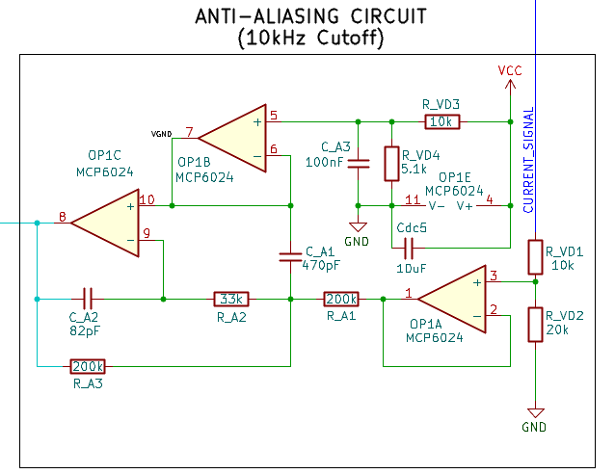
Figure 3.9. Second-order multiple-feedback low-pass anti-aliasing circuit.

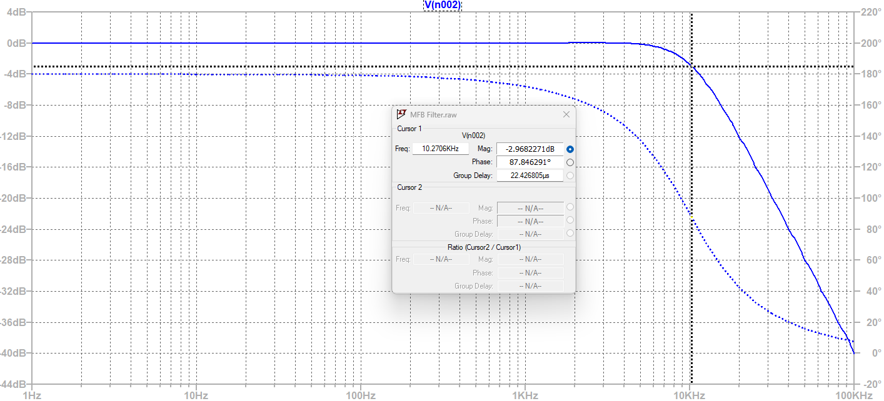
Figure 3.10. Bode response of the anti-aliasing filter.

Figure 3.9 shows the analog low-pass filter placed between the current sensor and the ADC. Figure 3.10 verifies that the filter attenuates higher-frequency content before sampling. The implemented firmware also applies a digital soft anti-aliasing filter in the current-feature path, so the analog and digital filters work together rather than as isolated design elements [57].
The frequency-setting values shown in Figure 3.9 were checked against the standard second-order low-pass relationship
$$f_{0}=\frac{1}{2π\sqrt{R_{1}R_{2}C_{1}C_{2}}}.$$
Using the schematic values $R_{1}=200kΩ$, $R_{2}=33kΩ$, $C_{1}=470pF$, and $C_{2}=82pF$ gives
$$f_{0}=\frac{1}{2π\sqrt{(200kΩ)(33kΩ)(470pF)(82pF)}}≈9.98kHz.$$
This agrees with the plotted cutoff region in Figure 3.10, where the simulated response is approximately -3dB near 10kHz. Since a second-order Butterworth response has $Q≈0.707$ and reaches the -3dB point at its natural frequency, the plotted response was treated as a near-Butterworth anti-aliasing stage rather than a high-Q peaking filter. The firmware’s additional digital filter uses a similar low-peaking setting ($Q=0.73$) before feature extraction.
The op amp for this stage must support single-supply operation at the available logic rail, input and output swing around the mid-supply bias, unity-gain-stable active-filter operation, and enough bandwidth and slew-rate margin for a 10kHz cutoff [57]. For a conservative 3.3V peak-to-peak signal, the minimum sinusoidal slew rate is
$$SR_{min}=2πfV_{p}=2π(10kHz)(1.65V)≈0.104V/μs.$$
The MCP6024-class device indicated in the schematic satisfies this application class because it is a rail-to-rail input/output, unity-gain-stable, 10MHz single-supply op amp family [76]. These checks support waveform acquisition for the prototype tests, but they do not replace full analog compliance testing of the assembled board.
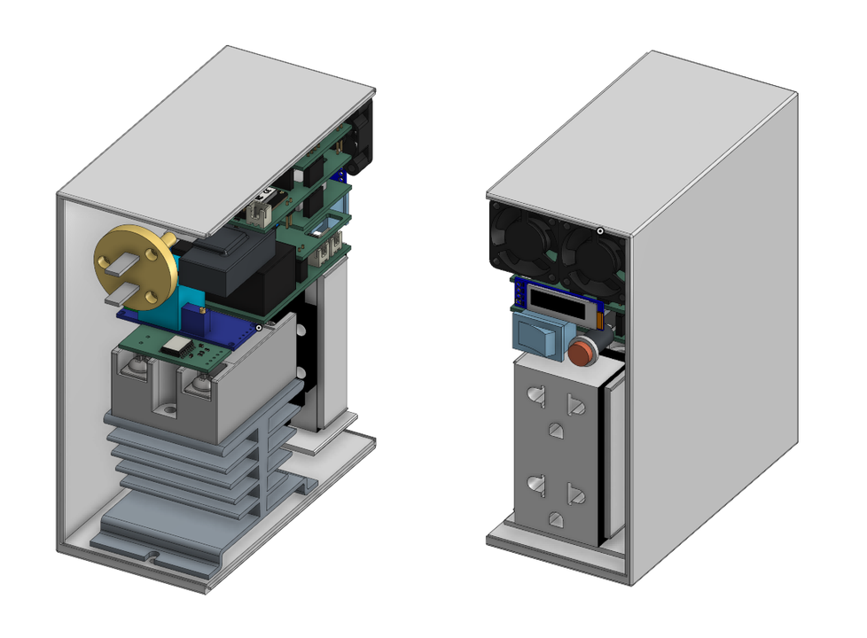
Figure 3.11. Three-dimensional model of the prototype without the case.

Figure 3.11 was used to check the relative placement of the PCB, outlet, relay, fan, and front-panel controls before final enclosure assembly. This reduced the chance that the enclosure would interfere with airflow, wiring, or user access.
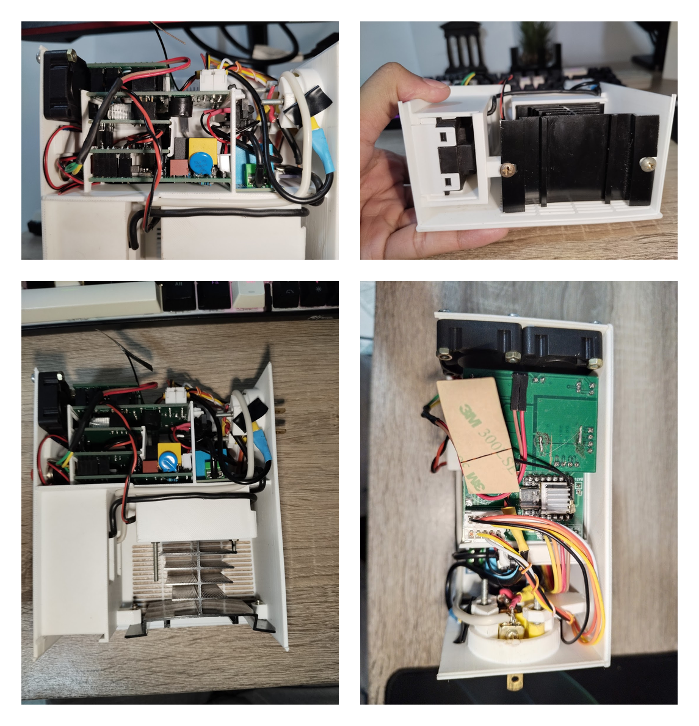
Figure 3.12. Actual prototype assembly without the case.
Figure 3.12 confirms that the physical wiring followed the planned internal organization. The exposed view was used during bench testing to probe the sensing, supply, relay, and communication subsystems.
The enclosure model is shown in Figure 3.13. It shows the intended user-facing arrangement: outlet access, front controls, ventilation, and rear plug connection. The enclosure therefore served both a mechanical and an operator-interface purpose.
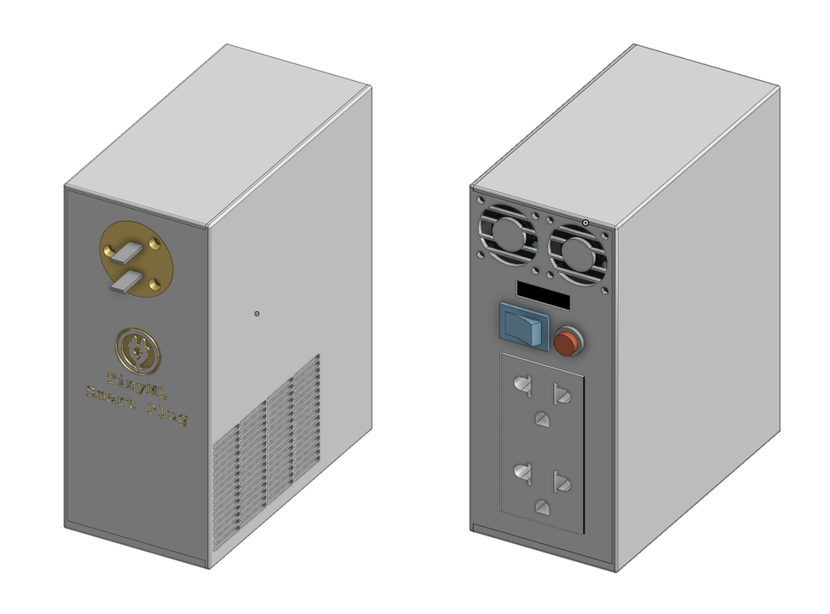
Figure 3.13. Three-dimensional model of the prototype with the case.
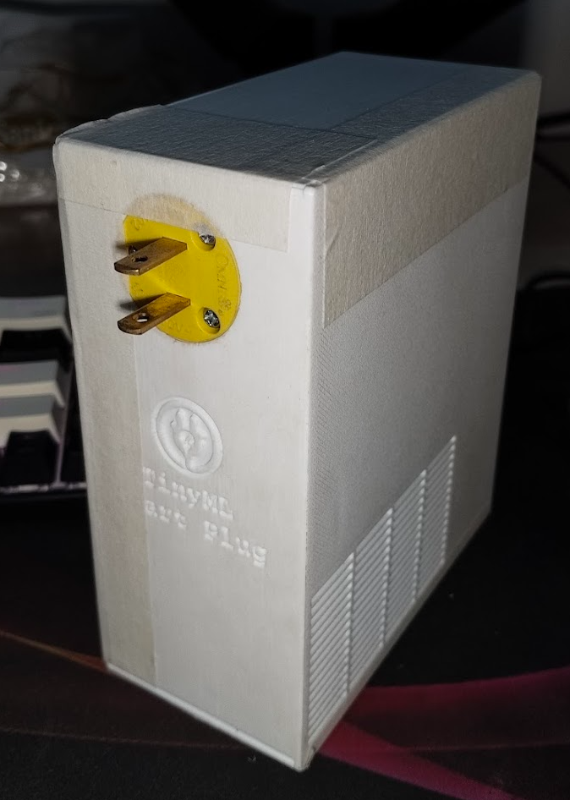  (a) Plug side | 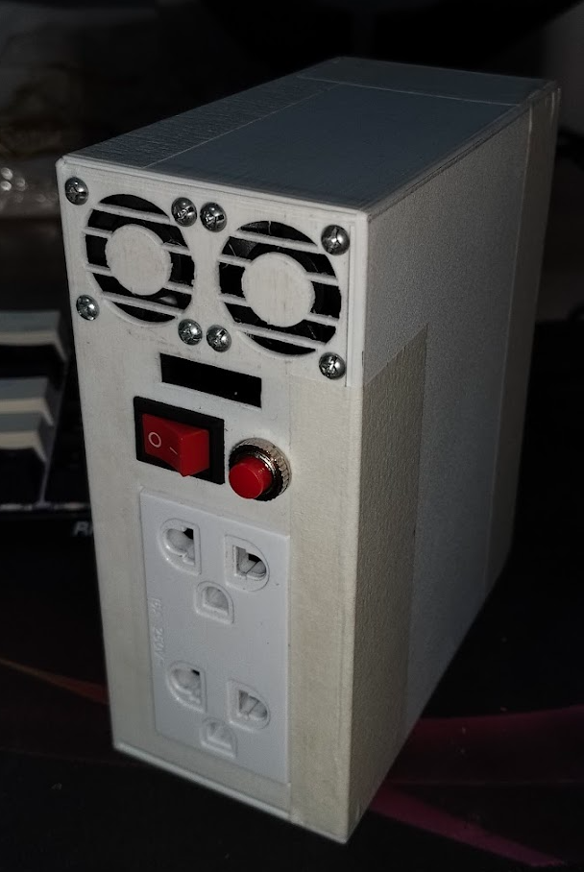  (b) Outlet and control side
Figure 3.14. Actual prototype with the case installed.
The completed enclosed prototype is shown in Figure 3.14. Figure 3.14(a) shows the plug side of the completed device, while Figure 3.14(b) shows the outlet, fan vents, and front-panel controls. This view documents the final physical form used for the overload, socket-heating, and series arc-fault tests described later in this chapter.
The major hardware elements are summarized in Table 3.4.
Table 3.4. Major hardware elements of the prototype
Subsystem | Components | Application
Microcontroller | ESP32-S3 | Local computation, Wi-Fi communication, TinyML inference, relay control
Voltage sensing | ZMPT101B module | RMS voltage measurement and voltage protection input
Current sensing | ACS37035 with MCP3204 ADC | RMS current measurement and waveform-feature source
Temperature sensing | 10k$Ω$ thermistor | Device temperature measurement for thermal estimation
Protection actuator | Solid-state relay module | Load disconnection after latched protection condition
User interface | OLED, buzzer, LEDs, PWA | Local and remote warning and monitoring

Table 3.4 shows that the prototype combines conventional sensing and switching hardware with local embedded inference. The hardware alone does not determine the protection behavior; the firmware computations in the following sections define how the raw signals are interpreted.

3.4 TinyML Development and Deployment Workflow
The TinyML workflow used logged current-waveform features to train two embedded models: a load-context model and a series arc-fault model. The context model estimated the appliance family during the early stable portion of a load run. Its load-family output was then used as an input to the arc model, where it was encoded as context fields. The arc model combined selected arc-sensitive features with that context output to classify whether a frame was consistent with a series arc fault. Random Forest classification was selected because it can model nonlinear feature interactions while remaining exportable as a compact tree ensemble for microcontroller execution [68], [69].
Figure 3.15 shows the data-logging, labeling, training, and deployment path used by the project.
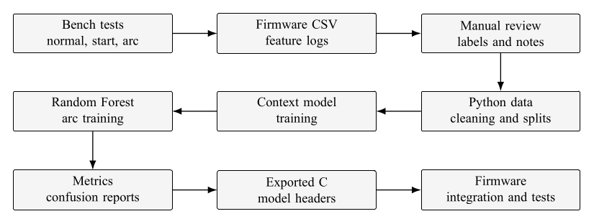
Figure 3.15. Data logging, labeling, and TinyML deployment workflow.

Figure 3.15 shows that the training workflow was not performed directly on the microcontroller. The firmware generated CSV records from bench tests, the records were reviewed and labeled, and Python scripts then cleaned the rows, formed training and test splits, trained the context and arc models, computed confusion reports, and exported C headers. The final embedded test was therefore a deployment check of the exported headers inside the firmware, not a new training step on the ESP32-S3. This follows the usual TinyML pattern of offline training followed by resource-constrained on-device execution [43], [73].
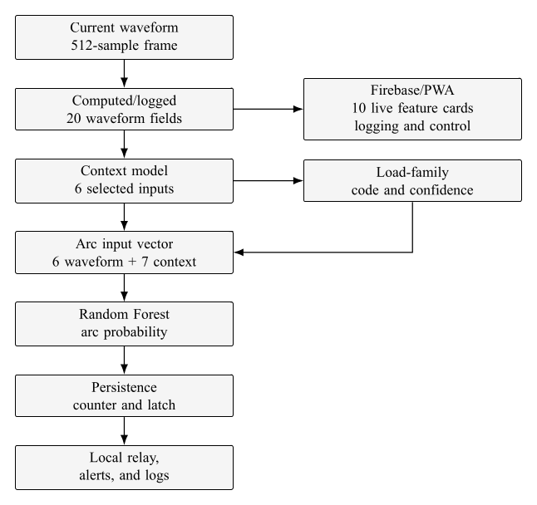
Figure 3.16. TinyML processing sequence from feature logging to embedded inference.

Figure 3.16 shows that the firmware computes feature fields first, then updates context, then evaluates the arc classifier. This order is important because the deployed arc header includes both waveform features and context fields. The load-family result is therefore not only a display label; when confidence is sufficient, it becomes part of the input context supplied to the arc model. The flowchart also separates three feature sets: the candidate fields computed and logged by the firmware, the six base waveform features selected for the deployed arc model, and the 10 live feature cards shown by the PWA. A broader 14-feature order remains in the PWA metadata and session viewer for historical review and CSV inspection.
Arc labels were assigned from logged waveform sessions. The labeling interface is shown in Figure 3.17.
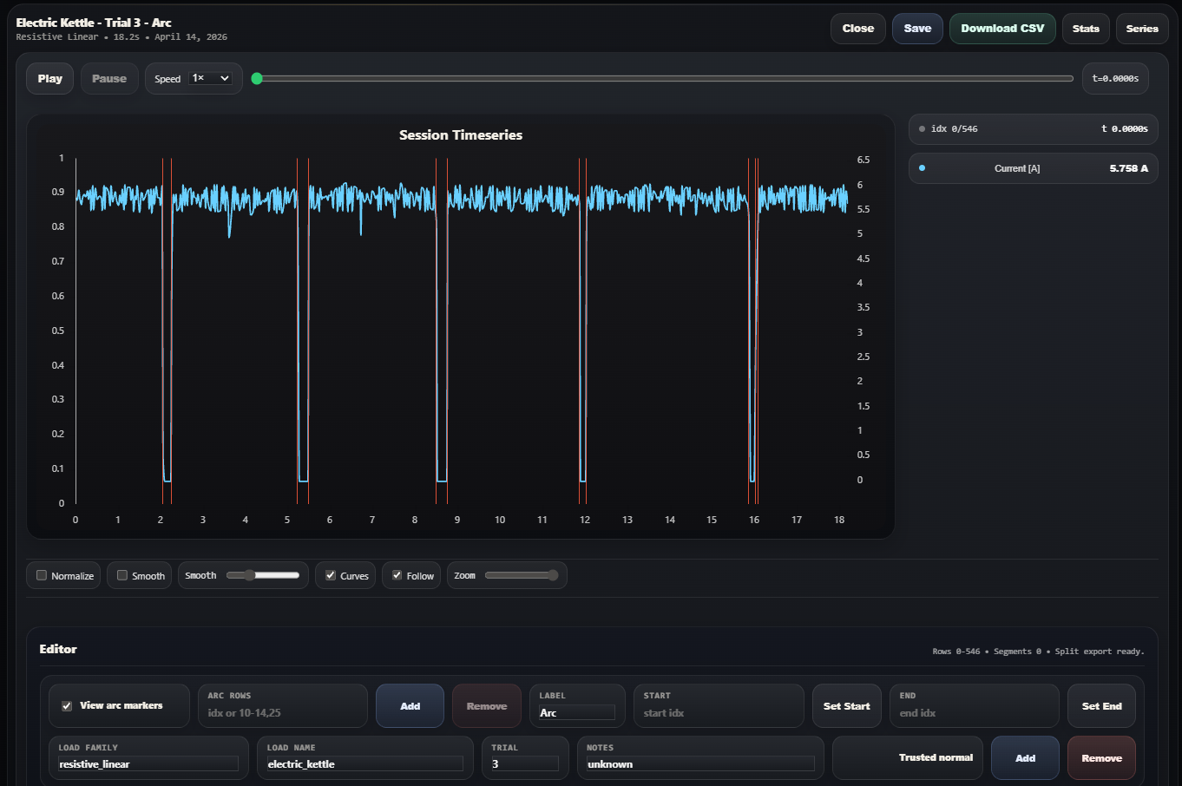
Figure 3.17. Arc labeling using logged waveform data.

Figure 3.17 shows how the arc windows were marked from the collected logs. This manual labeling step was necessary because series arcs are sparse and brief relative to normal operating frames. The cleaning script prepared separate trainable datasets for arc detection and load-context classification from these records.
The local Python trainer used for model development is shown in Figure 3.18.
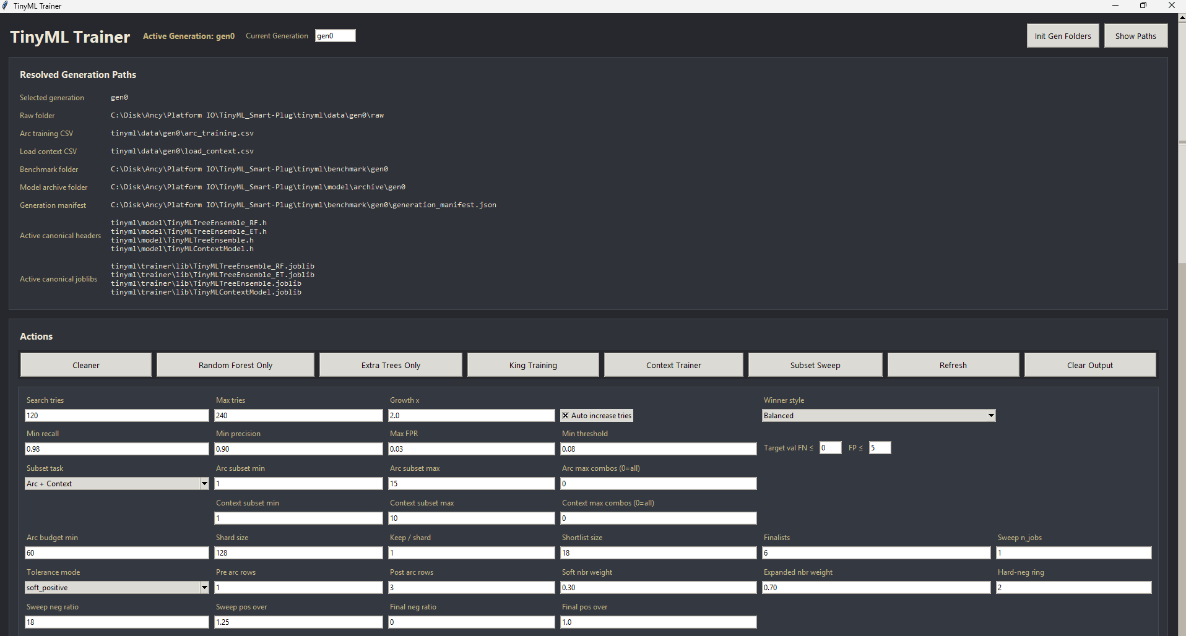
Figure 3.18. Local Python TinyML trainer.
Figure 3.18 documents the offline training environment used to prepare the exported embedded model files. The workflow used separate data preparation, context-model training, Random Forest training, shared TinyML utility, and generation-path routines as the source of truth for feature selection, data splits, hyperparameter search, metric computation, and embedded export. The dataset-preparation, training-report, and exported embedded-model summaries are provided in Appendix F.2.

3.4.1 Context Model
The deployed context model is a centroid or prototype classifier, not a Random Forest. The context model defines six input features: $ΔI_{rms}$, half-cycle asymmetry, midband residual ratio, current THD, mid/high-frequency spectral flux, and high-frequency energy delta. During runtime, the firmware averages usable feature frames over the acquisition interval, standardizes each averaged feature, computes the squared Euclidean distance to each family centroid, and applies a softmax to the negative distances:
$$p_{c}=\frac{exp(-d_{c}^{2})}{\sum_{j=1}^{C}{exp}(-d_{j}^{2})}, d_{c}^{2}=\sum_{i=1}^{m}{{\left(\frac{x_{i}-μ_{i}}{σ_{i}}-q_{c,i}\right)}^{2}}.$$
In (3.4), $p_{c}$ is the context confidence for family $c$, $x_{i}$ is the averaged runtime feature, $μ_{i}$ and $σ_{i}$ are the training-set mean and standard deviation exported in the header, $q_{c,i}$ is the standardized centroid coordinate for family $c$, $m=6$ is the context input dimension, and $C=6$ is the number of load families. A family is accepted only when the best confidence is at least 0.45; otherwise, the context remains unknown.
The context acquisition constants in the firmware require a load to remain active before the context is latched. A provisional context may be used after the minimum acquisition period, and the final context is latched after the configured 5s acquisition window when confidence is sufficient. This prevents brief startup artifacts from immediately forcing a load family into the arc classifier.

3.4.2 Arc Model
The deployed series-arc classifier is the Random Forest used by the embedded arc model. The deployed Random Forest arc model defines 13 inputs: six base waveform features, six one-hot context-family fields, and one context confidence field. The base features are maximum low-current run, zero-dwell ratio, low-current ratio, absolute RMS-current z-score relative to baseline, midband residual ratio, and mid/high-frequency spectral flux. These were selected because series arcs can produce current interruption, restrike spikes, cycle-to-cycle waveform disturbance, and broadband spectral changes [34], [35], [50], [53].
The deployed arc decision is summarized in Table 3.5.
Table 3.5. Deployed Random Forest arc-model settings
Item | Deployed value | Source or role
Model type | Random Forest | Exported tree ensemble from the local training workflow
Input dimension | 13 | Six waveform features plus seven context fields
Base feature count | 6 | Arc-sensitive features used before context fields
Default arc threshold | 0.4800 | Probability threshold for supported context families
Context confidence minimum | 0.4500 | Minimum accepted context confidence
Unknown-context threshold | 0.7800 | More conservative threshold when context is unknown
Unknown minimum feature votes | 3 | Additional runtime safeguard for unknown-context decisions

Table 3.5 shows that the deployed inference was context-aware. The model used lower thresholds for selected known families and a higher threshold for unknown context, reducing nuisance trips when the load family could not be established confidently. The firmware then passed the arc classification to the protection manager, where a leaky counter required persistence before relay disconnection.

3.4.3 Feature Selection for the Deployed Arc Model
The exported firmware header is the source of truth for the deployed feature selection. It defines 13 arc-model inputs: six waveform features and seven context fields. Therefore, this paper treats the context one-hot fields and context confidence as model inputs, but not as additional waveform features. The selected waveform features are maximum low-current run, zero-dwell ratio, low-current ratio, absolute RMS-current z-score relative to baseline, midband residual ratio, and mid/high-frequency spectral flux. The full computed/logged feature contract is given in Section 3.7.

3.4.4 Training Split and Model Evaluation
The Random Forest report shows that the final arc dataset was split into 35,512 training rows, 9,434 validation rows, and 10,268 test rows. The final training report used 5 cross-validation splits during search and reported the held-out test metrics after model selection. The best exported hyperparameters were 160 trees, maximum tree depth of 16, minimum leaf size of 4, minimum split size of 12, maximum feature fraction of 0.35, bootstrap sampling enabled, and entropy criterion. Train/test splitting, cross-validation, and confusion-matrix metrics are standard model-evaluation practices for supervised classification [69], [74].
The held-out test-set confusion matrix in the exported report contained 10,173 true negatives, 5 false positives, 25 false negatives, and 65 true positives. The corresponding frame-level accuracy, precision, recall, and F1-score were 99.7078%, 92.8571%, 72.2222%, and 81.25%, respectively. Event-level evaluation was also reported because arc faults occur in grouped episodes rather than as isolated independent frames; the event-level recall was 84.0%, with one false-alarm event in the test sessions.

3.5 Sensor Calibration and Computations
Sensor calibration converted raw sensor-derived values into engineering units used by the protection routines. Polynomial calibration was used for the voltage and current channels because the measured sensor outputs were not perfectly proportional to the reference instruments over the tested range. Ordinary least-squares regression estimates coefficients by minimizing the sum of squared residuals between the measured and fitted values [71]. The calibration coefficients below were verified from the firmware configuration. The raw calibration records are retained in Appendix A, specifically Tables [tab:app-a-voltage-calibration], [tab:app-a-current-calibration], and [tab:app-a-temperature-calibration].

3.5.1 Voltage Calibration
The voltage calibration setup is shown in Figure 3.19.
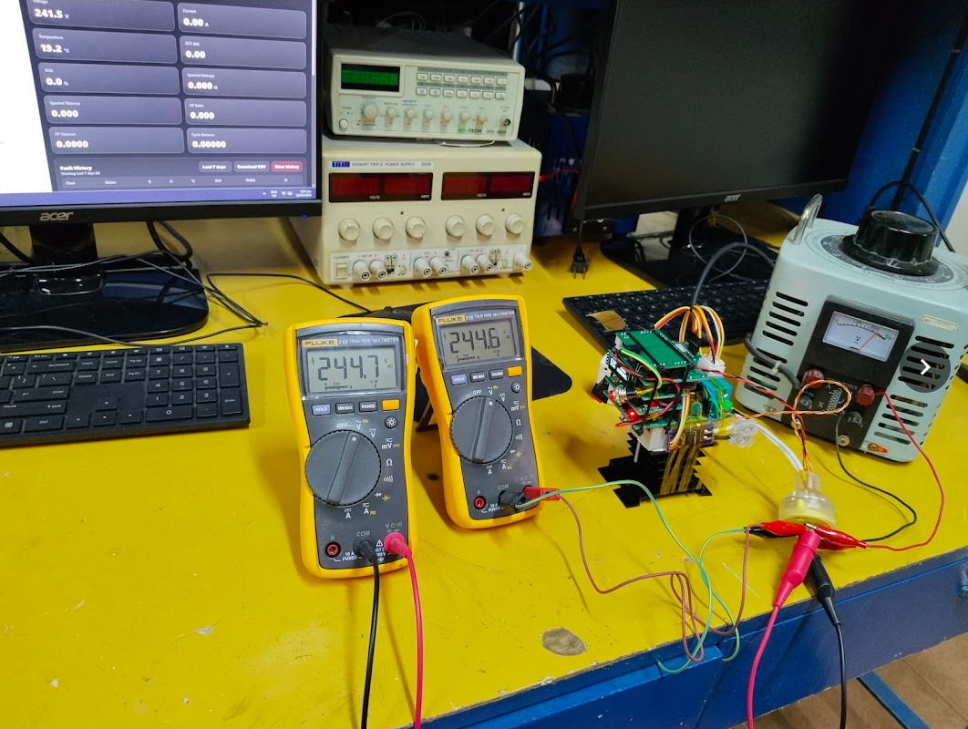
Figure 3.19. Data-collection setup for voltage calibration.

Figure 3.19 shows the prototype voltage channel being compared with reference multimeters while the applied voltage was varied. The calibration target was the reference RMS voltage, not the uncorrected sensor output.
The fitted voltage regression is shown in Figure 3.20.
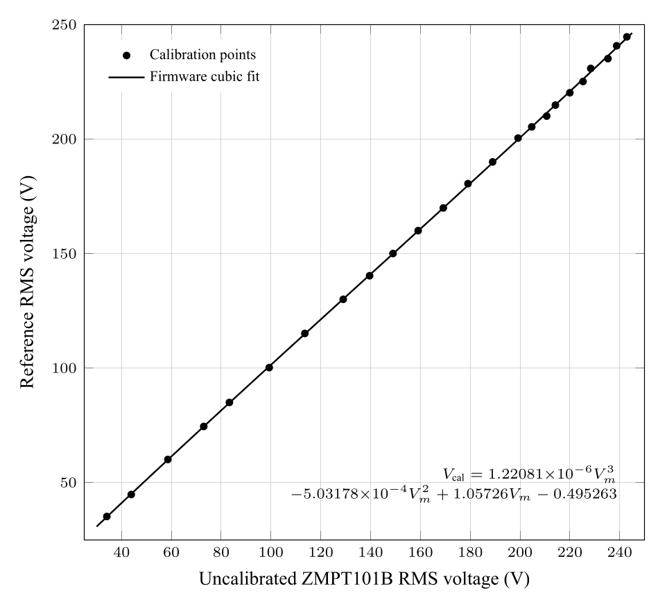
Figure 3.20. Cubic regression for voltage calibration.

Figure 3.20 supports the cubic correction used by the firmware. The implemented voltage calibration is
$V_{cal}=1.22081×{10}^{-6}V_{m}^{3}-5.03178×{10}^{-4}V_{m}^{2}+1.05726V_{m}-0.495263.$ (3.5)
In (3.5), $V_{m}$ is the measured RMS voltage before the cubic correction and $V_{cal}$ is the calibrated RMS voltage used for display and voltage protection. The polynomial correction is needed because threshold decisions such as undervoltage, overvoltage, and mains-present detection depend on the calibrated value.

3.5.2 Current Calibration
The current calibration setup and load combinations are shown in Figures 3.21 and 3.22.
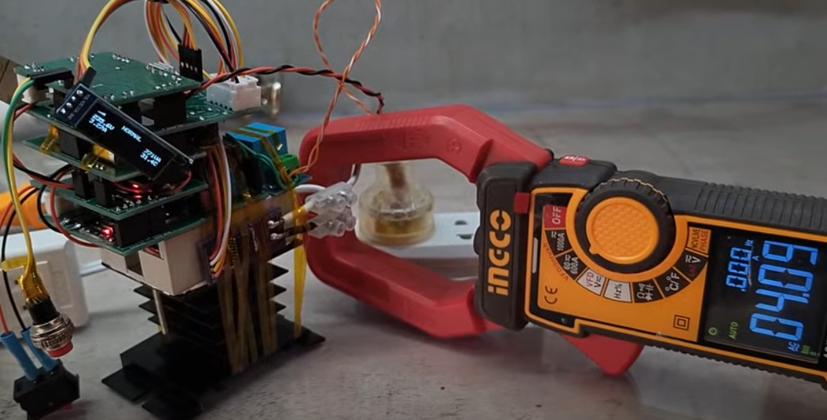
Figure 3.21. Data-collection setup for current calibration.

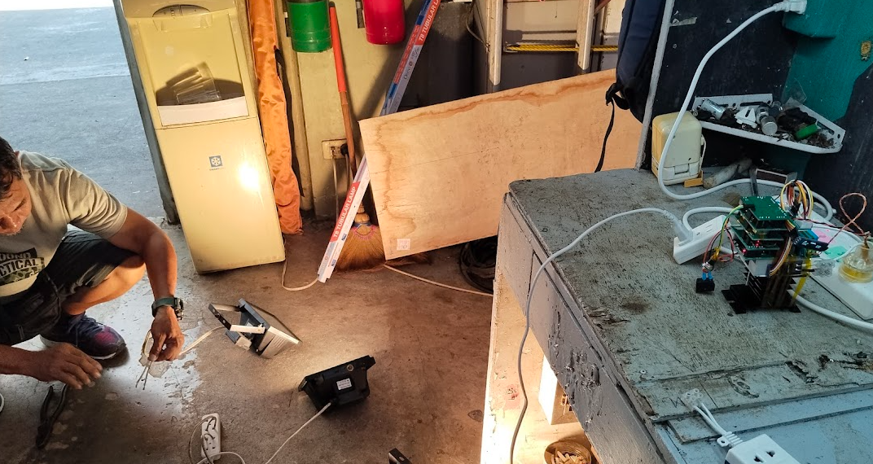
Figure 3.22. Load setups used for current calibration.

Figure 3.21 shows the comparison between the prototype current channel and a reference instrument. Figure 3.22 shows the different resistive and appliance loads used to span the current range needed for overload and arc-feature testing.
The fitted current regression is shown in Figure 3.23.
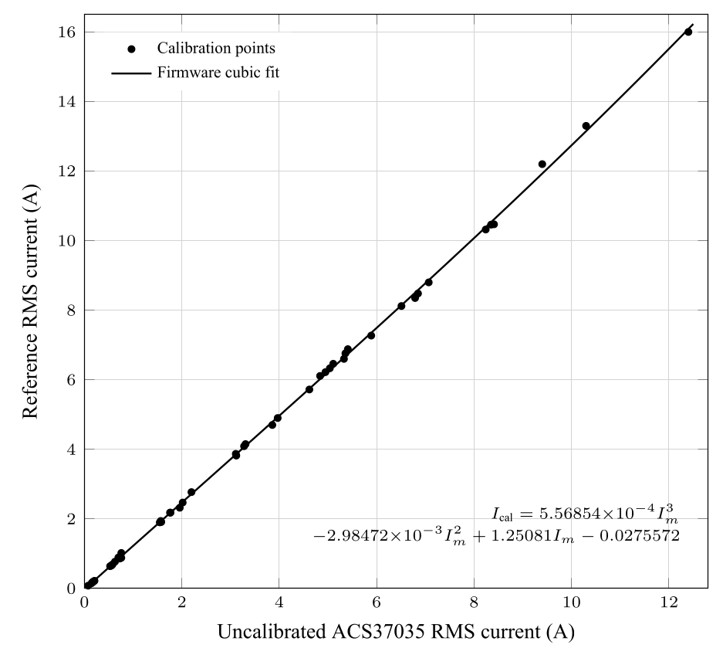
Figure 3.23. Cubic regression for current calibration.

The implemented current calibration is
$$I_{cal}=5.56854×{10}^{-4}I_{m}^{3}-2.98472×{10}^{-3}I_{m}^{2}+1.25081I_{m}-0.0275572. (3.6)$$
In (3.6), $I_{m}$ is the measured RMS current before the cubic correction and $I_{cal}$ is the calibrated RMS current used by the overload logic, socket-temperature model, and waveform-feature extractor. Negative fitted values are clamped to zero in firmware.
The device temperature measurement calibration setup is shown in Figure 3.24.

3.5.3 Device Temperature Measurement Calibration

Figure 3.24. Data-collection setup for device temperature measurement calibration.
Figure 3.24 shows the external thermistor measurement being compared with a reference temperature measurement. Thermistor placement is important because an external sensor can lag or under-read the hottest contact point inside a degraded socket [27], [29], [30]. The acquired temperature-resistance calibration points are listed in Table [tab:app-a-temperature-calibration].
The firmware computes the NTC resistance from the voltage-divider output:
$$R_{NTC}=\frac{V_{NTC}R_{D}}{V_{CC}-V_{NTC}}. (3.7)$$
In (3.7) $V_{NTC}$ is the measured divider voltage, $R_{D}=3.3kΩ$ is the fixed divider resistor, and $V_{CC}=3.3V$ is the divider supply. The resistance is then converted to temperature with the Beta equation:
$$T_{NTC}={\left[\frac{1}{T_{0}}+\frac{1}{β}ln\left(\frac{R_{NTC}}{R_{0}}\right)\right]}^{-1}-273.15. (3.8)$$
In (3.8), $T_{NTC}$ is in degrees Celsius, $T_{0}=298.15K$, $R_{0}=10kΩ$, and $β=4050$. The computed temperature is clamped from $-20​^{∘}C$ to $125​^{∘}C$ and filtered with a 3s time constant in the temperature-sensing routine.

3.6 Socket-Heating Temperature Models
The socket-heating computation uses two related models. The first is the expected normal socket temperature, which estimates the socket temperature expected under healthy contact behavior. The second is the estimated socket temperature, which is the protection-facing compensated value intended to respond to degraded-contact heating and external device temperature under-reading. This separation is necessary because a raw external thermistor does not directly measure the internal contact hotspot [30], [46], [47].

3.6.1 Expected Normal Temperature Model
The firmware first decides whether the load is active:
$$L=\left\{\begin{matrix}1, & \text{if mains is present and }I_{rms}≥0.35A, (3.9) \\ 0, & \text{otherwise}.\end{matrix}\right.$$
In (3.9), $L$ is the load-active flag and $I_{rms}$ is the calibrated RMS current. When $L=0$, the current dependent thermal rise is forced toward zero.
The current-dependent shape term is
$$s_{I}={\left[clamp\left(\frac{I_{rms}}{12.0}, 0, 1.25\right)\right]}^{2}. (3.10)$$
In (3.10), $s_{I}$ is the normalized squared current term. The 12.0A denominator and 1.25 clamp are firmware constants. The square term reflects that heat generation associated with resistive loss rises with current squared.
The ambient or baseline term is tracked from the device temperature measurement only when the load is off or the current is below 0.18A:
$$T_{a}\left[k\right]=T_{a}\left[k-1\right]+α_{a}\left(T_{NTC}\left[k\right]-T_{a}\left[k-1\right]\right), α_{a}=\frac{Δt}{240s}.(3.11)$$
In (3.11), $T_{a}$ is the inferred ambient or baseline temperature, $Δt$ is the elapsed firmware update time, and $T_{NTC}$ is the measured thermistor temperature. The 240s time constant prevents the baseline from following short-term load heating.
The target normal rise is
$$ΔT_{normal,target}=\left\{\begin{matrix}0.20+12.0s_{I}, & L=1, \\ 0, & L=0.\end{matrix}\right. (3.12)$$
In (3.12), $0.20​^{∘}C$ is the normal base rise and $12.0​^{∘}C$ is the normal current-rise gain. The fitted-gain source file was not present in the codebase; the least-squares derivation should therefore be checked against Appendix C or the original characterization worksheet.
The firmware filters this target with separate heating and cooling time constants:
$$ΔT_{normal}\left[k\right]=ΔT_{normal}\left[k-1\right]+α_{n}\left(ΔT_{normal,target}\left[k\right]-ΔT_{normal}\left[k-1\right]\right).(3.13)$$
In (3.13), $α_{n}=Δt/900s$ when the target rise is increasing and $α_{n}=Δt/1800s$ when the target rise is decreasing. These time constants represent the slower thermal response of the socket compared with the electrical measurements.
The expected normal socket temperature is then
$$T_{normal,exp}=clamp\left(T_{a}+ΔT_{normal}, -20, 125\right). (3.14)$$
In (3.14), $T_{normal,exp}$ is the baseline or normal thermal estimate. It represents what the socket temperature should be under expected contact behavior for the measured current history.

3.6.2 Estimated Socket Temperature Model
The measured device temperature value is compensated directly: (3.15)
$$T_{comp}=clamp\left(T_{NTC}+ΔT_{meas}, -20, 125\right), ΔT_{meas}=\left\{\begin{matrix}0.30+1.20s_{I}, & L=1, \\ 0, & L=0.\end{matrix}\right.$$
In (3.15), $T_{comp}$ is the compensated thermistor-based estimate, $0.30​^{∘}C$ is the measured base delta, and $1.20​^{∘}C$ is the measured current gain. These constants were verified from the firmware configuration; their original least-squares fitting worksheet must be verified manually if the derivation is required in the final defense copy.
Finally, the protection-facing socket estimate is
$$T_{socket,est}=clamp\left(max\left(T_{comp},T_{normal,exp}\right),-20,125\right). (3.16)$$
In (3.16), $T_{socket,est}$ is the estimated socket temperature used by the protection manager. The maximum operation makes the estimator conservative: it does not allow the compensated device temperature estimate to fall below the expected normal socket estimate when load current indicates that some heating should be present.
The verified thermal constants are summarized in Table 3.6.
Table 3.6. Socket-heating constants verified from firmware
Constant | Value | Function
Load-on current threshold | 0.35A | Enables current-dependent heating model
Ambient tracking current limit | 0.18A | Allows baseline tracking only at very low load
Ambient time constant | 240s | Slow baseline update
Normal reference current | 12.0A | Denominator for current-shape term
Normal base rise | 0.20°C | Minimum expected rise when load is active
Normal current gain | 12.0°C | Expected normal heating gain
Current-ratio clamp | 1.25 | Limits current-shape term
Heating time constant | 900s | Rise filter for normal estimate
Cooling time constant | 1800s | Fall filter for normal estimate
Measured base delta | 0.30°C | Direct thermistor compensation offset
Measured current gain | 1.20°C | Direct thermistor compensation gain
Estimated-temperature trip threshold | 40.0°C | Thermal relay trip threshold
Thermal warning and clear thresholds | 39.0°C / 38.6°C | Warning hysteresis

Table 3.6 distinguishes the thermal estimator from the warning and trip thresholds. The estimator produces $T_{socket,est}$, while the protection manager decides warning and relay action from that estimate.

3.6.3 Least-Squares Gain and Regression Derivation
The intended calibration path for the socket-heating constants is to compare the device temperature measurement and reference terminal readings against ambient, then fit the compensation terms from the characterization records. For a gain-only rise model, the least-squares gain is
k=i​xiyii​xi2, (3.17)
where $x_{i}$ is the predictor rise above ambient, such as device temperature measurement rise or current-shaped rise, and $y_{i}$ is the reference terminal rise above ambient. When an offset is required, the corresponding linear model is
$$ΔT_{ref}=aΔT_{device}+b. (3.18)$$
In (3.18), $ΔT_{ref}$ is the infrared thermometer or terminal-contact rise and $ΔT_{device}$ is the external thermistor rise. If time lag is evident, the time series should be aligned before fitting. The source worksheet used to choose the firmware constants was not present in the repository, so the constants in Table 3.6 are reported as verified firmware constants and should be recomputed from Appendix C or the original worksheet before final defense submission.

3.6.4 Firmware Implementation of Constants
As an example, consider a load-active frame at $I_{rms}=9.04A$. The current-shape term in (3.10) is
$$s_{I}={\left(\frac{9.04}{12.0}\right)}^{2}=0.568.$$
The direct thermistor-compensation rise in (3.15) is therefore $0.30+1.20(0.568)=0.982​^{∘}C$. If the device temperature measurement for that frame is $38.2​^{∘}C$, the direct compensated estimate is $T_{comp}=39.18​^{∘}C$ before the final maximum operation. For the same current, the normal target rise in (3.12) is $0.20+12.0(0.568)=7.02​^{∘}C$. The final protection-facing estimate still depends on the filtered normal-rise state and inferred ambient term, which is why the method evaluates a thermal history rather than only a single instantaneous current and device temperature reading.

3.7 Waveform Feature Computation and Selection
The arc-detection firmware computes waveform features from current samples rather than from RMS current alone. This is necessary because a series arc can leave the load current below a conventional breaker trip level while still introducing low-current gaps, restrike pulses, irregular zero-crossing behavior, and mid/high-frequency energy [34], [35], [53], [54]. The firmware uses a 512-sample frame at a 27kHz target sampling rate, with a 256-sample hop. A Hann window is applied before the FFT to reduce spectral leakage, which is standard practice in discrete Fourier analysis [70], [75]. For consistency with the feature grouping used in Chapter 2, the computed features are interpreted as either waveform-disturbance indicators or conduction-intermittence indicators. Waveform-disturbance features describe spectral, harmonic, residual, and cycle-shape changes, while conduction-intermittence features describe low-current dwell, interruption, and restrike-related behavior. The equation subsections below are implementation-level groups used to keep related computations together. Current-magnitude and conduction-gap features primarily support the conduction-intermittence family, while spectral, residual, waveform-shape, and harmonic features primarily support the waveform-disturbance family. Some features, such as RMS-current departure, can support both interpretations depending on whether the change is caused by load transition or arc-related interruption.

3.7.1 Feature-Set Contract Between Firmware, Trainer, and PWA
The firmware, trainer, exported model headers, and PWA do not use one single feature list for every purpose. In the inspected firmware revision, the runtime feature-layout header defines 20 waveform-related fields for export and logging. The deployed Random Forest arc model uses only six of those waveform features, then appends six context one-hot fields and one context confidence value for a 13-input model vector. The current live PWA dashboard renders only 10 waveform-feature cards, while the PWA metadata and session viewer retain a broader 14-feature order for review and CSV inspection.
Table 3.7 gives the source-of-truth contract used in this paper. A “Yes” in the arc-model column means that the feature is one of the six waveform inputs in the deployed Random Forest header. Context features used by the load-context model are noted separately because they support the context fields later appended to the arc vector, but they are not direct arc-model base inputs unless explicitly marked.

Table 3.7. Collected waveform features and deployed model feature selection

Feature name | Logged | Used by arc model | PWA card | Physical interpretation
abs_irms_zscore_vs_baseline | Yes | Yes | Live/CSV | Current magnitude departure from the
delta_irms_abs | Yes | Context input | Live/CSV | adaptive healthy baseline.  Frame-to-frame absolute RMS-current
halfcycle_asymmetry | Yes | Context input | Live/CSV | step.  Difference between positive and negative
suspicious_run_energy | Yes | No | CSV only | half-cycle RMS values.  Leaky internal score combining arc-like
delta_hf_energy | Yes | No | CSV only | indications.  Frame-to-frame change in high-
delta_flux | Yes | No | CSV only | frequency energy.  Frame-to-frame change in spectral flux.
midband_residual_ratio  zcv | Yes  Yes | Yes; also con- text input  No | Live/CSV  Session/CSV | Non-harmonic midband disturbance rel- ative to baseline current.  Legacy dashboard/export label associ-  ated with zero-dwell or zero-region tim-
spectral_flux_midhf | Yes | Yes; also con- | Live/CSV | ing review.  Abrupt mid/high-frequency spectral
peak_fluct_cv | Yes | text input  No | Session/CSV | change between frames.  Cycle-peak coefficient of variation.
residual_crest_factor | Yes | No | Session/CSV | Peak-to-RMS ratio of the residual distur-
thd_i | Yes | Context input | Live/CSV | bance.  Current total harmonic distortion from
hf_energy_delta | Yes | Context input | Live/CSV | the fundamental and harmonics.  High-frequency energy share relative to
edge_spike_ratio | Yes | No | Session/CSV | the learned baseline.  Edge or restrike spike strength relative to
v_sag_pct | Yes | No | CSV only | baseline current.  Voltage sag relative to the healthy RMS-
cycle_nmse | Yes | No | CSV only | voltage baseline.  Cycle-to-cycle normalized waveform
pulse_count_per_cycle | Yes | No | Session/CSV | mismatch.  Residual pulse count normalized per
zero_dwell_ratio | Yes | Yes | Live/CSV | mains cycle.  Portion of near-zero samples around zero
low_current_ratio | Yes | Yes | Live/CSV | crossings.  Portion of the frame below the low-
max_low_current_run_ms | Yes | Yes | Live/CSV | current threshold.  Longest low-current run expressed in
 |  |  |  | milliseconds.

Table 3.7 shows that the prototype does not compute only the 10 features shown on the live dashboard. It exports 20 candidate waveform-related feature fields, deploys six as base waveform inputs to the arc model, uses six context-model features to produce the context fields, displays 10 live feature cards in the current PWA dashboard, and keeps a broader metadata order for session review. This is for flexibility in future model refinement and to support the interpretability and review of a wider range of features during testing and analysis. The next sections describe the physical meaning and firmware computation of these features.

3.7.2 Collected Candidate Features
The current RMS value used in the feature frame is computed as
$$I_{rms}=\sqrt{\frac{1}{N}\sum_{n=0}^{N-1}{i}[n]^{2}}. (3.19)$$
In (3.19), $i[n]$ is the calibrated current sample after the firmware’s current conversion path and $N$ is the number of samples in the frame. RMS current is not counted as one of the 20 exported feature IDs, but it is the physical reference used by overload logic and by several arc features.

3.7.2.1 Current-Magnitude and Baseline Features
The RMS-current baseline z-score is
$$Z_{I}=\frac{|I_{rms}-μ_{I}|}{σ_{I}+{10}^{-6}}. (3.20)$$
In (3.20), $μ_{I}$ and $σ_{I}$ are the adaptive baseline mean and standard deviation maintained by the firmware. The feature is dimensionless, clipped by firmware, used by the deployed arc model, and shown in the PWA. It helps detect current magnitude departures that can accompany interruption and restrike.
The absolute RMS-current step is
$$ΔI_{rms}=\left|I_{rms}\left[k\right]-I_{rms}\left[k-1\right]\right|. (3.21)$$
The feature is expressed in amperes, supports the context model, and is shown in the PWA. It helps distinguish load turn-on, load-family changes, and abrupt waveform events from steady operation.
The voltage-sag feature is computed from the healthy voltage baseline:
$$V_{sag}=100max\left(0,\frac{B_{V}-V_{rms}}{B_{V}}\right). (3.22)$$
In (3.22), $B_{V}$ is the voltage baseline and $V_{rms}$ is the calibrated RMS voltage. The firmware logs for event interpretation, but the deployed arc model does not use it as a base feature.

3.7.2.2 Conduction-Gap and Pulse Features
The low-current ratio measures the portion of the frame close to zero current:
$$L_{ratio}=\frac{100}{N}\sum_{n=0}^{N-1}{1}\left(|i_{c}[n]|≤max(0.035, 0.06max(I_{rms},0.10))\right). (3.23)$$
In (3.23), $i_{c}[n]$ is the cleaned current sample and $1(⋅)$ is an indicator function. The result is a percentage. The feature is used by the deployed arc model and shown in the PWA because a high value can indicate current interruption during a series arc.
The maximum low-current run is computed as
$$t_{low,max}=\frac{1000 N_{run,max}}{f_{s}}. (3.24)$$
In (3.24), $N_{run,max}$ is the longest consecutive low-current run and $f_{s}$ is the sampling rate. The output is in milliseconds. The feature is used by the deployed arc model and shown in the PWA because series arcs can create observable extinction gaps.
The zero-dwell ratio measures near-zero dwelling around zero crossings. The firmware uses zero-crossing windows when crossings are stable and falls back to the low-current ratio when a robust dwell estimate is unavailable:
$$D_{0}=100\frac{N_{near zero}}{N_{zc window}}. (3.25)$$
The feature is a deployed arc-model input and is logged to CSV. In the current live PWA, the card label may appear as zero-cross variance or ZCV, but the quantity discussed in this paper is the zero-dwell or near-zero conduction behavior used by the arc model.
The residual pulse count per cycle is
$$P_{cycle}=\frac{N_{pulses}}{N/f_{s}⋅f_{0}}. (3.26)$$
In (3.26), $N_{pulses}$ is the detected residual-pulse count, $f_{s}$ is the sampling rate, and $f_{0}$ is the mains frequency. The feature is retained in the PWA session metadata and logged because short residual pulses are physically consistent with arc restrike, although the deployed arc model does not use this feature directly.

3.7.2.3 Spectral and Residual Features
The mid/high-frequency spectral flux feature compares the normalized magnitude spectrum of the present frame with the previous frame:
$$F_{midhf}=50\sum_{k=k_{0}}^{k_{1}}{\left|\frac{M_{k}}{\sum_{r=k_{0}}^{k_{1}}{M_{r}}}-\frac{M_{k,prev}}{\sum_{r=k_{0}}^{k_{1}}{M_{r,prev}}}\right|}. (3.27)$$
In (3.27), $M_{k}$ is the FFT magnitude in the 900Hz to 9000Hz flux band after skipping bins around mains harmonics. The feature is dimensionless, used by both the context model and deployed arc model, and shown in the PWA.
The high-frequency energy delta compares the high-frequency energy share with its baseline:
$$ΔE_{HF}=10\log_{10}\left(\frac{E_{HF}/(E_{HF}+E_{UM})+ϵ}{B_{HF}+ϵ}\right). (3.28)$$
In (3.28), $E_{HF}$ is the 4500–9000Hz band energy, $E_{UM}$ is the 900–4500Hz upper-midband energy, $B_{HF}$ is the baseline high-frequency share, and $ϵ$ is a small numerical offset. The result is in decibels, supports the context model, and is shown in the PWA as . The separate is the frame-to-frame absolute change of this high-frequency measure and is logged for analysis.
The midband residual ratio is computed from FFT energy in the 220–3200Hz midband after excluding harmonic bins:
$$R_{mid}=20\log_{10}\left(\frac{\sqrt{E_{mid,res}}/N}{max(B_{I}, 0.10)}\right). (3.29)$$
In (3.29), $E_{mid,res}$ is the residual midband energy, $N$ is the frame length, and $B_{I}$ is the baseline RMS current. The output is in decibels and is used by both the context model and the deployed arc model.
The residual crest factor is
$$C_{res}=20\log_{10}\left(\frac{\max_{n}|r[n]|}{\sqrt{\frac{1}{N}\sum_{n=0}^{N-1}{r}[n]^{2}}}\right), (3.30)$$
where $r[n]$ is the residual waveform after low-frequency content is removed. The feature is retained in the PWA session metadata and logged to describe spike-like residual behavior.
The edge-spike ratio is
$$S_{edge}=20\log_{10}\left(\frac{A_{edge}}{max(B_{I}, 0.10)}\right), (3.31)$$
where $A_{edge}$ is the firmware’s edge-burst amplitude estimate. The feature is retained in the PWA session metadata and helps identify restrike-like edges, but it is not a deployed arc-model base input.
The firmware also logs , the frame-to-frame change in spectral flux, and , a leaky internal score that increases when several arc-like cues occur together. These features support logging and future refinement; they are not used directly by the deployed Random Forest base vector.

3.7.2.4 Waveform Shape and Harmonic Features
The firmware computes current THD from the fundamental and harmonic tone powers:
$${THD}_{I}=100\sqrt{\frac{\sum_{h=2}^{10}{P_{h}}}{P_{1}}}. (3.32)$$
In (3.32), $P_{1}$ is the tracked fundamental tone power and $P_{h}$ is the tone power of harmonic $h$. The feature is a percentage, supports the context model, and is shown in the PWA.
The half-cycle asymmetry is
$$A_{half}=100\frac{|I_{pos}-I_{neg}|}{0.5(I_{pos}+I_{neg})}.(3.33)$$
In (3.33), $I_{pos}$ and $I_{neg}$ are the positive and negative half-cycle RMS values. The feature is dimensionless in percent, supports the context model, and is shown in the PWA.
The peak-fluctuation coefficient of variation is
$$C_{V,peak}=100\frac{σ(A_{pk})}{μ(A_{pk})},(3.34)$$
where $A_{pk}$ is the set of cycle peak magnitudes in the frame. The feature is retained in the PWA session metadata and describes irregular cycle peaks.
The cycle normalized mean-squared error is represented as
Ecycle=100 medianm​(cj[m]-cj-1[m])2m​cj-1[m]2+ϵ,(3.35)
where $c_{j}[m]$ and $c_{j-1}[m]$ are adjacent cycle segments aligned by the firmware. The feature is logged for waveform comparison but is not a deployed arc-model base input.

3.7.3 Selected Features Used by the Deployed Arc Model
The deployed arc model uses low_current_run_ms, zero_dwell_ratio,low_current_ratio,abs_irms_zscore_vs_baseline, midband_residual ratio, and spectral_flux_midhf. These six waveform features cover conduction gaps, current-magnitude departure, and mid/high-frequency disturbance. The model then appends six context-family one-hot inputs and one context-confidence input. The context inputs improve interpretation across appliance families, but they are not additional waveform features.

3.7.4 Features Shown in the PWA
The current live PWA dashboard contains 10 waveform feature cards: abs_irms_zscore_vs_baseline, delta_irms_abs, halfcycle_asymmetry, max_low_current_run_ms, low_current_ratio, zero_dwell_ratio, midband_residual_ratio, spectral_flux_midhf, thd_i, and hf_energy_delta.. The PWA metadata and session viewer still list 14 review features for CSV inspection, so this paper distinguishes the live dashboard display from the broader logging and review interface. This display set is broader than the deployed arc-model base vector so that the researchers can inspect useful diagnostic signals without implying that every displayed feature contributes directly to the Random Forest decision.

3.8 Fault Detection and Protection Logic
The protection manager receives calibrated voltage, calibrated RMS current, estimated socket temperature, and TinyML arc output. It then assigns warning and trip states according to thresholds and persistence rules in the firmware. The relay is opened only after a trip condition is accepted by the protection logic; warnings alone do not disconnect the load.

3.8.1 Voltage Supervision
Voltage supervision uses calibrated RMS voltage and mains-present state. The firmware defines the normal operating band as 200–250V. Instantaneous undervoltage protection is set at 170V, delayed undervoltage is set below 200V for 7s, delayed overvoltage is set above 250V for 7s, and instantaneous overvoltage is set at 260V. Recovery requires the voltage to return to 212–250V and remain stable for 5min.
These thresholds were verified from the firmware and are treated as design choices for supply-state supervision. However, the study does not claim validated voltage-protection due to the nature of the paper and the focus on fire-inducing fault types.
These values are summarized in Table 3.8.
Table 3.8. Voltage-protection thresholds verified from firmware
Condition | Firmware value | Interpretation
Normal lower limit | 200V | Lower edge of normal operation
Normal upper limit | 250V | Upper edge of normal operation
Instant undervoltage | 170V | Immediate severe undervoltage trip
Delayed undervoltage | 200V for 7s | Persistent low-voltage trip
Delayed overvoltage | 250V for 7s | Persistent high-voltage trip
Instant overvoltage | 260V | Immediate severe overvoltage trip
Recovery band | 212–250V for 5min | Stable voltage required before recovery

Table 3.8 shows that the voltage logic includes both instantaneous and delayed decisions. This avoids treating every brief voltage excursion as a latched trip while still allowing severe voltage conditions to disconnect promptly.

3.8.2 Overload Protection
The overload logic separates warning from relay trip. A warning begins when current exceeds 10.0A after the warning delay and clears below 9.6A. A sustained-overload trip requires the current average to remain above 14.5A long enough for the overload score to reach the trip score.
The persistence score is represented as
$$S_{OL}\left[k\right]=min\left(S_{max},S_{OL}\left[k-1\right]+1\right), I_{avg}≥14.5A, (3.36)$$
and
$$S_{OL}\left[k\right]=max\left(0,S_{OL}\left[k-1\right]-1\right), I_{avg}≤14.1A. (3.37)$$
In (3.36) and (3.37), $S_{OL}$ is the sustained-overload score, $I_{avg}$ is the firmware’s 1s averaged current, and $S_{max}=6$. The score is updated every 10s, and relay trip occurs at $S_{OL}=6$. Therefore, a persistent overload near or above 14.5A trips after about 60s, while shorter excursions can produce warnings without disconnection. Persistence-based behavior is consistent with the principle that overcurrent protection should distinguish brief transients from sustained thermal stress [22].

3.8.3 Socket-Heating Protection
Socket-heating protection uses the estimated socket temperature $T_{socket,est}$ from (3.16). The firmware uses a warning threshold of $39.0​^{∘}C$, a warning-clear threshold of $38.6​^{∘}C$, and a trip threshold of $40.0​^{∘}C$. The warning hysteresis reduces rapid warning toggling near the threshold, while the trip threshold creates a conservative response to possible contact heating.
The trip rule is
$$H=\left\{\begin{matrix}1, & T_{socket,est}≥40.0​^{∘}C, \\ 0, & T_{socket,est}<40.0​^{∘}C.\end{matrix}\right. (3.38)$$
In (3.38), $H$ is the heating-trip state. This trip criterion is intentionally based on the compensated socket estimate rather than the direct device temperature measurement because the external thermistor can under-read the contact hotspot during degraded-contact heating [30], [46], [47].

3.8.4 Series Arc-Fault Protection
The Random Forest arc model produces a frame-level arc class. The protection manager does not trip from a single isolated model output. Instead, the firmware uses a leaky counter:
$$C_{arc}\left[k\right]=min\left(16,C_{arc}\left[k-1\right]+2\right), {\hat{y}}_{arc}=1, (3.39)$$
and
$$C_{arc}\left[k\right]=max\left(0,C_{arc}\left[k-1\right]-6\right), {\hat{y}}_{arc}=0. (3.40)$$
In (3.39) and (3.40), $C_{arc}$ is the arc persistence counter and ${\hat{y}}_{arc}$ is the TinyML model output. The relay trips when $C_{arc}≥8$. The counter therefore requires repeated arc-positive frames and quickly decays when the classifier output returns to normal.
The firmware also includes a current-return verification path. If current falls below 0.03A before the arc counter reaches the trip threshold, the system waits up to 200ms to verify whether current returns before treating the event as an arc trip. This guards against disconnecting on a simple load turn off while still allowing fast response to arc-like interruption and restrike.

3.8.5 Protection Priority and Latching
When multiple protection conditions are present, the firmware assigns priorities: socket heating has priority 90, arc fault has priority 80, sustained overload has priority 60, and voltage protection has priority 50. The relay-latching circuit is pulsed by the firmware after a trip decision and the fault state remains latched until the user clears it. The priority values do not change the underlying detection equations; they determine which fault reason is reported when conditions overlap.
The principal thresholds are summarized in Table 3.9.
Table 3.9. Principal protection thresholds verified from firmware

Protection function | Warning or model threshold | Relay-trip condition
Voltage supervision | Outside 200–250V band | Instant 170/260V or delayed 7s low/high voltage
Overload | Warning above 10.0A; clear below 9.6A | 1s current average at or above 14.5A for about 60s
Socket heating | Warning at 39.0°C; clear at 38.6°C | Estimated socket temperature at or above 40.0°C
Series arc fault | RF probability threshold depends on context | Arc counter reaches 8 from repeated arc-positive frames

Table 3.9 shows that the prototype uses a hybrid method: deterministic thresholds for voltage, overload, and temperature, and TinyML-supported classification for series arcs. The hybrid design is intended to complement existing protection devices by observing socket-level thermal and waveform behavior that may not be sufficient to trip a branch breaker.

3.9 Test and Evaluation Procedures
The evaluation followed the same order as the implementation: sensor validation, overload testing, socket-heating characterization, socket-heating protection validation, series arc-fault testing, and TinyML model evaluation. Full calibration records are placed in Appendix A; socket-heating characterization and protection data are placed in Appendices C and D; arc-fault testing and data collection logs are placed in Appendices E and F. The letters, safety proposal, project schedule, and cost documentation are placed in Appendices G, H, and I.

3.9.1 Sensor-Validation Metrics
Sensor validation compared prototype readings against reference instruments. The mean absolute error was computed as
$$MAE=\frac{1}{n}\sum_{i=1}^{n}{|}y_{i}-{\hat{y}}_{i}|. (3.41)$$
The mean squared error was computed as
$$MSE=\frac{1}{n}\sum_{i=1}^{n}{(}y_{i}-{\hat{y}}_{i})^{2}. (3.42)$$
The root mean squared error was computed as
$$RMSE=\sqrt{\frac{1}{n}\sum_{i=1}^{n}{(}y_{i}-{\hat{y}}_{i})^{2}}. (3.43)$$
The mean absolute percentage error was computed as
$$MAPE=\frac{100}{n}\sum_{i=1}^{n}{\left|\frac{y_{i}-{\hat{y}}_{i}}{y_{i}}\right|}. (3.44)$$
In (3.41)–(3.44), $y_{i}$ is the reference measurement, ${\hat{y}}_{i}$ is the prototype measurement, and $n$ is the number of test points. MAE gives the average magnitude of error, MSE and RMSE penalize larger errors more strongly, and MAPE expresses the error relative to the reference value [72].

3.9.2 Overload Test Procedure
Overload testing used high-power load combinations to determine whether the prototype warned above the warning threshold and tripped only when the sustained-overload condition persisted. The block diagram of the overload test is shown in Figure 3.25.
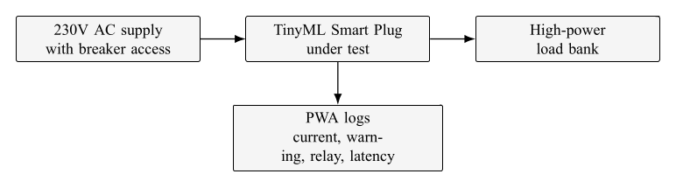
Figure 3.25. Testing setup block diagram for overload evaluation.

Figure 3.25 shows the prototype placed between the supply and load bank so that it could measure current and disconnect the load through its relay. This matches the current path used in normal operation.
The actual overload test setup is shown in Figure 3.26.
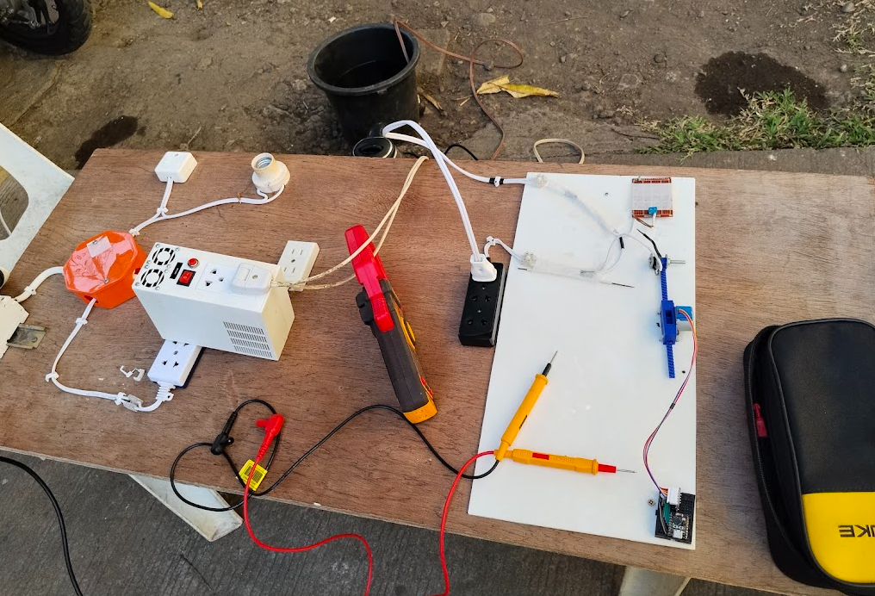
Figure 3.26. Actual test setup for overload evaluation.

Figure 3.26 documents the physical load arrangement used to create warning and sustained-overload conditions. During each trial, mean voltage, mean current, peak current, warning state, relay state, and trip latency were recorded.

3.9.3 Socket-Heating Test Procedure
Socket-heating tests compared normal and intentionally degraded socket contacts under similar load levels. The objective was to determine whether degraded contacts produced faster and higher temperature rise, and whether the external device temperature measurement and compensated estimator could provide useful warning before dangerous contact heating progressed.
Figure 3.27 shows the socket-heating test block diagram.
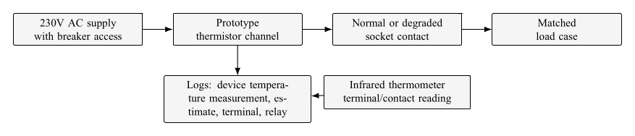
Figure 3.27. Testing setup block diagram for socket-heating evaluation.

Figure 3.27 shows that both the prototype device temperature measurement and a reference socket or terminal temperature measurement were observed during testing. This made it possible to distinguish device temperature measurement, estimated socket temperature, and reference terminal temperature in the results.
The degraded socket contacts are shown in Figure 3.28.
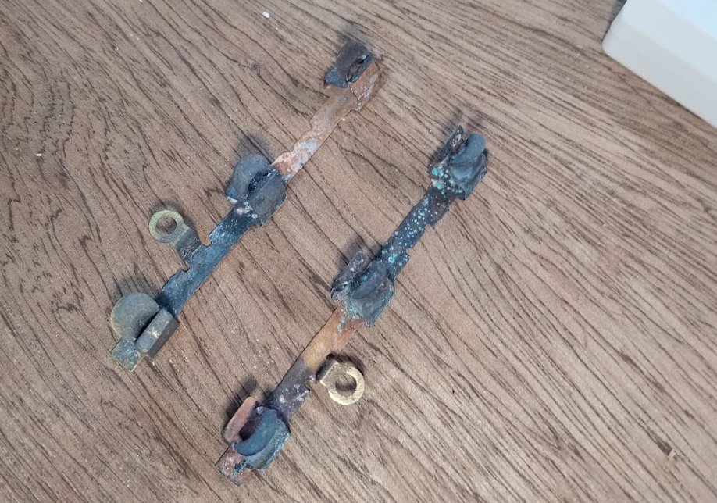
Figure 3.28. Corroded socket contacts used for degraded-contact testing.

Figure 3.28 documents the degraded-contact condition used to accelerate contact heating. The degraded socket was compared against a normal socket under matched load combinations.
The actual socket-heating test setup is shown in Figure 3.29.
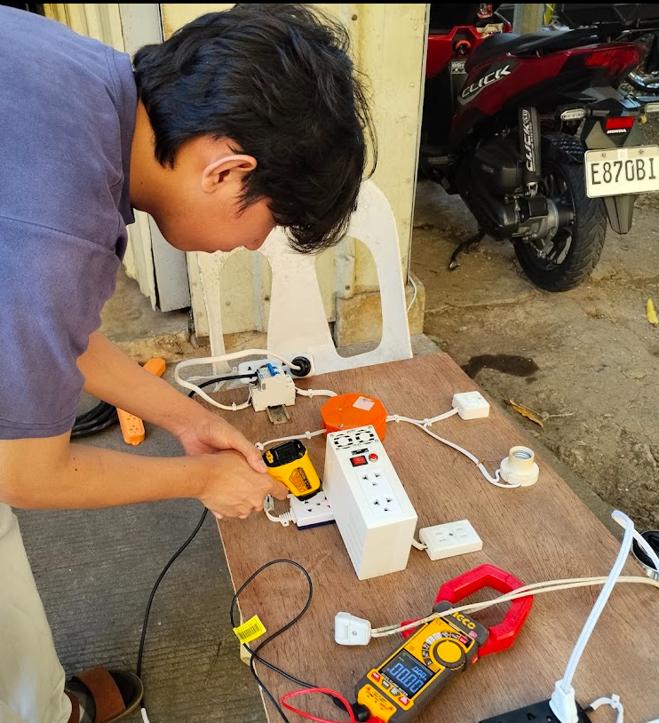
Figure 3.29. Actual test setup for socket-heating evaluation.

Figure 3.29 shows the bench configuration used to record time, current, device temperature measurement, estimated socket temperature, reference terminal temperature, and relay behavior. The characterization data in Appendix C were used to support the thermal model, while the protection validation data in Appendix D were used to evaluate relay response.

3.9.4 Series Arc-Fault Test Procedure
Series arc-fault testing used a controlled arc platform and appliance loads. The goal was to create repeatable waveform disturbances while recording current features, model outputs, relay behavior, and event labels. The assistance letter and safety proposal for this testing activity are included in Appendix G. The arc platform is shown in Figure 3.30.
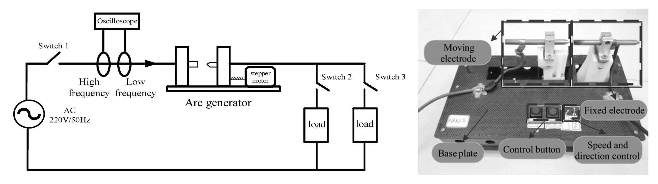
Figure 3.30. Series arc-fault test platform.

Figure 3.30 shows the principle of the series arc test: the current path is interrupted by an adjustable contact gap, allowing a controlled arc disturbance to appear in series with the load. The adapted source describes a 220V/50Hz platform using a fixed electrode and a moving electrode controlled by a stepper motor [48]. The prototype testing used the same series-interruption principle as a guide, while the actual bench setup used in this study is documented in Figure 3.32.
The block diagram of the series arc-fault test is shown in Figure 3.31.
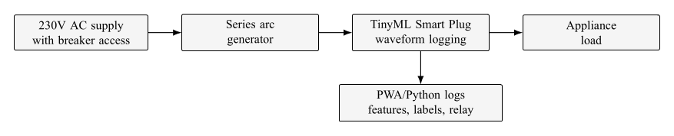
Figure 3.31. Testing setup block diagram for series arc-fault evaluation.

Figure 3.31 shows the smart plug measuring the load current while the arc generator is placed in series with the appliance. This setup is consistent with the feature definitions in Section 3.7, which depend on current waveform disturbance.
The actual series arc-fault test setup is shown in Figure 3.32.
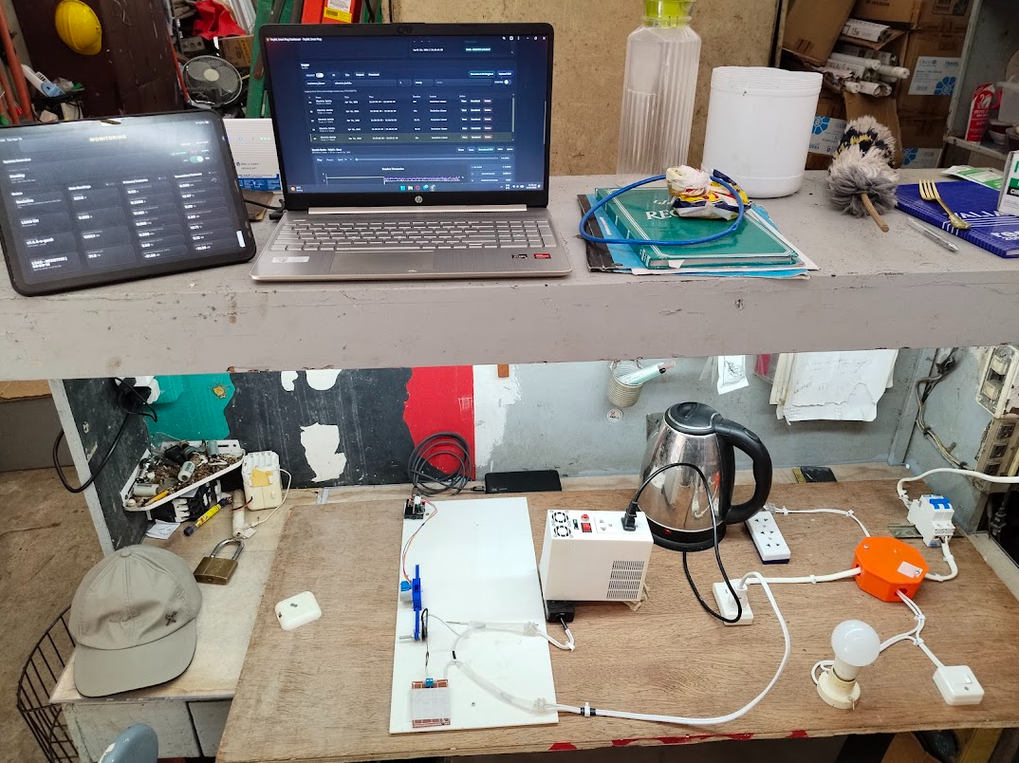
Figure 3.32. Actual test setup for series arc-fault evaluation.

Figure 3.32 documents the laboratory arrangement used to collect arc and normal trials. Complete arc-fault test records are referenced in Appendices E and F.

3.9.5 Classification Metrics
For arc-fault evaluation, the positive class was the arc-fault condition and the negative class was normal operation. Accuracy, precision, recall, and F1-score were computed from true positives (TP), false positives (FP), true negatives (TN), and false negatives (FN):
$$Accuracy=\frac{TP+TN}{TP+TN+FP+FN}, (3.45)$$
$$Precision=\frac{TP}{TP+FP}, (3.46)$$
$$Recall=\frac{TP}{TP+FN}, (3.47)$$
and
$$F_{1}=2\frac{Precision×Recall}{Precision+Recall}. (3.48)$$
In (3.45)–(3.48), precision measures how many trip decisions were actually arc faults, recall measures how many arc faults were detected, and F1-score summarizes the balance between false trips and missed faults. These metrics are commonly used for supervised classification and confusion-matrix evaluation [74].

Chapter 4

RESULTS AND DISCUSSION

This chapter presents the results in the same sequence as the methodology in Chapter 3. Sensor validation is discussed first because the protection decisions depend on calibrated voltage, current, and temperature measurements. The following sections then interpret overload protection, socket-heating characterization, socket-heating protection validation, series arc-fault detection, TinyML model performance, and the overall feasibility of the prototype.

4.1 Sensor Validation
The sensor-validation results determine whether the calibrated measurements were reliable enough for the protection decisions described in Chapter 3. In this section, the voltage, current, and device-temperature channels are interpreted in terms of decision reliability rather than as isolated measurement exercises.

4.1.1 Voltage Sensor Validation
The voltage sensor was compared with a Fluke 115 True RMS multimeter at ten test points.
Table 4.1. Validation results for the voltage sensor

Test | Device (V) | Fluke (V) | Abs. error (V) | Squared error (V²)
1 | 181.0 | 184.7 | 3.7 | 13.69
2 | 196.1 | 192.8 | 3.3 | 10.89
3 | 198.4 | 201.9 | 3.5 | 12.25
4 | 210.3 | 213.6 | 3.3 | 10.89
5 | 223.8 | 219.7 | 4.1 | 16.81
6 | 221.0 | 225.4 | 4.4 | 19.36
7 | 234.6 | 230.9 | 3.7 | 13.69
8 | 232.7 | 236.5 | 3.8 | 14.44
9 | 247.5 | 243.1 | 4.4 | 19.36
10 | 244.3 | 249.2 | 4.9 | 24.01

Table 4.1 shows the validation results for the voltage sensor. The corrected prototype readings produced an MAE of 3.910V, MSE of 15.539V$​^{2}$, and RMSE of 3.94V. These errors are small relative to the firmware voltage bands in Table 3.8; therefore, the calibrated voltage channel is adequate for distinguishing normal operation from the undervoltage and overvoltage regions used in this prototype. The result supports voltage state discrimination, but it does not by itself certify the device for utility-grade metering.

4.1.2 Current Sensor Validation
The current sensor was compared with an Ingco clamp meter.
Table 4.2. Validation results for the current sensor

Test | Device (A) | Clamp meter (A) | Abs. error (A) | Squared error (A²)
1 | 0.66 | 0.68 | 0.02 | 0.0004
2 | 1.98 | 1.94 | 0.04 | 0.0016
3 | 5.00 | 5.11 | 0.11 | 0.0121
4 | 7.80 | 7.63 | 0.17 | 0.0289
5 | 8.97 | 9.14 | 0.17 | 0.0289
6 | 10.76 | 10.58 | 0.18 | 0.0324
7 | 11.84 | 12.06 | 0.22 | 0.0484
8 | 14.00 | 13.74 | 0.26 | 0.0676
9 | 14.34 | 14.67 | 0.33 | 0.1089
10 | 16.14 | 15.86 | 0.28 | 0.0784

Table 4.2 shows that error increased slightly at higher currents but remained much smaller than the distance between the warning and sustained-trip thresholds. The current channel produced an MAE of 0.178A, MSE of 0.04076A$​^{2}$, and RMSE of 0.202A. This level of error is acceptable for the implemented warning and sustained-trip thresholds because the warning threshold is 10.0A and the sustained-overload threshold is 14.5A. The same current channel is also used by the socket thermal model and the TinyML feature extractor, so a low RMS-current error improves both threshold and feature reliability. This supports the overload results discussed in Section 4.2.

4.1.3 Device Temperature Measurement Validation
The TTC05103JSY 10k$Ω$ thermistor was compared with a reference infrared thermometer at the sensor measurement point.
Table 4.3. Validation results for the device temperature measurement thermistor channel

Test | Device (◦C) | IR thermometer (◦C) | Abs. error (◦C) | Squared error (◦C²)
1 | 27.9 | 27.4 | 0.5 | 0.25
2 | 31.1 | 31.8 | 0.7 | 0.49
3 | 37.7 | 36.6 | 1.1 | 1.21
4 | 41.1 | 41.9 | 0.8 | 0.64
5 | 48.2 | 47.3 | 0.9 | 0.81
6 | 51.2 | 52.5 | 1.3 | 1.69
7 | 59.0 | 58.1 | 0.9 | 0.81
8 | 61.6 | 63.2 | 1.6 | 2.56
9 | 67.8 | 66.8 | 1.0 | 1.00
10 | 68.3 | 69.7 | 1.4 | 1.96

Table 4.3 supports the use of the thermistor channel as a stable observable input for the thermal estimator. The device temperature measurement channel produced an MAE of 1.02°C, MSE of 1.142°C$​^{2}$, and RMSE of 1.07°C. This validates the thermistor channel itself, but it must not be interpreted as a direct validation of internal contact temperature. Hence, it reinforces the methodological need for the compensated socket-temperature model because the sensor is external to the highest-temperature contact interface. The heating tests later show that the socket terminal can be much hotter than the external thermistor reading or compensated estimate.

4.2 Overload Protection
Five overload-related trials were conducted using high-power load combinations. All trials entered the overload-warning region, but only the most severe case remained above the sustained-overload criterion long enough to trip the relay. This matches the firmware method in Section 3.8.2, where warning and sustained trip are intentionally separated.
Table 4.4. Overload evaluation results
Trial | Load setup | Mean V | Mean A | Peak A | Warning | Trip latency
1 | 1300W electric kettle + water | 231.8 | 12.87 | 14.85 | Yes | –
2 | heater  1300W electric kettle + 1500W | 229.5 | 12.33 | 13.63 | Yes | –
3 | electric kettle  1500W electric kettle + water | 229.6 | 13.36 | 14.86 | Yes | –
4 | heater  1300W electric kettle + water | 224.0 | 17.30 | 19.73 | Yes | 61.3s
5 | heater + 2 × 500W halogen lamp  heater + 500W halogen lamp | 229.1 | 14.42 | 16.23 | Yes | –

1300W electric kettle + water

Table 4.4 shows that warning occurred in all heavy-load cases, while relay disconnection occurred only in Trial 4. The mean current of Trial 4 was 17.30A, clearly above the 14.5A sustained-overload threshold, and the 61.3s trip latency agrees with the intended 60s persistence behavior. Trials 1, 3, and 5 reached peak values near or above the sustained threshold, but they did not remain in the sustained-overload state long enough for the score to reach the trip value.
This result supports the overload objective because the prototype behaved as a warning-and-persistence device rather than an instantaneous current cutoff. The main limitation is that the tests were conducted with selected laboratory load combinations; broader appliance combinations and longer-duration thermal tests would be needed before choosing final consumer-product trip curves.

4.3 Socket-Heating Characterization
The socket-heating characterization compared a normal socket with a degraded socket under similar current levels. The purpose was to verify the Chapter 3 assumption that socket temperature is not determined by current alone; contact condition changes the rate and final magnitude of heating. The plotted trends in this section were generated from the full characterization records in Appendix C.
The water-heater-only characterization trend is shown in Figure 4.1.
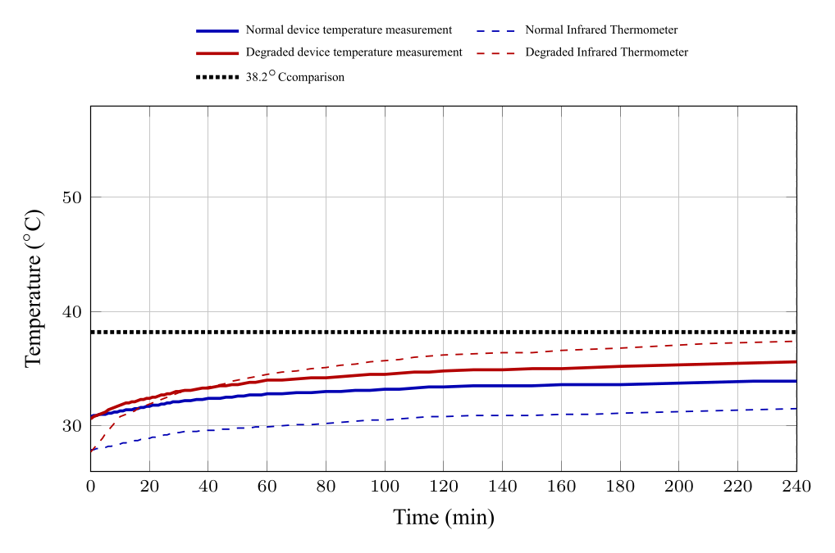
Figure 4.1. Water heater temperature trend during socket-heating characterization.

Figure 4.1 shows that at about 5.2A, both socket conditions stayed below the 38.2°C comparison point within the 240min window. The corroded socket still ended hotter than the normal socket, showing the beginning of contact-condition influence even at the lowest tested load.
The water heater plus one halogen lamp trend is shown in Figure 4.2.
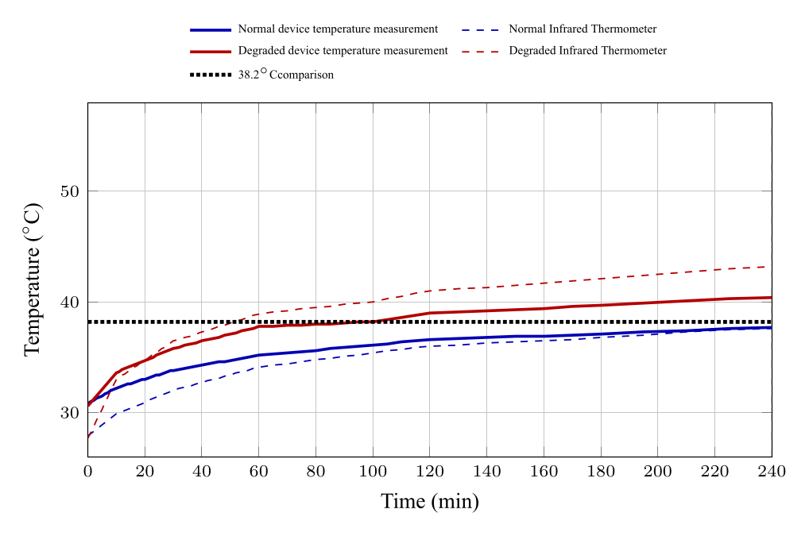
Figure 4.2. Water heater plus one halogen lamp temperature trend during characterization.

Figure 4.2 shows clearer separation between normal and corroded behavior. The corroded socket reached the 38.2°C comparison point, while the normal socket did not reach that point within the same window.
The water heater plus two halogen lamps trend is shown in Figure 4.3.
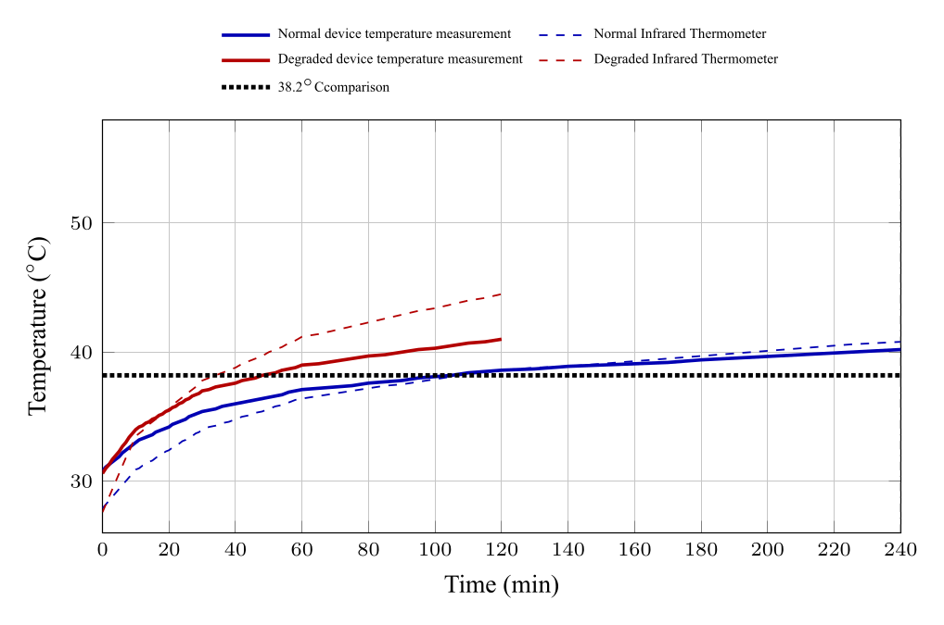
Figure 4.3. Water heater plus two halogen lamps temperature trend during characterization.

Figure 4.3 shows that the degraded socket reached the comparison temperature much earlier than the normal socket. The terminal temperature also rose above the device temperature measurement, supporting the need to treat the external thermistor channel as an under-reading proxy rather than the actual hotspot.
The water heater plus three halogen lamps trend is shown in Figure 4.4.
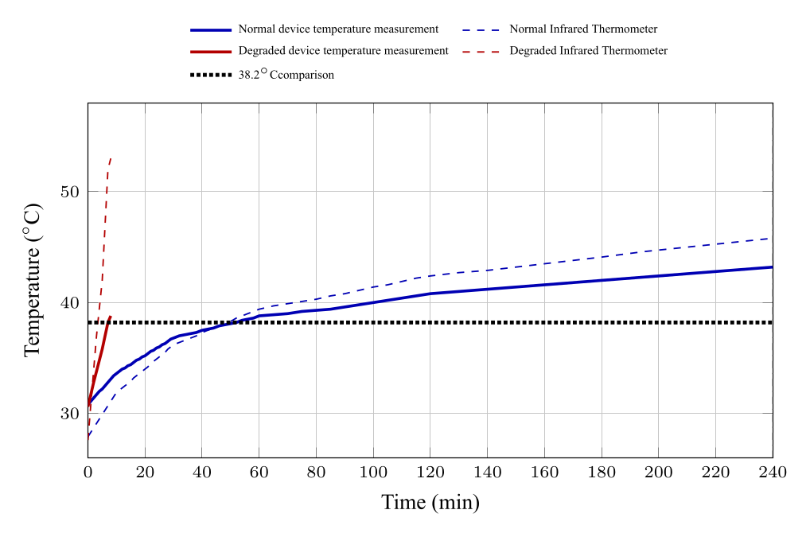
Figure 4.4. Water heater plus three halogen lamps temperature trend during characterization.

Figure 4.4 shows the strongest time-to-threshold contrast in the characterization set: the corroded socket reached the comparison point after only 7min, while the normal socket reached it after 52min.
The water heater plus four halogen lamps trend is shown in Figure 4.5.
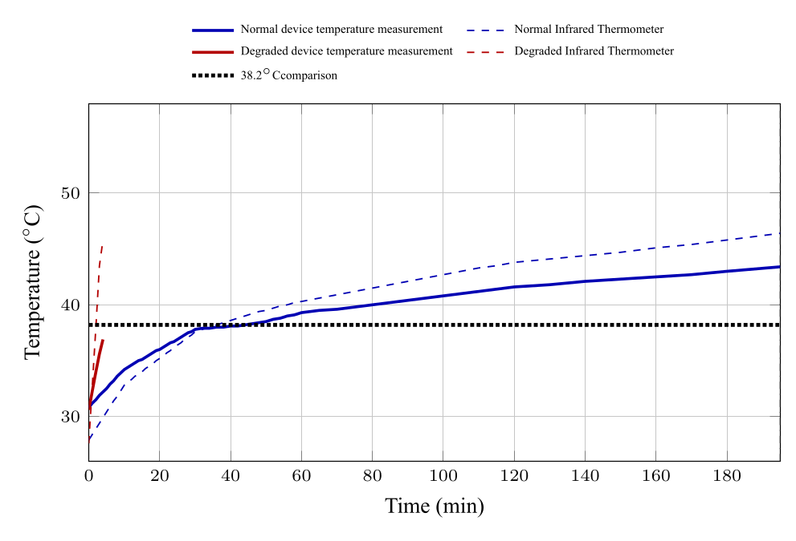
Figure 4.5. Water heater plus four halogen lamps temperature trend during characterization.

Figure 4.5 shows that the high-current degraded trial developed rapidly and was stopped after a short observation window. The terminal temperature reached 45.8°C within 4min even though the final device temperature measurement was only 36.9°C.
Table 4.5 summarizes the characterization data used to interpret these trends.
Table 4.5. Summary of socket-heating characterization data

Load case | Socket | Time to  38.2°C | Mean  A | Final Device  temp. | Final IR temp. | Window (min)
Water heater | Normal | – | 5.18 | 33.9 | 31.5 | 240
Water heater | Corroded | – | 5.16 | 35.6 | 37.4 | 240
Water heater + 1 lamp | Normal | – | 7.12 | 37.7 | 37.6 | 240
Water heater + 1 lamp | Corroded | 95 | 7.10 | 40.4 | 43.2 | 240
Water heater + 2 lamps | Normal | 105 | 9.07 | 40.2 | 40.8 | 240
Water heater + 2 lamps | Corroded | 48 | 9.05 | 41.0 | 44.5 | 120
Water heater + 3 lamps | Normal | 52 | 11.06 | 43.2 | 45.8 | 240
Water heater + 3 lamps | Corroded | 7 | 11.15 | 38.8 | 53.0 | 8
Water heater + 4 lamps | Normal | 44 | 13.00 | 43.4 | 46.4 | 195
Water heater + 4 lamps | Corroded | – | 13.10 | 36.9 | 45.8 | 4

Table 4.5 confirms that degraded contact changed both heating speed and hotspot severity. At about 9A, the corroded socket reached 38.2°C in 48min compared with 105min for the normal socket. At about 11A, the corroded socket reached the same point in 7min compared with 52min for the normal socket. These results support the need for the compensated thermal model described in Section 3.6.
The characterization records also show how the firmware constants are used in the socket-temperature estimate. For example, the corroded water-heater plus two-lamp characterization case in Table 4.5 had a mean current of about 9.05A. Using the firmware current-shape term in (3.10),
$$s_{I}={\left(\frac{9.05}{12.0}\right)}^{2}=0.569.$$
The expected-normal target rise from (3.12) is then $0.20+12.0(0.569)=7.03​^{∘}C$, while the direct measured-temperature compensation from (3.15) is $0.30+1.20(0.569)=0.98​^{∘}C$. These calculations do not re-fit the constants; they demonstrate how the firmware-verified constants are applied to the measured current and device temperature. The original fitting worksheet used to choose the constants was not present in the repository, so the constants should be treated as firmware-verified design values and not as a new independent regression result from the summarized table alone.

4.4 Socket-Heating Protection Validation
Socket-heating protection validation evaluated the relay-facing estimated socket temperature. The important distinction is between three plotted temperatures and one internal model state. Device temperature measurement is the temperature measured or processed by the prototype’s thermistor channel. The infrared thermometer reading is the reference terminal or contact-region reading. Estimated socket temperature is the compensated protection-facing estimate derived from the characterization model. The expected normal socket temperature is an internal comparator used by the estimator. The trip threshold applies to the estimated socket temperature, while the infrared thermometer reading shows how hot the socket contact area became during the same trial. The plotted trends in this section were generated from the full protection validation records in Appendix D.
The water-heater-only protection trend is shown in Figure 4.6.
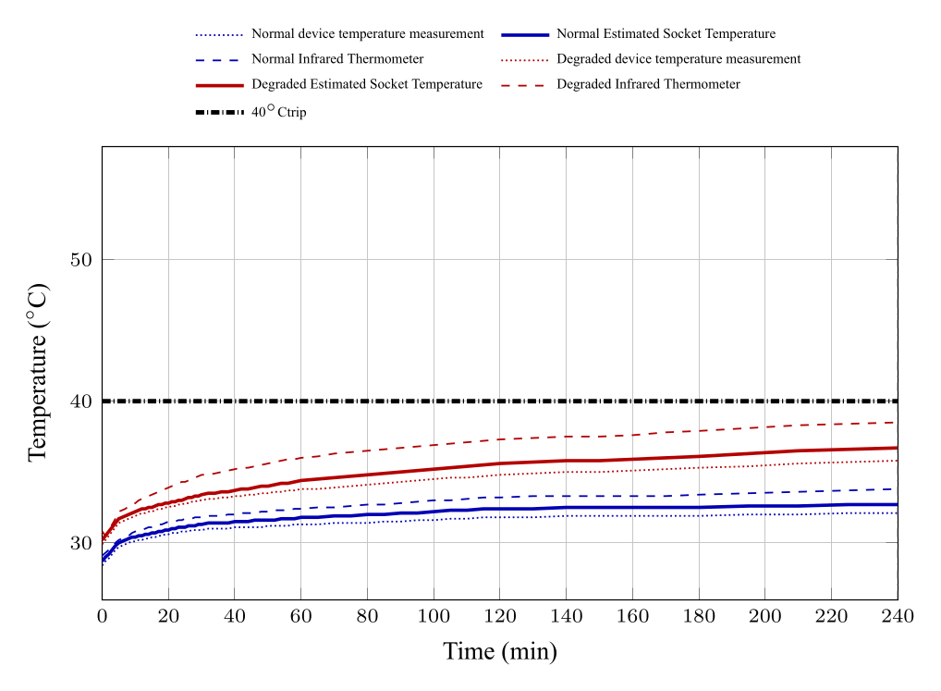
Figure 4.6. Water heater temperature trend during socket-heating protection validation.

Figure 4.6 shows that the low-current case did not trip for either socket condition within the observation window. The corroded terminal still ended hotter than the normal terminal, but the estimated socket temperature stayed below the 40°C trip threshold.
The water heater plus one halogen lamp protection trend is shown in Figure 4.7.
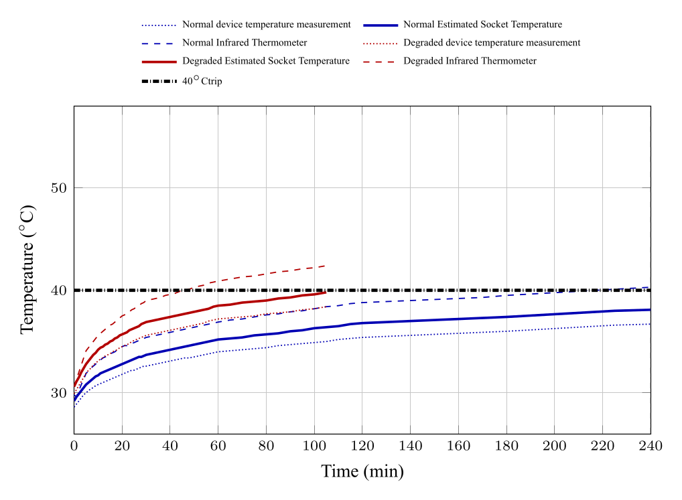
Figure 4.7. Water heater plus one halogen lamp trend during protection validation.

Figure 4.7 shows that the normal socket did not trip, while the corroded socket reached a protection-relevant state after a longer heating period. This supports the estimator’s role in distinguishing slow thermal buildup from immediate current overload.
The water heater plus two halogen lamps protection trend is shown in Figure 4.8.
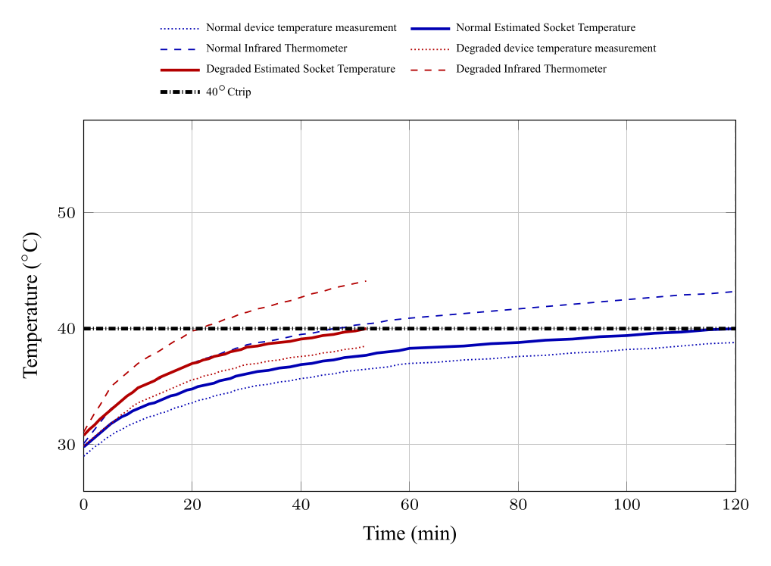
Figure 4.8. Water heater plus two halogen lamps trend during protection validation.

Figure 4.8 shows that the corroded socket tripped much earlier than the normal socket at approximately the same current. The reference terminal temperature was already above the estimated value at trip, which confirms that the estimator acts as an early proxy for a hotter internal condition.
The water heater plus three halogen lamps protection trend is shown in Figure 4.9.
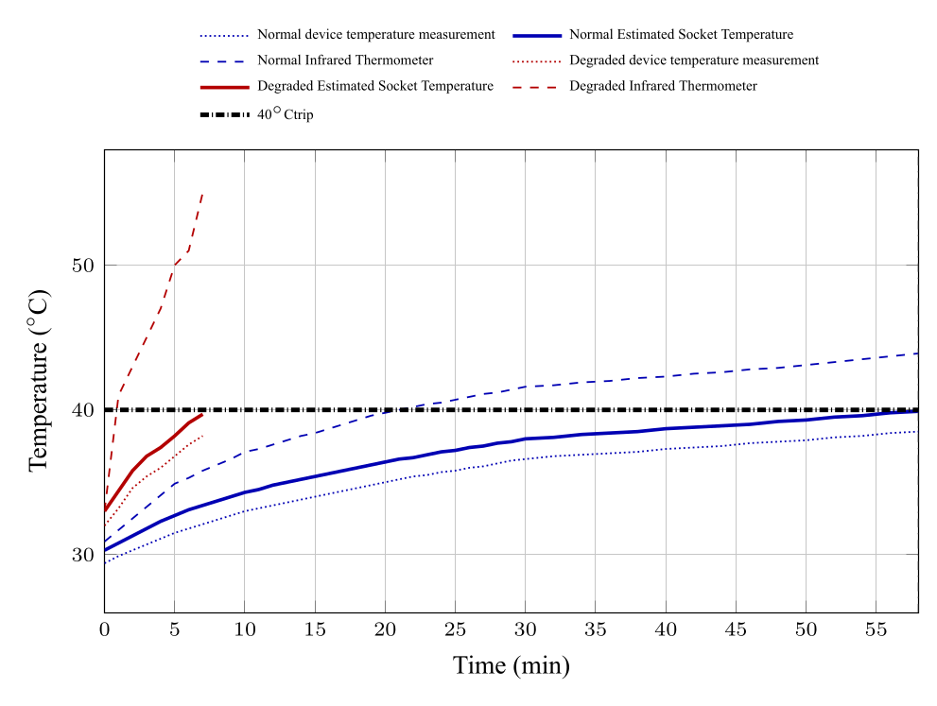
Figure 4.9. Water heater plus three halogen lamps trend during protection validation.

Figure 4.9 shows fast thermal development in the corroded case. The relay acted within the short test window, while the reference terminal temperature reached 55.0°C.
The water heater plus four halogen lamps protection trend is shown in Figure 4.10.
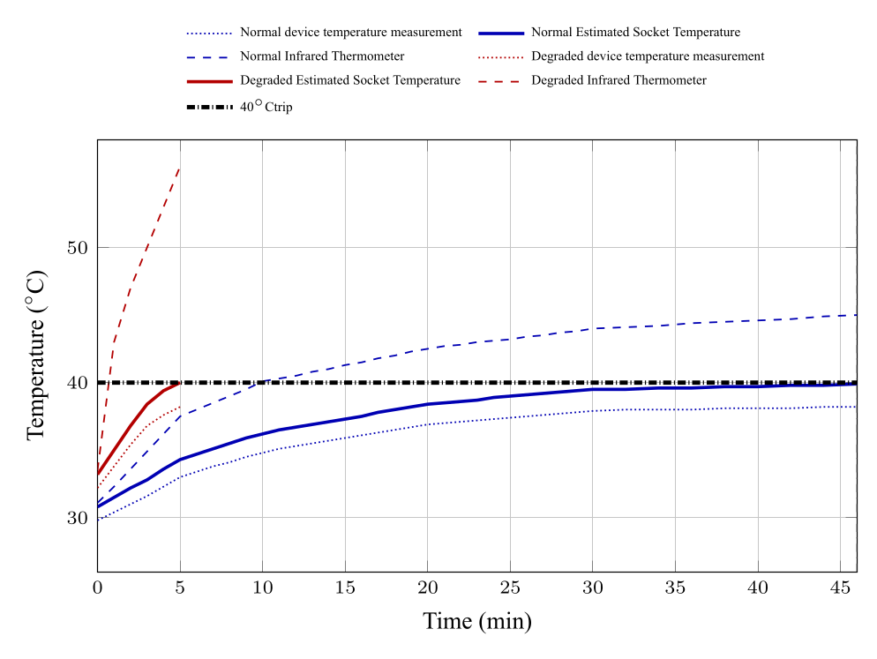
Figure 4.10. Water heater plus four halogen lamps trend during protection validation.

Figure 4.10 shows the most severe heating case. The corroded socket tripped after 5min when the estimated socket temperature reached 40.0°C, while the reference terminal temperature had already reached 56.0°C.
Table 4.6 summarizes the protection validation results.
Table 4.6. Socket-heating protection validation results

Load case | Socket | Mean A | Device 38.2 | Est. 40 | Est. temp | IR temp | Relay
Water heater | Normal | 5.17 | – | – | 32.7 | 33.8 | No
Water heater | Corroded | 4.85 | – | – | 36.7 | 38.5 | No
Water heater + 1 | Normal | 7.11 | – | – | 38.1 | 40.3 | No
lamp
Water heater + 1 | Corroded | 7.10 | 100 | – | 39.8 | 42.4 | Yes
lamp
Water heater + 2 | Normal | 9.06 | 100 | 120 | 40.0 | 43.2 | Yes
lamps
Water heater + 2 | Corroded | 9.04 | 48 | 52 | 40.0 | 44.1 | Yes
lamps
Water heater + 3 | Normal | 11.07 | 54 | – | 39.9 | 43.9 | Yes
lamps
Water heater + 3 | Corroded | 11.14 | 7 | – | 39.7 | 55.0 | Yes
lamps
Water heater + 4 | Normal | 13.02 | 44 | – | 39.9 | 45.0 | Yes
lamps
Water heater + 4 | Corroded | 13.08 | 5 | 5 | 40.0 | 56.0 | Yes
lamps

Table 4.6 shows that degraded and higher-current conditions tripped earlier than low-current or healthy-socket conditions. The result supports the protection objective because the relay response followed the compensated estimated socket temperature, not merely current magnitude. A limitation remains: the external thermistor channel and compensation model still underestimated the hottest terminal temperature in severe degraded-contact cases. The prototype therefore demonstrates useful complementary protection, but a final certified design would need a validated thermal model across more socket types, contact materials, enclosure conditions, and ambient conditions.

4.5 Series Arc-Fault Detection
The series arc-fault tests evaluated whether waveform disturbance could be converted into a relay decision. During arcing, the current waveform was expected to show low-current gaps, restrike spikes, unstable cycle shape, and changes in mid/high-frequency content. These behaviors correspond to the features defined in Section 3.7, especially maximum low-current run, low-current ratio, zero-dwell behavior, midband residual ratio, and spectral flux.
The trial-level results are summarized as confusion matrices in Table 4.7. Here, “relay trips” is the positive prototype response and “arcing event” is the positive ground-truth condition.
Table 4.7. Trial-level confusion matrices for series arc-fault testing

Device group | Prototype response | Arcing event | Normal event
Recognized loads | Relay trips | 49 | 0
Recognized loads | Relay remains on | 1 | 50
Unrecognized loads | Relay trips | 47 | 1
Unrecognized loads | Relay remains on | 3 | 49
All tested loads | Relay trips | 96 | 1
All tested loads | Relay remains on | 4 | 99

Table 4.7 shows that the prototype detected 96 of 100 arc trials and produced one relay trip during 100 normal trials. The recognized load group had no normal-event false trip and one missed arc event. The unrecognized group was more difficult, with three missed arcs and one false trip. This difference is expected because unrecognized devices introduce waveform behavior not directly represented during model fitting.
The result supports the arc-detection objective under the tested laboratory conditions. The classifier response was strongest when the arc created persistent low-current gaps and spectral disturbance, allowing the leaky arc counter to reach the relay-trip threshold. The missed trials indicate that not all arcs produced equally strong or persistent feature responses, especially when the load type differed from the fitted set. Therefore, the prototype should be interpreted as a controlled feasibility demonstration, not as a certified AFCI-equivalent device.

4.6 Arc-Fault Dataset Summary
The cleaned arc-training dataset contained 49,296 rows, of which 283 were arc markers, equivalent to about 0.577% of the retained data. This confirms that the problem was highly imbalanced: most frames represented normal operation even in sessions that contained an arc event. The imbalance explains why frame-level accuracy alone can be misleading; a classifier can appear accurate by predicting mostly normal frames. Precision, recall, F1-score, and event-level metrics are therefore needed to interpret the safety behavior.
Complete trial tables and raw collection logs are provided in Appendices E and F. These appendices are important because the summary table in the main text cannot show every feature frame, arc marker, or relay-state transition.

4.7 TinyML Model Performance
The TinyML results were interpreted at two levels. First, the embedded prototype was evaluated by trial-level relay behavior in the laboratory. Second, the exported Random Forest report was evaluated by held-out frame-level and event-level metrics. Both views are useful: trial-level behavior reflects the complete protection sequence, while frame-level metrics show how the model performed before relay-counter persistence.
Table 4.8 gives the trial-level metrics for recognized loads, unrecognized loads, and all loads combined.
Table 4.8. Trial-level arc-fault performance metrics

Load group | Accuracy | Precision | Recall | F1-score
Recognized loads | 99.00% | 100.00% | 98.00% | 98.99%
Unrecognized loads | 96.00% | 97.92% | 94.00% | 95.92%
All tested loads | 97.50% | 98.97% | 96.00% | 97.46%

Figure 4.11 graphs the same four metrics by load setup. This presentation compares like quantities across recognized, unrecognized, and combined test groups; it does not mix unrelated metrics as separate one-off bars.
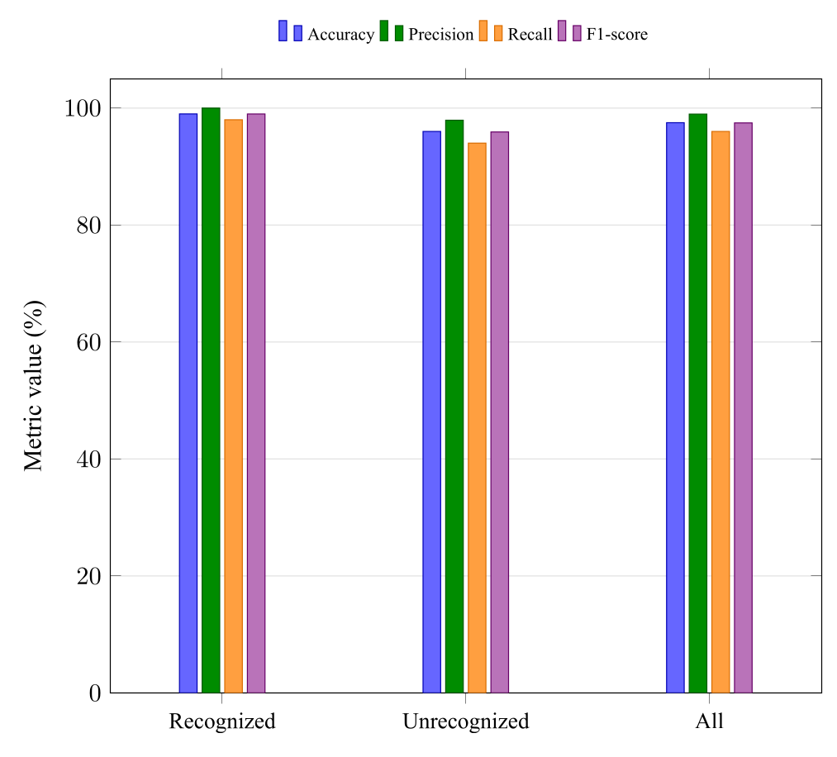
Figure 4.11. Trial-level performance metrics by recognized and unrecognized load setup.

Table 4.8 and Figure 4.11 show high overall performance across 200 trial outcomes. Precision is related to nuisance trips: the 98.97% overall precision means that only one normal event was incorrectly tripped in the trial set. Recall is related to safety sensitivity: the 96.00% overall recall means that four arc trials were missed. The recognized-load group had slightly higher recall and no normal-event false trip, while the unrecognized-load group accounted for three of the four missed arc trials and the single false trip. This indicates that the deployed model generalized reasonably, but the unrecognized load cases remained the more difficult condition.
The trial-level classifier and persistence logic produced balanced performance: precision remained high for nuisance-trip reduction, while recall remained high enough to detect most arc trials. These results apply to the deployed feature contract described in Section 3.7.1: six selected waveform features were used by the arc model, with context fields appended to the model vector.
The per-load trial metrics are shown in Table 4.9.
Table 4.9. Per-load trial-level performance metrics

Device Device type Accuracy Precision Recall F1-score

Water heater | Resistive | 100% | 100% | 100% | 100%
Halogen lamp | Resistive | 100% | 100% | 100% | 100%
Electric kettle | Resistive | 100% | 100% | 100% | 100%
40W stand fan | Inductive | 100% | 100% | 100% | 100%
Handheld vacuum | Brushed | 95% | 100% | 90% | 94.74%
Electrolux vacuum | Brushed | 95% | 100% | 90% | 94.74%
Angle grinder | Brushed | 95% | 100% | 90% | 94.74%
Bench cutter | Brushed | 95% | 100% | 90% | 94.74%
Impact drill | Brushed | 95% | 90.91% | 100% | 95.24%
Heat gun | Resistive | 100% | 100% | 100% | 100%

Table 4.9 shows where the group-level metrics came from without adding another graph below it. The impact drill is the only load listed with precision below 100%, meaning it contributed the normal-event false trip. The handheld vacuum, vacuum cleaner, angle grinder, and bench cutter had lower recall, meaning those load cases contributed missed arc trials.
The same appendix data can also be aggregated by load setup and load family. For load setup, recognized loads contributed 49 detected arc trials, one missed arc trial, 50 correct normal trials, and no false trip; unrecognized loads contributed 47 detected arc trials, three missed arc trials, 49 correct normal trials, and one false trip. For family grouping, water heater, halogen lamp, electric kettle, and heat gun were treated as resistive loads; the 40W stand fan was treated as the inductive load; and the handheld vacuum, Electrolux vacuum, angle grinder, bench cutter, and impact drill were treated as brushed or universal-motor loads. These aggregations summarize the recorded trial tables in Appendix E; they are not additional test conditions.
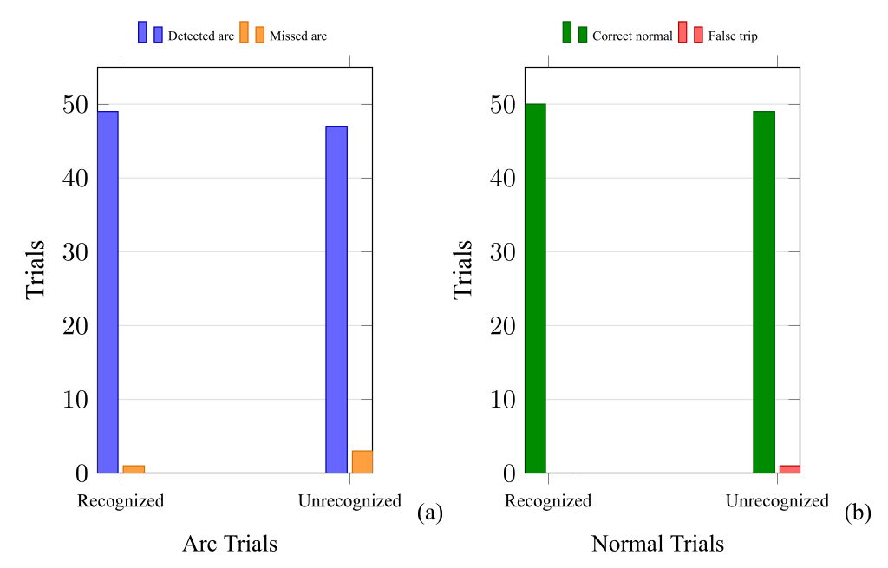
Figure 4.12. Grouped trial outcomes for recognized and unrecognized load setups.

Figure 4.12(a) shows that the unrecognized group had more missed arc trials than the recognized group. Figure 4.12(b) shows that the only normal-event false trip also came from the unrecognized group. These results are consistent with the per-load results in Table 4.9: generalization loads were still handled by the protection sequence, but they produced the remaining errors.
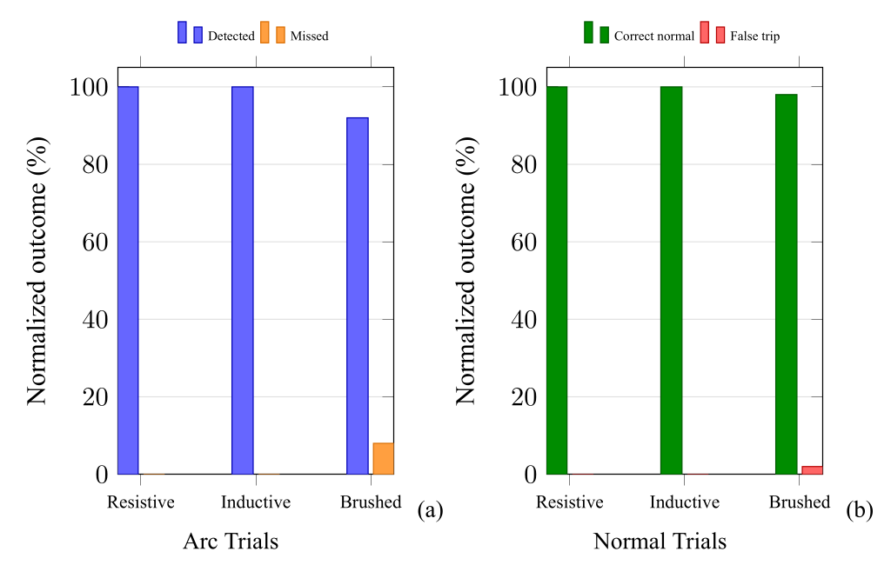
Figure 4.13. Normalized grouped trial outcomes by load family.
Figure 4.13 is normalized because the family groups did not contain the same number of devices or trials. In Figure 4.13(a), resistive and inductive load-family trials had 100% arc detection, while the brushed-load family had 92% arc detection and 8% missed arc trials. In Figure 4.13(b), the brushed-load family also contained the only false trip, giving 98% correct normal classification and 2% false-trip outcome for that family. The normalized view therefore shows that the brushed or universal-motor group was the main source of residual model error rather than simply the largest group in raw counts.
The exported Random Forest report provides a second view of performance. The held-out test split contained 10,268 feature rows, including 90 positive rows. The frame-level confusion matrix contained 10,173 true negatives, 5 false positives, 25 false negatives, and 65 true positives. The corresponding frame-level accuracy was 99.7078%, precision was 92.8571%, recall was 72.2222%, and F1-score was 81.25%. At event level, the same report showed 25 true arc events, 21 detected events, 4 missed events, 31 predicted events, 1 false-alarm event, 84.0% event recall, 96.7742% event precision, and 89.9358% event F1-score. The data-preparation, training-report, and exported-model details supporting these metrics are summarized in Appendix F.2.
These model-report values are lower than the final trial-level relay metrics because they evaluate individual frames and event groupings before the full trial-level interpretation. This does not invalidate the trial results; it shows that the firmware’s persistence logic is part of the protection behavior. The deployed model should therefore be judged as a model-plus-firmware system, not as a standalone frame classifier.

4.8 Model Limitations
The main limitation is dataset coverage. The tests included recognized and unrecognized loads, but they did not cover all appliance families, wiring conditions, electrode materials, contact gaps, ambient conditions, or utility waveform variations. The results therefore support prototype feasibility and future development, but they do not establish compliance with AFCI standards or replacement equivalence with certified protective devices.

4.9 Overall Prototype Feasibility
The combined results show that the TinyML Smart Plug achieved the intended hybrid behavior under controlled laboratory conditions. The calibrated voltage, current, and temperature measurements were accurate enough to support the implemented thresholds. The overload tests showed warning behavior followed by relay trip only when sustained overload persisted. The socket-heating tests showed that degraded contact can cause faster and more severe heating than current magnitude alone suggests. The arc-fault tests showed that waveform features and Random Forest inference can support local relay action for series-arc events in the tested load set.
The prototype is best interpreted as complementary protection. It adds socket-level monitoring of overload persistence, thermal rise, and waveform disturbance, but it is not a replacement for circuit breakers, AFCIs, GFCIs, proper wiring practice, contact inspection, or certified protection devices. This boundary matters because the tests were conducted on a laboratory bench, the thermal estimator was deliberately conservative, and the TinyML model was trained and evaluated on a finite set of loads and arc conditions.
The results nevertheless support the study objective: a compact microcontroller-based smart plug can combine calibrated sensing, deterministic threshold logic, compensated socket-temperature estimation, local TinyML inference, relay latching, and PWA monitoring in a single prototype. The next engineering step is not simply to lower thresholds or add more model complexity; it is to broaden the dataset, validate the thermal estimator against additional socket constructions, test across more appliance families, and compare behavior against applicable protection-device standards. The project schedule and cost breakdown in Appendices H and I document the scope and material basis of this prototype-level implementation.

Chapter 5

CONCLUSION AND RECOMMENDATION

5.1 Conclusions
The study demonstrated that the TinyML Smart Plug is feasible as a complementary residential protection prototype under controlled laboratory conditions. The calibrated voltage, current, and temperature channels produced errors low enough to support protection decisions, with Chapter 4 reporting mean absolute errors of 3.910V, 0.178A, and 1.02°C, respectively. These results support the first objective because the prototype was able to acquire the required electrical and thermal quantities and use them in embedded decision logic.
The overload tests showed that the prototype could distinguish warning-level current from sustained overload. All overload trials generated warnings, while only the trial with a 17.30A mean current produced a relay trip after 61.3s. This agrees with the implemented persistence method and supports the objective of adding time-aware overload response rather than using an instantaneous cutoff for every current excursion.
The socket-heating tests confirmed that degraded contact can create faster and more severe heating than a normal socket at comparable current levels. The estimated socket temperature reached the 40°C trip threshold earlier in corroded-socket trials, and the reference terminal temperature was already higher than the device temperature reading at trip. This supports the need for a thermal protection layer that is separate from current-only protection, while also showing that sensor placement and thermal lag remain important limitations.
The series arc-fault tests showed that embedded TinyML inference was practical on the implemented platform. Across the tested devices, the prototype achieved 97.50% accuracy, 98.97% precision, 96.00% recall, and a 97.46% F1-score. These results support the objective of detecting arc-related waveform disturbance using a feature-based embedded model. However, the result should be interpreted within the tested load set and laboratory arc platform only. The prototype is therefore complementary protection and is not a replacement for circuit breakers, AFCIs, GFCIs, wiring inspection, certified receptacles, or other mandatory protection devices.

5.2 Recommendations
Longer validation should be performed in real-house or semi-field conditions. Future tests should include ordinary daily load transitions, shared branch circuits, extension cords, aged receptacles, and different wiring lengths so that nuisance trips and missed-fault behavior can be evaluated outside the controlled bench setup.
The arc-fault dataset should be expanded to include more load families, additional appliance models, more arc severities, and non-fault disturbances such as motor startup, switching noise, loose plugs without arcing, and intermittent contact. This would give the Random Forest model stronger coverage of nuisance events and would help improve recall for less obvious arc-fault cases.
The socket-temperature subsystem should be improved through better thermal sensor placement and additional model validation. Future prototypes should evaluate thermistors placed closer to the plug-contact interface, multiple temperature sensors, and longer degraded-contact trials so that the relationship among device temperature measurement, estimated socket temperature, and actual terminal temperature can be fitted with stronger evidence.
The enclosure, creepage and clearance distances, insulation barriers, relay rating, wire gauge, strain relief, and thermal isolation should be redesigned for certification-oriented testing. Future work should include tests aligned with applicable electrical safety and appliance standards before any field or consumer deployment is considered.
The monitoring system should add stronger event logging and data export. Exportable CSV logs, timestamps synchronized across waveform and telemetry events, firmware-version fields, and clearer fault-state records would make future validation easier and would support model retraining from field data.
Finally, future implementations may use a microcontroller platform with more memory and data-handling margin. Additional resources would allow longer waveform buffers, larger validation logs, broader feature comparison, and more robust embedded inference while keeping the protection logic responsive.

REFERENCES
[1] J. RITA and G. I. News, “Electrical issues remain most common cause of fire —BFP data,” GMA News Online, Feb. 28, 2025. Accessed: Nov. 20, 2025. [Online]. Available: https://www.gmanetwork.com/news/topstories/nation/937689/electrical-issues-remain-most-common-cause-of-fire-bfp-data/story/
[2] R. Campbell, “Home Fires Caused by Electrical Failure or Malfunction,” NFPA Report. Accessed: Apr. 16, 2026. [Online]. Available: https://www.nfpa.org/education-and-research/research/nfpa-research/fire-statistical-reports/home-fires-caused-by-electrical-failure-or-malfunction
[3] S. Burge, “International Fire & Safety Journal,” International Fire & Safety Journal. Accessed: Apr. 16, 2026. [Online]. Available: https://internationalfireandsafetyjournal.com/electrical-fire-causes/
[4] L. Angelo, “Philippine-Electrical-Code-Summary,” Scribd. Accessed: Apr. 16, 2026. [Online]. Available: https://www.scribd.com/document/603015383/Philippine-Electrical-Code-Summary
[5] R. Celino, “Philippine-Electrical-Wiring-PEC.docx,” Scribd. Accessed: Apr. 16, 2026. [Online]. Available: https://www.scribd.com/document/630563555/Philippine-Electrical-Wiring-PEC-docx
[6] T. Kelly, “Hidden Heat: The Unseen Hazard of a High Resistance Connection,” Warren Forensics. Accessed: Apr. 16, 2026. [Online]. Available: https://www.warrenforensics.com/2025/09/10/hidden-heat-the-unseen-hazard-of-a-high-resistance-connection/
[7] J. Zhang, G. Su, T. Chen, C. Li, and W. Mi, “Glowing Contact in Electrical Fires: Experimental Investigation and Modeling of its Heat Intensity and Thermal Hazards,” Elsevier BV, 2023. Accessed: Apr. 16, 2026. [Online]. Available: https://doi.org/10.2139/ssrn.4343005
[8] P. Ferrez, D. Gabioud, and P. Roduit, “NILM-Based Solutions for the Automation of Energy Services in Residential Buildings,” in Proceedings of the 13th International Conference on Smart Cities and Green ICT Systems, SCITEPRESS - Science and Technology Publications, 2024, pp. 85–95. Accessed: Apr. 16, 2026. [Online]. Available: https://doi.org/10.5220/0012733400003714
[9] M. I. Al-Karkhi, G. Rzadkowski, L. Ibraheem, and M. Aqib, “Anomaly Detection in Electrical Systems Using Machine Learning and Statistical Analysis,” Terra Joule Journal, vol. 1, no. 2, Jun. 2025, doi: 10.64071/3080-5724.1012.
[10] M. Antonini, M. Pincheira, M. Vecchio, and F. Antonelli, “An Adaptable and Unsupervised TinyML Anomaly Detection System for Extreme Industrial Environments,” Sensors, vol. 23, no. 4, p. 2344, Feb. 2023, doi: 10.3390/s23042344.
[11] Iberdrola, “SDG 11: Sustainable cities and communities,” Iberdrola. Accessed: Apr. 16, 2026. [Online]. Available: https://www.iberdrola.com/sustainability/committed-sustainable-development-goals/sdg-11-sustainable-cities-and-communities
[12] Schneider Electric, “What is inverse time tripping? Are circuit breakers inverse time trip?,” Schneider Electric. Accessed: Apr. 16, 2026. [Online]. Available: https://www.se.com/us/en/faqs/FA115818/
[13] S. Bal and Z. A. Tamus, “A Method for Assessing the Degradation of PVC-Insulated Low-Voltage Distribution Cables Exposed to Short-Term Cyclic Aging,” Electronics, vol. 13, no. 6, Mar. 2024, doi: 10.3390/electronics13061085.
[14] International Standard, “Polyvinyl chloride insulated cables of rated voltages up to and including 450/750V - Part 1: General requirements,” IEC 60227-1. IEC, Feb. 2024. [Online]. Available: https://cdn.standards.iteh.ai/samples/107534/dcd54a582d404508a7d63ec8beabad33/IEC-60227-1-2024.pdf
[15] V. Waldmann, K. Narayanan, N. Combes, D. Jost, X. Jouven, and E. Marijon, “Electrical cardiac injuries: current concepts and management,” European Heart Journal, vol. 39, no. 16, pp. 1459–1465, Apr. 2017, doi: 10.1093/eurheartj/ehx142.
[16] D. Lee, A. Trotta, and W. King Jr., “New Technology for Preventing Residential Electrical Fires: Arc-Fault Circuit Interrupters (AFCIs).” U.S. Consumer Product Safety Commission, 2003. Accessed: Apr. 16, 2026. [Online]. Available: https://www.cpsc.gov/s3fs-public/AFCIFireTechnology.pdf
[17] W. Meese and R. Beausoliel, “Exploratory Study of Glowing Electrical Connections,” NBSIR 76-1011. National Bureau of Standards. [Online]. Available: https://nvlpubs.nist.gov/nistpubs/Legacy/IR/nbsir76-1011.pdf
[18] D. Newbury and S. Greenwald, “Observations on the Mechanisms of High Resistance Junction Formation in Aluminum Wire Connections.” National Bureau of Standards. [Online]. Available: https://nvlpubs.nist.gov/nistpubs/jres/85/jresv85n6p429_A1b.pdf
[19] NEMA, “How SPDs work,” NEMA Surge protection Institute. Accessed: Apr. 16, 2026. [Online]. Available: https://www.nemasurge.org/how-spd-s-work/
[20] IEEE Standards Association, “IEEE C62.72-2016: IEEE Guide for the Application of Surge-Protective Devices for Use on the Load Side of Service Equipment in Low-Voltage (1000V or Less, 50Hz or 60Hz) AC Power Circuits,” IEEE Standards Association. [Online]. Available: https://standards.ieee.org/ieee/C62.72/4623/
[21] ABB Ltd., “Comparison of tripping characteristics for miniature circuit-breakers.” 2013. [Online]. Available: https://library.e.abb.com/public/114371fcc8e0456096db42d614bead67/2CDC400002D0201_view.pdf
[22] V. Tverdochleb, “What is IEC 60947-2 and IEC 60898-1, and how are they used?,” Schneider Electric Blog. Accessed: Apr. 16, 2026. [Online]. Available: https://blog.se.com/energy-management-energy-efficiency/energy-regulations/2014/02/06/iec-60898-1-iec-60947-2-tale-two-standards/
[23] OSHA, “eTool : Construction - Electrical Incidents - Ground-Fault Circuit Interrupters (GFCI),” Occupational Safety and Health Administration. Accessed: Apr. 16, 2026. [Online]. Available: https://www.osha.gov/etools/construction/electrical-incidents/ground-fault-circuit-interrupters
[24] M. Benfer and D. Gottuk, “Development and Analysis of Electrical Receptacle Fires.” U.S. Department of Justice, Sep. 2013. Accessed: Apr. 16, 2026. [Online]. Available: https://www.ojp.gov/pdffiles1/nij/grants/243828.pdf
[25] International Standard, “Plugs and socket-outlets for household and similar purposes – Part 1: General requirements,” IEC 60884-1:2022. IEC, Aug. 2022. [Online]. Available: https://cdn.standards.iteh.ai/samples/23612/a1e17dc388fe439b963c04ba4ca5c4c5/IEC-60884-1-2022.pdf
[26] UL Standards, “Attachment Plugs and Receptacles,” UL 498, no. 16. UL Standard for Safety, Sep. 21, 2021. [Online]. Available: https://www.lisungroup.com/wp-content/uploads/2023/10/UL498-2021.pdf
[27] Vishay, “NTC Thermistors,” Resistive Products. Vishay, Jan. 2021. [Online]. Available: https://www.vishay.com/docs/29053/ntcappnote.pdf
[28] Microchip Technology, “Using NTC Temperature sensor integrated into power module .” Microchip Technology, 2025. [Online]. Available: https://ww1.microchip.com/downloads/aemDocuments/documents/PPM/ApplicationNotes/ApplicationNotes/APT0406-Using-NTC-Temperature-Sensor-Integrated-Into-Power-Module.pdf
[29] Watlow, “Determining Sensor Placement In A Thermal System,” Watlow. Accessed: Apr. 16, 2026. [Online]. Available: https://www.watlow.com/resources-and-support/engineering-tools/knowledge-base/sensor-placement-in-a-thermal-system
[30] C. Wilson, G. McIntosh, and R. S. Timsit, “Contact spot temperature and the temperature of external surfaces in an electrical connection,” in 26th International Conference on Electrical Contacts (ICEC 2012), IET, 2012, pp. 12–17. Accessed: Apr. 16, 2026. [Online]. Available: https://doi.org/10.1049/cp.2012.0614
[31] K. Dziarski, L. Druzynski, A. Hulewicz, and J. Piechocki, “Indirect Thermographic Measurement of the Contact Temperature of an Electromechanical Relay,” Measurement Science Review, vol. 26, no. 2, pp. 67–72, Mar. 2026, doi: 10.2478/msr-2026-0009.
[32] S. S. Saha, S. S. Sandha, and M. Srivastava, “Machine Learning for Microcontroller-Class Hardware: A Review,” arXiv.org. [Online]. Available: https://arxiv.org/abs/2205.14550
[33] C. Tian et al., “Arc fault detection using artificial intelligence: Challenges and benefits,” Mathematical Biosciences and Engineering, vol. 20, no. 7, pp. 12404–12432, 2022, doi: 10.3934/mbe.2023552.
[34] H. Zhao, J. Liu, and J. Lou, “Series arc fault detection based on current fluctuation and zero-current features,” Electric Power Systems Research, vol. 202, p. 107626, Jan. 2022, doi: 10.1016/j.epsr.2021.107626.
[35] G. Reji, K. Selvajyothi, and B. Raja, “Investigating THD for Series Arc Fault Detection in Single-phase Electrical Networks,” in 2024 6th International Conference on Energy, Power and Environment (ICEPE), IEEE, Jun. 2024, pp. 1–6. Accessed: Apr. 16, 2026. [Online]. Available: https://doi.org/10.1109/icepe63236.2024.10668947
[36] Y.-S. Kim, D.-Y. Jang, and W.-C. Lee, “Arc Fault Line Detection in Multi-Load Systems Using High-Frequency Noise and Zero-Crossing Period Analysis,” Journal of Electrical Engineering & Technology, vol. 21, no. 1, pp. 539–557, Aug. 2025, doi: 10.1007/s42835-025-02393-1.
[37] H. Wang, J. Kang, and Y. Lin, “Low-Voltage Series Arc Fault Detection Based on Multi-Feature Fusion and Improved Residual Network,” Electronics, vol. 14, no. 7, Mar. 2025, doi: 10.3390/electronics14071325.
[38] W. Gao, J. Rao, F. Cui, and R.-J. Wai, “A two-level classification diagnosis method for AC arc faults based on data random fusion and MC-MGCNN network,” Measurement, vol. 224, p. 113878, Jan. 2024, doi: 10.1016/j.measurement.2023.113878.
[39] X. Ning, T. Ding, and H. Zhu, “Research on Arc Fault Detection Based on Conditional Batch Normalization Convolutional Neural Network with Cost-Sensitive Multi-Feature Extraction,” Sensors, vol. 24, no. 23, Nov. 2024, doi: 10.3390/s24237628.
[40] R. Medico et al., “A voltage and current measurement dataset for plug load appliance identification in households,” Scientific Data, vol. 7, no. 1, pp. 49-, Feb. 2020, doi: 10.1038/s41597-020-0389-7.
[41] H. Shareef, M. Asna, R. Errouissi, and A. Prasanthi, “Rule-Based Non-Intrusive Load Monitoring Using Steady-State Current Waveform Features,” Sensors, vol. 23, no. 15, Aug. 2023, doi: 10.3390/s23156926.
[42] H. P. Devarapalli, V. S. S. S. S. Dhanikonda, and S. B. Gunturi, “Non-Intrusive Identification of Load Patterns in Smart Homes Using Percentage Total Harmonic Distortion,” Energies, vol. 13, no. 18, Sep. 2020, doi: 10.3390/en13184628.
[43] R. David et al., “TensorFlow Lite Micro: Embedded Machine Learning on TinyML Systems,” arXiv.org. [Online]. Available: https://arxiv.org/abs/2010.08678
[44] I. Asianuba and U. Innocent, “Smart Overload Fault Trip System For Domestic Application Using Gsm Communication Module,” International Journal of Engineering Trends and Technology, vol. 68, no. 1, pp. 98–103, Jan. 2020, doi: 10.14445/22315381/ijett-v68i1p216.
[45] S. Bajracharya, S. Paudel, P. Lama, and R. Upadhyay, “Smart Multiplug: IoT-Based Energy Monitoring and Remote-Control System for Sustainable Power Management,” International Journal on Engineering Technology, vol. 2, no. 2, pp. 248–255, May 2025, doi: 10.3126/injet.v2i2.78651.
[46] J. Zhang, L. Huang, T. Chen, and G. Su, “Simulation based analysis of electrical fire risks caused by poor electric contact between plug and receptacle,” Fire Safety Journal, vol. 126, p. 103434, Dec. 2021, doi: 10.1016/j.firesaf.2021.103434.
[47] C. Li et al., “Experimental study of ignition process caused by poor electrical contact of connecter,” Process Safety and Environmental Protection, vol. 189, pp. 1517–1526, Sep. 2024, doi: 10.1016/j.psep.2024.07.006.
[48] L. Qi, T. Kawaguchi, and S. Hashimoto, “Series Arc Fault Detection Based on Improved Artificial Hummingbird Algorithm Optimizer Optimized XGBoost,” Applied Sciences, vol. 15, no. 12, p. 6861, Jun. 2025, doi: 10.3390/app15126861.
[49] Q. Gong, K. Peng, W. Wang, B. Xu, X. Zhang, and Y. Chen, “Series Arc Fault Identification Method Based on Multi-Feature Fusion,” Frontiers in Energy Research, vol. 9, Jan. 2022, doi: 10.3389/fenrg.2021.824414.
[50] Y.-W. Liu, C.-J. Wu, and Y.-C. Wang, “Detection of serial arc fault on low-voltage indoor power lines by using radial basis function neural network,” International Journal of Electrical Power &amp; Energy Systems, vol. 83, pp. 149–157, Dec. 2016, doi: 10.1016/j.ijepes.2016.04.013.
[51] G. Zhang, X. Ji, Y. Li, and W. Xu, “Power-Based Non-Intrusive Condition Monitoring for Terminal Device in Smart Grid,” Sensors, vol. 20, no. 13, p. 3635, Jun. 2020, doi: 10.3390/s20133635.
[52] W. Chen et al., “Lightweight Arc Fault Detection Method Based on Adam-Optimized Neural Network and Hardware Feature Algorithm,” Energies, vol. 17, no. 6, p. 1412, Mar. 2024, doi: 10.3390/en17061412.
[53] H.-K. Ji, G. Wang, W.-H. Kim, and G.-S. Kil, “Optimal Design of a Band Pass Filter and an Algorithm for Series Arc Detection,” Energies, vol. 11, no. 4, p. 992, Apr. 2018, doi: 10.3390/en11040992.
[54] M.-S. Kim, J.-W. Sung, Y.-H. Kim, S.-S. Kwak, and S.-D. Choi, “Dual-Band-Based Moving Z-Score Algorithm for Detecting Series AC Arc Faults,” Journal of Electrical Engineering & Technology, vol. 20, no. 5, pp. 3189–3201, Mar. 2025, doi: 10.1007/s42835-025-02203-8.
[55] “Firebase,” Firebase. Accessed: Apr. 16, 2026. [Online]. Available: https://firebase.google.com/
[56] “Use Firebase in a progressive web app (PWA) ,” Firebase. Accessed: Apr. 16, 2026. [Online]. Available: https://firebase.google.com/docs/web/pwa
[57] Texas Instrument, “Single-supply, 2nd-order, multiple feedback low-pass filter circuit,” Analog Engineer’s Circuit. Texas Instrument, Jun. 2021. [Online]. Available: https://www.ti.com/lit/an/sboa231/sboa231.pdf?ts=1776718687168
[58] I. Abubakar, S. N. Khalid, M. W. Mustafa, H. Shareef, and M. Mustapha, “Calibration of ZMPT101B Voltage Sensor Module Using Polynomial Regression for Accurate Load Monitoring,” ARPN Journal of Engineering and Applied Sciences, vol. 12, no. 4, Feb. 2017. [Online]. Available: https://www.researchgate.net/publication/316636029_Calibration_of_ZMPT101B_voltage_sensor_module_using_polynomial_regression_for_accurate_load_monitoring
[59] Y. Liu, Y. Liu, W. Zhang, and J. Zhang, “The Study of Temperature Calibration Method for NTC Thermistor,” in 2020 IEEE 4th International Conference on Frontiers of Sensors Technologies (ICFST), IEEE, Nov. 2020, pp. 50–53. Accessed: Apr. 16, 2026. [Online]. Available: https://doi.org/10.1109/icfst51577.2020.9294760
[60] “Hall-Effect Current Sensors: Principles of Operation and Implementation Techniques,” IEEE Xplore. [Online]. Available: https://ieeexplore.ieee.org/document/9568879
[61] S. Sathyanarayanan, “Confusion Matrix-Based Performance Evaluation Metrics,” African Journal of Biomedical Research, pp. 4023–4031, Nov. 2024, doi: 10.53555/ajbr.v27i4s.4345.
[62] “Usage and limits ,” Firebase. Accessed: Apr. 16, 2026. [Online]. Available: https://firebase.google.com/docs/firestore/quotas
[63] A. Pathak, “How to Add Web Push Notifications to your PWA on iOS and Android (The Easy Way),” PushAlert Blog. Accessed: Apr. 16, 2026. [Online]. Available: https://pushalert.co/blog/pwa-push-notifications-ios-android/
[64] “How to enable push notifications on Progressive Web App,” Trengo Help Center. Accessed: Apr. 16, 2026. [Online]. Available: https://help.trengo.com/article/how-to-enable-push-notifications-on-progressive-web-app
[65] “How to Set Up Push Notifications for Your PWA (iOS and Android).” Accessed: Apr. 16, 2026. [Online]. Available: https://www.mobiloud.com/blog/pwa-push-notifications
[66] N. Goel, “Custom A2HS For Your PWA,” C# Corner, Jul. 15, 2020. Accessed: Apr. 16, 2026. [Online]. Available: https://www.c-sharpcorner.com/article/custom-a2hs-for-your-pwa/
[67] Idris, “Exploring Firebase’s Free Tier: How Much Can You Get for Free?,” DEV Community, Sep. 13, 2024. Accessed: Apr. 16, 2026. [Online]. Available: https://dev.to/iredox10/exploring-firebases-free-tier-how-much-can-you-get-for-free-3971
[68] L. Breiman, “Random forests,” Machine Learning, vol. 45, no. 1, pp. 5–32, 2001, doi: 10.1023/A:1010933404324.
[69] F. Pedregosa et al., “Scikit-learn: Machine learning in Python,” Journal of Machine Learning Research, vol. 12, no. 85, pp. 2825–2830, 2011. [Online]. Available: https://www.jmlr.org/papers/v12/pedregosa11a.html
[70] F. J. Harris, “On the use of windows for harmonic analysis with the discrete Fourier transform,” Proceedings of the IEEE, vol. 66, no. 1, pp. 51–83, Jan. 1978, doi: 10.1109/PROC.1978.10837.
[71] D. C. Montgomery, E. A. Peck, and G. G. Vining, Introduction to Linear Regression Analysis, 5th ed. Hoboken, NJ, USA: Wiley, 2012.
[72] R. J. Hyndman and A. B. Koehler, “Another look at measures of forecast accuracy,” International Journal of Forecasting, vol. 22, no. 4, pp. 679–688, 2006, doi: 10.1016/j.ijforecast.2006.03.001.
[73] P. Warden and D. Situnayake, TinyML: Machine Learning with TensorFlow Lite on Arduino and Ultra-Low-Power Microcontrollers. Sebastopol, CA, USA: O’Reilly Media, 2019.
[74] D. M. W. Powers, “Evaluation: From precision, recall and F-measure to ROC, informedness, markedness and correlation,” Journal of Machine Learning Technologies, vol. 2, no. 1, pp. 37–63, 2011.
[75] A. V. Oppenheim and R. W. Schafer, Discrete-Time Signal Processing, 3rd ed. Upper Saddle River, NJ, USA: Pearson, 2010.
[76] Microchip Technology, “MCP6021/1R/2/3/4 Rail-to-Rail Input/Output, 10 MHz Op Amps,” Microchip Technology. Accessed: May 06, 2026. [Online]. Available: https://www.microchip.com/en-us/product/MCP6024

