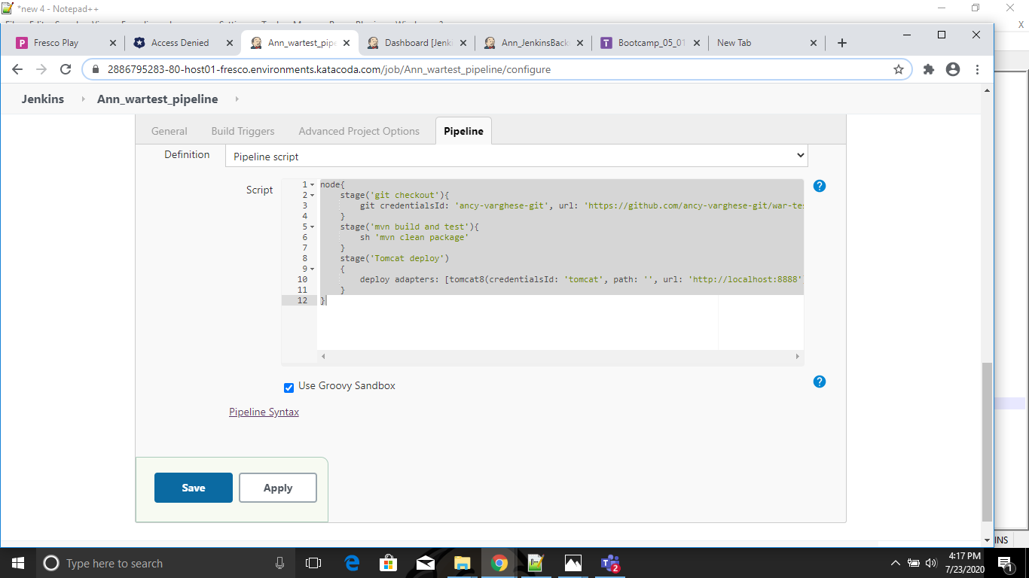

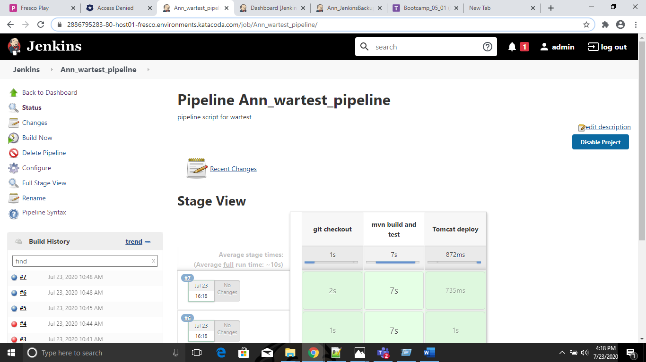

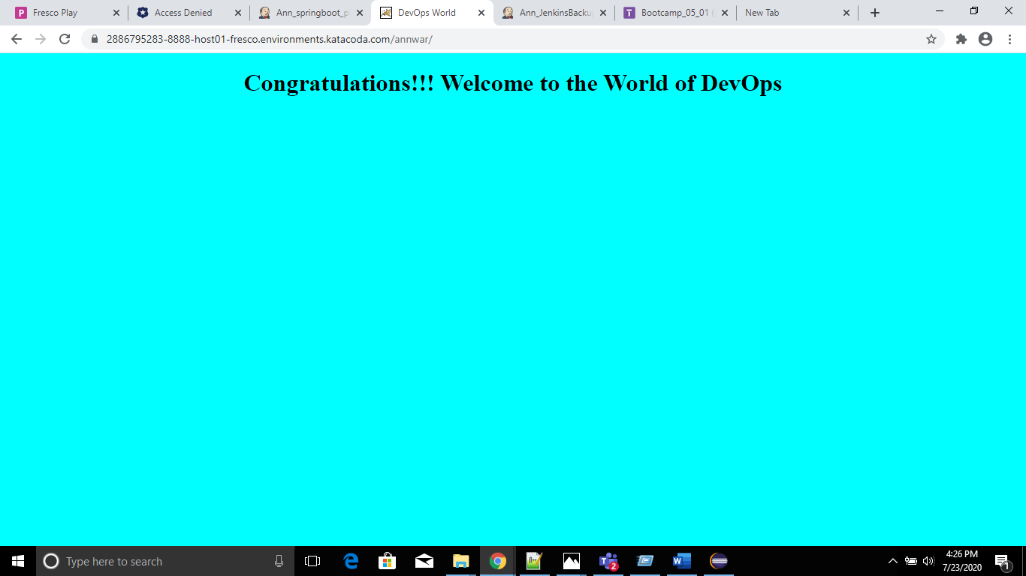

**Console Output**

Started by user [admin](https://2886795283-80-host01-fresco.environments.katacoda.com/user/admin)

Running in Durability level: MAX_SURVIVABILITY

[Pipeline] Start of Pipeline

[Pipeline] node

Running on [Jenkins](https://2886795283-80-host01-fresco.environments.katacoda.com/computer/(master)/) in /root/.jenkins/workspace/Ann_wartest_pipeline@2

[Pipeline] {

[Pipeline] stage

[Pipeline] { (git checkout)

[Pipeline] git

using credential ancy-varghese-git

Cloning the remote Git repository

Cloning repository <https://github.com/ancy-varghese-git/war-test.git>

> git init /root/.jenkins/workspace/Ann_wartest_pipeline@2 # timeout=10

Fetching upstream changes from <https://github.com/ancy-varghese-git/war-test.git>

> git --version # timeout=10

using GIT_ASKPASS to set credentials ancygit

> git fetch --tags --progress <https://github.com/ancy-varghese-git/war-test.git> +refs/heads/*:refs/remotes/origin/* # timeout=10

> git config remote.origin.url <https://github.com/ancy-varghese-git/war-test.git> # timeout=10

> git config --add remote.origin.fetch +refs/heads/*:refs/remotes/origin/* # timeout=10

> git config remote.origin.url <https://github.com/ancy-varghese-git/war-test.git> # timeout=10

Fetching upstream changes from <https://github.com/ancy-varghese-git/war-test.git>

using GIT_ASKPASS to set credentials ancygit

> git fetch --tags --progress <https://github.com/ancy-varghese-git/war-test.git> +refs/heads/*:refs/remotes/origin/* # timeout=10

> git rev-parse refs/remotes/origin/master^{commit} # timeout=10

> git rev-parse refs/remotes/origin/origin/master^{commit} # timeout=10

Checking out Revision 92c99490fac1473962ffa104c3d7ab717b5dfa0d (refs/remotes/origin/master)

> git config core.sparsecheckout # timeout=10

> git checkout -f 92c99490fac1473962ffa104c3d7ab717b5dfa0d # timeout=10

> git branch -a -v --no-abbrev # timeout=10

> git checkout -b master 92c99490fac1473962ffa104c3d7ab717b5dfa0d # timeout=10

Commit message: "Adding dockerfile and dockercompose"

> git rev-list --no-walk 92c99490fac1473962ffa104c3d7ab717b5dfa0d # timeout=10

[Pipeline] }

[Pipeline] // stage

[Pipeline] stage

[Pipeline] { (mvn build and test)

[Pipeline] sh

+ mvn clean package

[INFO] Scanning for projects...

[INFO]

[INFO] ------------------------------------------------------------------------

[INFO] Building war-test Maven Webapp 0.0.1-SNAPSHOT

[INFO] ------------------------------------------------------------------------

[INFO]

[INFO] --- maven-clean-plugin:2.5:clean (default-clean) @ war-test ---

[INFO] Deleting /root/.jenkins/workspace/Ann_wartest_pipeline@2/target

[INFO]

[INFO] --- maven-resources-plugin:2.6:resources (default-resources) @ war-test ---

[INFO] Using 'UTF-8' encoding to copy filtered resources.

[INFO] skip non existing resourceDirectory /root/.jenkins/workspace/Ann_wartest_pipeline@2/src/main/resources

[INFO]

[INFO] --- maven-compiler-plugin:3.2:compile (default-compile) @ war-test ---

[INFO] Changes detected - recompiling the module!

[INFO] Compiling 1 source file to /root/.jenkins/workspace/Ann_wartest_pipeline@2/target/classes

[INFO]

[INFO] --- maven-resources-plugin:2.6:testResources (default-testResources) @ war-test ---

[INFO] Using 'UTF-8' encoding to copy filtered resources.

[INFO] skip non existing resourceDirectory /root/.jenkins/workspace/Ann_wartest_pipeline@2/src/test/resources

[INFO]

[INFO] --- maven-compiler-plugin:3.2:testCompile (default-testCompile) @ war-test ---

[INFO] Changes detected - recompiling the module!

[INFO] Compiling 1 source file to /root/.jenkins/workspace/Ann_wartest_pipeline@2/target/test-classes

[INFO]

[INFO] --- maven-surefire-plugin:2.17:test (default-test) @ war-test ---

[INFO] Surefire report directory: /root/.jenkins/workspace/Ann_wartest_pipeline@2/target/surefire-reports

-------------------------------------------------------

T E S T S

-------------------------------------------------------

Running com.TestCalculator

hello

Tests run: 3, Failures: 0, Errors: 0, Skipped: 0, Time elapsed: 0.665 sec - in com.TestCalculator

Results :

Tests run: 3, Failures: 0, Errors: 0, Skipped: 0

[INFO]

[INFO] --- maven-war-plugin:2.2:war (default-war) @ war-test ---

[INFO] Packaging webapp

[INFO] Assembling webapp [war-test] in [/root/.jenkins/workspace/Ann_wartest_pipeline@2/target/war-test]

[INFO] Processing war project

[INFO] Copying webapp resources [/root/.jenkins/workspace/Ann_wartest_pipeline@2/src/main/webapp]

[INFO] Webapp assembled in [22 msecs]

[INFO] Building war: /root/.jenkins/workspace/Ann_wartest_pipeline@2/target/war-test.war

[INFO] WEB-INF/web.xml already added, skipping

[INFO] ------------------------------------------------------------------------

[INFO] BUILD SUCCESS

[INFO] ------------------------------------------------------------------------

[INFO] Total time: 4.373 s

[INFO] Finished at: 2020-07-23T10:48:31+00:00

[INFO] Final Memory: 15M/36M

[INFO] ------------------------------------------------------------------------

[Pipeline] }

[Pipeline] // stage

[Pipeline] stage

[Pipeline] { (Tomcat deploy) ([hide](https://2886795283-80-host01-fresco.environments.katacoda.com/job/Ann_wartest_pipeline/7/console))

[Pipeline] deploy

[DeployPublisher][INFO] Attempting to deploy 1 war file(s)

[DeployPublisher][INFO] Deploying /root/.jenkins/workspace/Ann_wartest_pipeline@2/target/war-test.war to container Tomcat 8.x Remote with context annwar

Redeploying [/root/.jenkins/workspace/Ann_wartest_pipeline@2/target/war-test.war]

Undeploying [/root/.jenkins/workspace/Ann_wartest_pipeline@2/target/war-test.war]

Deploying [/root/.jenkins/workspace/Ann_wartest_pipeline@2/target/war-test.war]

[Pipeline] }

[Pipeline] // stage

[Pipeline] }

[Pipeline] // node

[Pipeline] End of Pipeline

Finished: SUCCESS

**Page generated:**Jul 23, 2020 10:49:21 AM UTC