# SRS OF ONLINE SAVINGS BANK ACCOUNT

**1.INTRODUCTION**

**1.1 PURPOSE**

**Online banking system** provides is specifically developed for **internet banking** for Balance Enquiry, Funds Transfer to another account in the same **bank**, Request for cheque book/change of address/stop payment of cheques, Mini statements. An **SRS** minimizes the time and effort required by developers to achieve desired **goals** and also minimizes the development cost.

**1.2 SCOPE**

An online banking system will be applicable everywhere, where banking exists. It will be more efficient and easier way to have a record on systems through which everyone can easily access it according to his rights as compared to the traditional banking system.

**1.4 REFERENCES**

This web application has been prepared on the basis of discussion with Team members, faculty members and also taken information from following books & website.

1.4.1. Websites:

1.4.1.1. [www.google.com](http://www.google.com)

1.4.1.2. [www.wikipedia.org](http://www.wikipedia.org)

1.4.1.3. [www.w3schools.com](http://www.w3schools.com)

1.4.2. Books:

1.4.2.1. Fundamental of Software Engineering By Rajiv Mall.

1.4.2.2. Software Engineering : A practitioner’s approach Ed. By Pressman, Roger.

**2.General Descriptions:**

**2.1. Product Perspective:**

Following is the context or origin of online banking system. Comparison b/w the Tradition system and the new system can also be cleared through the system models.

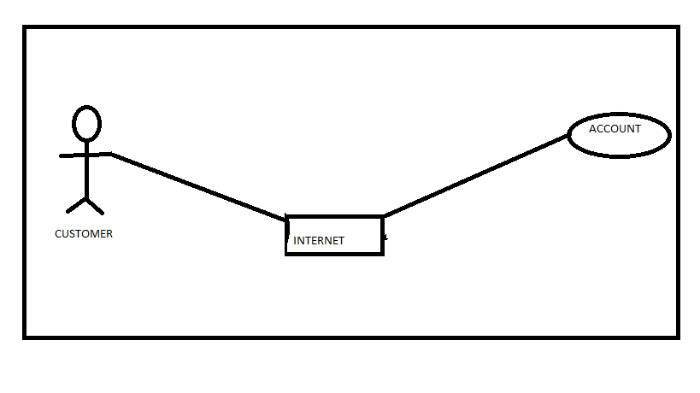

**2.2. Functionalities:**

**2.2.1 Login:**

Customer logins by entering customer name & a login pin.

**2.2.2 Validation:**

When a customer enters the ATM card, its validity must be ensured. Then customer is allowed to enter the valid PIN. The validation can be for following conditions Validation for lost or stolen card When card is already reported as lost or stolen then the message “Lost/Stolen card!!!”.Validation for card’s expiry date If the card inserted by the customer has crossed the expiry date then the system will prompt “Expired Card”. Validation for PIN After validating the card, the validity of PIN must be ensured. If he/she fails to enter valid code for three times then the card will not be returned to him. That means the account can be locked. The counter for number of logins must be maintained

**2.2.3 Get balance information:**

This system must be networked to the bank’s computer. The updated database of every customer is maintained with bank. Hence the balance information of every account is available in the database and can be displayed to the customer.

**2.2.4 Payment of Money:**

A customer is allowed to enter the amount which he/she wishes to withdraw. If the entered amount is less than the available balance and if after withdraw if the minimum required balance is maintained then allow the transaction.

**2.2.5 Transfer of Money:**

The customer can deposit or transfer the desired amount of money.

**2.2.6 Transaction Report**:

The bank statement showing credit and debit information of corresponding account must be printed by the machine.

**2.2.7. Online Billing Option:**

Customers will be able to shop online and pay the bills from their account. A secure way will be provided for the billing. Online shopping will provide them the easiest way to buy and sell their items.

**2.2.8. Check book Allotment:**

If the customer’s checks have been completed, a new check book will be allotted to him.

**2.3 Generals Constraints:**

Some general constraints should be defined which will have a great part in the overall succession of the online banking project.

**2.3.1. Hardware Requirements:**

As this system is an online Web-based application so a client server will be the most suitable Organizational style for this system. Computer systems will be needed by each of the actor as well as that user must be connected to the internet. So, concisely following hardware will be needed.

1) Computer systems

2) Internet availability

**2.3.2. Safety and Security:**

Of all the things you want to keep safe, your financial information is surely near the top of the list. Online banks know protecting your financial information is serious business. They use a combination of cutting edge technology and industry best practices to protect your personal and financial information.

**2.4 Assumptions and Dependencies**:

Following are the assumptions and dependencies which are related to this online banking project.

1) This project is a stand-alone project so it will not affect the system where it will be embedded.

2) This project is a web-based project while the staff was addict of using traditional methods of data storage and retrieval so they will be trained a bit to jump to it.

3) This system will not depend on any other module. It will be a web-based so everyone will independently contact it.

4) It is will not affect the environment at all. 5) Banks will feel free to adopt it because it will not be so much expensive.

**3.1 Functional Requirements:**

Following are the services which this system will provide. These are the facilities and functions required by the customer.

a) Online balance check.

b) Online shopping opportunity.

c) Online data entry by the staff.

d) Updating the data.

e) Balance transfer.

f) Check book Allotment.

**3.1.1) Context Diagram**

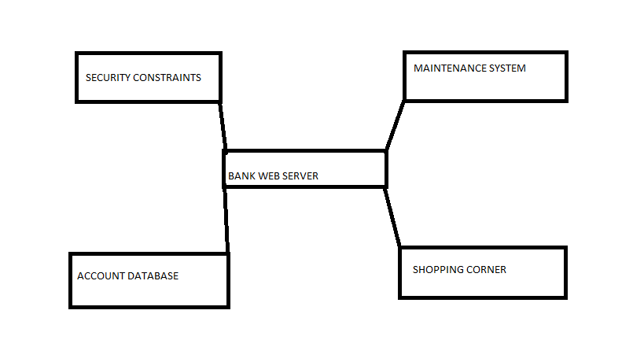

**3.2) External Interface Requirements:**

**4.1 Hardware Interface**

Various interfaces for the product could be

1. Touch screen/Monitor

2. Keypad

3. Continuous battery backup

4. Printer which can produce the hard copy.

5. Interface that connects the device to bank’s computer.

6. An interface that can count currency notes.

4.2. Software Interface:

HTML, Web Browser, Flash Player, MS Office, Windows XP/9x/ME. Web Server: HTML, MS Office, Windows XP/9x/ME.

**4.3 Communication Interface**:

The Customer must connect to the Internet to access the Website: a) Dialup Modem of 52 kbps. b) Broadband Internet. c) Dialup or Broadband Connection with a Internet Provider.

**5. Performance Requirements**

The system should be compatible enough to hold the general traffic .It should not get hang or show some other problems arising out due to large no of concurrent users . The system should be fast enough to meet the customer The high and low temperature should not affect the performance of the device. An uninterrupted transaction must be performed.

**6.Constraints**

The information of all the users must be stored in a database that is accessible by the On- line Banking System. The Online Banking System is connected to the computer and is running all 24hours a day. The  users  access  the  Online  Banking  System from any computer  that has Internet  browsing capabilities and an Internet connection.

The users must have their correct usernames and passwords to enter into the Online Banking System.

Design Constraints:

Software Language Used

The languages that shall be used for coding Online Banking System are c , cpp, java , and  HTML.  For working  on the  coding  phase  of  the  Online  job portal  System Web Sphere  Application  Server/WebSphere  Application  Server  CE  Server  needs  to  be  installed.

Database design

|  |
| --- |
|  |

In our database design, we give names to data flows, processes and data stores. Although the names are descriptive of data, they do not give details .So following DFD, our interest is to build some details of the contents of data flows, processes and data store. A data dictionary is a structured repository of data about data. It is a set of rigorous definitions  of all DFD  data elements  and data  structures  .

**7. Performance**

**7.1 Security**

The banking system must be fully accessible   to only authentic user. It should require pin for entry to a new environment.

**7.2 Reliability**

The application should be highly reliable and it should generate all the updated information in correct order.

**7.3 Availability**

Any information about the account should be quickly available from any computer to the authorized user. The previously visited customer’s data must not be cleared.

**7.4 Maintainability**

The application should be maintainable in such a manner that if any new requirement occurs then it should be easily incorporated in an individual module.

**7.5 Portability**

The application should be portable on any windows based system. It should not be machine specific.

**INDEX**

1.INTRODUCTION

1.1 PURPOSE

1.2 SCOPE

1.3 REFERENCE

2GENERAL DESCRIPTION

2.1PRODUCT PERSPECTIVE

2.2 FUNCTIONALITIES

2.2.1LOGIN

2.2.2VALIDATION

2.2.3GET BALANCE INFORMATION

2.2.4PAYMENT OF MONEY

2.2.5 TRANSFER OF MONEY

2.2.6 TRANSACTION REPORT

2.2.7ONLINE BILLING OPTION

2.2.8CHECK BOOK ALLOTMENT

2.3 GENERAL CONSTRAINTS

2.3.1HARDWARE REQUIREMENTS

2.3.2SAFETY AND SECURITY

2.4 ASSUMPTIONS AND DEPENDENCIES

3.1 FUNCTIONAL REQUIREMENTS

3.1.1 CONTEXT DIAGRAM

3.1.2 EXTERNAL INTERFACE REQUIREMENTS

4.1 HARDWARE INTERFACE

4.2SOFTWARE INTERFACE

4.3 COMMUNICATION INTERFACE

5 PERFORMANCE REQUIREMENTS

6.CONSTRAINTS

7.PERFORMANCE

7.1 SECURITY

7.2RELIABILITY

7.3 AVAILABILITY

7.4 MAINTAINABILITY

7.5 PORTABILITY