1. Lighting
Use proper natural or artificial lighting to clearly capture the subject and surroundings.

2. Framing
Use a suitable camera angle and framing to clearly present the subject.
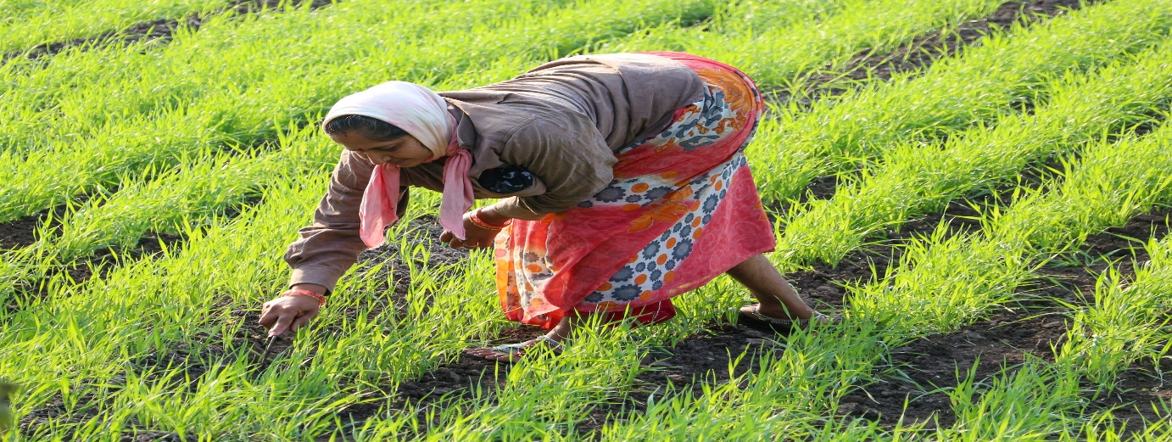
3. Informed Consent
Take permission from participants before taking photographs or recording videos.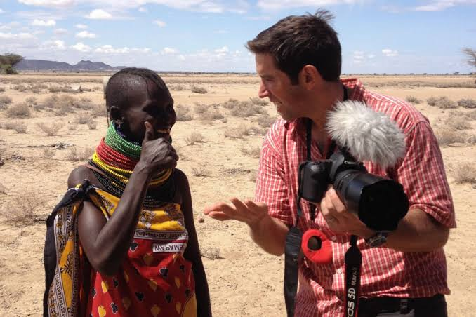
4. Context Capture
Capture the subject along with its surroundings to show the complete context.
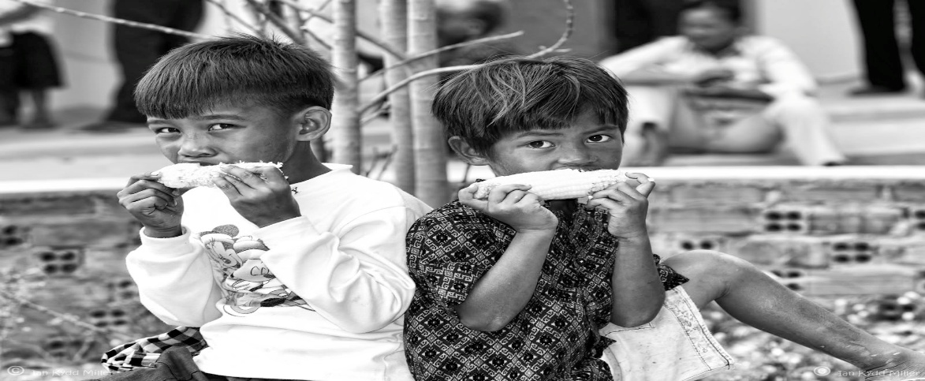
5. Body Language
Observe and capture facial expressions, gestures, posture and body movements.
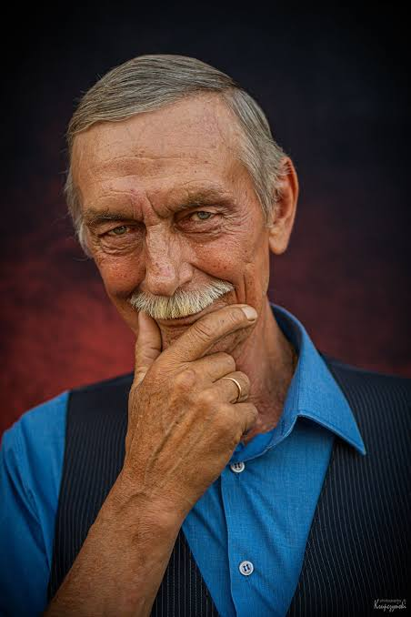

6. Environment
Photograph important places, objects and surroundings related to the fieldwork.
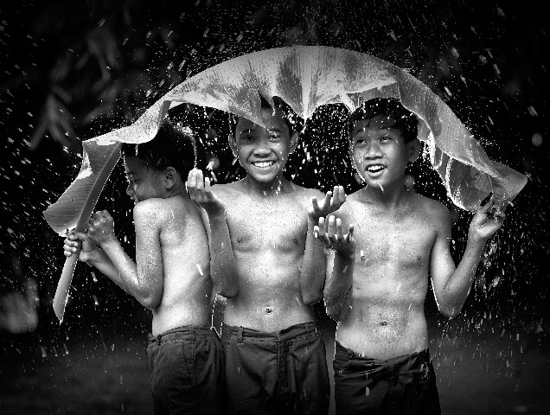
7. Participant Interaction
Capture natural interactions and activities between participants without disturbing them.
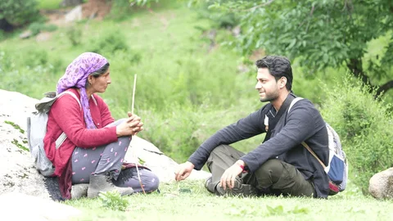
8. Cultural Sensitivity

Respect local customs, traditions, beliefs and cultural practices while taking photographs or videos.
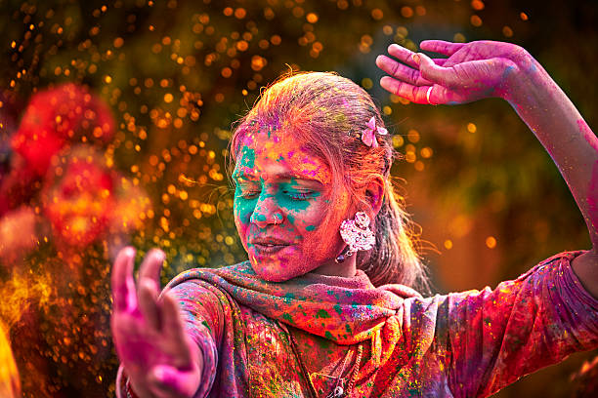
9. Privacy and Ethics
Protect the privacy and dignity of participants and avoid recording sensitive information without permission.
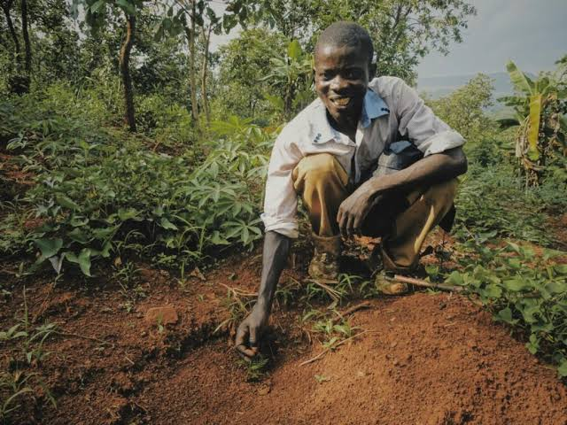

10. Documentation and Field Notes
Record the date, location, subject and observations related to each photograph or video.


