**Enterprise UXpedition: 世界に広がり、拡張性があり、ユーザーフレンドリーな組織を作り出そう**

The complexity and challenge of making global enterprises user-friendly is one of the most di cult challenges in the world today. Some wonder if it is possible at all. Great Enterprise User Experience (for both customers and employees) requires leadership, planning, and operations to work alongside all of the classic enterprise disciplines.

by XPLANE

# なぜ?

**どのように?**

### Build a sustainable practice.

**Follow my lead**

**We have come a long way!**

### Prepare for change.

You are the keeper of the flame. Keep an eye on the horizon. An acquisition, a merger, new CEO, all of these things are possible



Enterprise UX helps you avoid risk and wasted time on innovation e"orts that are unlikely to work by keeping enterprise e"orts closely linked to customer value.

Here is a current state snapshot of how the best minds in Enterprise UX today are tackling this complex challenge.

Make sure your methodology has a clear

path so others can follow your lead.

### Measure value and impact.

Measure the impact you deliver. Use numbers to make your case when you need more resources and funding.

and they might set you back to square one. Be ready.

### Why am I allocating new budget amounts for this thing I’ve never heard of?

**CRAFT AN ENTERPRISE EXPERIENCE**

**OUR PROMISE**

**1**

**4**

### Persevere.

The air is thin near the top. It doesn’t get easier, it gets harder. When you fall, get back up. Be ready to fight for what you believe in.

**LEAVE A LEGACY**

### Compare.

**We do it this way.**

**Cool!**

### We need to make better decisions and reduce risk and uncertainty.

**Clarify your vision.**

A clear value promise to customers unites people, drives decisions, aligns teams, and creates momentum.

### Map the territory.

Scout out the situation

### Nurture relationships.

Empathy for customers and colleagues unblocks things, builds alignment, and sets you up to build momentum and get quick wins.

Compare perspectives, maps, and tools with other silos. Find common languages, tools, and templates that can work across all teams.

## 3 TRANSCEND SILOS

### Enterprise UX will help us make sure we are doing the right things.

with generative research.

**We can help! Thanks!**

### Okay. But how will we measure it?

**OUR PLAN**

## LEAD TEAMS

**2**

**THAT EXECUTE**

**ORG CHART**

**Here’s where we fit.**

### Choose an approach.

**TALENT PLAN**

What are the goals for users and stakeholders?

What will you do first? What people, skills, and

tools do you need?

**THIS WAY!**

**Carve out your place.** Frame how and where Enterprise UX sits in the larger organization, especially in regards to engineering and development.

**Balance optimism and realism.** As an optimist, you must help people focus on the goal. But as a realist, you must also plan and prepare for worst-case scenarios.

### Make connections.

People from across the enterprise speak di"erent languages, use di"erent tools, and have di"erent points of view and skills. You need to be a connector, a bridge-builder, and a diplomat.

### This will help our Net Promoter Score, increase brand loyalty, and reduce costs related to customer attrition, brand switching, and customer support.

**Blaze a trail.**

As you make your way, reflect on what you are learning and

develop a design system to make it easier for others to follow.

### Build your team.

What positions do you need? How will you balance the workloads

within your budget?

Download the PDF xplane.com/EUXpedition

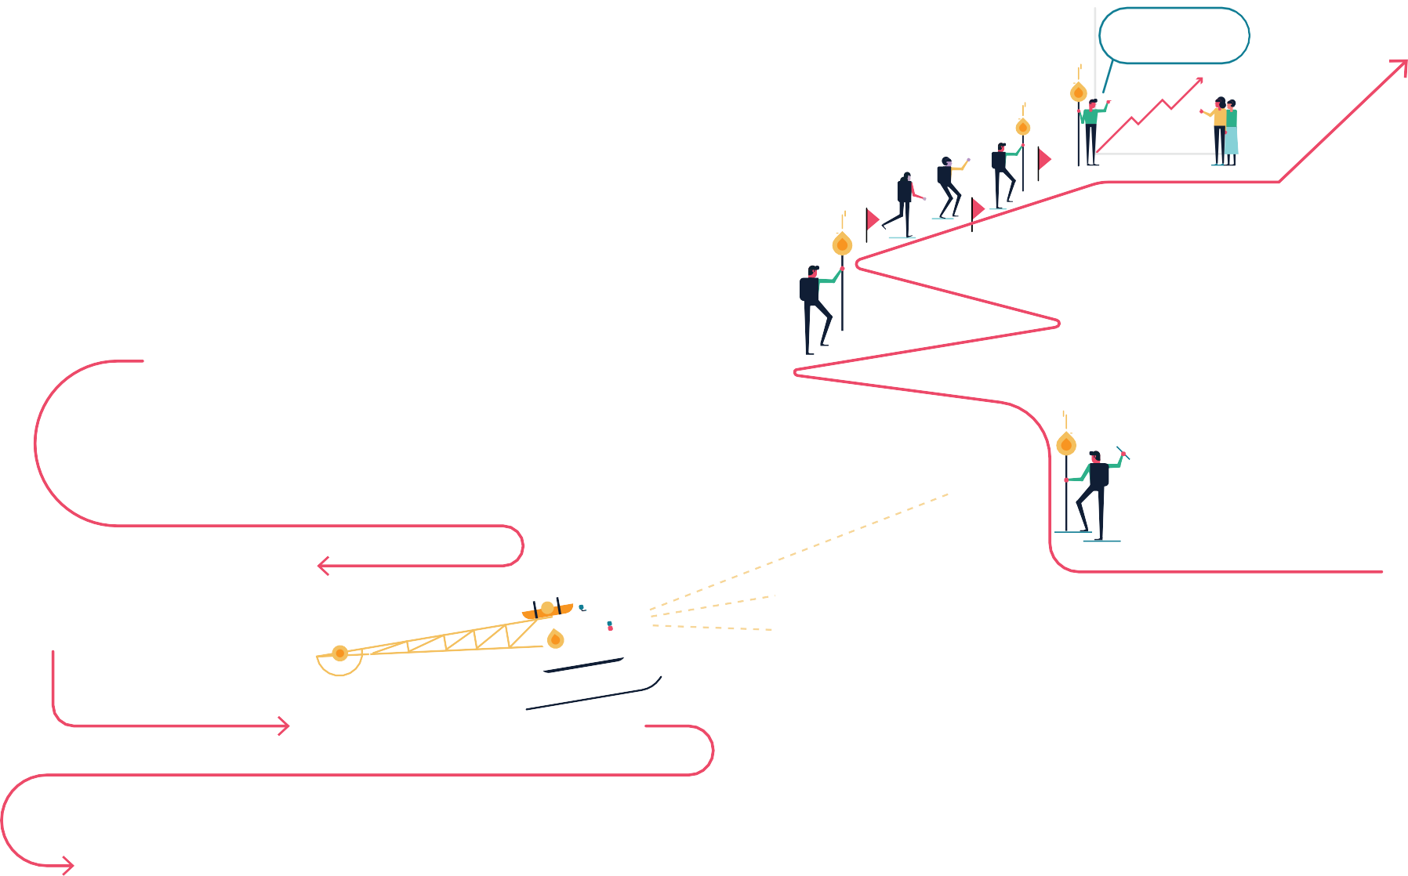

Sources: Lou Rosenfeld, Theresa Neil, Phillip Hunter, Colette Vardeman, and the Enterprise UX team. Do you have something you need to explain? ©XPLANE.com 2017