**Lab Report**

Title: LAB 0

Notice: Dr. Bryan Runck

Author: Cole Anderson

Date: 1/30/21

**Project Repository:** <https://github.com/and04671/GIS5572/tree/main/Lab0>

**Abstract**

This lab uses the ArcPro, ArcOnline, and Jupyter interfaces to compare commands and execution. The data used shows scenic roads, which were buffered in all environments. The secondary goal was to gain usable knowledge of GITHUB processes.

**Problem Statement**

Compare and contrast the buffer tools in ArcPro, Jupyter Notebooks in ArcPro, and Jupyter Notebooks in ArcOnline by using all three to create the same result. Illustrate the similarities/differences in methodology/requirements between the three tools.

*Table 1. Problem Statement Requirements*

|  |  |  |  |  |  |  |
| --- | --- | --- | --- | --- | --- | --- |
| **#** | **Requirement** | **Defined As** | **Spatial Data** | **Attribute Data** | **Dataset** | **Preparation** |
| 1 | Network Data to Buffer | Raw input dataset from MNDOT | Road Centerlines | N/a | <https://gisdata.mn.gov/dataset/trans-routes-tour> |  |
| 2 |  |  |  |  |  |  |
| 3 |  |  |  |  |  |  |
| 4 |  |  |  |  |  |  |

**Input Data**

The data chosen for this lab was a MNDOT dataset of the scenic byways in Minnesota, collected form the MN Geospatial Commons

*Table 2. Data Collected*

|  |  |  |  |
| --- | --- | --- | --- |
| **#** | **Title** | **Purpose in Analysis** | **Link to Source** |
| 1 | Scenic Byways in Minnesota | Raw input dataset for buffering from MNDOT LRS | <https://gisdata.mn.gov/dataset/trans-routes-tour> |
| 2 |  |  |  |
| 3 |  |  |  |
|  |  |  |  |

**Methods**

**ArcPro**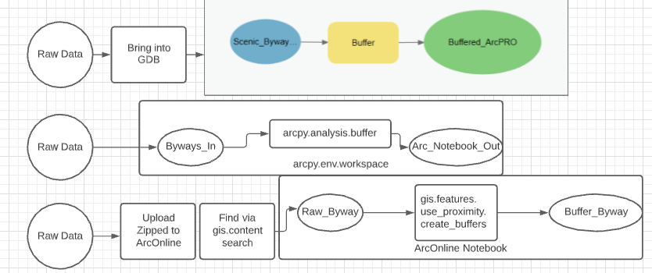

After downloading and unzipping the raw data, import desired road layer to Lab0 GDB (Default). Add roads layer to map for visualization. Execute buffer tool dialog, setting input as roads layer and output as buffered roads in the same Lab0 GDB. Add buffered roads layer to map to check for proper final result.

**Jupyter ArcPro**

After downloading data, establish environment at Lab0 GDB. Import arcpy module. Execute analysis.buffer with input parameter as unbuffered roads, output in same GDB established earlier. Notebook is in GitHub folder.

**Jupyter ArcOnline**



In account home, create a new notebook. Add input layer to ArcOnline first (by hand, script was having issues, but can do from ArcPro on computer. Find the newly uploaded layer using content search and assign to variable. Execute create_buffers on created variable. This will create another feature layer under the user content.

**Results**

|  |  |  |  |  |  |
| --- | --- | --- | --- | --- | --- |
| **Method** | **Start Data** | **Buffer Method** | **End Result** | **Other Requirements** |  |
| ArcPro | SHP | Geoprocessing > Analysis Tools > Buffer | Added to GDB | GUI Navigation |  |
| Jupyter | SHP | arcpy.analysis.Buffer | Added to GDB | Establish environment |  |
| ArcOnline | Zipped SHP | arcgis.features.use_proximity.create_buffers | Feature Collection | Upload and Search |  |

**Results Verification**

All methods should have created a curved end buffer around all of the Scenic Byway polyline features. All three methods followed the correct, and same, roads. The left image shows the outputs from the ArcPro and Jupyter methods. Both the inner and out ring buffers follow the same paths, though the Jupyter buffer extends farther away (the values should be the same; the values and units are set the same in each tool). The right image shows the layer output from the ArcOnline Method. It is exactly identical to the ArcPro buffer. The results all meet the goal.

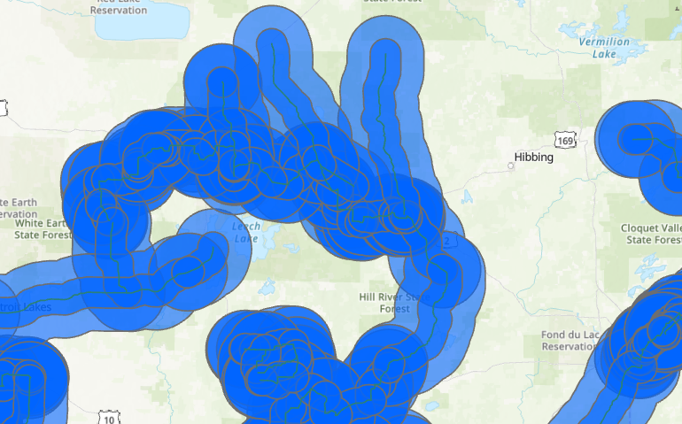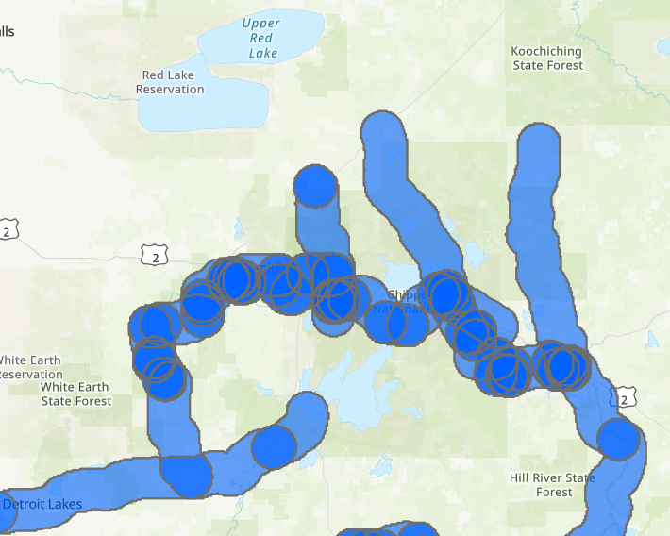

**Discussion and Conclusion**

**GitHub**

The GitHub setup was relatively simple with both GitHub Desktop and GitHub profile open. I have used GitHub often in previous classes. New in this class: Creating new repositories from online allows a simpler method of creating folders inside repositories, something that doesn’t always work correctly from the Desktop. The difficult elements of GitHub are GitBash and mentally keeping track of how the versions of a document are connected. Overall, this version management software is a more complicated, but smoother and more capable file sharing option than something like Google Docs or email.

**ESRI Ecosystem Options**

The three environment options for ArcGIS all can accomplish the same tasks, but provide advantages and disadvantages in different areas. The ArcPro GUI is easy to use for professionals new to GIS and visual crosschecking of results, but can sometimes present too many tabs, panels, and extra information. The Jupyter inside ArcPro takes more time to learn in terms of methods and formatting, but is extremely simple to use after some practice. A code editor has the advantage that clicking through long lists of tools and options is not required. The ArcOnline method still seems unwieldy. Clearly the visual based point-and-click tools are the intended functions in the online editor. It was difficult to find good documentation for the required ArcGIS API without significant digging and trial. It is is not the simplest option for simple analysis, but the ability to share data on a single platform is convenient.

**References**

Arcgis.features module. (2021). Retrieved January 31, 2021, from https://developers.arcgis.com/python/api-reference/arcgis.features.html

Portal for ArcGIS. (2021). Retrieved January 31, 2021, from https://enterprise.arcgis.com/en/portal/latest/use/geoanalytics-create-buffers.htm#

ArcGIS Pro Help: Use ModelBuilder. (2020). Retrieved January 31, 2021, from https://pro.arcgis.com/en/pro-app/latest/help/analysis/geoprocessing/modelbuilder/modelbuilder-quick-tour.htm

MNDOT. (2020). Scenic Byways in Minnesota. Retrieved January 31, 2021, from https://gisdata.mn.gov/dataset/trans-routes-tour

**Self-score**

|  |  |  |  |
| --- | --- | --- | --- |
| **Category** | **Description** | **Points Possible** | **Score** |
| **Structural Elements** | All elements of a lab report are included **(2 points each)**:  Title, Notice: Dr. Bryan Runck, Author, Project Repository, Date, Abstract, Problem Statement, Input Data w/ tables, Methods w/ Data, Flow Diagrams, Results, Results Verification, Discussion and Conclusion, References in common format, Self-score | 28 | **26** |
| **Clarity of Content** | Each element above is executed at a professional level so that someone can understand the goal, data, methods, results, and their validity and implications in a 5 minute reading at a cursory-level, and in a 30 minute meeting at a deep level **(12 points)**. There is a clear connection from data to results to discussion and conclusion **(12 points)**. | 24 | **22** |
| **Reproducibility** | Results are completely reproducible by someone with basic GIS training. There is no ambiguity in data flow or rationale for data operations. Every step is documented and justified. | 28 | **25** |
| **Verification** | Results are correct in that they have been verified in comparison to some standard. The standard is clearly stated **(10 points)**, the method of comparison is clearly stated **(5 points)**, and the result of verification is clearly stated **(5 points)**. | 20 | **19** |
|  |  | 100 | **94** |