viz

## R Scatterplot

library(dplyr)

##   
## Attaching package: 'dplyr'

## The following objects are masked from 'package:stats':  
##   
## filter, lag

## The following objects are masked from 'package:base':  
##   
## intersect, setdiff, setequal, union

library(ggplot2)  
library(gapminder)  
  
  
#invesitate data  
summary(gapminder)  
  
#now let's plot it

# setup dataframe  
g = gapminder %>%  
 filter(year==2007) %>% # most recent year   
 mutate(pop_m = pop/1e6) # population, millions  
  
# plot scatterplot of most recent year   
# ggplot(dataframe (it's called g now), aes means what're you gonna assign to the x and y axes?))  
s = ggplot(g, aes(x=gdpPercap, y=lifeExp)) +  
 geom_point()  
s

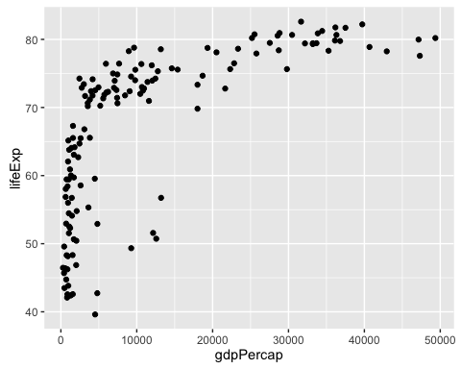

s+geom_smooth()

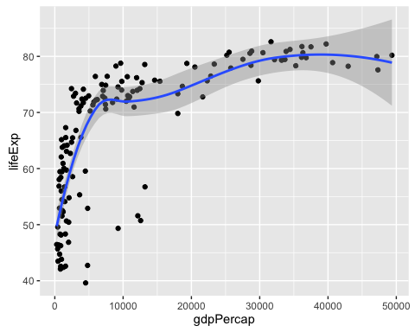

#how cool is that! Make a variable (s) then shape it in different ways by 'adding' a function to it  
  
#now add an aesthetic, like size of points corresponding to population size  
s = ggplot(g, aes(x=gdpPercap, y=lifeExp)) +  
 geom_point()  
s



s+aes(size=pop_m)

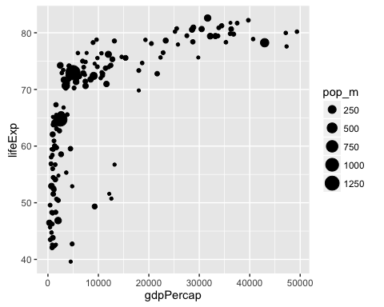

#add another aesthetic (aes)  
  
s = ggplot(g, aes(x=gdpPercap, y=lifeExp)) +  
 geom_point()  
s



s+aes(size=pop_m)+  
 aes(color=continent)+  
 ggtitle('Health & Wealth of Nations for 2007') +  
 xlab('GDP per capita ($/year)') +  
 ylab('Life expectancy (years)')

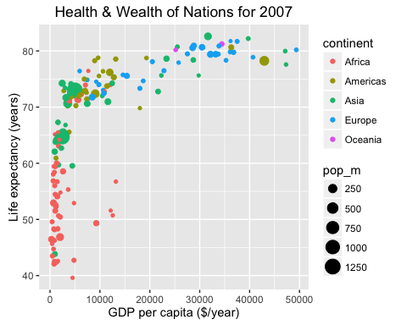

## now, if we wanted to, we could go to the top and switch output to a different type. For example, a slide show presentation file type. Which would make it a slideshow. Pretty cool. Go to rmarkdown.rstudio/com or something like that to experiment with different types.