**LEMBAR SOAL TUGAS MAHASISWA**

**(LTM)**

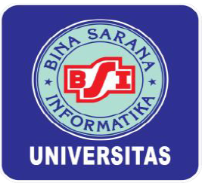

**MATA KULIAH**  
**WEB PROGRAMMING II** (**682)**

Nama : Kristian Rosady

NIM : 12200580

Kelas : 12.3A.31

Program Studi : Sistem Informatika

UNIVERSITAS BINA SARANA INFORMATIKA

JAKARTA

2021

1. Controller  
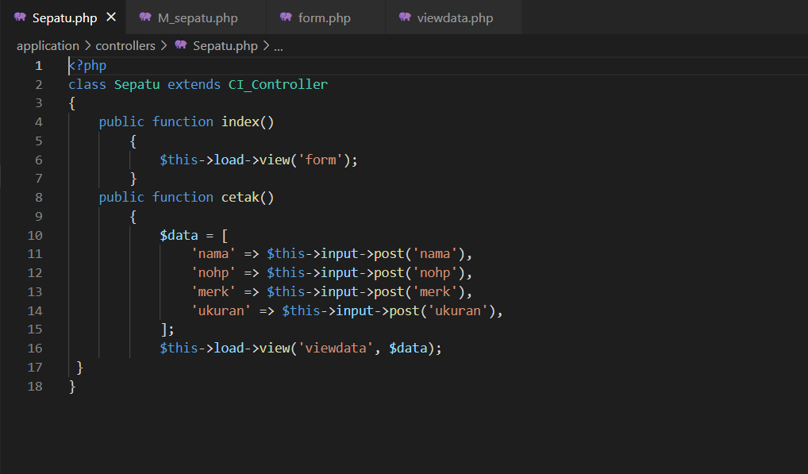  
  
2. Model  
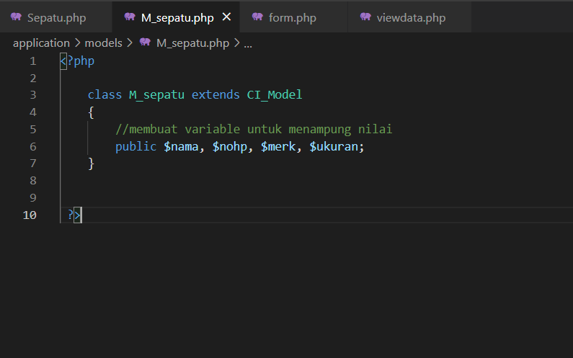  
  
  
  
  
  
  
  
  
  
3. View Form  
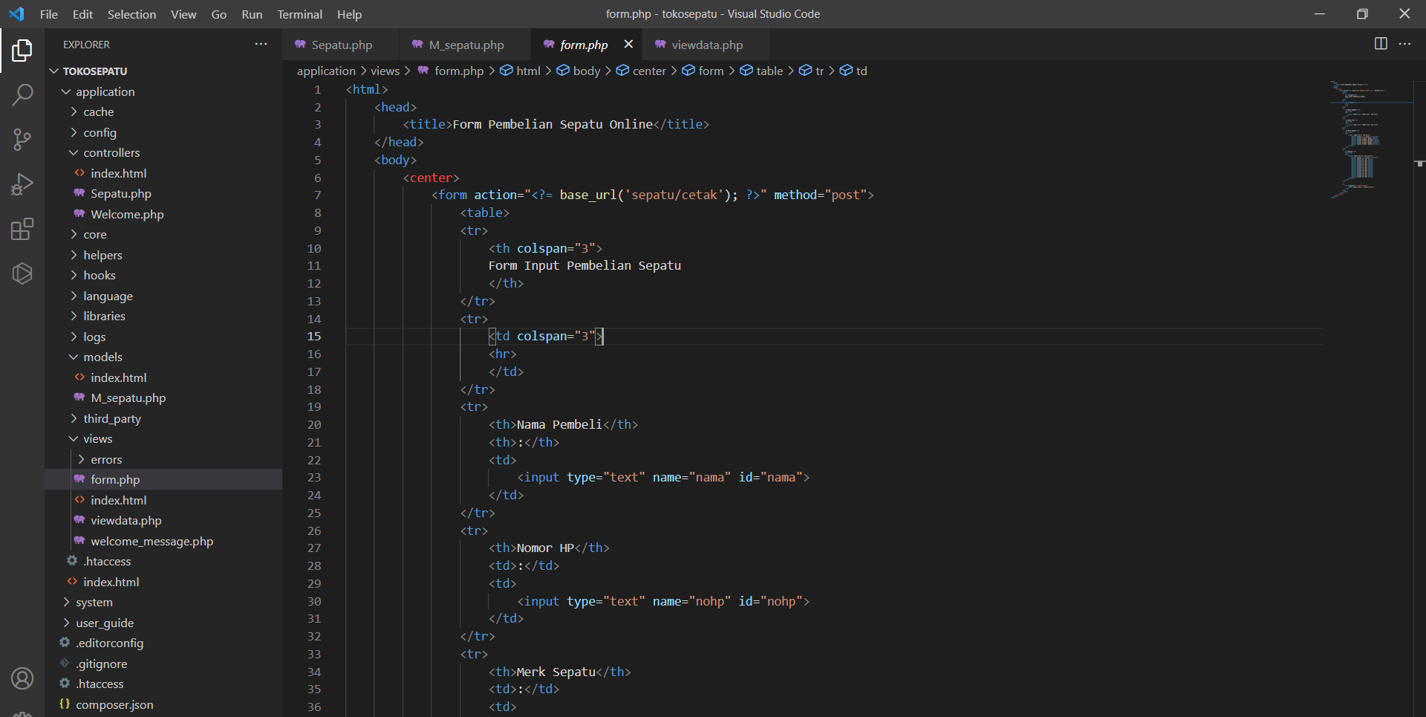  
  
  
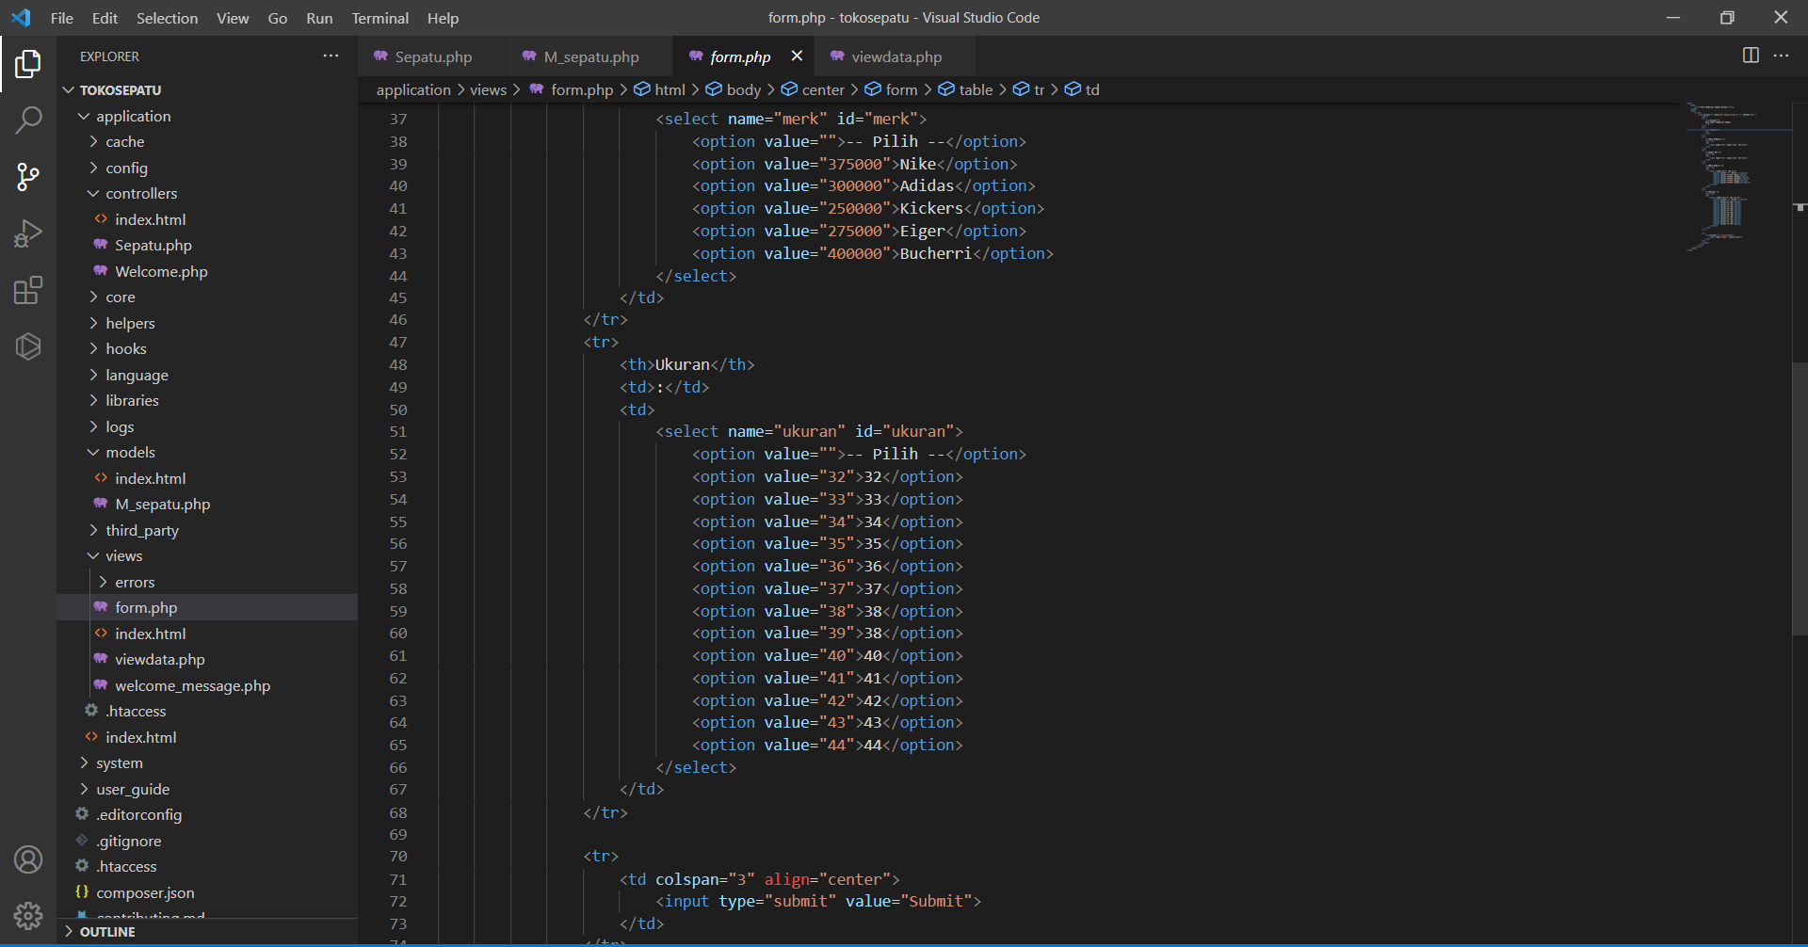  
  
  
  
  
  
  
  
  
  
  
4. View Data

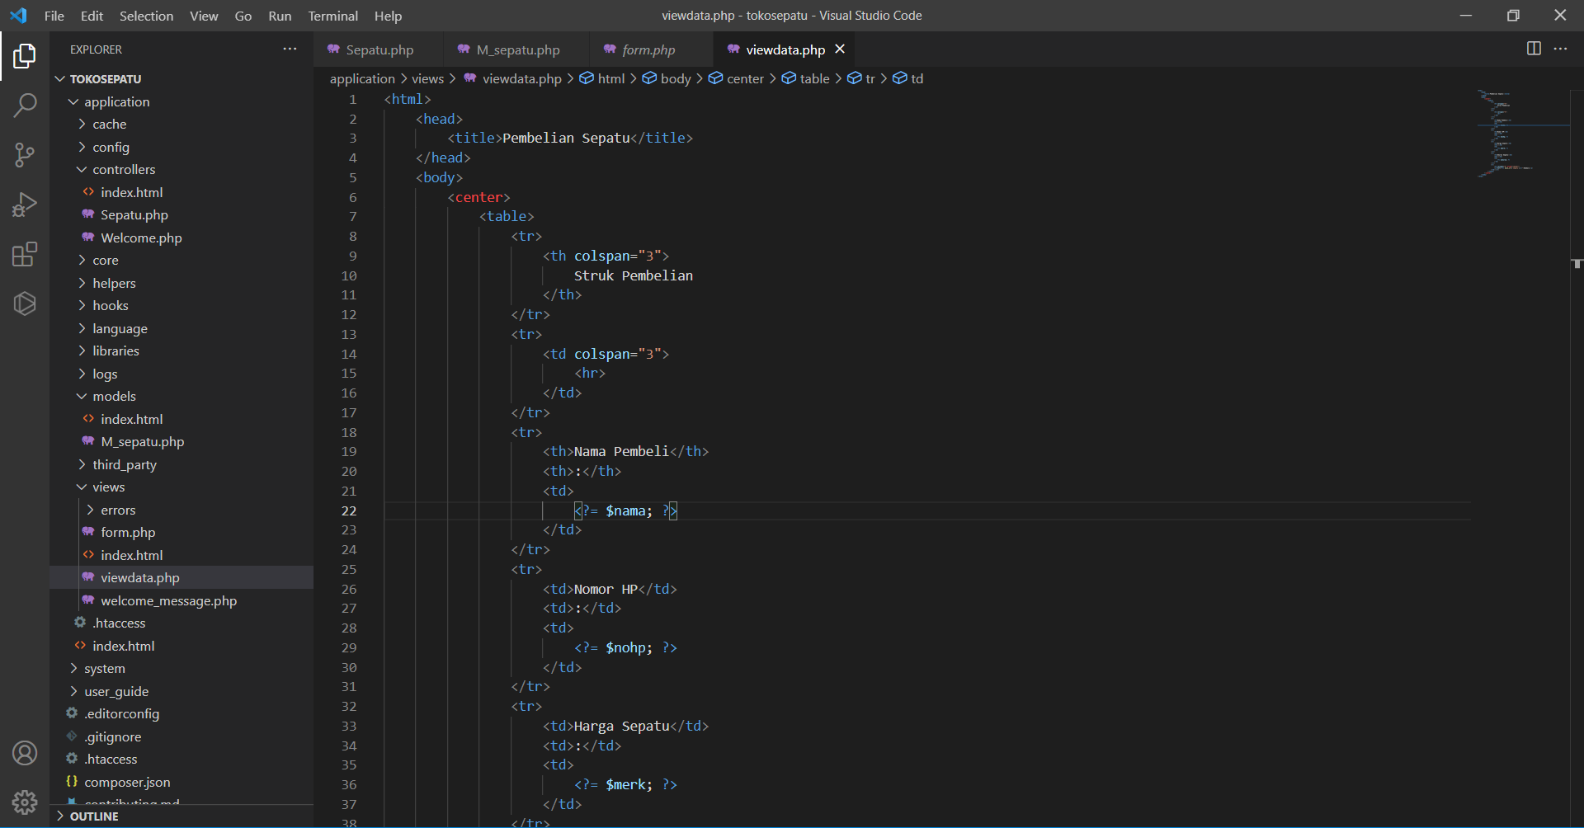  
  
  
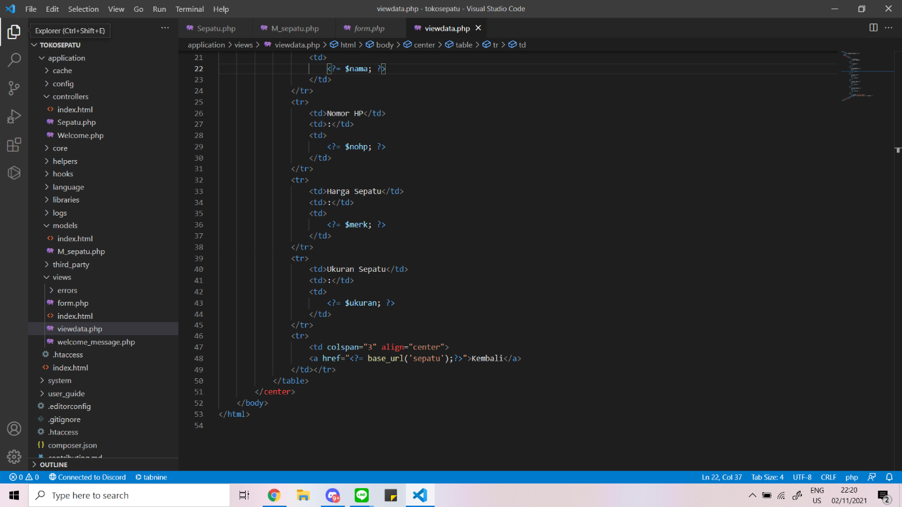  
  
  
  
  
  
  
  
  
  
5. Output  
