Web GIS Laboratory 4
GeoDjango with PostGIS, the admin panel and Leaflet
Screenshot evidence, Checkpoints 1–8 and installation errors
Contents
Section | Figures | Shows
Checkpoint 1 | 1–2 | Django project created and running
Checkpoint 2 | 3 | PostgreSQL and PostGIS installed, webgis database ready
Checkpoint 3 | 4–7 | Django connected to PostGIS
Checkpoint 4 | 8–10 | A model with a geometry field
Checkpoint 5 | 11–14 | Load the districts
Checkpoint 6 | 15–23 | The admin panel
Checkpoint 7 | 24–26 | Leaflet map fed by Django
Checkpoint 8 | 27–30 | Extension: asking PostGIS a spatial question
Appendix A | 31–32 | Installation errors and fixes
Software versions
Component | Version
Python | 3.14.2
Django | 6.1.2
PostgreSQL | 17.11
PostGIS | 3.6.2 (GEOS 3.14.1, PROJ 8.2.1 inside PostGIS)
GDAL / GEOS seen by Django | 3.13.3 / 3.15.0 (OSGeo4W)

Checkpoint 1 – Django project created and running
Required: the “install worked” page with the address bar visible, and the output of python -m django --version.
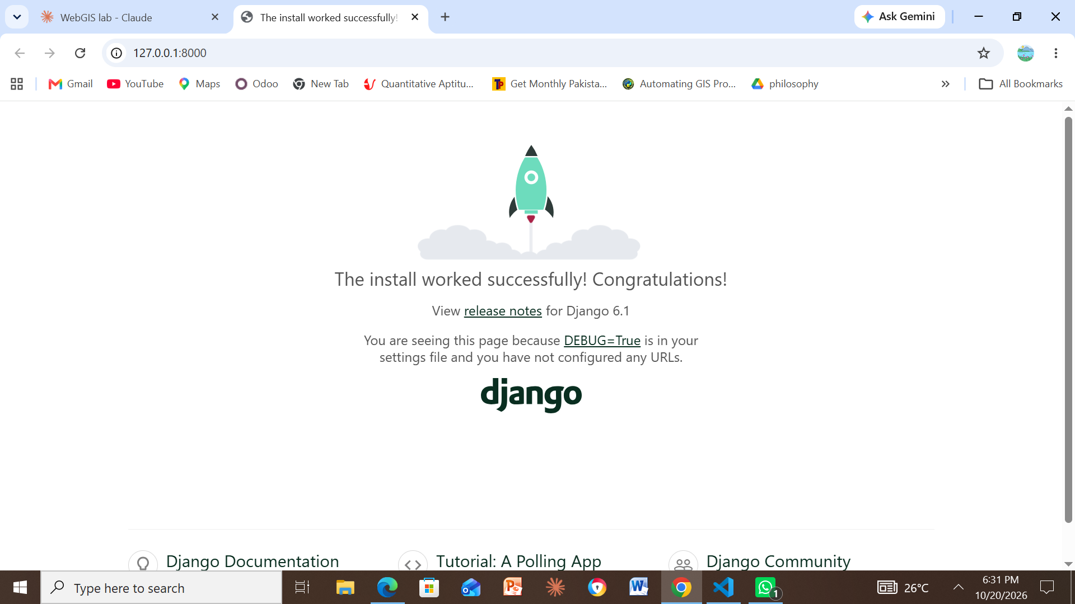
Figure 1. The Django “The install worked successfully!” page at 127.0.0.1:8000.
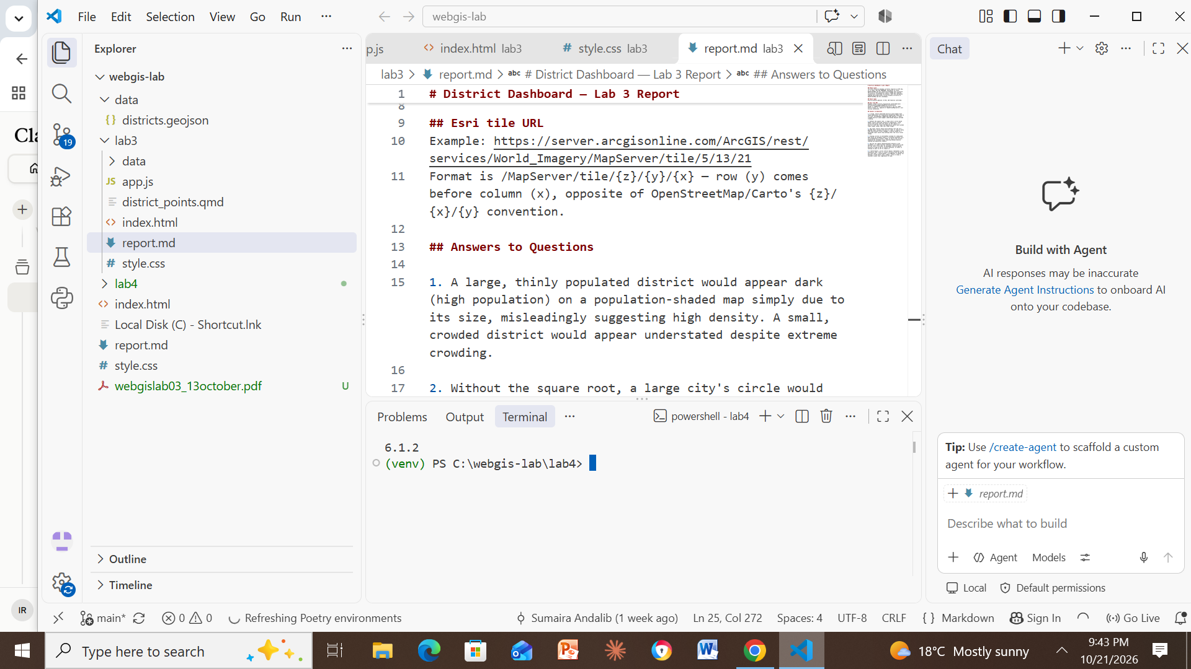
Figure 2. Output of python -m django --version inside the activated (venv): Django 6.1.2.

Checkpoint 2 – PostgreSQL and PostGIS installed, webgis database ready
Required: pgAdmin with the webgis database selected and the result of postgis_full_version() visible.
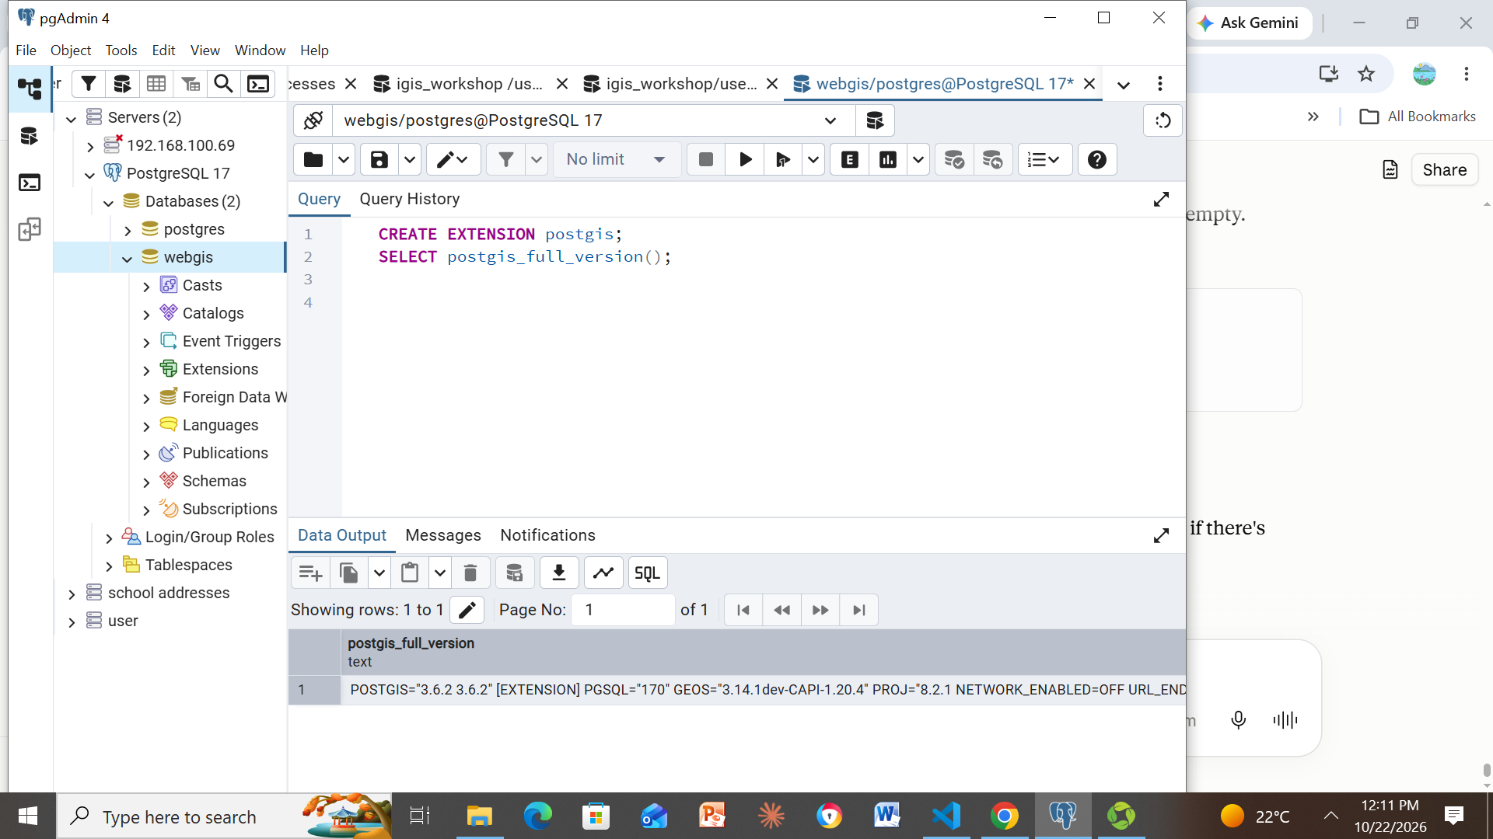
Figure 3. pgAdmin with the webgis database selected; CREATE EXTENSION postgis and postgis_full_version() return PostGIS 3.6.2, GEOS 3.14.1 and PROJ 8.2.1 on PostgreSQL 17.

Checkpoint 3 – Django connected to PostGIS
Required: output of the GDAL/GEOS check, manage.py check and migrate, and the tables in pgAdmin.
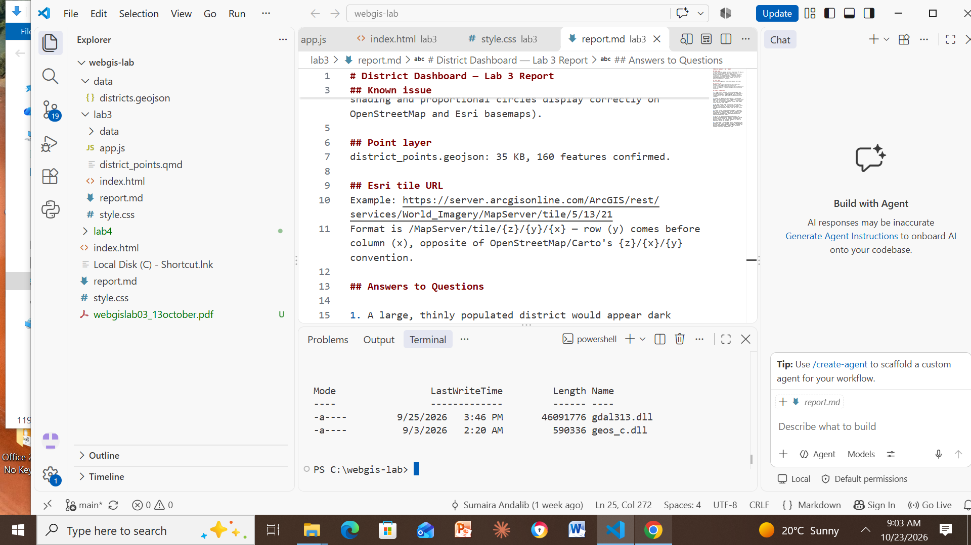
Figure 4. OSGeo4W installed: C:\OSGeo4W\bin contains gdal313.dll and geos_c.dll.
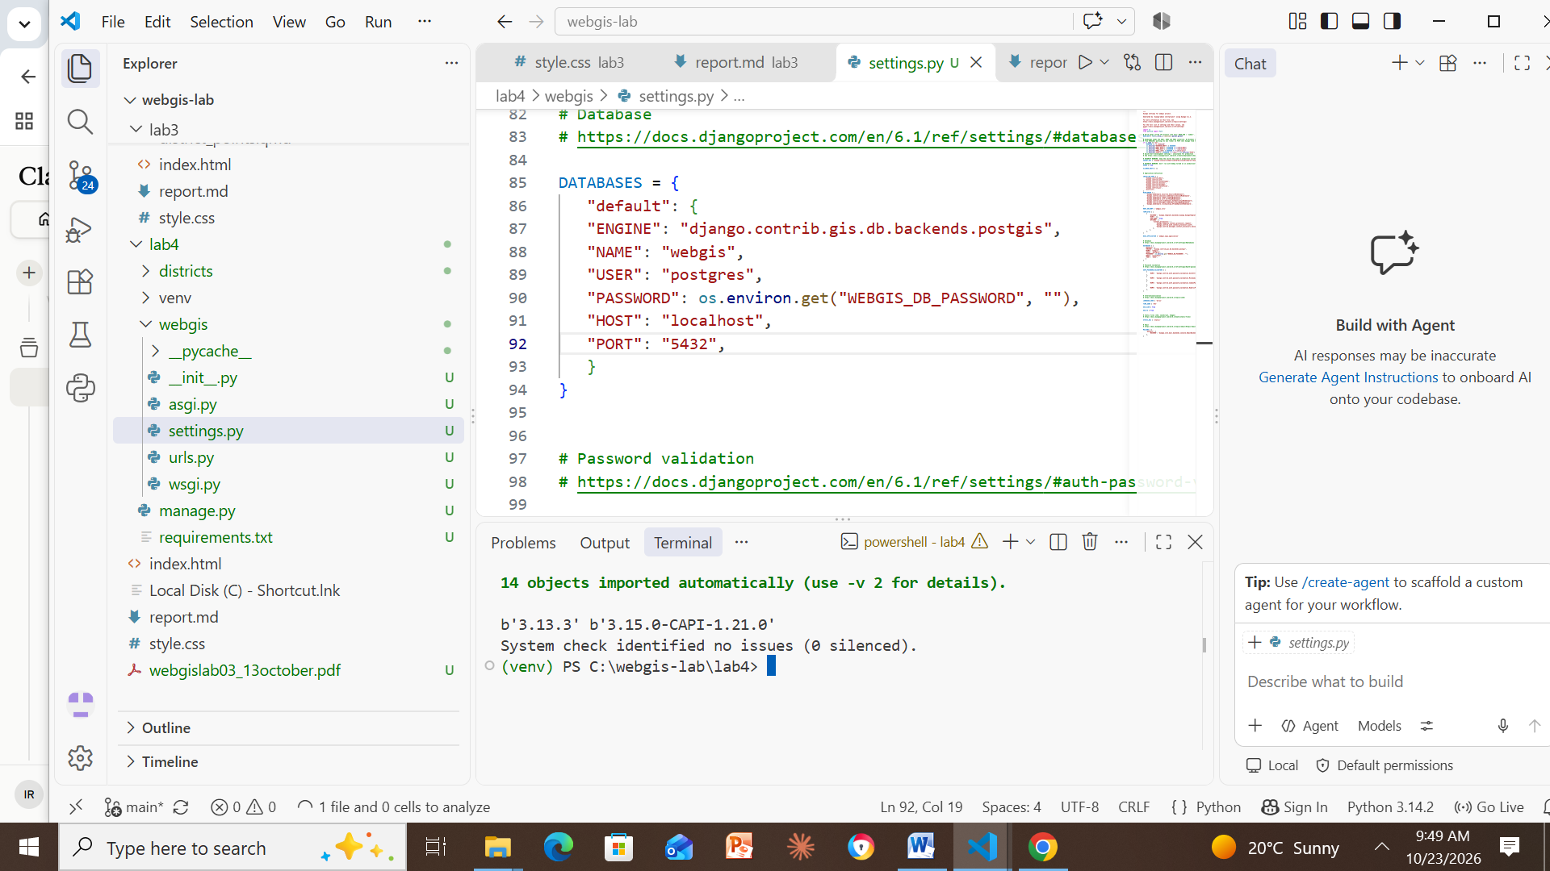
Figure 5. Python loads GDAL 3.13.3 and GEOS 3.15.0; python manage.py check reports “no issues (0 silenced)”. The PostGIS DATABASES settings are visible above.
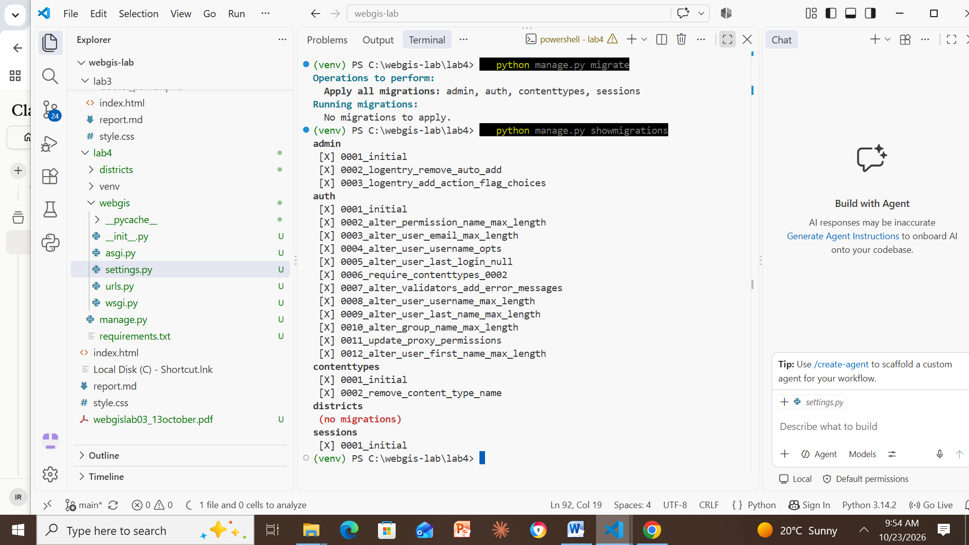
Figure 6. python manage.py migrate (no migrations left to apply) followed by showmigrations: every admin, auth, contenttypes and sessions migration is marked [X].
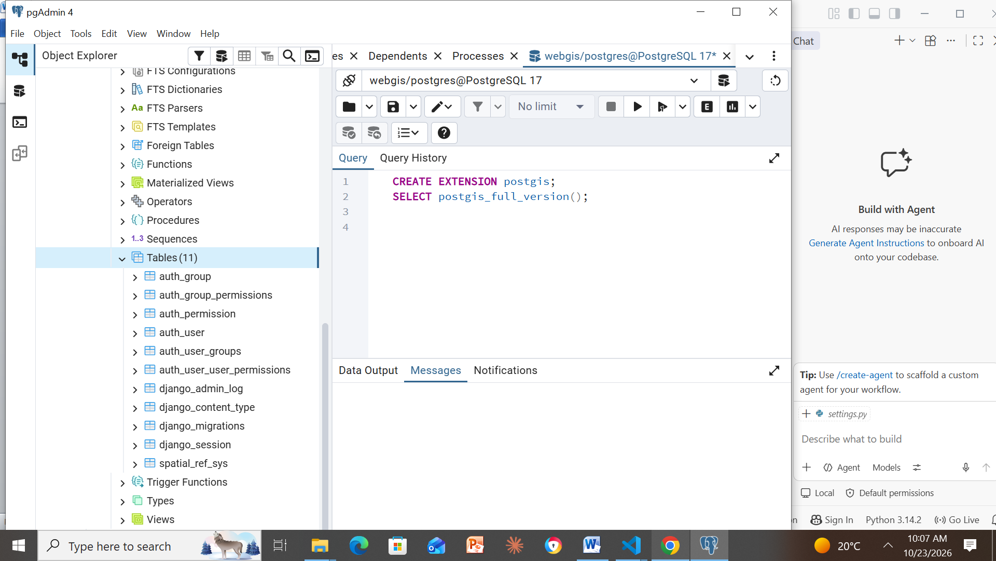
Figure 7. pgAdmin, webgis → Schemas → public → Tables (11): Django’s tables plus PostGIS’s spatial_ref_sys.

Checkpoint 4 – A model with a geometry field
Required: the output of sqlmigrate and the districts_district columns in pgAdmin.
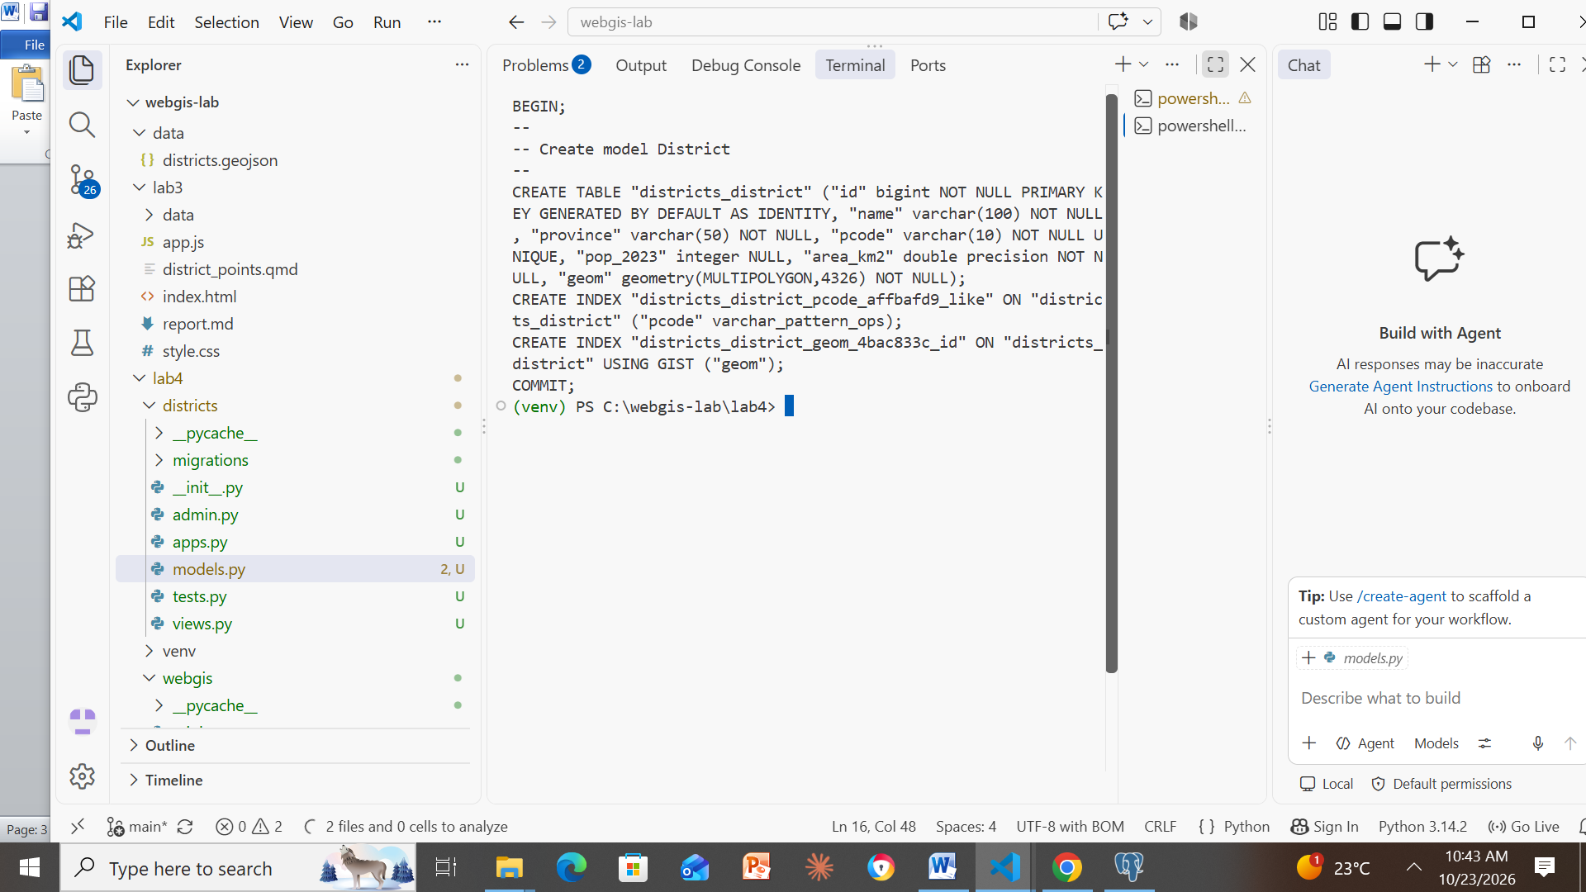
Figure 8. python manage.py sqlmigrate districts 0001: the geom column is geometry(MULTIPOLYGON,4326) NOT NULL, and a GIST spatial index is created on it.
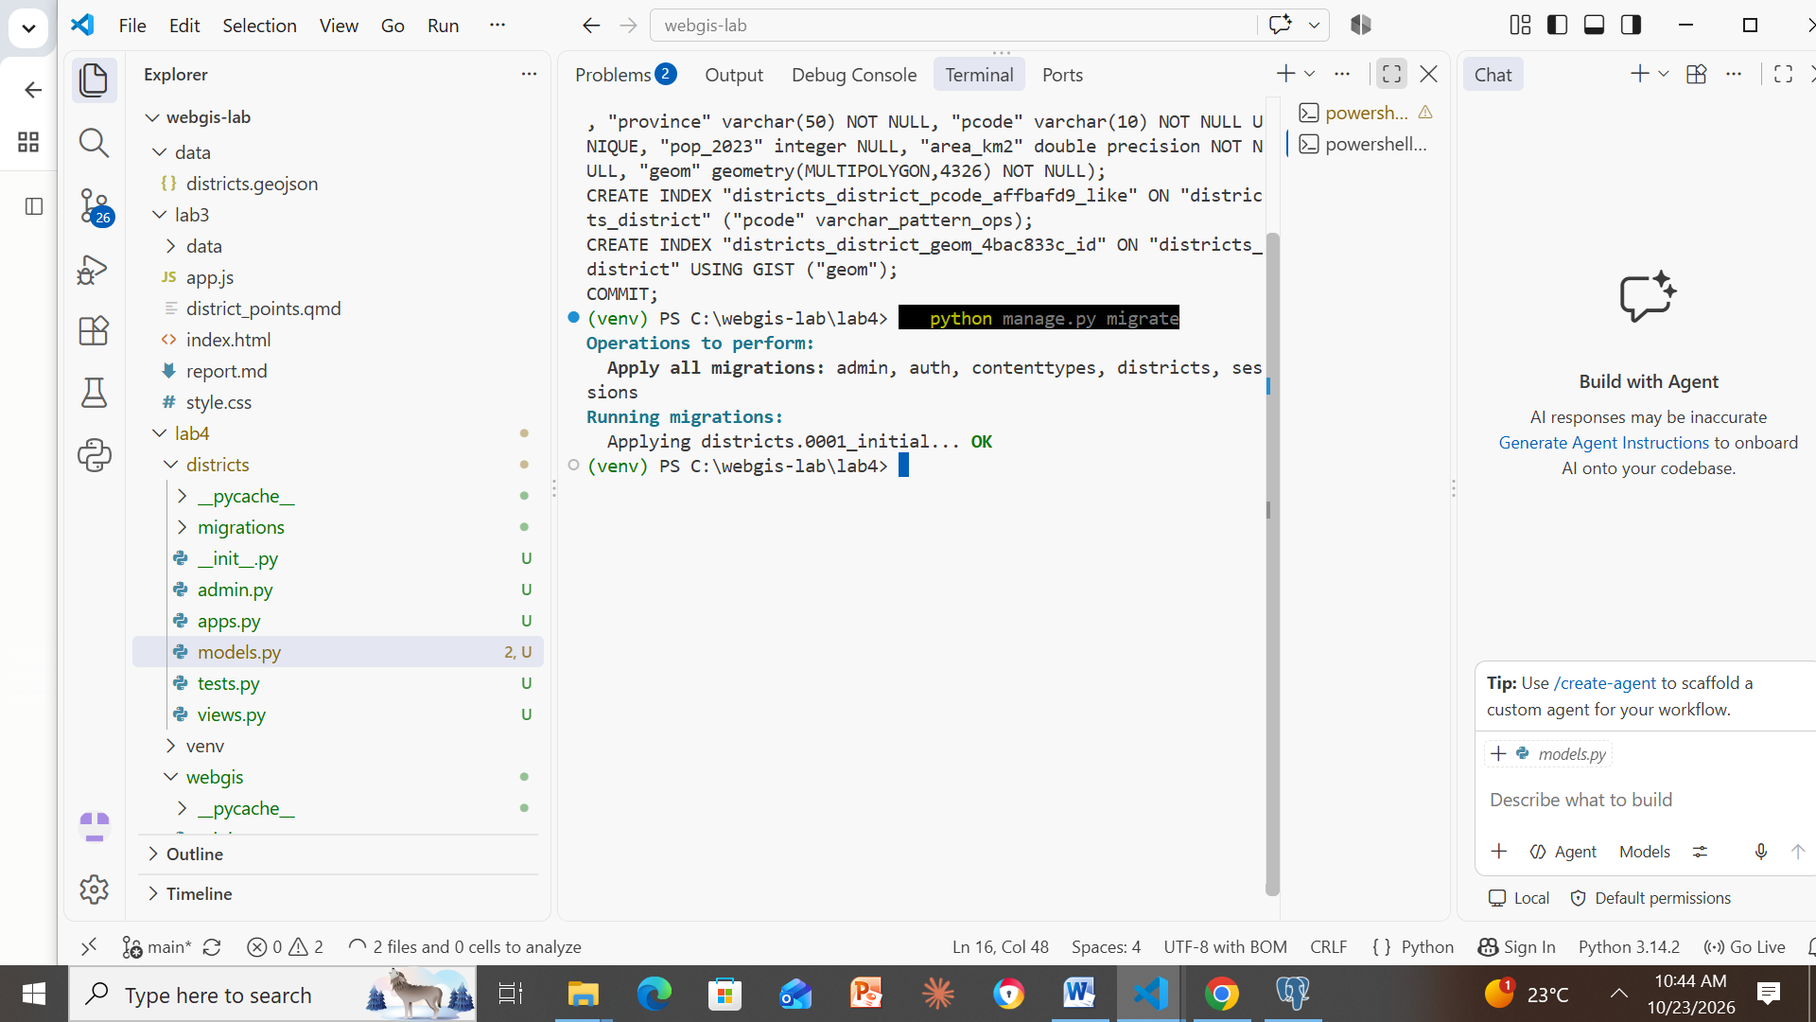
Figure 9. python manage.py migrate applies districts.0001_initial… OK.
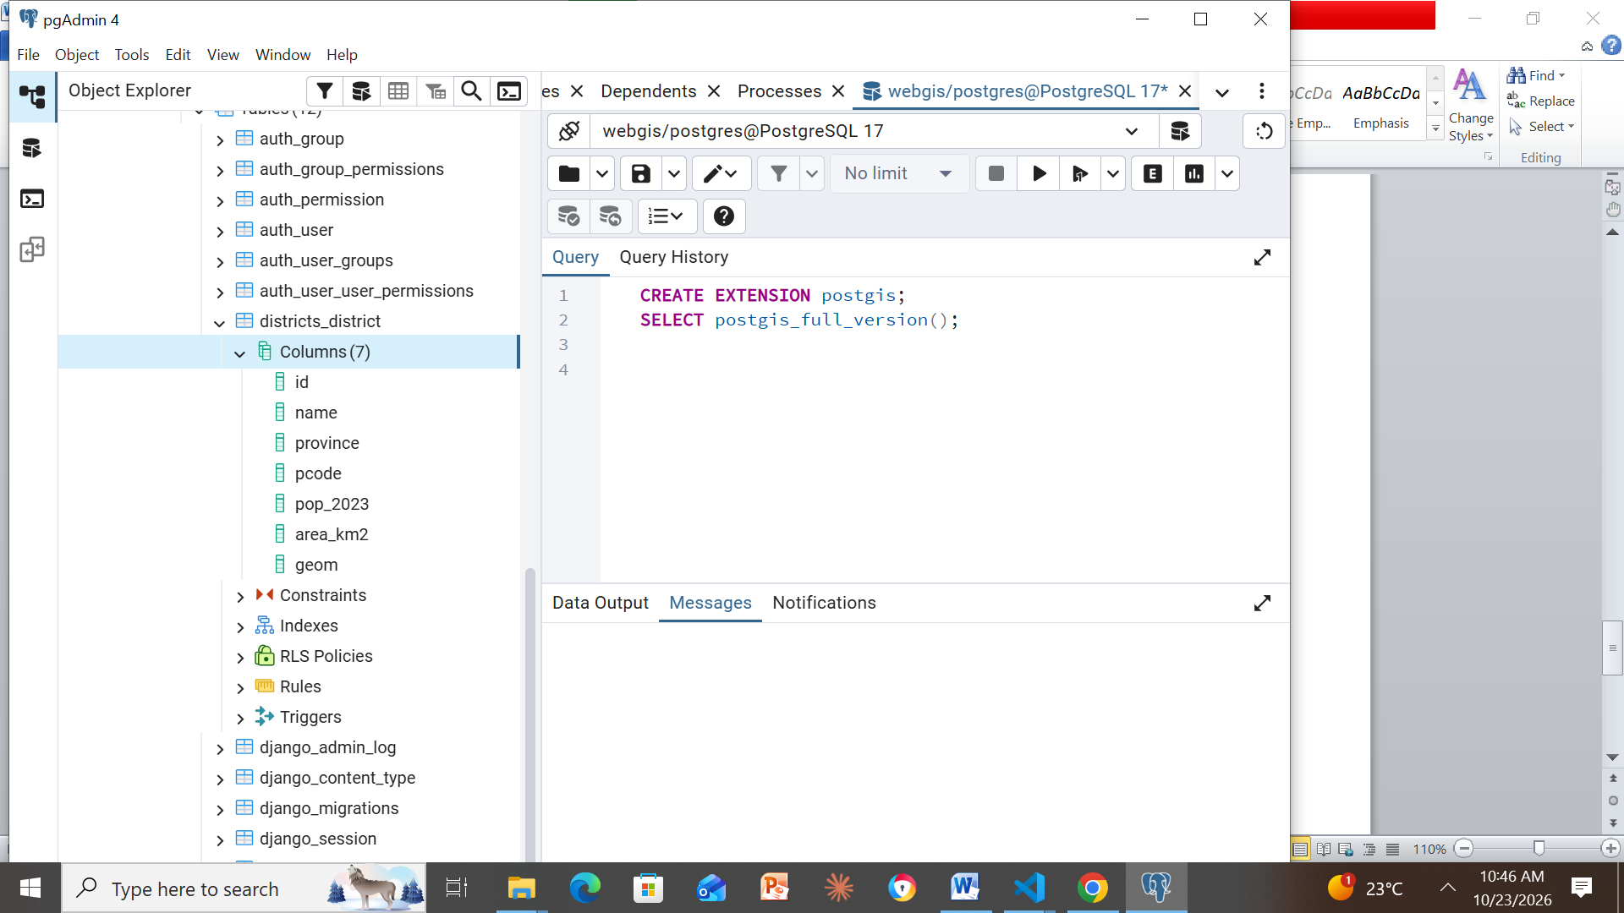
Figure 10. pgAdmin: districts_district has 7 columns – id, name, province, pcode, pop_2023, area_km2 and geom.

Checkpoint 5 – Load the districts
Required: output of the loading script and of the seven shell queries.
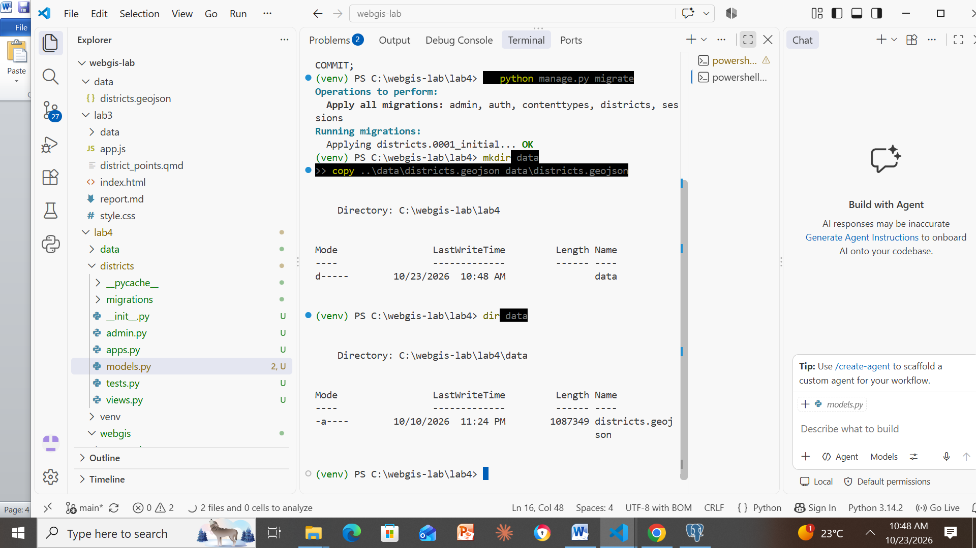
Figure 11. data folder created in lab4 and districts.geojson copied into it (dir data lists the file).
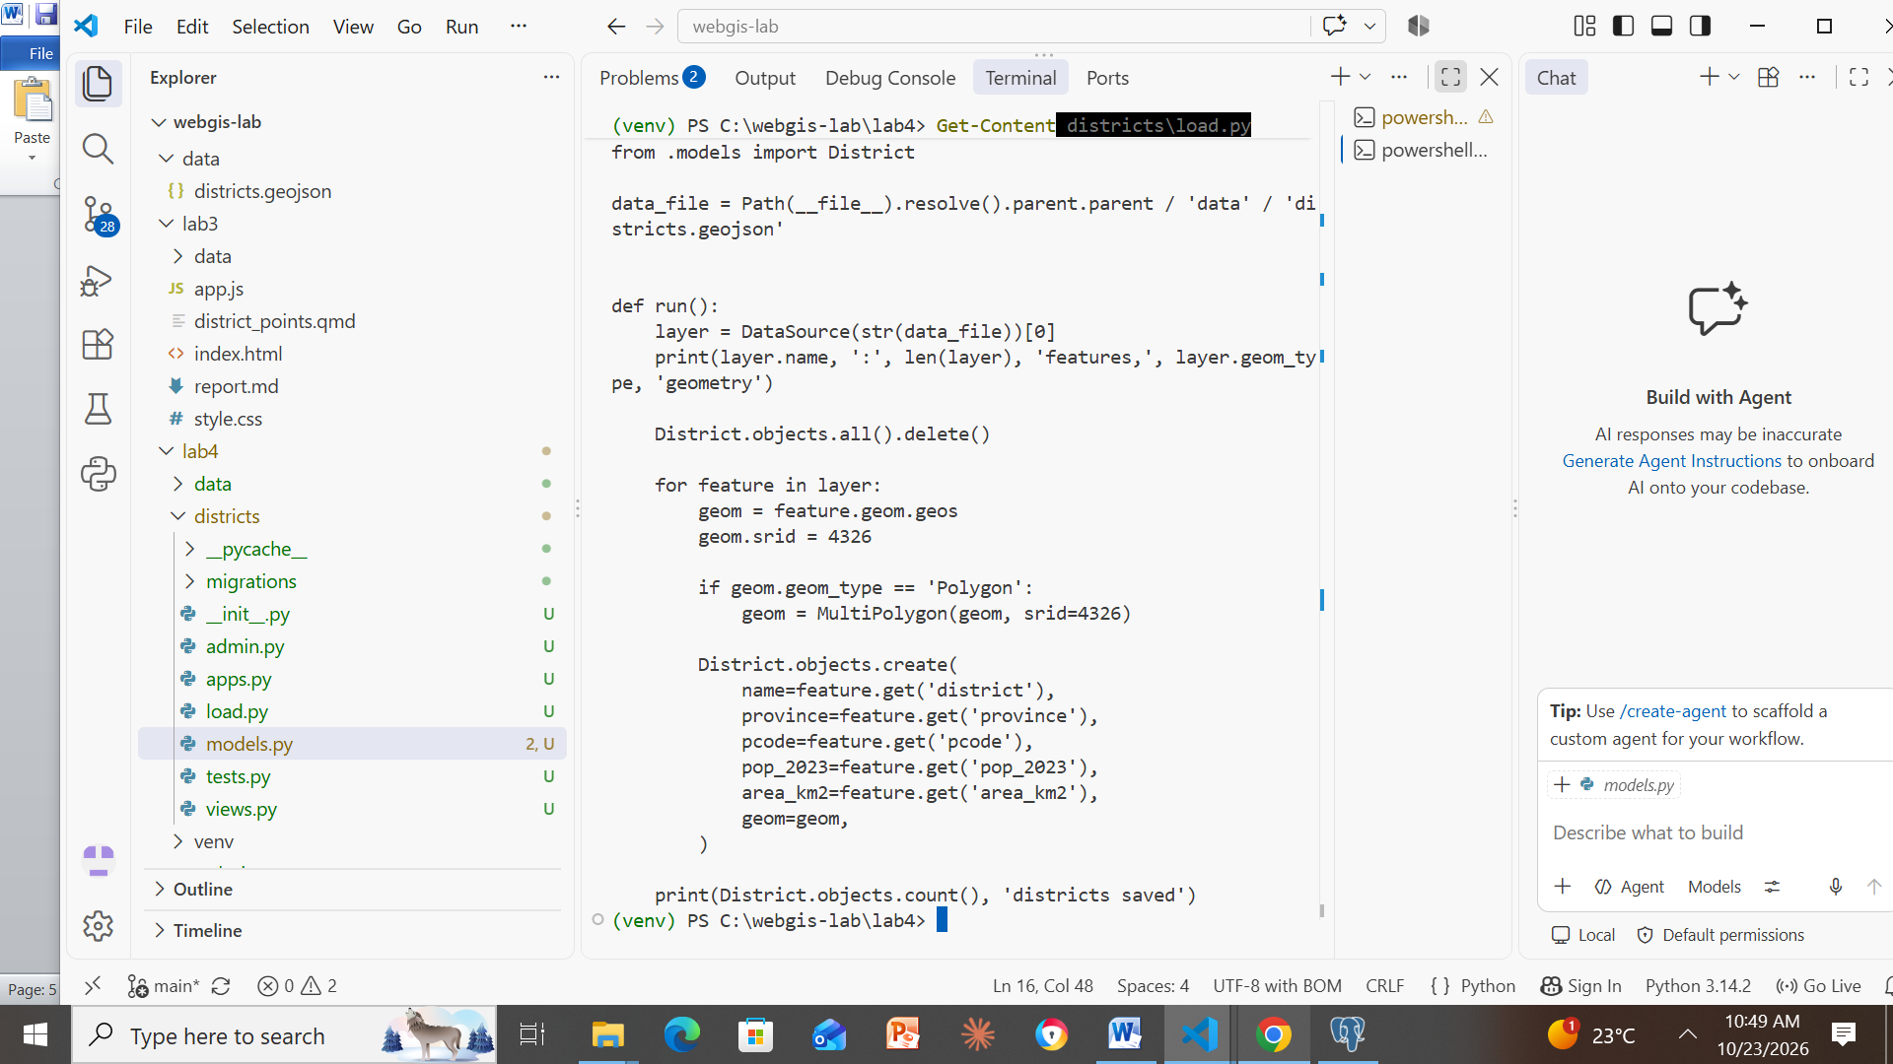
Figure 12. districts/load.py: reads the GeoJSON, wraps any Polygon in a MultiPolygon, and saves each district to PostGIS.
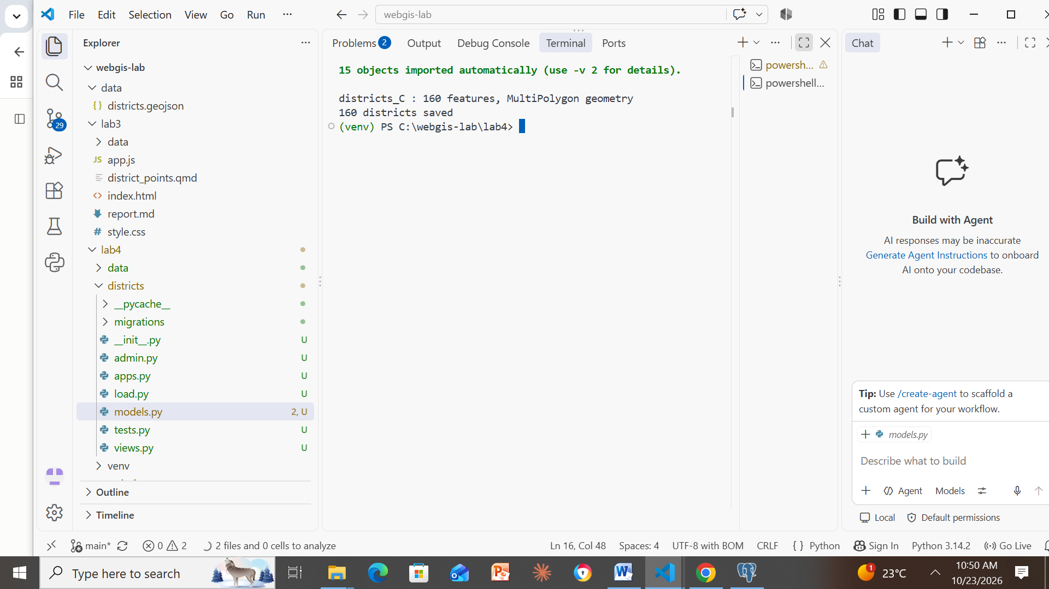
Figure 13. Loader output: districts_C – 160 features, MultiPolygon geometry; 160 districts saved.
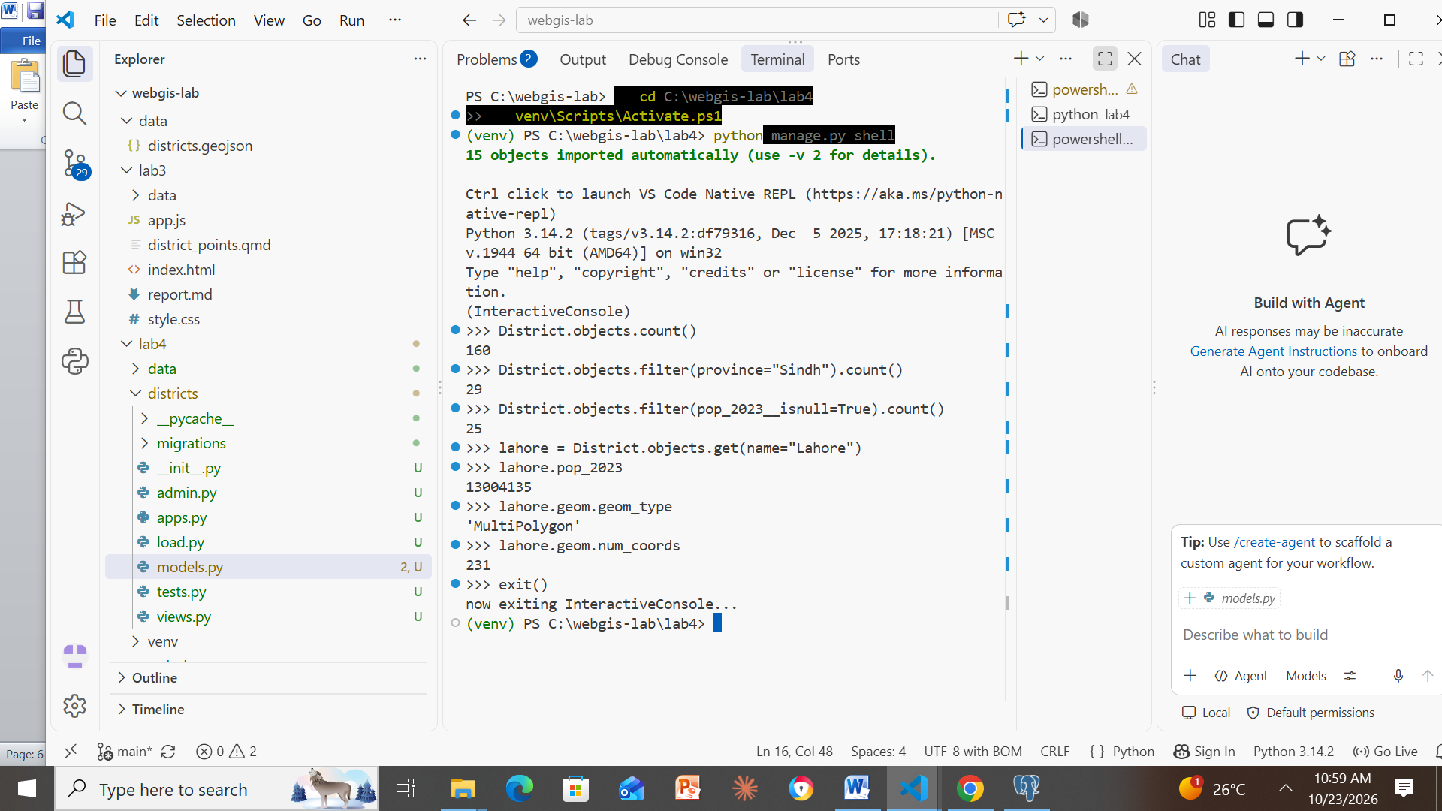
Figure 14. Django shell queries: 160 districts, 29 in Sindh, 25 without a census figure; Lahore pop_2023 = 13004135, geometry type MultiPolygon, 231 coordinates.

Checkpoint 6 – The admin panel
Required: the list filtered to one province, Lahore’s page with its map, and the pgAdmin query showing the edited population.
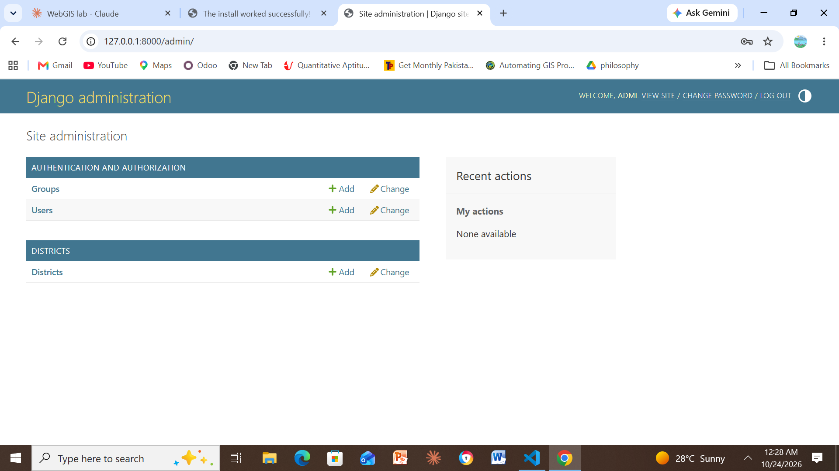
Figure 15. Django administration home, logged in as admi: Groups and Users, plus the registered Districts model.
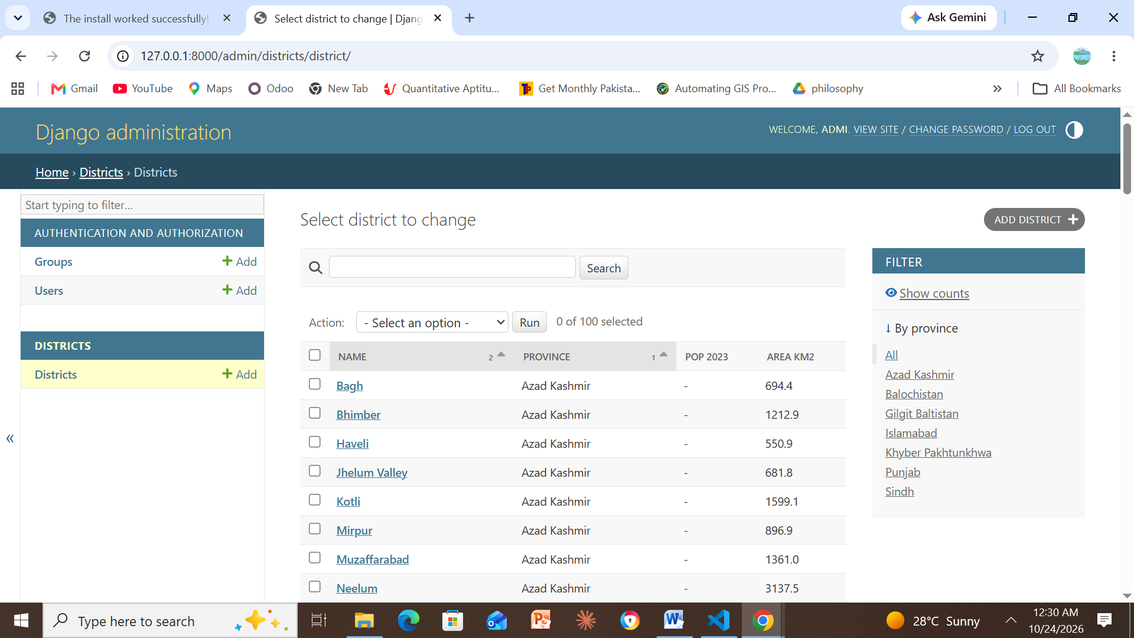
Figure 16. Districts list with the columns Name, Province, Pop 2023 and Area km2, the search box and the By province filter.
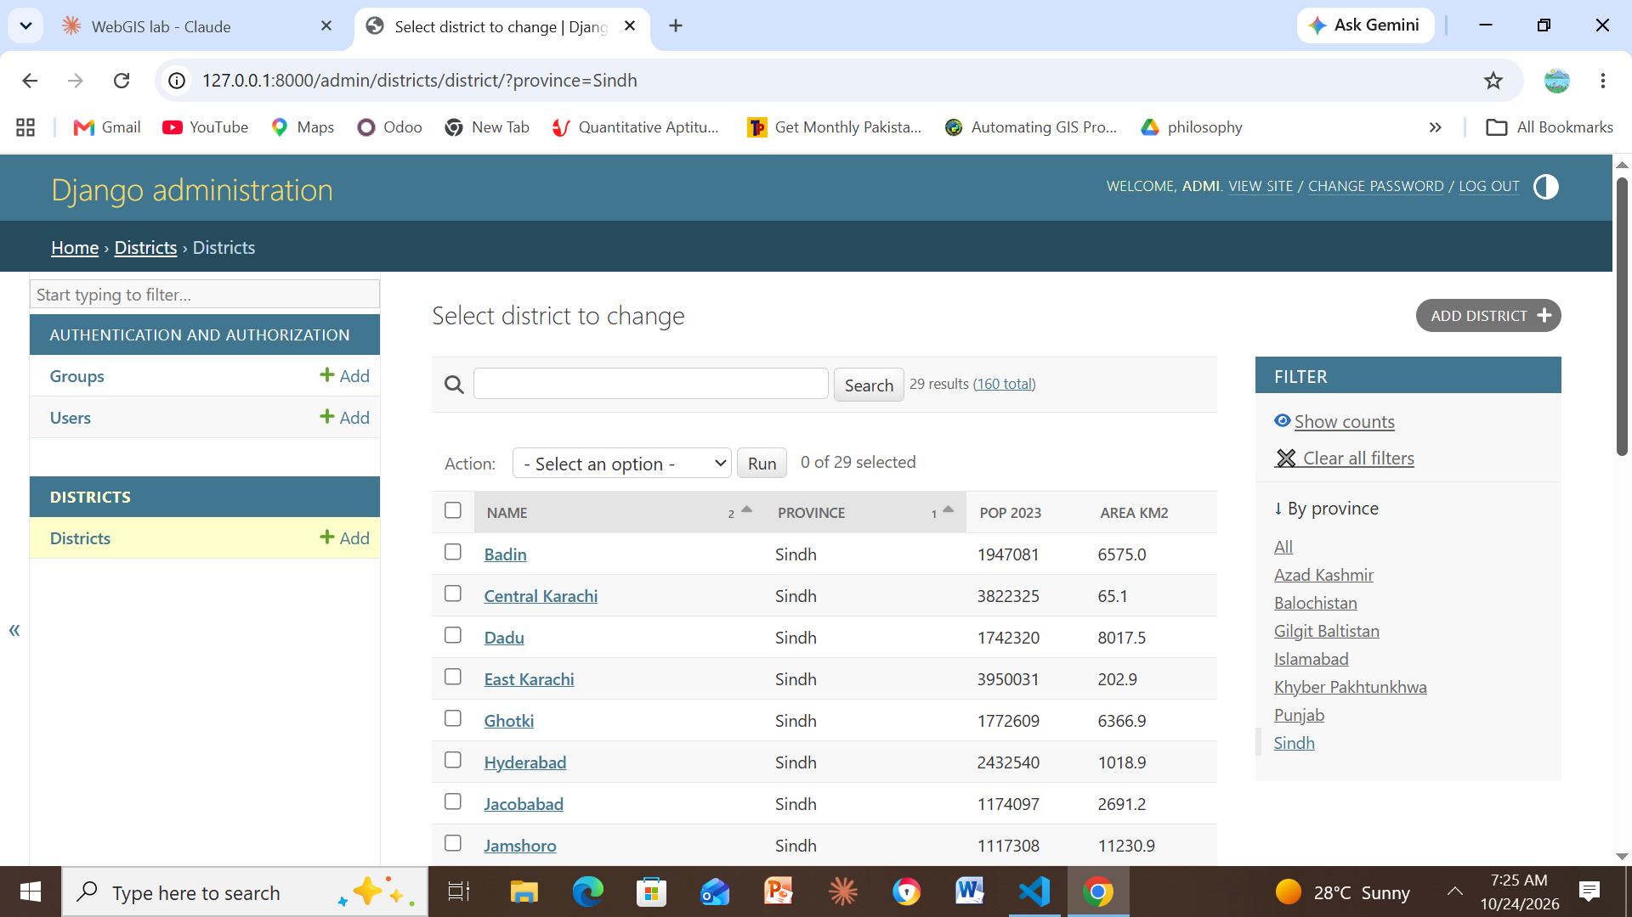
Figure 17. List filtered to Sindh: 29 districts.
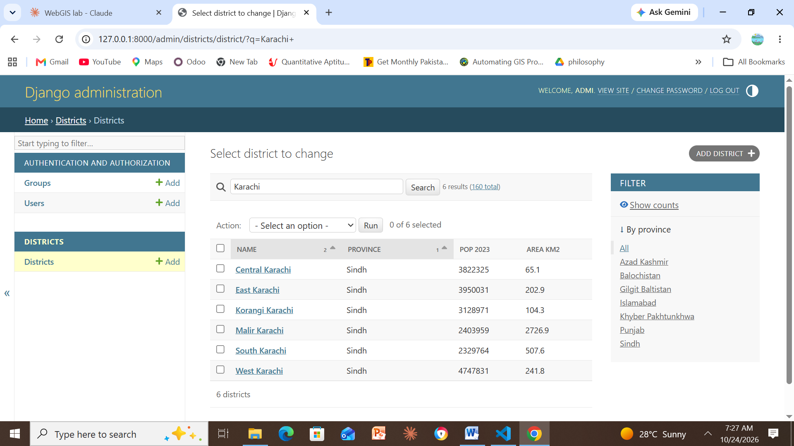
Figure 18. Search for “karachi”: 6 results, sorted by population (descending).
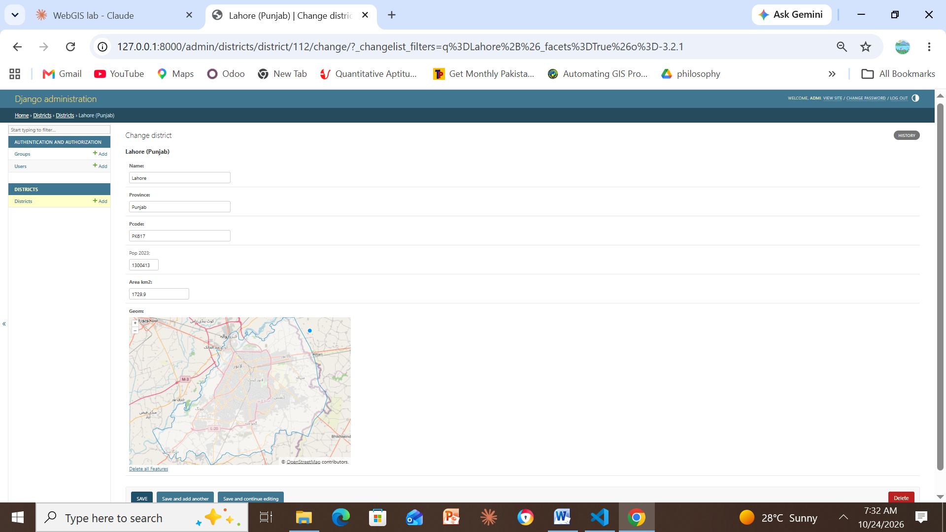
Figure 19. Lahore (Punjab) change page: the Geom field shows Lahore’s boundary on an OpenStreetMap basemap.
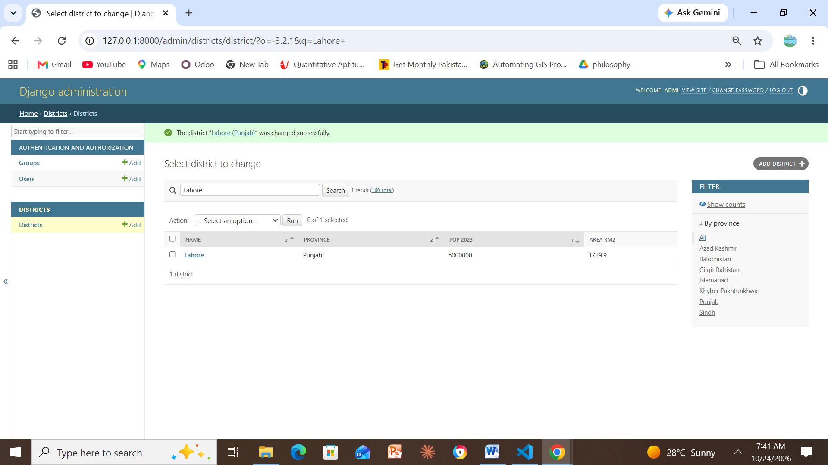
Figure 20. Pop 2023 changed to 5000000 and saved: “The district ‘Lahore (Punjab)’ was changed successfully.”
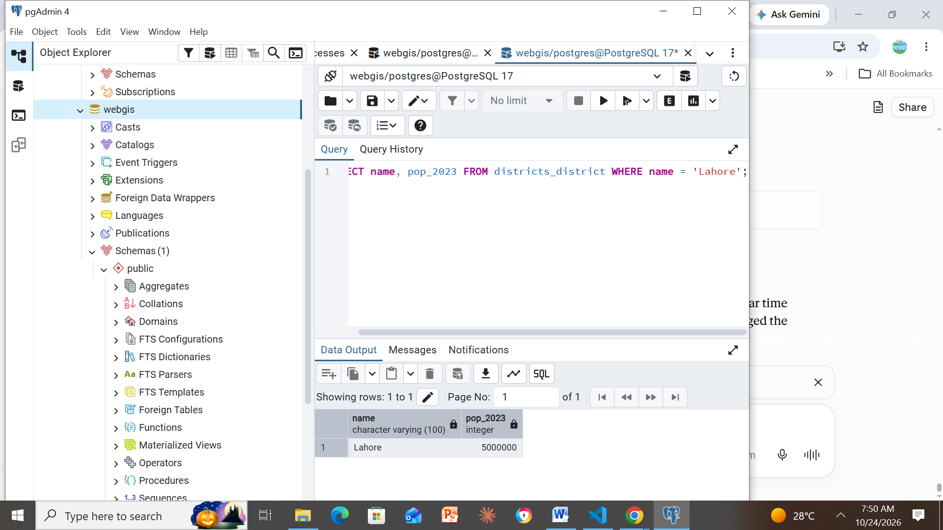
Figure 21. pgAdmin query SELECT name, pop_2023 FROM districts_district WHERE name = ’Lahore’ returns 5000000, confirming the edit reached the database.
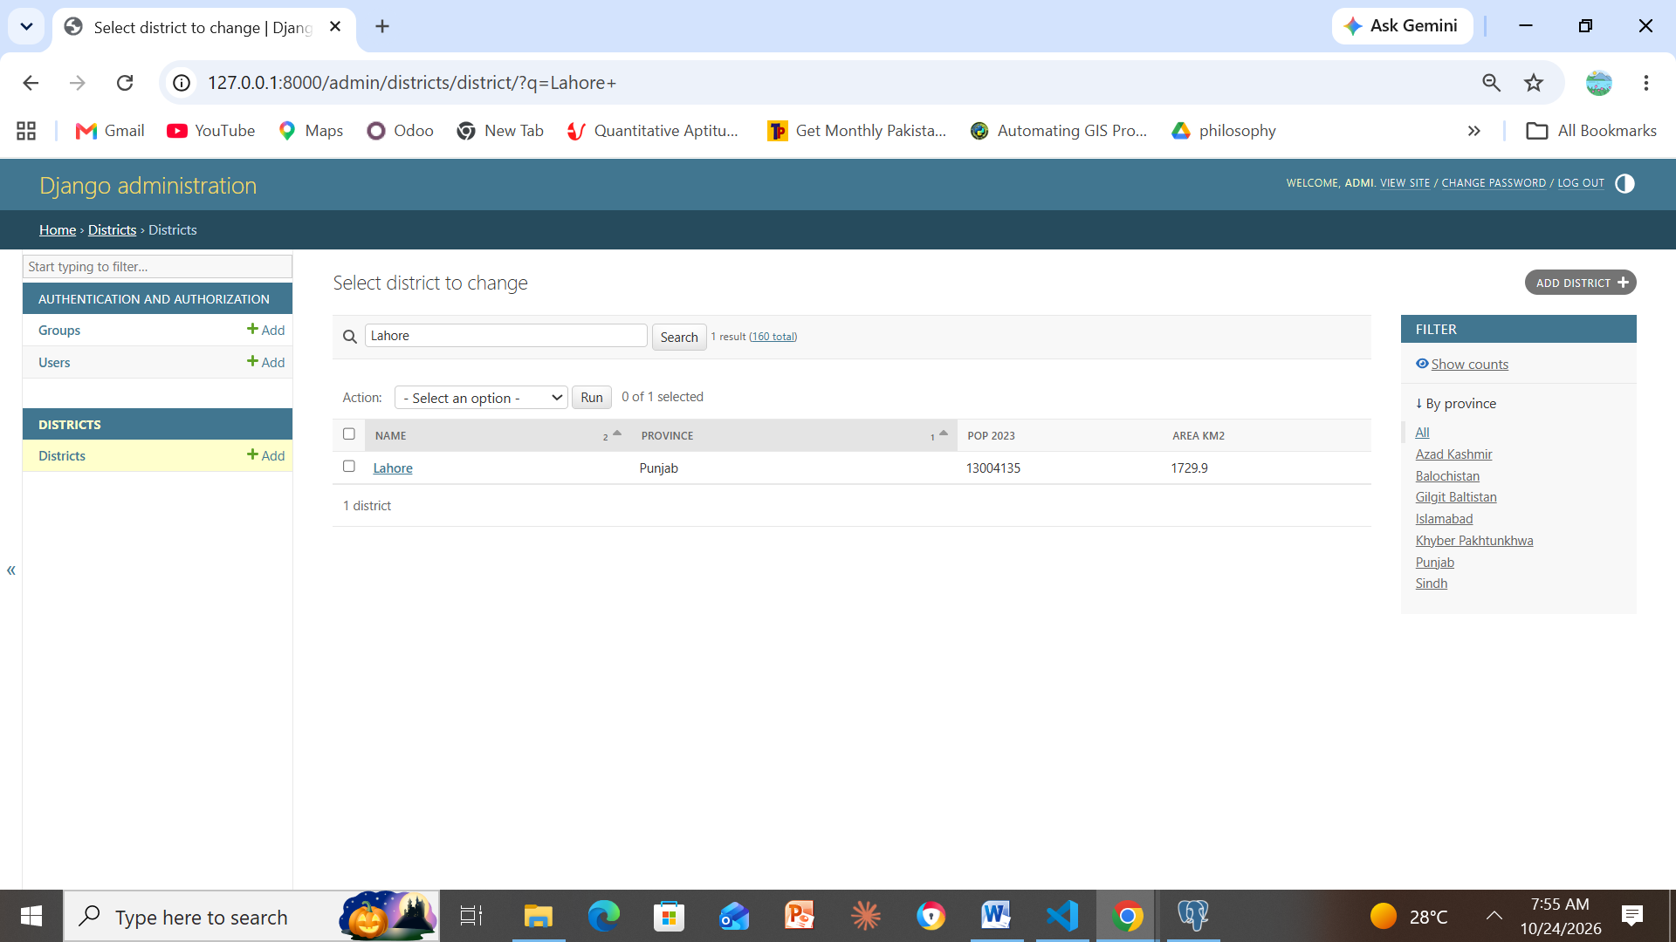
Figure 22. Lahore’s population restored to its original value, 13004135.
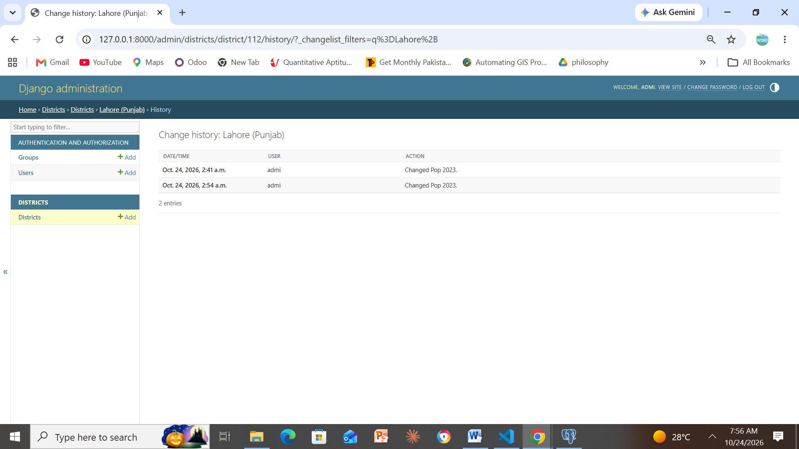
Figure 23. Change history of Lahore (Punjab): two “Changed Pop 2023” entries by user admi.

Checkpoint 7 – Leaflet map fed by Django
Required: the map at 127.0.0.1:8000 with a tooltip showing, and the Network tab with the api/districts/ request and its size.
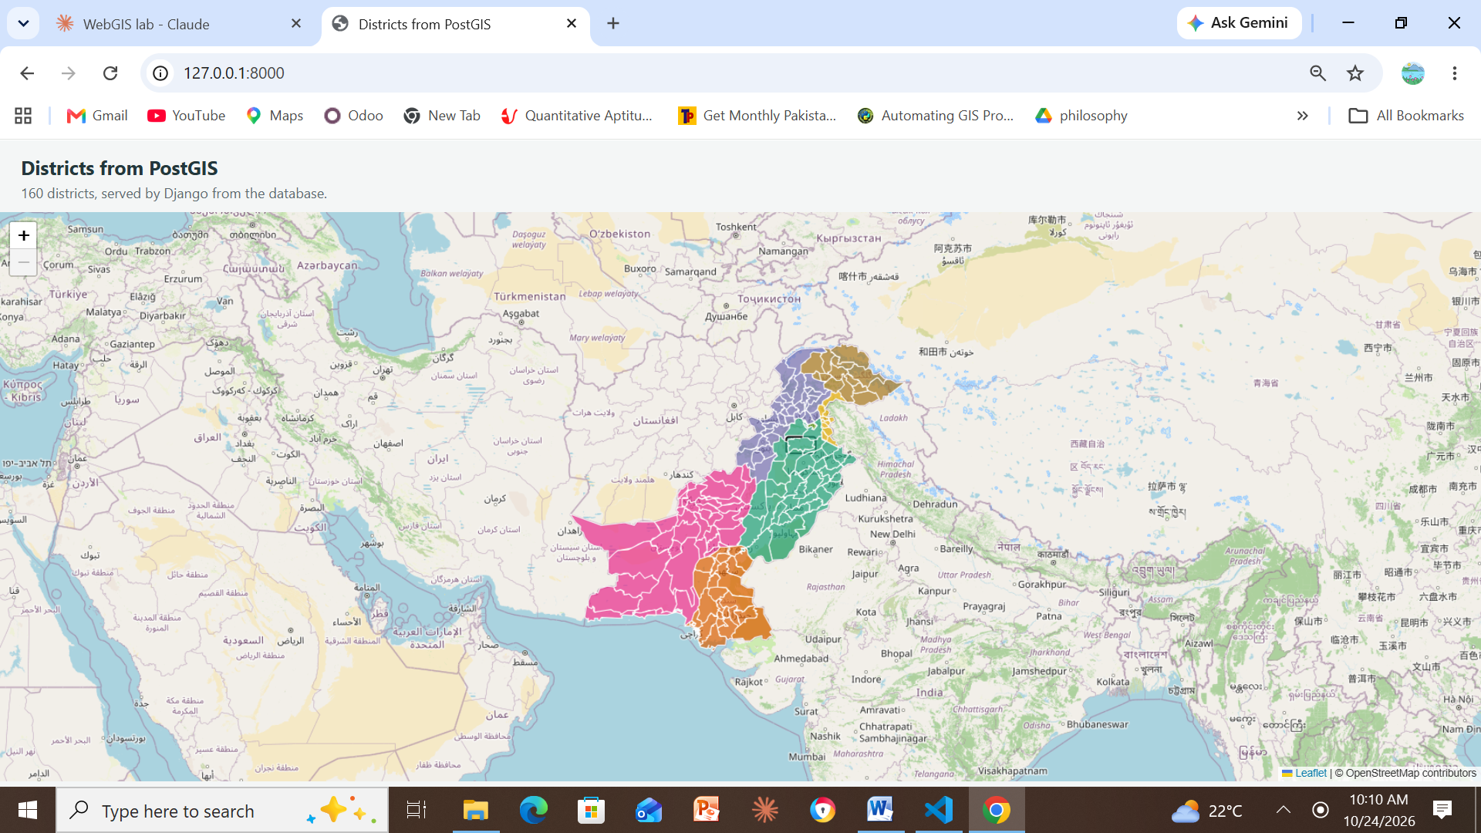
Figure 24. Leaflet map at 127.0.0.1:8000: 160 districts coloured by province, served by Django from PostGIS.
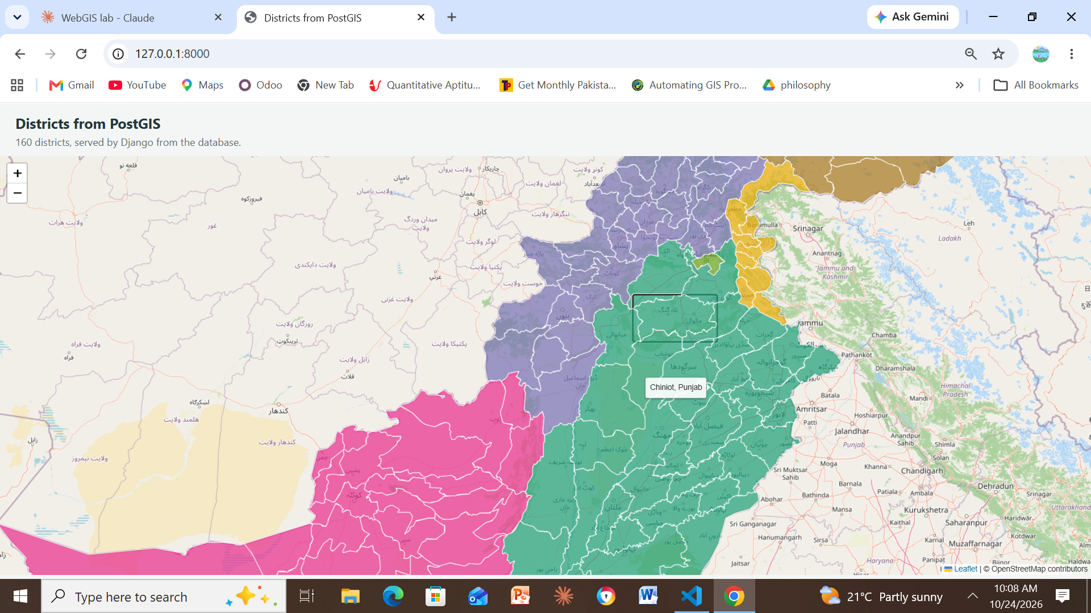
Figure 25. Zoomed in, hovering a district shows the tooltip “Chiniot, Punjab”.
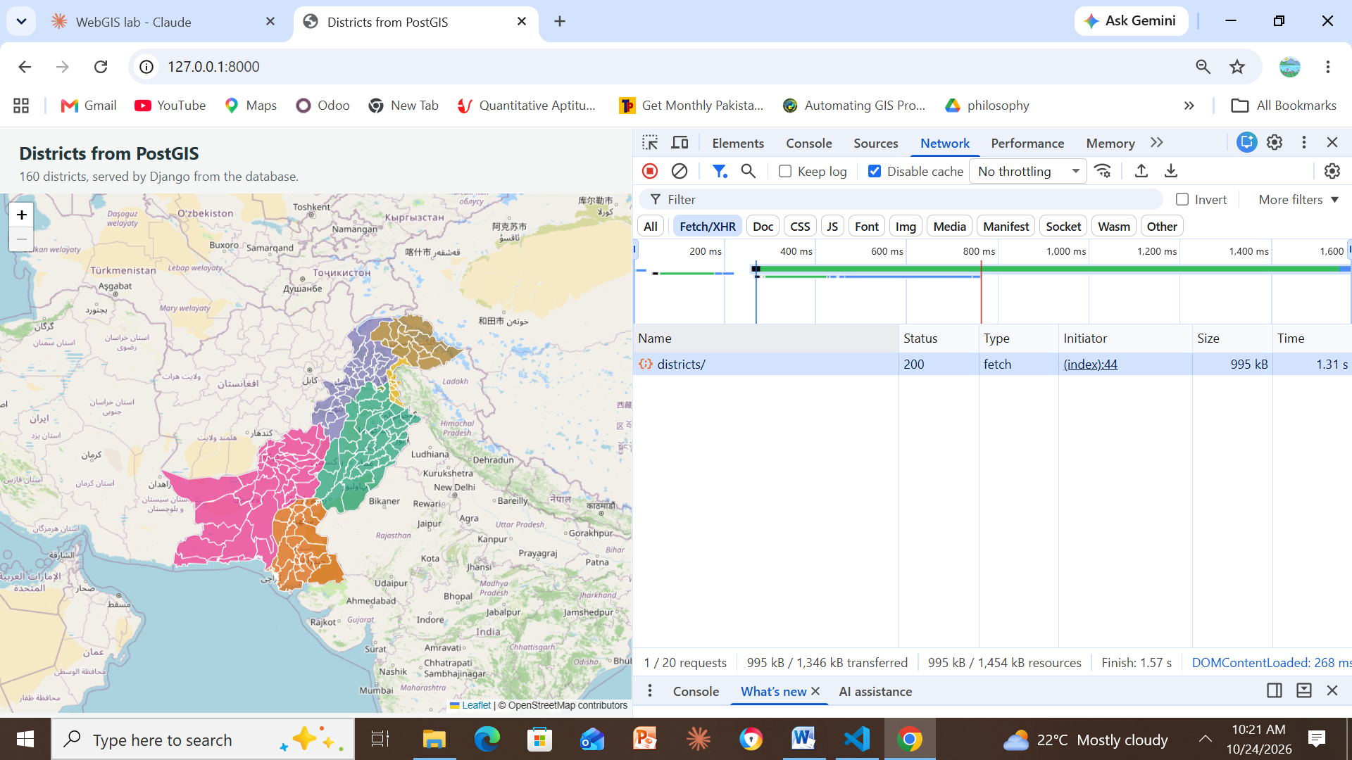
Figure 26. Chrome DevTools → Network (Fetch/XHR): GET /api/districts/ returns 200, type fetch, size 995 kB.

Checkpoint 8 – Extension: asking PostGIS a spatial question
Required: a popup produced by clicking the map, and the result of the area query.
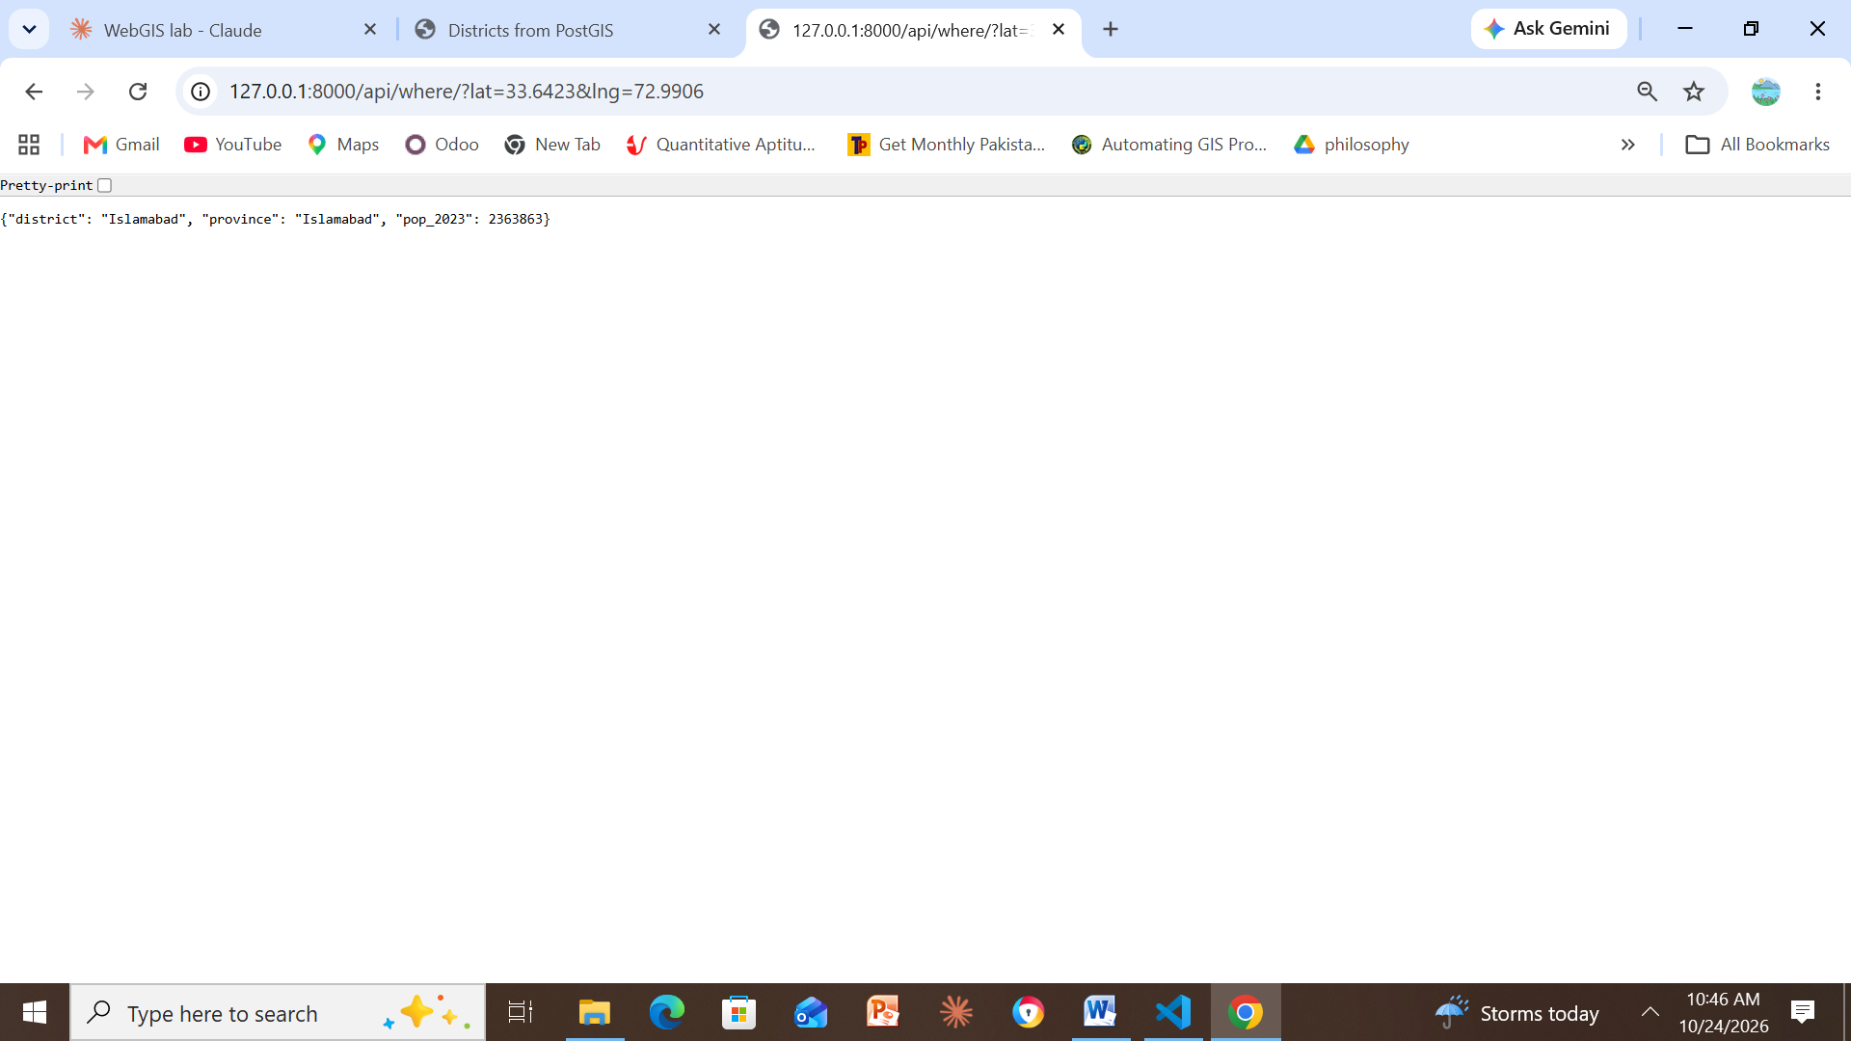
Figure 27. /api/where/?lat=33.6423&lng=72.9906 returns {“district”: “Islamabad”, “province”: “Islamabad”, “pop_2023”: 2363863}.
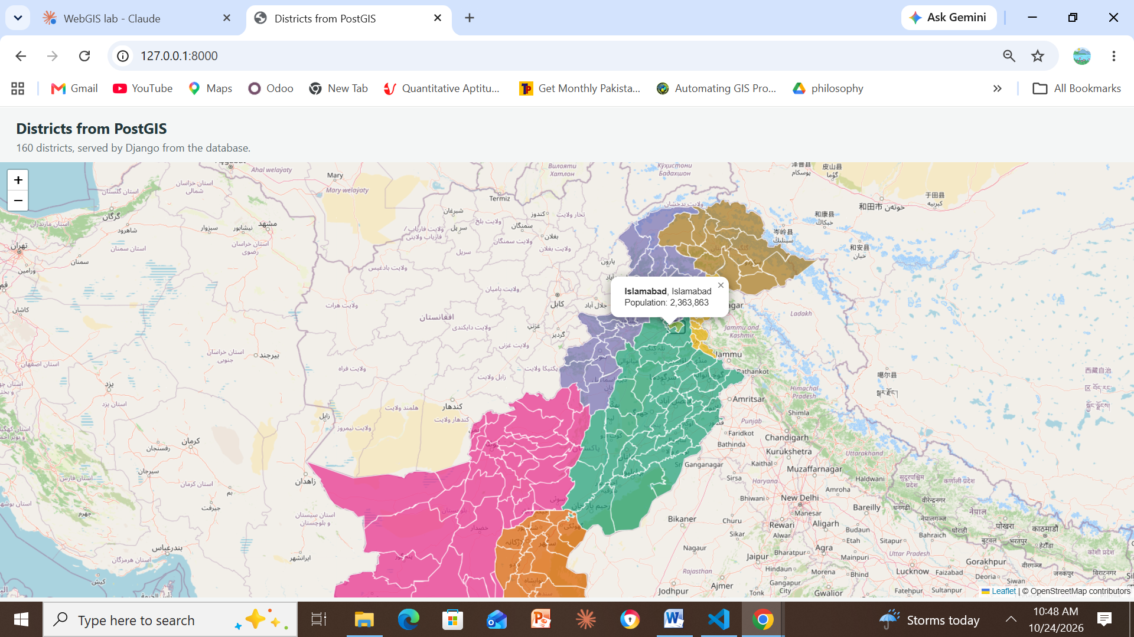
Figure 28. Clicking the map calls /api/where/ and opens a popup: Islamabad, Islamabad – Population: 2,363,863.
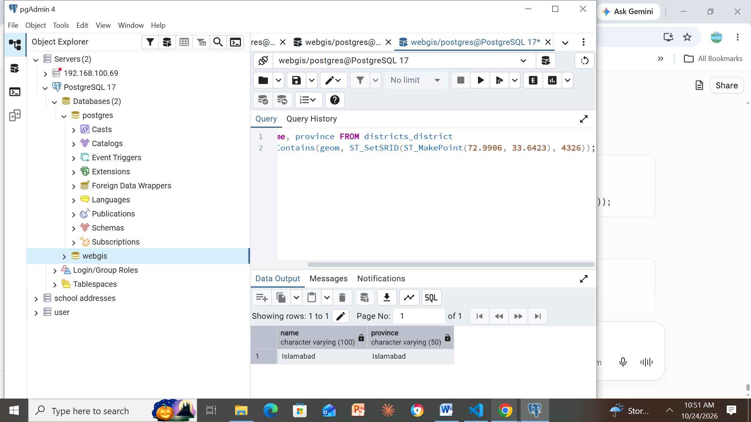
Figure 29. Same question in SQL (ST_Contains with ST_MakePoint(72.9906, 33.6423)): Islamabad.
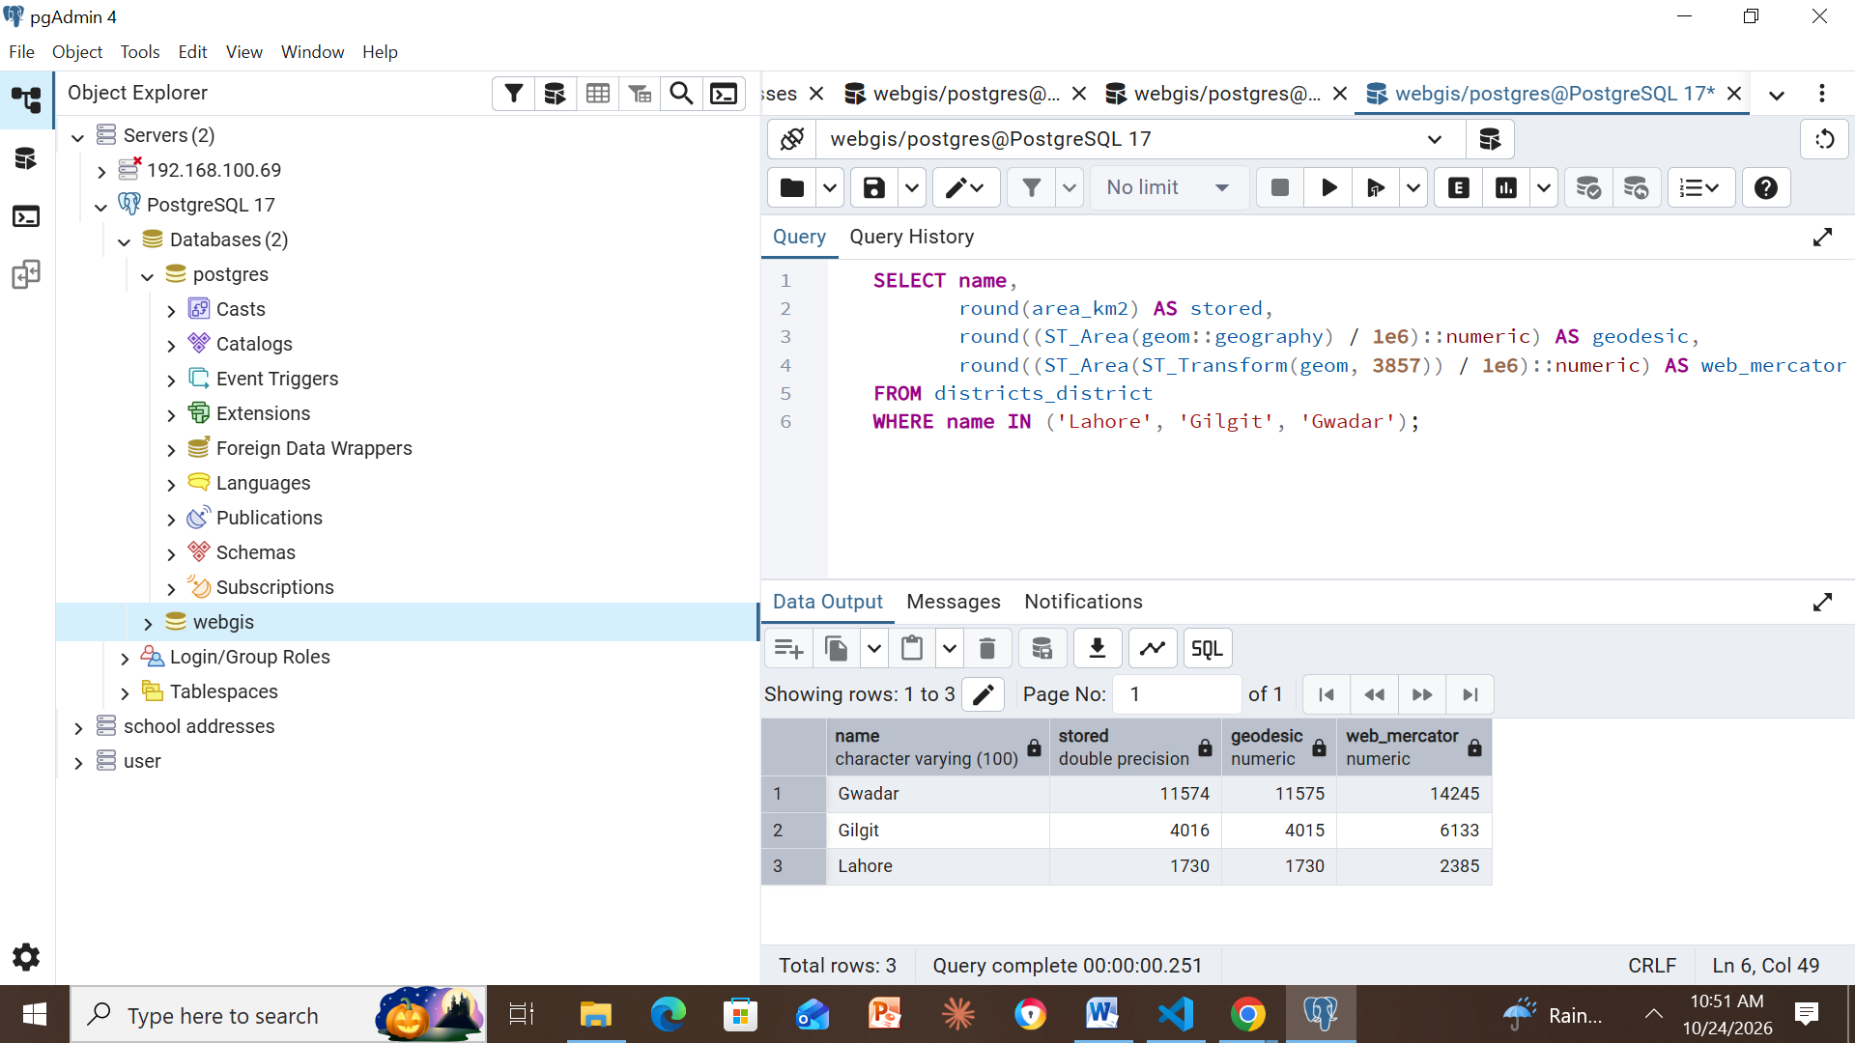
Figure 30. Area comparison (km²): stored vs geodesic vs Web Mercator for Gwadar (14245), Gilgit (6133) and Lahore (2385) – Web Mercator inflates area more at higher latitude.

Appendix A – Installation errors and fixes
Errors met during installation, copied from the screen, and what fixed each one.
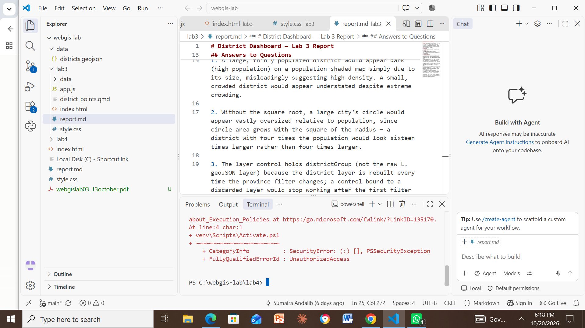
Figure 31. PowerShell blocked venv\Scripts\Activate.ps1 (SecurityError / UnauthorizedAccess). Fixed with Set-ExecutionPolicy -Scope CurrentUser RemoteSigned.
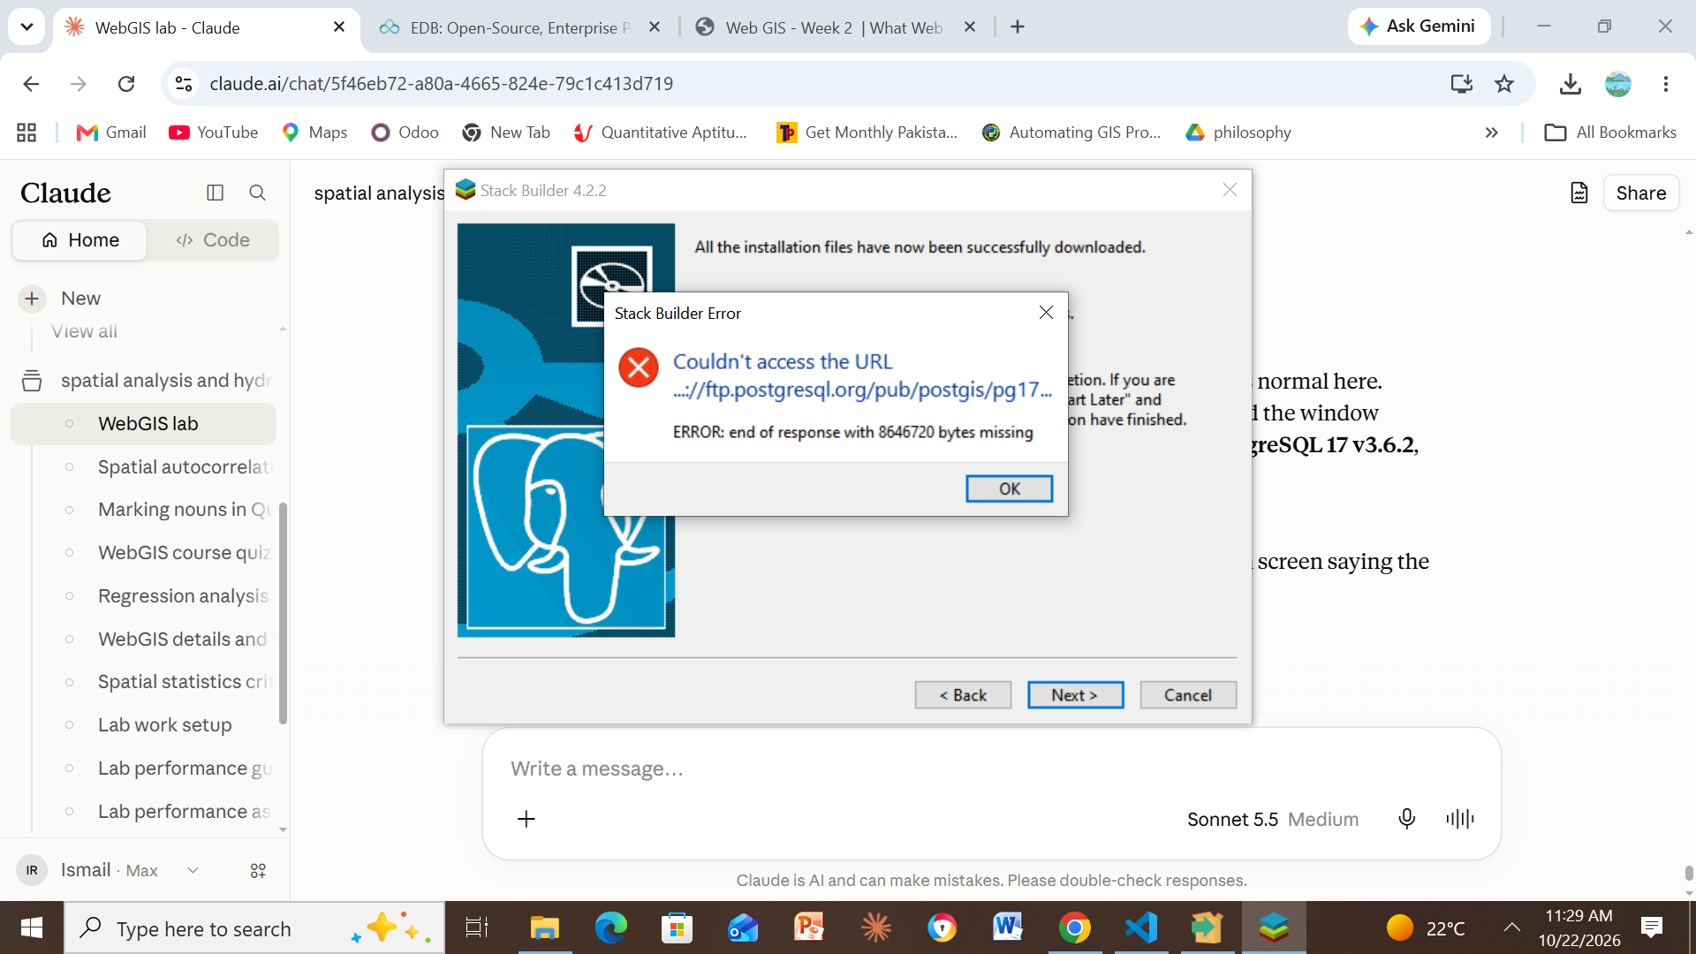
Figure 32. Stack Builder error while downloading the PostGIS bundle: “ERROR: end of response with 8646720 bytes missing”. The PostGIS installer still completed, and CREATE EXTENSION postgis then ran without errors (Checkpoint 2).

