Google Maps
Google Map:
Google Map is a Map, with this Component class can display the map with help of google-play-servicesAPI Library.
Map Fragment is the simplest way to place a map in an app. It’s a wrapper around a view of a map to automatically handle the necessary life cycle needs.
Being a fragment, this component can be added to an activity layout file simply with the XML like below.
Andriod.name: com.google.android.gms.maps.supportMapFragment.
It supports Below <11 upto versions also.
Andriod.name: com.google.android.gms.maps.MapFragment.
It supports Above >11 versions only.
For displaying map Need API Key permission uses libraries and some Callback methods.
GoogleApiClient :
The main entry point for Google Play services integration.
GoogleApiClient is used with a variety of static methods. Some of these methods require that GoogleApiClient be connected, some will queue up calls before GoogleApiClient is connected; check the specific API documentation to determine whether you need to be connected.
Before any operation is executed, the GoogleApiClient must be connected using the connect() method. The client is not considered connected until the onConnected(Bundle) callback has been called.
When your app is done using this client, call disconnect(), even if the async result from connect() has not yet been delivered.
You should instantiate a client object in your Activity's onCreate(Bundle) method and then call connect() inonStart() and disconnect() in onStop(), regardless of the state.

Builder to configure a GoogleApiClient.
Example:

GoogleApiClient client = new GoogleApiClient.Builder(this)
.addApi(Plus.API)
.addScope(Plus.SCOPE_PLUS_LOGIN)
.setAccountName("users.account.name@gmail.com")
.build();
client.connect();

To get SHA1 in Android Studio:
- Right Click on your package and choose New -> Google -> Google Maps Activity
- Android Studio redirect you to google_maps_api.xml
And you will see all you need to get google_maps_key
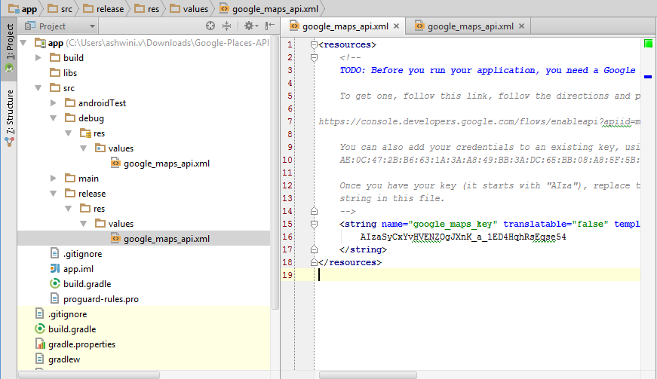
Example for displaying map:
http://www.androidhive.info/2013/08/android-working-with-google-maps-v2/
- Showing/Displaying Markers in GoogleMap
By Using Marker Class we can display the marker in Google map with the help of LatLng values.
- Connecting Markers In Google Map
Connecting Markers In two Ways
I. Connecting without URL
II. Connecting with URL
Connecting without URL
We can connect the marker with help of Array of LatLng values by adding to the polylineOptions./
This polylineOptions add to GoogleMap.
Result: In this we can get the straight line to connect the another marker.
Connecting with URL
By using below url we can connect the markers accurately point to point .
This is best approach for connecting two markers.
https://maps.googleapis.com/maps/api/directions/json?origin=17.3998,78.4766&destination=17.4833,78.4167&sensor=false
- Places API.
By using this Places API , we can display List of places, Nearest places, Specific
places and sorted places.
For Retrieving specific places and places details need a browser key. For that go to google console api and create browser.
Steps to create a key:
- Create Server key by providing Ipaddress.
- Create Browser key.
- And finally enable places related apis.
Below are the sample formatted urls for placedetails and places search.
https://maps.googleapis.com/maps/api/place/nearbysearch/json?location=-33.8670,151.1957&radius=500&types=food&name=cruise&key=YOUR_API_KEY

https://maps.googleapis.com/maps/api/place/details/json?placeid=Place_ID&key=YOUR_API_KEY
From below link you can find many sample Snippets.
https://developers.google.com/places/android-api/signup
https://developers.google.com/maps/web-services/

