 | 

Work Based Learning
WKL200 Project Report
THERAPEACE CONTROL
Digital Client and Appointment Management Prototype for a Massage Therapy Business
Programme | FdSc / Cert HE Computing
Module | Work Based Learning (WKL200)
Assessment | Project Report (3000 words) + Product
Student name | Anda
Student ID | [ENTER STUDENT ID]
Business context | Therapeace Massage
Submission date | [ENTER SUBMISSION DATE]

Important submission note: This is a structured draft and working prototype based on the supplied WKL200 example. Replace all bracketed placeholders and add genuine stakeholder/client dates, feedback and signatures where required. Do not submit invented evidence.

Declaration of AI Use
The supplied example contains an AI-use declaration. Because AI assistance has been used to help prepare this draft, the declaration below is intentionally transparent. Check the current assessment rules before submission and amend only so that it accurately describes the work you actually submit.
Select | Statement
[ ] | I can confirm that I have not used any AI tools within this piece of work.
[X] | I have used AI tools to help me with developing ideas.
[X] | I have used AI tools to help formulate a plan or structure for my assessment.
[X] | I have used AI tools to assist with research/gathering information.
[X] | I have used AI tools to help understand key theories and concepts.
[ ] | I have used AI tools to identify themes as part of data analysis.
[X] | I have used AI tools to give feedback on a draft piece of work.
[X] | I have used AI tools to proofread spelling and grammar.
[X] | I have used AI tools to generate tables, figures or diagrams.

Academic integrity: The final submission should be reviewed in your own words and must comply with your institution’s AI and authenticity rules. Client review evidence and signatures must be genuine.

Therapeace Control
Digital Client and Appointment Management Prototype for a Massage Therapy Business

Project Overview
This report documents the planning, design, execution and evaluation of Therapeace Control, a browser-based prototype developed for a massage therapy business context. It follows the structure of the supplied WKL200 example while changing the workplace issue, data model, interface, testing evidence and reflection so that the work is original to the massage sector.
Product status: The accompanying product is functional and was tested with fictional data. It is an academic prototype and must not be used to store real health or consultation information.

Contents
- Section 1: Planning & Design
- Project Proposal
- Project Requirements
- Resources, Deliverables & Budget
- Feasibility Study
- Methodology: Agile & UCD
- Existing Solutions Evaluation
- Sprint Documentation
- Design Documentation
- Section 2: Execution
- Project Management & Risk
- System Screenshots
- Testing
- Stakeholder Review Record
- Critical Self-Reflection
- Conclusion
- Appendices
- References

Section 1: Planning & Design

Project Proposal
Therapeace Control is a web-based prototype created to improve the administration of a small independent massage therapy business. The work-based issue identified for the project is the fragmentation of everyday information across messages, paper notes, calendar entries and separate payment records. When booking information and client details are held in different places, the therapist has to repeat searches, manually check availability and remember whether a client has paid or whether consultation information has been completed. This increases administration time and creates a greater possibility of missed information or inconsistent records.
The proposed solution is Therapeace Control, a lightweight browser application that places the most common administrative tasks in one interface. The prototype provides a sign-in screen, a dashboard, client records, appointment management, a service catalogue, payment-status tracking, birthday reminders, search and filtering, a WhatsApp shortcut and a JSON backup function. Fictional demonstration data are used throughout the prototype. The system is intentionally presented as an academic prototype rather than as a production clinical record system.
The main objective is to demonstrate how computing skills can be applied to a real massage-business workflow. The expected outcome is a working and testable product that reduces the number of separate steps required to find a client, schedule a treatment, check payment status and review the day’s appointments. A second objective is to apply project-management methods and user-centred design so that the system remains simple enough for a solo therapist to use between appointments. A third objective is to evaluate limitations honestly, particularly data protection and the difference between a prototype and a system suitable for processing real health information.

Project Objectives
- Centralise the most common client and appointment administration tasks in one prototype interface.
- Demonstrate CRUD operations for massage client and booking records.
- Provide search, filtering, payment tracking and a useful daily dashboard.
- Apply Agile project management and user-centred design principles.
- Test the final product against observable acceptance criteria and evaluate limitations honestly.

Project Requirements
The requirements were prioritised from the daily tasks that are most important to a massage therapist. The minimum functional requirements were: a protected entry screen; a dashboard showing daily activity; the ability to add, edit, search and delete client records; the ability to add, edit, filter and delete appointments; a fixed massage-service catalogue; treatment-note and consent-status fields; payment tracking; birthday alerts; and data export. Non-functional requirements included a clear interface, responsive layout, simple navigation, readable text, quick feedback after actions and safe use of fictional data for demonstrations.
The scope was deliberately controlled. Online payments, automated SMS reminders, client self-booking, multi-user roles, a hosted database and real authentication were placed in the future backlog. This prevented the project from becoming too large for the available assessment period while still producing a coherent product. The scope also supports the learning outcome of applying a solution rather than only describing one.
ID | Requirement | Acceptance statement | Priority
FR1 | Demo sign-in | User can enter the prototype using the demonstration password. | Must
FR2 | Client management | Add, edit, search and delete fictional client records. | Must
FR3 | Appointment management | Add, edit, filter and delete appointments. | Must
FR4 | Service catalogue | Select a defined massage service and display duration/price. | Must
FR5 | Payment status | Track Paid, Unpaid or Deposit paid. | Must
FR6 | Dashboard | Show daily appointments and summary indicators. | Must
FR7 | Birthday reminder | Identify a client whose birthday is today. | Should
FR8 | WhatsApp shortcut | Construct a wa.me greeting link from demo phone data. | Should
FR9 | Data export | Export prototype state to JSON. | Could
NFR1 | Responsive UI | Layout adapts to desktop and mobile widths. | Must
NFR2 | Prototype safety | Visible warning and fictional data only. | Must

Resources, Deliverables and Budget
The development resources were a laptop, a modern web browser, a code editor, HTML5, CSS3 and JavaScript. Browser localStorage was used as a simple persistence mechanism so that the prototype could demonstrate create, read, update and delete operations without a paid server. Project evidence was created using a Kanban backlog, a Gantt chart, test records, diagrams and screenshots. The main deliverables are the working Therapeace Control prototype, source files, README/user instructions, a test plan, a project backlog and this report with supporting evidence.
The direct development budget is £0 because the prototype uses existing hardware and freely available browser technologies. No paid API, hosting package or commercial database is required for the assessment version. This makes the project economically feasible for a student prototype. However, a real deployment would require a separate budget for secure hosting, authentication, backup, maintenance and possibly messaging services. Treating the prototype cost and the production cost as different categories avoids the misleading assumption that a free demonstration is automatically suitable for real business use.
Resource | Purpose / note | Prototype cost
Laptop / browser | Existing equipment | £0
HTML/CSS/JavaScript | Browser technologies | £0
VS Code or equivalent editor | Free development tool | £0
LocalStorage prototype persistence | Built into browser | £0
Diagrams / testing evidence | Created with local tools | £0
Production hosting/authentication | Future phase - not included | TBC

Success Criteria and Acceptance Measures
Success was defined through observable acceptance criteria rather than only visual completion. The prototype would be considered successful if a user could sign in to the demonstration, locate a client through search, create and amend a client record, create and filter an appointment, identify payment status, see the daily schedule on the dashboard and use the system at both desktop and mobile widths. A further criterion was that the source package could be opened without a paid service or private account. These criteria were linked directly to the final test plan.
Usability success was measured through consistency and task simplicity. Important actions use the same button style, status information is shown through labelled badges, and navigation remains visible on desktop while changing to a mobile control at smaller widths. Data-protection success for the academic version was defined differently: the system must clearly warn that it is a prototype and must use fictional records. This prevents a technically working demonstration from being confused with a compliant production system.

Feasibility Study

Technical Feasibility
Technical feasibility is high because the prototype is based on standard browser technologies that run on current desktop and mobile browsers. The application is self-contained and does not depend on a remote service for its core demonstration. The interface and logic are separated into HTML, CSS and JavaScript files, while the data are stored as structured client and appointment objects. The main technical limitation is that localStorage is not an appropriate substitute for a secure server-side data store where sensitive information is involved.

Operational Feasibility
Operational feasibility is also strong for a solo massage practice because the workflow mirrors familiar activities: selecting a client, selecting a massage service, choosing a date and time, and updating payment status. The dashboard reduces navigation by bringing daily appointments, outstanding payments, booking value and birthday reminders together. Responsive design was included so the interface can adapt to a smaller screen. This is relevant because a therapist may check the system between treatments rather than while sitting at a full desktop workstation.

Economic / Compliance Feasibility
From a compliance perspective, the prototype must not be used for real health information. The Information Commissioner’s Office explains that health data are special category data under the UK GDPR and require additional protection (ICO, 2024a). The ICO also advises organisations to consider suitable security measures for sensitive personal information (ICO, n.d.). For that reason, the application displays a visible prototype warning and contains fictional records. A production version would need a lawful basis, an Article 9 condition where special category data are processed, secure authentication, access control, encryption, retention rules, privacy information, backups and appropriate organisational procedures.

Methodology: Agile and User-Centred Design
An Agile approach was selected because the product could be divided into small functional increments and refined after each review. The Agile Manifesto values working software, customer collaboration and responding to change (Beck et al., 2001). These principles fit a small business system because the exact usefulness of a dashboard, filters or reminders becomes easier to judge after a visible prototype exists. Four short sprints were used: requirements and structure; client management; appointments and business features; and final dashboard, testing and documentation.
The project also applied user-centred design. Instead of starting from technology, the interface was organised around the actions a therapist needs to perform quickly. Navigation labels use business terms such as Clients, Appointments, Services and Data tools rather than technical database terms. Forms use short field labels and related fields are grouped together. The dashboard presents only a small number of useful indicators rather than a large analytics screen. Norman (2013) argues that good design should make possible actions understandable to users; this influenced the decision to use visible buttons, consistent status badges and immediate confirmation messages.
Agile and user-centred design work together in this project. The sprint structure controlled delivery, while user-centred thinking influenced what was built inside each sprint. The approach also made it easier to place non-essential ideas into a future backlog rather than forcing every possible feature into the first version.

Existing Solutions Evaluation and Recommendation
Commercial booking platforms already offer many functions that a massage business may need. Fresha, for example, promotes scheduling, client-management and payment features for beauty and wellness businesses, including massage providers (Fresha, n.d.). A commercial platform can therefore be a better operational choice than maintaining custom software, especially when payments, automated reminders and marketplace booking are required.
The purpose of Therapeace Control is different. It is a computing project intended to demonstrate problem analysis, interface design, data structures, CRUD operations, filtering, testing and evaluation in a work context. The prototype also allows the workflow to be tailored to the assessment scenario instead of being restricted to the configuration of an existing product. The recommendation is therefore not that the business should replace established commercial systems with this prototype. The recommendation is to use the prototype as evidence of a proposed customised workflow and, if future development is justified, rebuild the data layer with production-grade authentication and storage. A commercial platform should also be compared on total cost, support, security responsibilities and business requirements before any real implementation decision.

Sprint Documentation
The four-sprint structure mirrors the iterative approach used in the supplied example project but uses original massage-business requirements and product evidence.

Sprint 1 - Requirements & Structure
Sprint 1 focused on requirements, scope and interface structure. The main outputs were the functional requirements, the initial navigation layout, the client/appointment data model and the project backlog. A key decision was to separate the assessment prototype from any production claim. This reduced risk because health-related information would not be entered during development. The retrospective outcome was that clear scope boundaries were essential before coding.
Element | Summary
Goal | Define work-based issue, scope, interface and logical data model.
Deliverables | Requirements list, wireframe structure, backlog, use-case/data model.
Challenge / risk | Scope risk: too many booking/marketing ideas.
Retrospective decision | Move hosted and automated features to future backlog.

Sprint 2 - Client Management
Sprint 2 focused on client management. The client list, search, consent-status filter, add/edit form and delete workflow were implemented. Fictional client records were added to demonstrate the interface. The main usability issue identified was the need to avoid overloading the client form with too many clinical fields, so the prototype keeps only a short consultation-summary area. The retrospective showed that a small number of well-labelled fields made the screen easier to scan.
Element | Summary
Goal | Build client CRUD, search and consent status.
Deliverables | Client list, add/edit dialog, search, consent filter, delete workflow.
Challenge / risk | Form becoming too long.
Retrospective decision | Keep a concise consultation summary for prototype.

Sprint 3 - Appointments & Business Features
Sprint 3 focused on appointments and massage-business features. Appointment create/edit/delete functions, status and payment fields, service selection, date filtering and treatment notes were added. The service catalogue contains several common massage categories and example prices. A birthday reminder and WhatsApp link were added as engagement features. During review, the project scope was checked again and automated messaging was kept out of the prototype because it would require an external service and additional consent/privacy considerations.
Element | Summary
Goal | Build booking workflow and service/payment features.
Deliverables | Appointment CRUD, filters, services, payment status, birthday/WhatsApp.
Challenge / risk | External messaging would increase scope/privacy complexity.
Retrospective decision | Use a simple URL shortcut only; no automated messaging.

Sprint 4 - Dashboard, Testing & Polish
Sprint 4 focused on integration, dashboard information, responsive layout, backup controls and testing. Dashboard statistics were calculated from the appointment data, and the interface was tested at desktop and mobile widths. A JSON export and demo-data reset were added to support demonstration and repeatable testing. The sprint ended with a structured test run and evidence screenshots. Remaining items, including hosted authentication, a protected database, automated reminders and online client self-booking, were moved to the future backlog.
Element | Summary
Goal | Integrate dashboard, responsive UI, backup and test evidence.
Deliverables | Statistics, mobile layout, JSON export/reset, screenshots, test results.
Challenge / risk | Time available for final regression testing.
Retrospective decision | Prioritise acceptance tests before cosmetic changes.

Design Documentation
Information gathering was based on the workflow of a small appointment-based massage business and on the structure of the supplied WKL200 example project. The central user is the massage therapist, who needs to move between client records and bookings with minimal interruption. The use-case diagram therefore models one main actor and the most frequent actions: sign in, manage clients, search, manage appointments, record treatment notes, update payment status, view birthday reminders, open a WhatsApp greeting and export a backup.
The logical data model contains Client, Appointment and Service entities. A Client has one-to-many Appointments, while a Service can be referenced by many appointments. In the assessment prototype these structures are represented as JavaScript objects in browser storage. This keeps the implementation simple and visible for assessment. In a production rebuild, the same logical relationships could be transferred to relational tables with primary and foreign keys, access controls and server-side validation.

Use Case Diagram
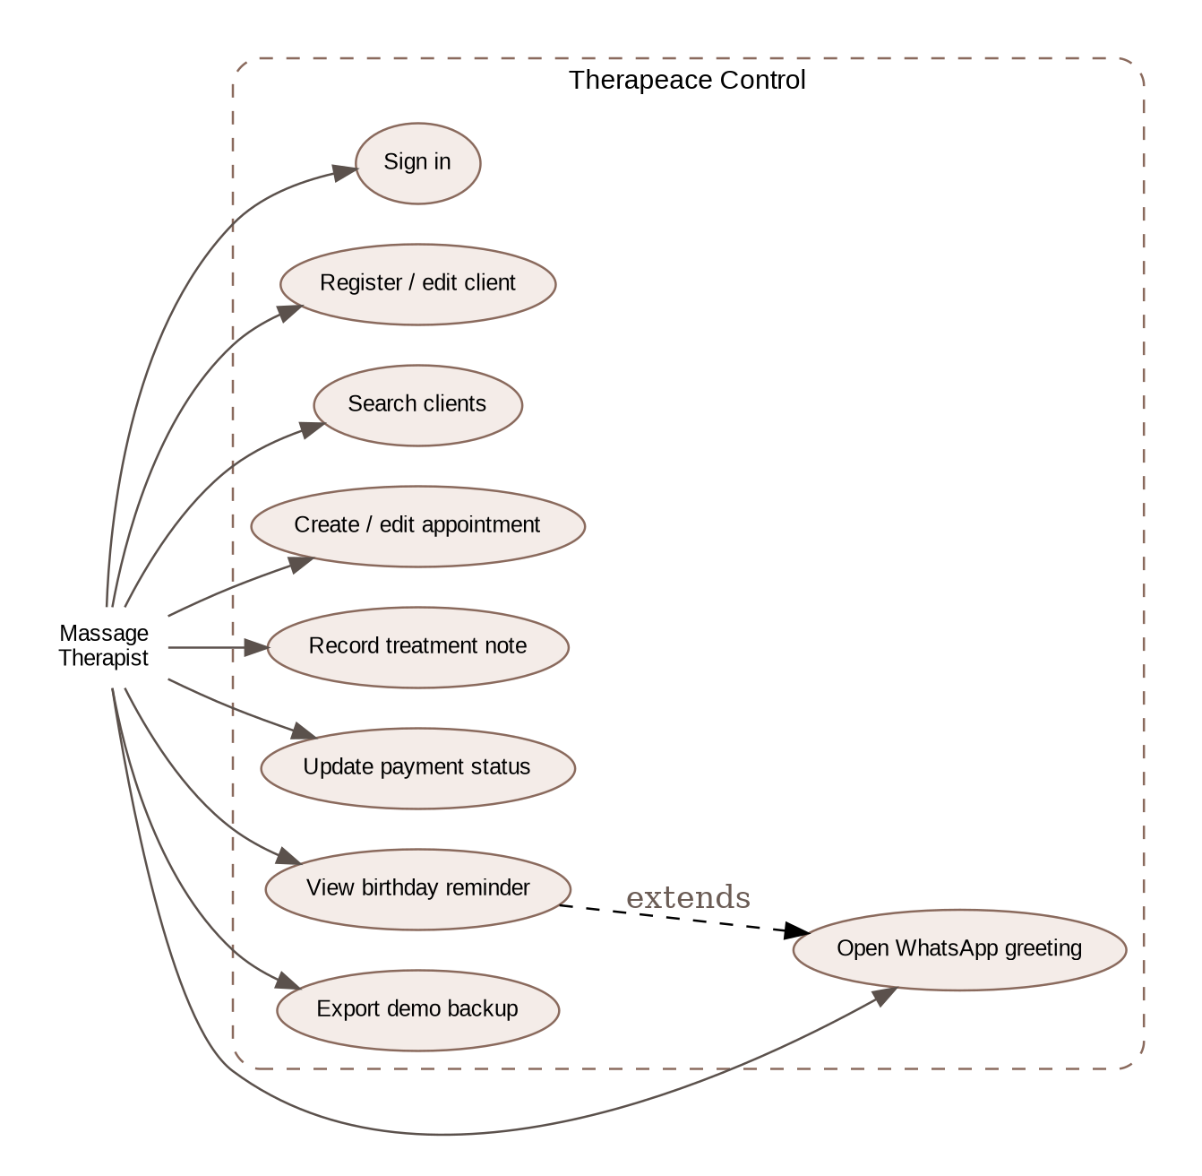
Figure 1. Therapeace Control use-case diagram.

Logical Data Model
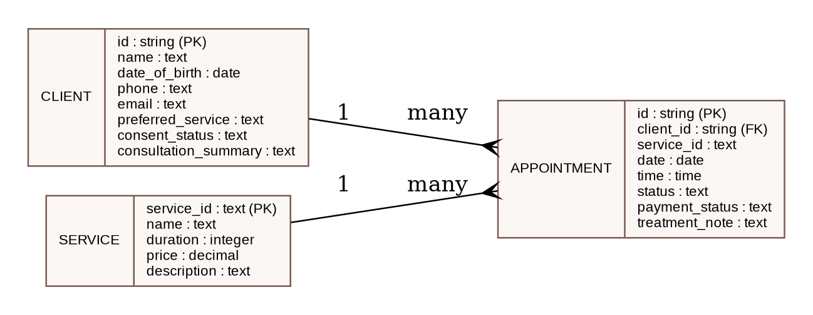
Figure 2. Logical data model for Client, Appointment and Service entities.

Section 2: Execution

Project Management, Timeline and Risk
A Kanban board was used to show work moving from To Do to In Progress and Done. This was useful because the sprint backlog contained a mix of coding, testing and documentation tasks. The final board shows that the assessment requirements were completed while production features remain clearly separated in the backlog. The Gantt chart provides a second view of the project by showing the timing of requirements, design, four implementation sprints, testing and report preparation.
The main project risks were scope growth, loss of development files, weak privacy controls, inconsistent browser behaviour, insufficient time for testing and confusion between a prototype and a production system. Scope growth was reduced through a future backlog. File-loss risk was reduced by maintaining separate source files and a final ZIP package. Privacy risk was reduced by using fictional data and adding a warning banner. Cross-browser and responsive risk was addressed through repeatable interface testing. Time risk was reduced by prioritising the minimum viable features before visual polish. The largest residual risk is still data security if the prototype were used outside its intended academic purpose; the mitigation is to prohibit real data until a secure architecture is implemented.

Updated Gantt Chart
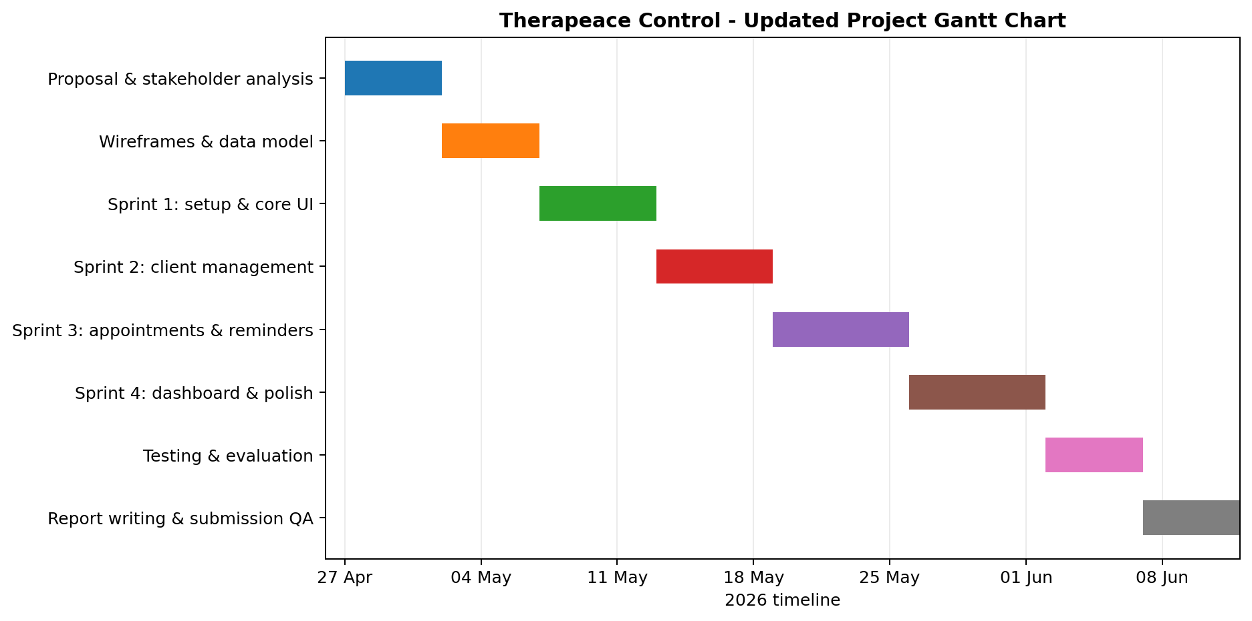
Figure 3. Updated project Gantt chart showing requirements, four sprints, testing and report preparation.

Kanban Evidence
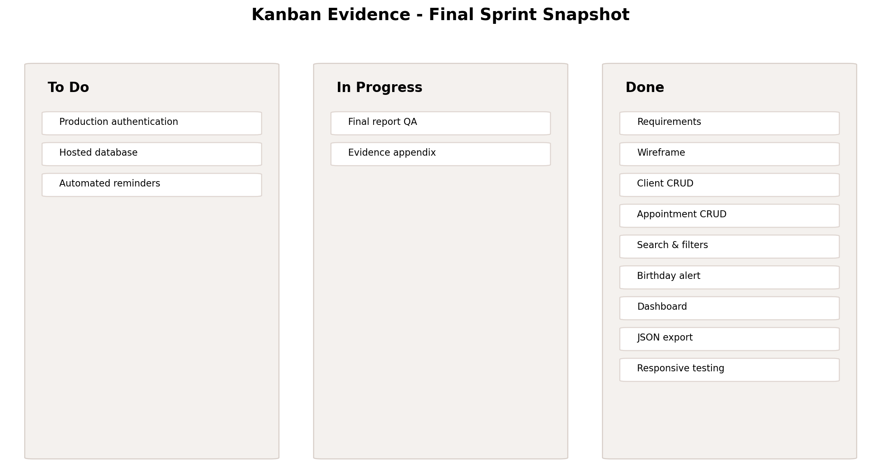
Figure 4. Final Kanban snapshot, separating completed assessment features from future production backlog.

Risk Assessment
Risk | Impact | Effect | Mitigation | Residual
Scope growth | High | Too many optional business features could prevent completion. | Use Must/Should/Could priorities and future backlog. | Low
Use of real sensitive data | High | Prototype architecture is not suitable for health information. | Fictional data only; visible warning; production security backlog. | Low for assessment
File loss | Medium | Source/report evidence could be lost. | Maintain separate source package and final ZIP backup. | Low
Browser/responsive defects | Medium | Layout or forms may fail at small widths. | Desktop/mobile regression tests. | Low
Testing time | Medium | Late changes may introduce defects. | Acceptance criteria and final automated browser test. | Low
Stakeholder evidence incomplete | Medium | Client review evidence may not meet tutor expectation. | Use genuine review templates; do not fabricate signatures. | Medium

Project Execution and Testing
The final product was assembled as a self-contained browser application. The login screen introduces the system and makes the prototype status clear. After sign-in, the dashboard displays registered clients, today’s appointments, outstanding payments and the total value of upcoming bookings. The daily schedule and birthday reminder are visible without opening another screen. The Clients page provides search, consent filtering and CRUD controls. The Appointments page provides date/status filtering, service information and payment tracking. The Services page gives a concise catalogue, while Data tools provide JSON export and reset functions.
A structured automated browser test was then carried out against the final source by loading the HTML, CSS and JavaScript together in a headless Chromium environment. Twelve functional and responsive tests passed. These included rejection of an incorrect password, successful demo sign-in, adding and searching a client, filtering by consent status, editing a client, creating an appointment, filtering by date, recalculating dashboard value, displaying a birthday reminder, constructing a WhatsApp URL and showing the mobile-menu control at a narrow viewport. The successful test results demonstrate that the main functional requirements operate consistently in the assessment prototype. The evidence uses fictional data only.

System Screenshots
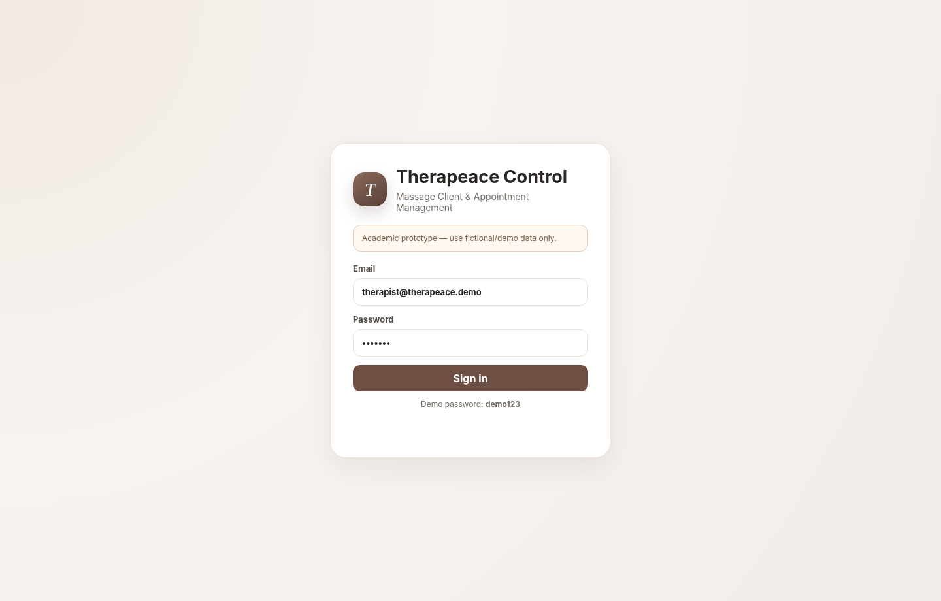
Figure 5. Prototype sign-in screen with academic-use warning.
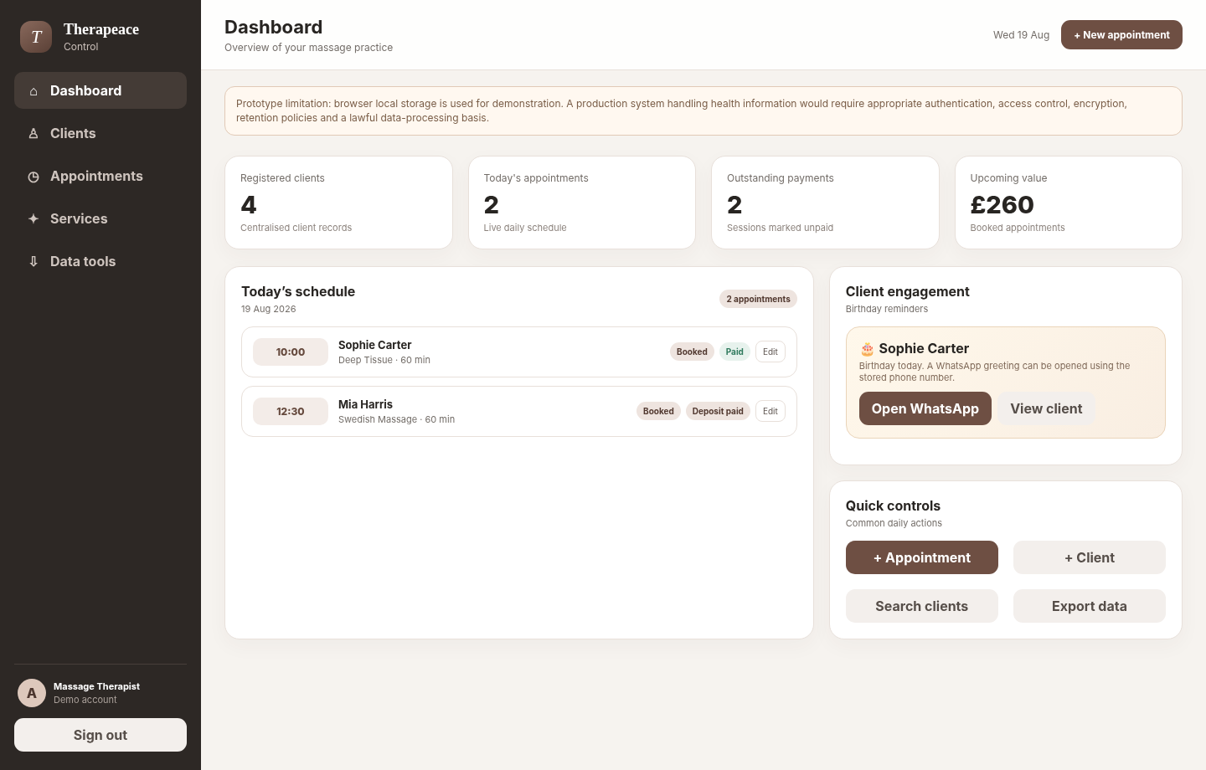
Figure 6. Dashboard showing daily schedule, summary indicators and birthday reminder.
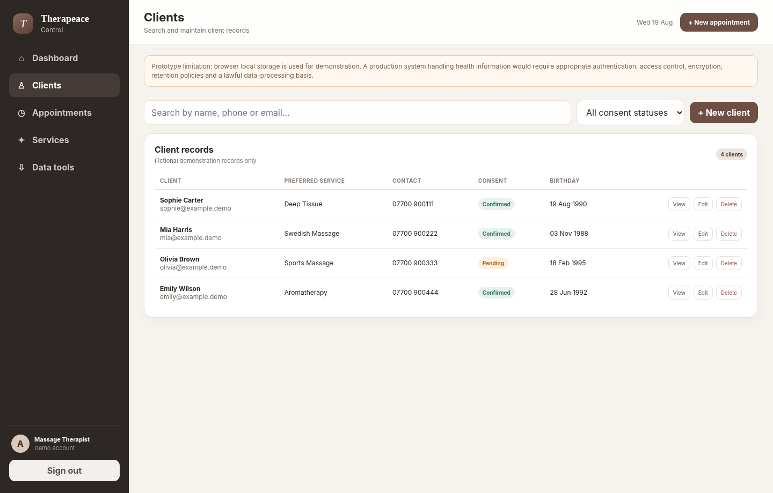
Figure 7. Client management screen with search and consent filtering.
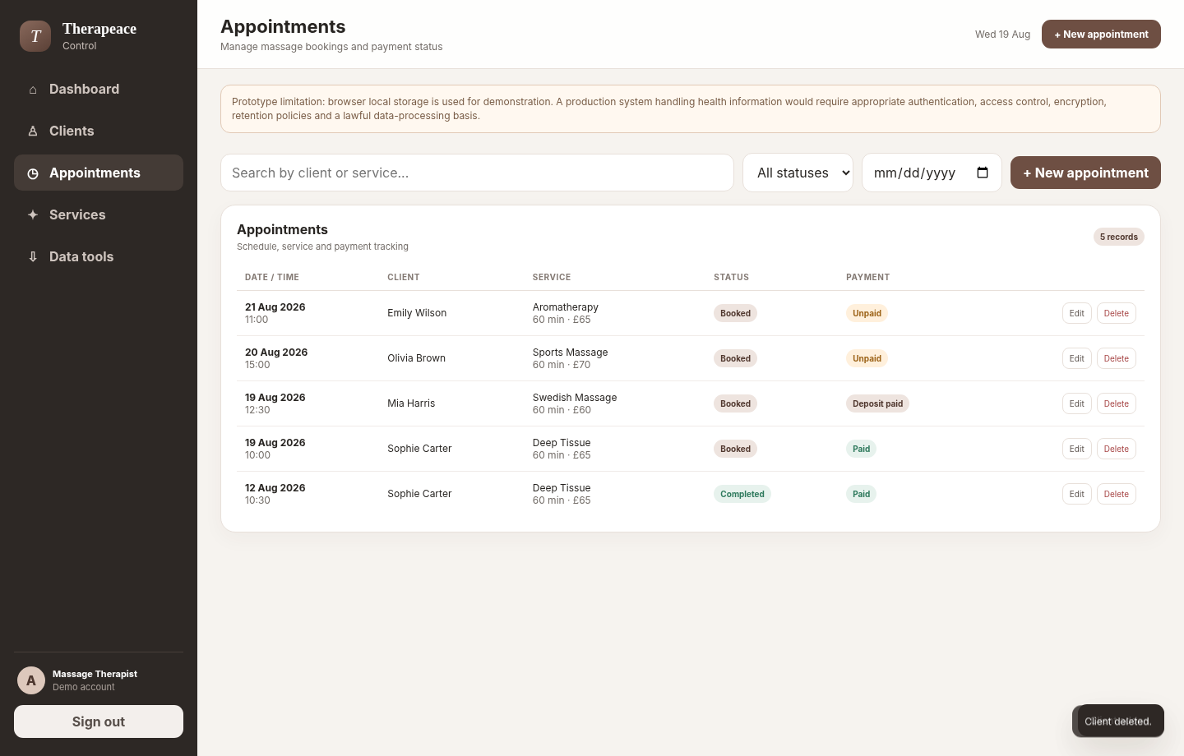
Figure 8. Appointment management screen with service, status and payment tracking.
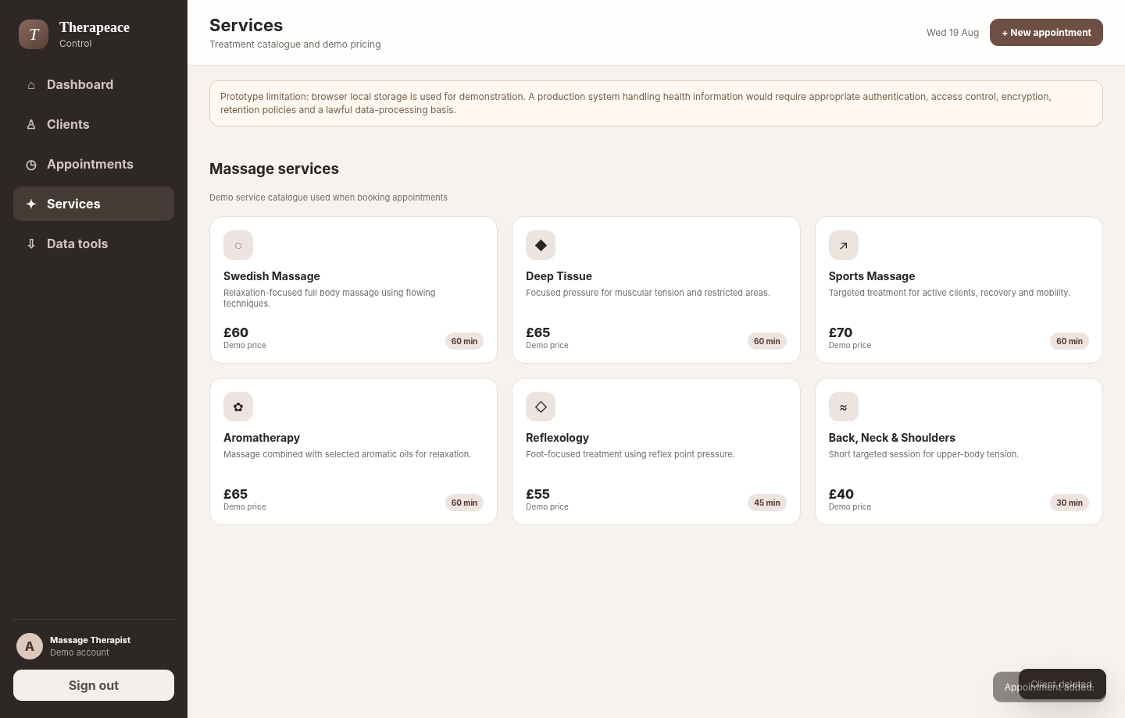
Figure 9. Massage service catalogue used by the booking workflow.
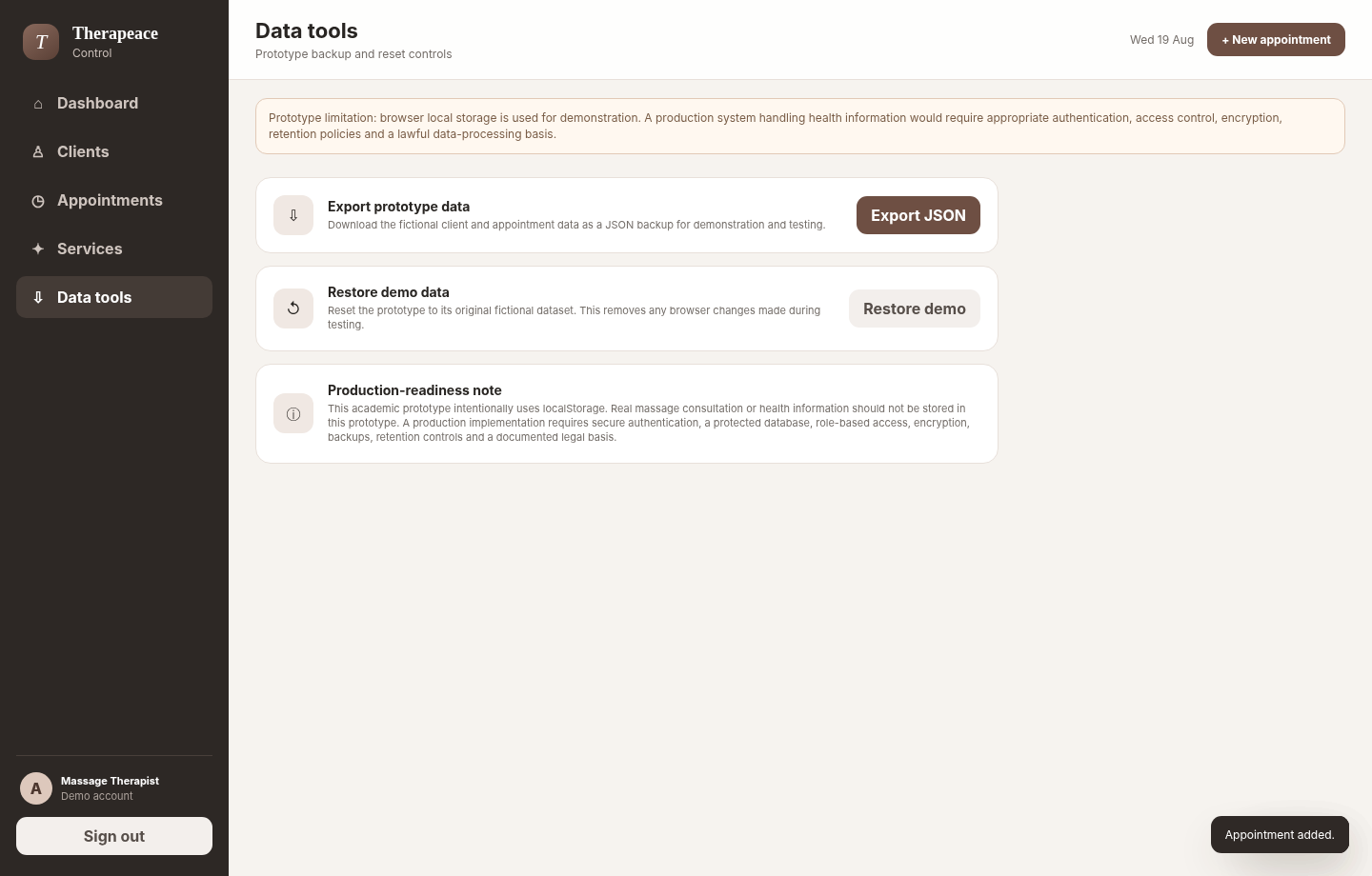
Figure 10. Data tools screen for prototype export and reset.

Testing Results
ID | Feature | Expected result | Observed result | Status
T01 | Login validation | Incorrect password is rejected | Incorrect demo password rejected. | PASS
T02 | Demo login | Dashboard is shown after correct password | Dashboard displayed after successful demo sign-in. | PASS
T03 | Add client | New client appears in client records | Automated Test Client displayed in client records. | PASS
T04 | Client search | Search returns matching client | One matching result displayed: Automated Test Client. | PASS
T05 | Consent filter | Only pending records are shown | Only Olivia Brown with Pending consent displayed. | PASS
T06 | Edit client | Edited name replaces original | Edited Test Client replaced the original name. | PASS
T07 | Add appointment | New appointment appears with date/time | New appointment displayed for 22 Aug 2026 at 09:30. | PASS
T08 | Appointment date filter | Only selected date remains | Only the selected 22 Aug 2026 appointment remained visible. | PASS
T09 | Dashboard statistics | Upcoming booking value updates after appointment creation | Dashboard statistics refreshed after the new appointment was created. | PASS
T10 | Birthday reminder | Today birthday card is displayed | Birthday reminder displayed for Sophie Carter. | PASS
T11 | WhatsApp shortcut | wa.me URL is generated | WhatsApp wa.me link generated for Sophie Carter. | PASS
T12 | Responsive layout | Mobile menu button becomes visible | Mobile menu control became visible at narrow viewport. | PASS

Test evidence: 12/12 automated functional and responsive checks passed in the final browser test run using fictional demonstration data.

Stakeholder / Client Review Record
The supplied example project includes signed client review forms at the end of each sprint. For this massage project, the same review structure has been prepared, but no external client feedback or signature has been invented. The appendix contains four review templates covering planned goals, completed deliverables, feedback, risks and next actions. Before submission, these should be completed with genuine evidence if the tutor requires an independent client or workplace supervisor.
Where the project is accepted as a self-employed work-based project, the owner-therapist can act as the business stakeholder and record genuine self-review observations, while technical evidence comes from the test log and screenshots. The key point is that the report should match what actually happened. Dates, names, comments and signatures must not be copied from the supplied example project or fabricated simply to make the evidence look complete.

Critical Self-Reflection
This project improved my understanding of the difference between building a screen that looks professional and building a system that is genuinely appropriate for a workplace. At the start, it was tempting to include many features because massage businesses can use online booking, payments, reminders, consultation forms, reporting and marketing tools. The Agile backlog helped me separate the essential workflow from ideas that would increase complexity. This made the final product more coherent and easier to test.
The strongest part of the project is the integration of several small business tasks into one consistent interface. Client information, bookings, payment status, service selection and dashboard information all use the same underlying data. I also improved my confidence with JavaScript state changes, form handling, filtering and responsive CSS. The automated test run was particularly useful because it showed that changes should be checked against expected behaviour rather than judged only by appearance.
The most important limitation is security. A front-end password and browser localStorage are appropriate only for demonstration. They do not provide the controls needed for real client records. Recognising this changed the way I presented the project: instead of describing it as a complete practice-management system, I describe it as a functional prototype with a clear production backlog. This is a more accurate evaluation and shows that technical feasibility must include the context in which data will be used.
If I repeated the project, I would formalise stakeholder feedback earlier and create acceptance criteria before starting each sprint. I would also separate business data from interface code from the beginning and introduce automated unit tests for calculations and validation. For a production phase, my first priority would be secure authentication and a protected backend rather than adding more visual features. I would also conduct a data-protection impact assessment where appropriate and obtain specialist advice before processing consultation or health information.
Overall, the project developed both technical and professional skills. I had to plan, prioritise, test, document limitations and make decisions based on the needs of the intended user. The experience reinforced that software development in a work context includes communication, risk, privacy, scope and evaluation as well as coding.

Conclusion
Therapeace Control demonstrates a complete work-based project cycle from problem identification to planning, implementation, testing and reflection. The identified issue was fragmented administration in a small massage-business workflow. The proposed improvement was a single browser interface for client records, appointments, service information, payments, reminders and basic backup. Four Agile sprints were used to control scope and deliver working features in stages.
The final prototype meets the assessment-level objectives and passed the recorded functional tests. It also provides evidence through diagrams, a Gantt chart, Kanban board, screenshots and test results. The project does not claim to be production-ready for real health information; that limitation is explicitly documented. Future development should focus first on secure authentication, protected database storage and privacy controls, followed by optional business features such as automated reminders, online booking and reporting. This balance between a working product and critical evaluation makes the project suitable as a demonstration of computing skills applied to the massage therapy sector.

Appendices

Appendix A - Use Case Diagram


Appendix B - Logical Data Model


Appendix C - Gantt Chart


Appendix D - Kanban Snapshot


Appendix E - Product File Structure
File | Purpose
index.html | Application structure and dialogs
styles.css | Responsive interface styling
app.js | Data, CRUD logic, filters, statistics and actions
README.md | Run instructions and limitations
docs/test-plan.md | Manual/functional test plan
docs/data-model.md | Prototype data model explanation
docs/project-backlog.csv | Sprint backlog and future items

The product source is supplied separately as a ZIP file so that it can be submitted alongside the report, consistent with the assessment brief requirement to submit working project files.

Appendix F - Sprint Review & Stakeholder Meeting Forms
Evidence warning: The forms below contain real project deliverables but the reviewer name, feedback, date and signature fields are deliberately left for genuine completion. Do not invent them.

Sprint Review & Stakeholder Meeting Form
Field | Details
Student name | Anda
Sprint number | 1
Sprint title | Sprint 1 - Requirements & Structure
Review date | [ENTER REAL DATE]
Reviewer | [ENTER REAL CLIENT / TUTOR / WORKPLACE REVIEWER]

1. Sprint Summary
Item | Description
Planned sprint goal | Define work-based issue, scope, interface and logical data model.
Completed deliverables | Requirements list, wireframe structure, backlog, use-case/data model.
Known challenge / blocker | Scope risk: too many booking/marketing ideas.
Retrospective decision | Move hosted and automated features to future backlog.

2. Demonstration / Evidence of Work
Evidence demonstrated: source files, relevant system screen(s), backlog status and test evidence for this sprint.

3. Genuine Reviewer Feedback
Area | Reviewer feedback
What worked well | [TO COMPLETE AFTER REAL REVIEW]
Issues / concerns / requests for change | [TO COMPLETE AFTER REAL REVIEW]
Suggested improvements / next steps | [TO COMPLETE AFTER REAL REVIEW]

4. Risk & Blocker Assessment
Risk / blocker | Impact | Action
Scope risk: too many booking/marketing ideas. | Medium | Move hosted and automated features to future backlog.

5. Sign-off
Reviewer name: ______________________________________________
Signature: ____________________________________________________
Date: _________________________________________________________
Student acknowledgement: ______________________________________

Sprint Review & Stakeholder Meeting Form
Field | Details
Student name | Anda
Sprint number | 2
Sprint title | Sprint 2 - Client Management
Review date | [ENTER REAL DATE]
Reviewer | [ENTER REAL CLIENT / TUTOR / WORKPLACE REVIEWER]

1. Sprint Summary
Item | Description
Planned sprint goal | Build client CRUD, search and consent status.
Completed deliverables | Client list, add/edit dialog, search, consent filter, delete workflow.
Known challenge / blocker | Form becoming too long.
Retrospective decision | Keep a concise consultation summary for prototype.

2. Demonstration / Evidence of Work
Evidence demonstrated: source files, relevant system screen(s), backlog status and test evidence for this sprint.

3. Genuine Reviewer Feedback
Area | Reviewer feedback
What worked well | [TO COMPLETE AFTER REAL REVIEW]
Issues / concerns / requests for change | [TO COMPLETE AFTER REAL REVIEW]
Suggested improvements / next steps | [TO COMPLETE AFTER REAL REVIEW]

4. Risk & Blocker Assessment
Risk / blocker | Impact | Action
Form becoming too long. | Medium | Keep a concise consultation summary for prototype.

5. Sign-off
Reviewer name: ______________________________________________
Signature: ____________________________________________________
Date: _________________________________________________________
Student acknowledgement: ______________________________________

Sprint Review & Stakeholder Meeting Form
Field | Details
Student name | Anda
Sprint number | 3
Sprint title | Sprint 3 - Appointments & Business Features
Review date | [ENTER REAL DATE]
Reviewer | [ENTER REAL CLIENT / TUTOR / WORKPLACE REVIEWER]

1. Sprint Summary
Item | Description
Planned sprint goal | Build booking workflow and service/payment features.
Completed deliverables | Appointment CRUD, filters, services, payment status, birthday/WhatsApp.
Known challenge / blocker | External messaging would increase scope/privacy complexity.
Retrospective decision | Use a simple URL shortcut only; no automated messaging.

2. Demonstration / Evidence of Work
Evidence demonstrated: source files, relevant system screen(s), backlog status and test evidence for this sprint.

3. Genuine Reviewer Feedback
Area | Reviewer feedback
What worked well | [TO COMPLETE AFTER REAL REVIEW]
Issues / concerns / requests for change | [TO COMPLETE AFTER REAL REVIEW]
Suggested improvements / next steps | [TO COMPLETE AFTER REAL REVIEW]

4. Risk & Blocker Assessment
Risk / blocker | Impact | Action
External messaging would increase scope/privacy complexity. | Medium | Use a simple URL shortcut only; no automated messaging.

5. Sign-off
Reviewer name: ______________________________________________
Signature: ____________________________________________________
Date: _________________________________________________________
Student acknowledgement: ______________________________________

Sprint Review & Stakeholder Meeting Form
Field | Details
Student name | Anda
Sprint number | 4
Sprint title | Sprint 4 - Dashboard, Testing & Polish
Review date | [ENTER REAL DATE]
Reviewer | [ENTER REAL CLIENT / TUTOR / WORKPLACE REVIEWER]

1. Sprint Summary
Item | Description
Planned sprint goal | Integrate dashboard, responsive UI, backup and test evidence.
Completed deliverables | Statistics, mobile layout, JSON export/reset, screenshots, test results.
Known challenge / blocker | Time available for final regression testing.
Retrospective decision | Prioritise acceptance tests before cosmetic changes.

2. Demonstration / Evidence of Work
Evidence demonstrated: source files, relevant system screen(s), backlog status and test evidence for this sprint.

3. Genuine Reviewer Feedback
Area | Reviewer feedback
What worked well | [TO COMPLETE AFTER REAL REVIEW]
Issues / concerns / requests for change | [TO COMPLETE AFTER REAL REVIEW]
Suggested improvements / next steps | [TO COMPLETE AFTER REAL REVIEW]

4. Risk & Blocker Assessment
Risk / blocker | Impact | Action
Time available for final regression testing. | Medium | Prioritise acceptance tests before cosmetic changes.

5. Sign-off
Reviewer name: ______________________________________________
Signature: ____________________________________________________
Date: _________________________________________________________
Student acknowledgement: ______________________________________

References
Beck, K., Beedle, M., van Bennekum, A., Cockburn, A., Cunningham, W., Fowler, M., Grenning, J., Highsmith, J., Hunt, A., Jeffries, R., Kern, J., Marick, B., Martin, R.C., Mellor, S., Schwaber, K., Sutherland, J. and Thomas, D. (2001) Manifesto for Agile Software Development. Available at: agilemanifesto.org (Accessed: 19 August 2026).
Barker, S. (2009) Brilliant project management: What the best project managers know, do and say. Englewood Cliffs: Prentice Hall.
Fresha (n.d.) Massage therapy software and booking features. Available at: fresha.com/for-business/massage (Accessed: 19 August 2026).
Information Commissioner’s Office (ICO) (2024) What is special category data? Available at: ico.org.uk (Accessed: 19 August 2026).
Information Commissioner’s Office (ICO) (n.d.) Data security advice for small organisations. Available at: ico.org.uk (Accessed: 19 August 2026).
Norman, D.A. (2013) The Design of Everyday Things. Revised and expanded edn. New York: Basic Books.

Source and Submission Notes
The report structure was based on the WKL200 assessment brief, the supplied WBL Project Report Template and the supplied example project used as a structural reference. The massage content, diagrams, source code, screenshots and testing evidence in this pack were newly created for Therapeace Control.
Before submitting: Enter your student ID and submission date; verify the assessment’s AI rules; complete genuine stakeholder evidence if required; open the product in your browser and perform your own final check; and make sure the final wording accurately reflects your own work and experience.

